UNIT-II

2.1. Queue:

A queue is another special kind of list, where items are inserted at one end called the rear and deleted at the other end called the front. Another name for a queue is a “FIFO” or “First-in-first-out” list.

The operations for a queue are analogues to those for a stack, the difference is that the insertions go at the end of the list, rather than the beginning. We shall use the following operations on queues:

enqueue: which inserts an element at the end of the queue.

dequeue: which deletes an element at the start of the queue.

2.1.1. Representation of Queue:

Let us consider a queue, which can hold maximum of five elements. Initially the queue is empty.

0 1 2 3 2

Que u e E mpt y
F RO NT = REA R = 0
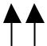

F R
Now, insert 11 to the queue. Then queue status will be:

0 | 1 | 2 | 3 | 2
 |  |  |  |  | REA R = REA R + 1 = 1
11 |  |  |  |  | REA R = REA R + 1 = 1
11 |  |  |  |  | F RO NT = 0

F R

Next, insert 22 to the queue. Then the queue status is:

0 | 1 | 2 | 3 | 2
 |  |  |  |  | REA R = REA R + 1 = 2
11 | 22 |  |  |  | REA R = REA R + 1 = 2
11 | 22 |  |  |  | F RO NT = 0

F R

Again insert another element 33 to the queue. The status of the queue is:

0 |  | 1 | 2 | 3 |  | 2
11 |  | 22 | 33 |  |  |  | REA R = REA R + 1 = 3
 |  | 22 | 33 |  |  |  | F RO NT = 0
F |  |  |  | R

Now, delete an element. The element deleted is the element at the front of the queue.

So the status of the queue is:

0 | 1 | 2 | 3 | 2
 |  |  |  |  | REA R = 3
 | 22 | 33 |  |  | REA R = 3
 | 22 | 33 |  |  | F RO NT = F R O NT + 1 = 1

F R
Again, delete an element. The element to be deleted is always pointed to by the FRONT pointer. So, 22 is deleted. The queue status is as follows:

0 | 1 | 2 | 3 | 2
 |  |  |  |  | REA R = 3
 |  | 33 |  |  | REA R = 3
 |  | 33 |  |  | F RO NT = F R O NT + 1 = 2

F R
Now, insert new elements 22 and 55 into the queue. The queue status is:

0 | 1 | 2 | 3 | 2
 |  |  |  |  | REA R = 5
 |  | 33 | 22 | 55 | REA R = 5
 |  | 33 | 22 | 55 | F RO NT = 2

F R
Next insert another element, say 66 to the queue. We cannot insert 66 to the queue as the rear crossed the maximum size of the queue (i.e., 5). There will be queue full signal. The queue status is as follows:

0 | 1 | 2 | 3 | 2
 |  |  |  |  | REA R = 5
 |  | 33 | 22 | 55 | REA R = 5
 |  | 33 | 22 | 55 | F RO NT = 2

F R
Now it is not possible to insert an element 66 even though there are two vacant positions in the linear queue. To over come this problem the elements of the queue are to be shifted towards the beginning of the queue so that it creates vacant position at the rear end. Then the FRONT and REAR are to be adjusted properly. The element 66 can be inserted at the rear end. After this operation, the queue status is as follows:

0 |  | 1 | 2 | 3 | 2
 |  |  |  |  |  |  | REA R = 2
33 |  | 22 | 55 | 66 |  |  | REA R = 2
 |  |  |  |  |  |  | F RO NT = 0
F |  |  |  |  | R

This difficulty can overcome if we treat queue position with index 0 as a position that comes after position with index 2 i.e., we treat the queue as a circular queue.

2.1.2. Source code for Queue operations using array:

In order to create a queue we require a one dimensional array Q(1:n) and two variables front and rear. The conventions we shall adopt for these two variables are that front is always 1 less than the actual front of the queue and rear always points to the last element in the queue. Thus, front = rear if and only if there are no elements in the queue. The initial condition then is front = rear = 0. The various queue operations to perform creation, deletion and display the elements in a queue are as follows:

  - insertQ(): inserts an element at the end of queue Q.

  - deleteQ(): deletes the first element of Q.

  - displayQ(): displays the elements in the queue.
include <conio.h>
define MAX 6
int Q[MAX];
int front, rear;

void insertQ()
{
int data;
if(rear == MAX)

{
printf("\n Linear Queue is full");
return;
}
else
{
printf("\n Enter data: ");
scanf("%d", &data);
Q[rear] = data;
rear++;

printf("\n Data Inserted in the Queue ");
}
}
void deleteQ()
{
if(rear == front)
{
printf("\n\n Queue is Empty..");
return;
}

else
{

printf("\n Deleted element from Queue is %d", Q[front]); front++;
}
}
void displayQ()
{
int i;
if(front == rear)

{
printf("\n\n\t Queue is Empty");
return;
}
else
{
printf("\n Elements in Queue are: ");
for(i = front; i < rear; i++)
{
printf("%d\t", Q[i]);
}
}
}
int menu()

{
int ch;
clrscr();
printf("\n \tQueue operations using ARRAY..");
printf("\n -----------**********-------------\n");
printf("\n 1. Insert ");
printf("\n 2. Delete ");
printf("\n 3. Display");
printf("\n 2. Quit ");
printf("\n Enter your choice: ");

scanf("%d", &ch);
return ch;
}
void main()
{
int ch;
do
{
ch = menu();
switch(ch)

{
case 1:
insertQ();
break;
case 2:
deleteQ();
break;
case 3:
displayQ();
break;

case 2:
return;
}
getch();
} while(1);
}
2.1.3. Linked List Implementation of Queue:

We can represent a queue as a linked list. In a queue data is deleted from the front end and inserted at the rear end. We can perform similar operations on the two ends of a list. We use two pointers front and rear for our linked queue implementation.

The linked queue looks as shown in figure 2.2:

 | front |  |  |  |  |  |  |  |  |  |  |  |  |  |  |  | rear
 | 100 |  |  |  |  |  |  |  |  |  |  |  |  |  |  |  | 200
 |  |  |  |  | 10 | 200 |  |  |  | 20 | 300 |  |  |  | 30 |  | 200 |  |  |  |  |  |  | 20 | X
 | 100 |  |  |  |  |  |  | 200 |  |  |  |  | 300 |  |  |  |  |  | 200
 |  |  |  |  |  | Figure 2.2. Linked Queue representation




2.1.2. Source code for queue operations using linked list:

include <stdlib.h>
include <conio.h>

struct queue
{
int data;
struct queue *next;
};
typedef struct queue node;
node *front = NULL;
node *rear = NULL;

node* getnode()
{
node *temp;
temp = (node *) malloc(sizeof(node)) ;
printf("\n Enter data ");
scanf("%d", &temp -> data);
temp -> next = NULL;
return temp;
}
void insertQ()
{
node *newnode;
newnode = getnode();

if(newnode == NULL)

{
printf("\n Queue Full");
return;
}
if(front == NULL)
{
front = newnode;
rear = newnode;

}

else
{
rear -> next = newnode;
rear = newnode;
}
printf("\n\n\t Data Inserted into the Queue..");
}
void deleteQ()

{

node *temp;
if(front == NULL)
{
printf("\n\n\t Empty Queue..");
return;
}
temp = front;
front = front -> next;

printf("\n\n\t Deleted element from queue is %d ", temp -> data); free(temp);
}

void displayQ()

{
node *temp;
if(front == NULL)
{
printf("\n\n\t\t Empty Queue ");
}
else
{

temp = front;

printf("\n\n\n\t\t Elements in the Queue are: ");
while(temp != NULL )
{
printf("%5d ", temp -> data);
temp = temp -> next;
}
}
}

char menu()
{
char ch;
clrscr();
printf("\n \t..Queue operations using pointers.. ");
printf("\n\t -----------**********-------------\n");
printf("\n 1. Insert ");
printf("\n 2. Delete ");

printf("\n 3. Display");

printf("\n 2. Quit ");
printf("\n Enter your choice: ");
ch = getche();
return ch;
}

void main()
{
char ch;
do
{
ch = menu();
switch(ch)
{
case '1' :
insertQ();
break;

case '2' :

deleteQ();
break;
case '3' :
displayQ();
break;
case '2':
return;
}

getch();

} while(ch != '2');
}

2.2. Applications of Queue:

It is used to schedule the jobs to be processed by the CPU.

When multiple users send print jobs to a printer, each printing job is kept in the printing queue. Then the printer prints those jobs according to first in first out (FIFO) basis.

Breadth first search uses a queue data structure to find an element from a graph.

2.3. Circular Queue:

A more efficient queue representation is obtained by regarding the array Q[MAX] as circular. Any number of items could be placed on the queue. This implementation of a queue is called a circular queue because it uses its storage array as if it were a circle instead of a linear list.

There are two problems associated with linear queue. They are:

Time consuming: linear time to be spent in shifting the elements to the beginning of the queue.

Signaling queue full: even if the queue is having vacant position.

For example, let us consider a linear queue status as follows:

0 | 1 | 2 | 3 | 2
 |  |  |  |  | REA R = 5
 |  | 33 | 22 | 55 | REA R = 5
 |  | 33 | 22 | 55 | F RO NT = 2

F R

Next insert another element, say 66 to the queue. We cannot insert 66 to the queue as the rear crossed the maximum size of the queue (i.e., 5). There will be queue full signal. The queue status is as follows:

0 | 1 | 2 | 3 | 2
 |  |  |  |  | REA R = 5
 |  | 33 | 22 | 55 | REA R = 5
 |  | 33 | 22 | 55 | F RO NT = 2

F R

This difficulty can be overcome if we treat queue position with index zero as a position that comes after position with index four then we treat the queue as a circular queue.

In circular queue if we reach the end for inserting elements to it, it is possible to insert new elements if the slots at the beginning of the circular queue are empty.
2.3.1. Representation of Circular Queue:

Let us consider a circular queue, which can hold maximum (MAX) of six elements.

Initially the queue is empty.

F R
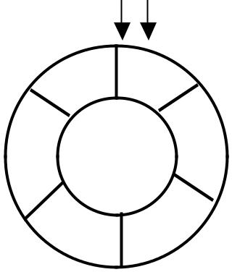

5 | 0
 | 1 |  | Que u e E mpt y
2 |  | M A X = 6
 |  | F RO NT = REA R = 0
 |  | CO U NT = 0

^{2 Circ ular Que ue}

Now, insert 11 to the circular queue. Then circular queue status will be:

 |  |  | F
 | 5 |  | 0 |  | R
 |  |  | 11 |  | R
 |  |  |  |  | F RO NT = 0
2 |  | 1 |  |  | F RO NT = 0
2 |  |  |  |  | REA R = ( REA R + 1) % 6 = 1
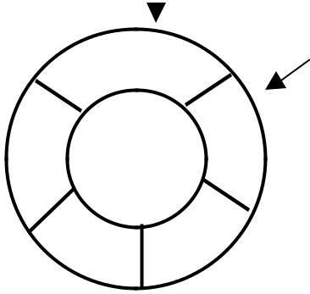
CO U NT = 1

^{2 Circ ular Que ue}

Insert new elements 22, 33, 22 and 55 into the circular queue. The circular queue status is:

F

R
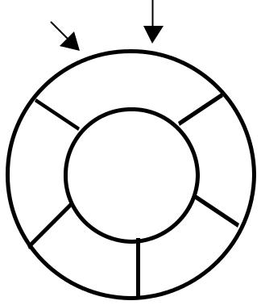

 | 5 | 0
 |  | 11
2 | 55 | 22 1 | FRONT = 0
2 | 55 |  | REAR = (REAR + 1) % 6 = 5
COUNT = 5

33

3 ² Circular Queue

Now, delete an element. The element deleted is the element at the front of the circular queue. So, 11 is deleted. The circular queue status is as follows:

R
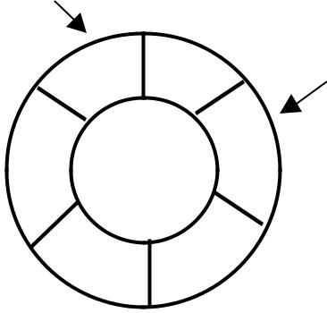

0
5

F

2 | 55 | 22 | 1

22 33

^{2 Circ ular Que ue}

F RO NT = (F R O NT + 1) % 6 = 1 REA R = 5
CO U NT = CO U NT - 1 = 2

Again, delete an element. The element to be deleted is always pointed to by the FRONT pointer. So, 22 is deleted. The circular queue status is as follows:

R
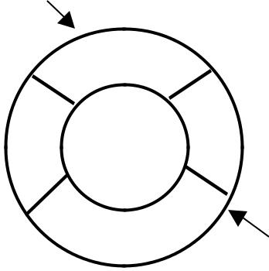

 | 5 |  | 0
2 | 55 |  | 1 | F RO NT = (F R O NT + 1) % 6 = 2
2 | 55 |  |  | REA R = 5
 |  |  |  | CO U NT = CO U NT - 1 = 3
 | 22
 | 22 |  | 33
 | 3 |  | 2 | F
 | Circ ular Que ue

Again, insert another element 66 to the circular queue. The status of the circular queue is:

 |  |  |  | R
 | 5 |  | 0
 | 66
2 | 55 |  |  |  |  | 1
2 | 55 |  |  |  |  | F RO NT = 2
 |  |  |  |  |  | REA R = ( REA R + 1) % 6 = 0
 |  |  |  |  |  | CO U NT = CO U NT + 1 = 2
 | 22
 | 22 |  |  | 33
 | 3 |  |  | 2 |  | F
 | Circ ular Que ue
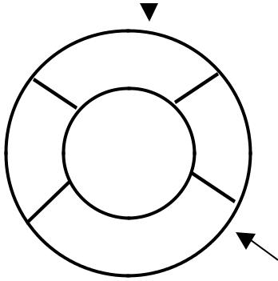

Now, insert new elements 77 and 88 into the circular queue. The circular queue status is:

 | 5 |  | 0
 | 66 |  | 77
2 | 55 | 88 |  | 1
2 | 55 |  |  | F RO NT = 2, REA R = 2
 |  |  |  | REA R = REA R % 6 = 2
 |  |  |  | CO U NT = 6
 | 22 | 33
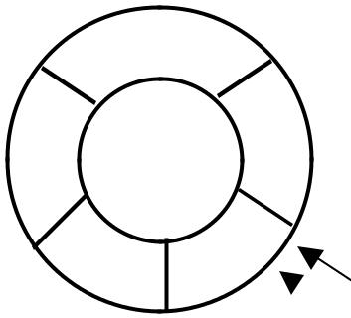
2 _{F} ^{R}

Circ ular Que ue

Now, if we insert an element to the circular queue, as COUNT = MAX we cannot add the element to circular queue. So, the circular queue is full.

2.3.2. Source code for Circular Queue operations, using array:

include <stdio.h>
include <conio.h>
define MAX 6

int CQ[MAX];
int front = 0;
int rear = 0;
int count = 0;

void insertCQ()
{
int data;
if(count == MAX)
{
printf("\n Circular Queue is Full");
}

else
{
printf("\n Enter data: ");
scanf("%d", &data);
CQ[rear] = data;
rear = (rear + 1) % MAX;
count ++;
printf("\n Data Inserted in the Circular Queue ");
}
}

void deleteCQ()
{
if(count == 0)
{
printf("\n\nCircular Queue is Empty..");
}
else
{
printf("\n Deleted element from Circular Queue is %d ", CQ[front]);

front = (front + 1) % MAX;
count --;
}
}

void displayCQ()
{
int i, j;
if(count == 0)
{
printf("\n\n\t Circular Queue is Empty ");

}
else
{
printf("\n Elements in Circular Queue are: ");
j = count;
for(i = front; j != 0; j--)
{
printf("%d\t", CQ[i]);
i = (i + 1) % MAX;
}

}
}

int menu()
{
int ch;
clrscr();
printf("\n \t Circular Queue Operations using ARRAY..");
printf("\n -----------**********-------------\n");
printf("\n 1. Insert ");

printf("\n 2. Delete ");
printf("\n 3. Display");
printf("\n 2. Quit ");
printf("\n Enter Your Choice: ");
scanf("%d", &ch);
return ch;
}

void main()
{
int ch;
do
{
ch = menu();
switch(ch)
{
case 1:
insertCQ();
break;
case 2:

deleteCQ();
break;
case 3:
displayCQ();
break;
case 2:
return;
default:
printf("\n Invalid Choice ");
}

getch();
} while(1);
}

2.4. Deque:

In the preceding section we saw that a queue in which we insert items at one end and from which we remove items at the other end. In this section we examine an extension of the queue, which provides a means to insert and remove items at both ends of the queue. This data structure is a deque. The word deque is an acronym derived from double-ended queue. Figure 2.5 shows the representation of a deque.

Deletion |  |  | 36 |  | 16 | 56 | 62 | 19 |  |  |  | Insertion
Insertion |  |  |  |  |  |  |  |  |  |  |  | Deletion
 |  |  | front |  |  |  |  | rear |  |  |  | Deletion



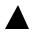

Figure 2.5. Representation of a deque.

A deque provides four operations. Figure 2.6 shows the basic operations on a deque.

enqueue_front: insert an element at front.

dequeue_front: delete an element at front.

enqueue_rear: insert element at rear.

dequeue_rear: delete element at rear.

 |  |  |  |  |  | enqueue_front(33) |  |  |  |  |  |  |  |  |  | enqueue_ |  | rear(22)
 |  | 11 | 22 |  |  |  |  |  |  |  | 33 | 11 | 22 |  |  |  |  |  |  |  |  | 33 | 11 | 22 | 22

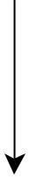

dequeue_front(33)

 |  |  |  |  |  |  | enqueue_front(55) |  |  |  |  |  |  |  |  | dequeue_ |  | rear(22)
 |  | 55 | 11 | 22 |  |  |  |  |  |  |  | 11 | 22 |  |  |  |  |  |  |  |  |  | 11 | 22 | 22



Figure 2.6. Basic operations on deque

There are two variations of deque. They are:

Input restricted deque (IRD)

Output restricted deque (ORD)

An Input restricted deque is a deque, which allows insertions at one end but allows deletions at both ends of the list.

An output restricted deque is a deque, which allows deletions at one end but allows insertions at both ends of the list.

2.5. Priority Queue:

A priority queue is a collection of elements such that each element has been assigned a priority and such that the order in which elements are deleted and processed comes from the following rules:

An element of higher priority is processed before any element of lower priority.

two elements with same priority are processed according to the order in which they were added to the queue.

A prototype of a priority queue is time sharing system: programs of high priority are processed first, and programs with the same priority form a standard queue. An efficient implementation for the Priority Queue is to use heap, which in turn can be used for sorting purpose called heap sort.

Linked List Implementation of Stack:

We can represent a stack as a linked list. In a stack push and pop operations are performed at one end called top. We can perform similar operations at one end of list using top pointer. The linked stack looks as shown in figure 2.3.

top
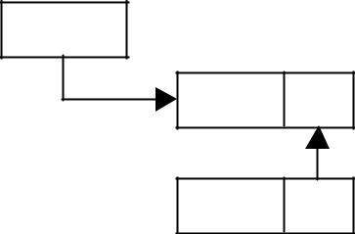

400
data next

40 X

400

400

300

 |  |  | 20 | 300
start |  |  | 200
100 |  |  | 10 | 200
 |  |  | 100

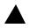

Figure Linked stack
representation

2.1.4. Source code for stack operations, using linked list:

include <stdio.h>
include <conio.h>
include <stdlib.h>

struct stack
{
int data;
struct stack *next;
};

void push();
void pop();
void display();
typedef struct stack node;
node *start=NULL;
node *top = NULL;

node* getnode()
{
node *temp;
temp=(node *) malloc( sizeof(node)) ;
printf("\n Enter data ");
scanf("%d", &temp -> data);
temp -> next = NULL;
return temp;
}

void push(node *newnode)
{
node *temp;
if( newnode == NULL )
{
printf("\n Stack Overflow..");
return;
}

if(start == NULL)
{
start = newnode;
top = newnode;
}
else

{
temp = start;
while( temp -> next != NULL)
temp = temp -> next;
temp -> next = newnode;
top = newnode;
}
printf("\n\n\t Data pushed into stack");
}
void pop()

{
node *temp;
if(top == NULL)
{
printf("\n\n\t Stack underflow");
return;
}
temp = start;
if( start -> next == NULL)
{

printf("\n\n\t Popped element is %d ", top -> data);
start = NULL;
free(top);
top = NULL;
}
else
{
while(temp -> next != top)
{
temp = temp -> next;

}
temp -> next = NULL;
printf("\n\n\t Popped element is %d ", top -> data);
free(top);
top = temp;
}
}
void display()
{
node *temp;

if(top == NULL)
{
printf("\n\n\t\t Stack is empty ");
}
else
{
temp = start;
printf("\n\n\n\t\t Elements in the stack: \n");
printf("%5d ", temp -> data);
while(temp != top)

{
temp = temp -> next;
printf("%5d ", temp -> data);
}
}
}

General Linear Lists

Linked lists and arrays are similar since they both store collections of data. Array is the most common data structure used to store collections of elements. Arrays are convenient to declare and provide the easy syntax to access any element by its index number. Once the array is set up, access to any element is convenient and fast. The disadvantages of arrays are:

The size of the array is fixed. Most often this size is specified at compile time. This makes the programmers to allocate arrays, which seems "large enough" than required.

Inserting new elements at the front is potentially expensive because existing elements need to be shifted over to make room.

Deleting an element from an array is not possible.

Linked lists have their own strengths and weaknesses, but they happen to be strong where arrays are weak. Generally array's allocates the memory for all its elements in one block whereas linked lists use an entirely different strategy. Linked lists allocate memory for each element separately and only when necessary.

Here is a quick review of the terminology and rules of pointers. The linked list code will depend on the following functions:

malloc() is a system function which allocates a block of memory in the "heap" and returns a pointer to the new block. The prototype of malloc() and other heap functions are in stdlib.h. malloc() returns NULL if it cannot fulfill the request. It is defined by:

void *malloc (number_of_bytes)

Since a void * is returned the C standard states that this pointer can be converted to any type. For example,

char *cp;
cp = (char *) malloc (100);

Attempts to get 100 bytes and assigns the starting address to cp. We can also use the sizeof() function to specify the number of bytes. For example,

int *ip;

ip = (int *) malloc (100*sizeof(int));

free() is the opposite of malloc(), which de-allocates memory. The argument to free() is a pointer to a block of memory in the heap — a pointer which was obtained by a malloc() function. The syntax is:

free (ptr);

The advantage of free() is simply memory management when we no longer need a block.

3.1. Linked List Concepts:

A linked list is a non-sequential collection of data items. It is a dynamic data structure. For every data item in a linked list, there is an associated pointer that would give the memory location of the next data item in the linked list.

The data items in the linked list are not in consecutive memory locations. They may be anywhere, but the accessing of these data items is easier as each data item contains the address of the next data item.

Advantages of linked lists:

Linked lists have many advantages. Some of the very important advantages are:

  - Linked lists are dynamic data structures. i.e., they can grow or shrink during the execution of a program.

  - Linked lists have efficient memory utilization. Here, memory is not pre-allocated. Memory is allocated whenever it is required and it is de-allocated (removed) when it is no longer needed.

  - Insertion and Deletions are easier and efficient. Linked lists provide flexibility in inserting a data item at a specified position and deletion of the data item from the given position.

  - Many complex applications can be easily carried out with linked lists.

Disadvantages of linked lists:

- It consumes more space because every node requires a additional pointer to store address of the next node.

- Searching a particular element in list is difficult and also time consuming.

3.2. Types of Linked Lists:

Basically we can put linked lists into the following four items:

Single Linked List.

Double Linked List.

Circular Linked List.

Circular Double Linked List.

A single linked list is one in which all nodes are linked together in some sequential manner. Hence, it is also called as linear linked list.

A double linked list is one in which all nodes are linked together by multiple links which helps in accessing both the successor node (next node) and predecessor node (previous node) from any arbitrary node within the list. Therefore each node in a double linked list has two link fields (pointers) to point to the left node (previous) and the right node (next). This helps to traverse in forward direction and backward direction.

A circular linked list is one, which has no beginning and no end. A single linked list can be made a circular linked list by simply storing address of the very first node in the link field of the last node.

A circular double linked list is one, which has both the successor pointer and predecessor pointer in the circular manner.

Comparison between array and linked list:

ARRAY | LINKED LIST
Size of an array is fixed | Size of a list is not fixed
Memory is allocated from stack | Memory is allocated from heap
It is necessary to specify the number of | It is not necessary to specify the
elements during declaration (i.e., during | number of elements during declaration
compile time). | (i.e., memory is allocated during run
 | time).
It occupies less memory than a linked | It occupies more memory.
list for the same number of elements.
Inserting new elements at the front is | Inserting a new element at any position
potentially expensive because existing | can be carried out easily.
elements need to be shifted over to
make room.
Deleting an element from an array is | Deleting an element is possible.
not possible.

Trade offs between linked lists and arrays:

FEATURE | ARRAYS | LINKED LISTS
Sequential access | efficient | efficient
Random access | efficient | inefficient
Resigning | inefficient | efficient
Element rearranging | inefficient | efficient
Overhead per elements | none | 1 or 2 links
Applications of linked list:

Linked lists are used to represent and manipulate polynomial. Polynomials are expression containing terms with non zero coefficient and exponents. For example:

P(x) = a₀ X^{n} + a₁ X^{n-1} + …… + a_{n-1} X + a_{n}

Represent very large numbers and operations of the large number such as addition, multiplication and division.

Linked lists are to implement stack, queue, trees and graphs.

Implement the symbol table in compiler construction

3.3. Single Linked List:

A linked list allocates space for each element separately in its own block of memory called a "node". The list gets an overall structure by using pointers to connect all its nodes together like the links in a chain. Each node contains two fields; a "data" field to store whatever element, and a "next" field which is a pointer used to link to the next node. Each node is allocated in the heap using malloc(), so the node memory continues to exist until it is explicitly de-allocated using free(). The front of the list is a pointer to the “start” node.

A single linked list is shown in figure 3.2.1.
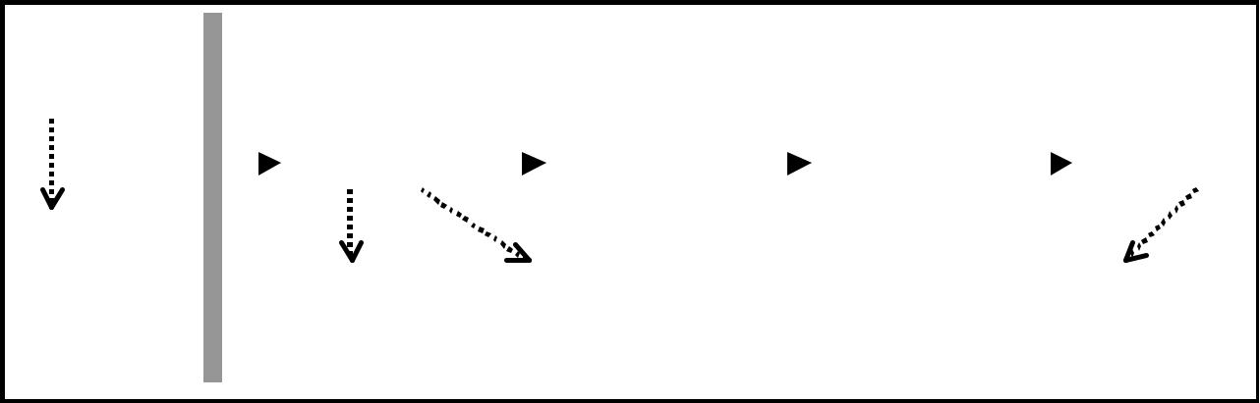

 | STACK |  |  |  |  |  |  |  |  |  |  |  |  |  | HEAP
 | 100
 | start
 | start |  |  |  |  |  | 10 |  |  | 200 |  |  |  | 20 | 300
The start |  | 100 |  |  |  |  |  |  |  |  |  | 200
pointer holds |  |  |  | Each node stores |  |  |  |  |  |  |  |  |  | Stores the next
the address
 |  |  |  | the data. |  |  |  |  |  |  |  |  |  | node address.
of the first
node of the
list.

Figure 3.2.1. Single Linked List

30 | 400 |  |  |  | 40 | X
300 |  |  | 400

The next field of the

last node is NULL.

The beginning of the linked list is stored in a "start" pointer which points to the first node. The first node contains a pointer to the second node. The second node contains a pointer to the third node, ... and so on. The last node in the list has its next field set to NULL to mark the end of the list. Code can access any node in the list by starting at the start and following the next pointers.

The start pointer is an ordinary local pointer variable, so it is drawn separately on the left top to show that it is in the stack. The list nodes are drawn on the right to show that they are allocated in the heap.

Implementation of Single Linked List:

Before writing the code to build the above list, we need to create a start node, used to create and access other nodes in the linked list. The following structure definition will do (see figure 3.2.2):

Creating a structure with one data item and a next pointer, which will be pointing to next node of the list. This is called as self-referential structure.

Initialise the start pointer to be NULL.

struct slinklist

{

int data;

struct slinklist* next;

};

typedef struct slinklist node;

node *start = NULL;

node: | data | next

 | start
Empty list: | NULL

Figure 3.2.2. Structure definition, single link node and empty list

The basic operations in a single linked list are:
Creation.

Insertion.

Deletion.

Traversing.
Creating a node for Single Linked List:

Creating a singly linked list starts with creating a node. Sufficient memory has to be allocated for creating a node. The information is stored in the memory, allocated by using the malloc() function. The function getnode(), is used for creating a node, after allocating memory for the structure of type node, the information for the item (i.e., data) has to be read from the user, set next field to NULL and finally returns the address of the node. Figure 3.2.3 illustrates the creation of a node for single linked list.

node* getnode()

{

node* newnode;

newnode = (node *) malloc(sizeof(node)); printf("\n Enter data: "); scanf("%d", &newnode -> data);

newnode -> next = NULL;

return newnode;
}

Figure 3.2.3. new node with a value of 10

newnode

X

100

Creating a Singly Linked List with ‘n’ number of nodes:

The following steps are to be followed to create ‘n’ number of nodes:

Get the new node using getnode(). newnode = getnode();

If the list is empty, assign new node as start. start = newnode;

If the list is not empty, follow the steps given below:

  - The next field of the new node is made to point the first node (i.e. start node) in the list by assigning the address of the first node.

  - The start pointer is made to point the new node by assigning the address of the new node.

Repeat the above steps ‘n’ times.

Figure 3.2.4 shows 4 items in a single linked list stored at different locations in memory.
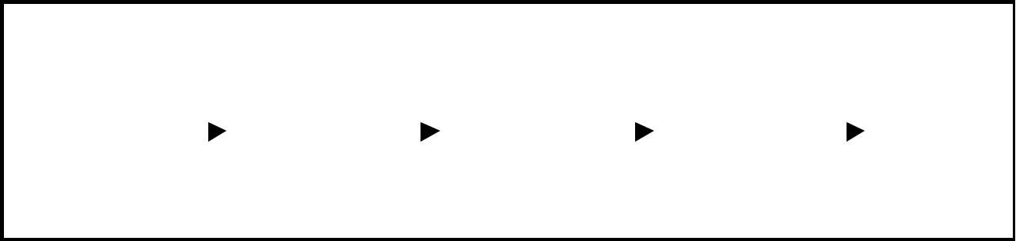

start
100
 |  |  |  | 10 | 200 |  |  | 20 | 300 |  |  | 30 | 400 |  |  | 40 | X
100 |  |  |  |  |  | 200 |  |  |  | 300 |  |  |  | 400

Figure 3.2.4. Single Linked List with 4 nodes

The function createlist(), is used to create ‘n’ number of nodes:

vo id createlist(int n)
{
int i;
no de * new no de;
no de *tem p;
for(i = 0; i < n ; i+ +)
{
new no de = getno de();
if(start = = NULL)
{
start = new no de;
}
else
{
tem p = start;
w hile(tem p - > next != NULL)
tem p = tem p - > next;
tem p - > next = new no de;
}
}
}

Insertion of a Node:

One of the most primitive operations that can be done in a singly linked list is the insertion of a node. Memory is to be allocated for the new node (in a similar way that is done while creating a list) before reading the data. The new node will contain empty data field and empty next field. The data field of the new node is then stored with the information read from the user. The next field of the new node is assigned to NULL. The new node can then be inserted at three different places namely:

Inserting a node at the beginning.

Inserting a node at the end.

Inserting a node at intermediate position.

Inserting a node at the beginning:

The following steps are to be followed to insert a new node at the beginning of the list:

Get the new node using getnode(). newnode = getnode();

If the list is empty then start = newnode.

If the list is not empty, follow the steps given below: newnode -> next = start;
start = newnode;

Figure 3.2.5 shows inserting a node into the single linked list at the beginning.
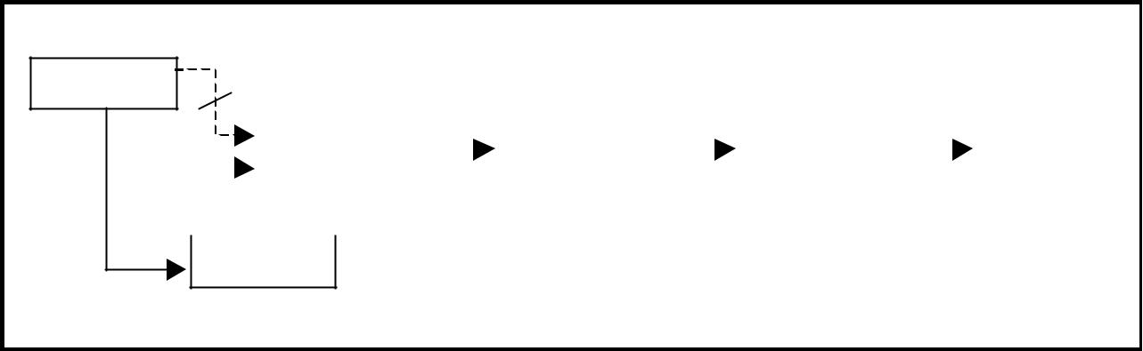

start

500

 |  |  | 10 |  | 200 |  |  |  | 20 | 300 |  |  | 30 | 400 |  |  | 40 | X
 |  |  | 100 |  |  |  |  |  | 200 |  |  |  | 300 |  |  |  | 400
5 |  |  |  | 100

500

Figure 3.2.5. Inserting a node at the beginning

The function insert_at_beg(), is used for inserting a node at the beginning

void insert_at_beg()

{
node *newnode;
newnode = getnode();
if(start == NULL)
{
start = newnode;
}
else
{
newnode -> next = start;

start = newnode;
}
}

Inserting a node at the end:

The following steps are followed to insert a new node at the end of the list:

Get the new node using getnode() newnode = getnode();

If the list is empty then start = newnode.

If the list is not empty follow the steps given below: temp = start;

while(temp -> next != NULL) temp = temp -> next;
temp -> next = newnode;

Figure 3.2.6 shows inserting a node into the single linked list at the end.
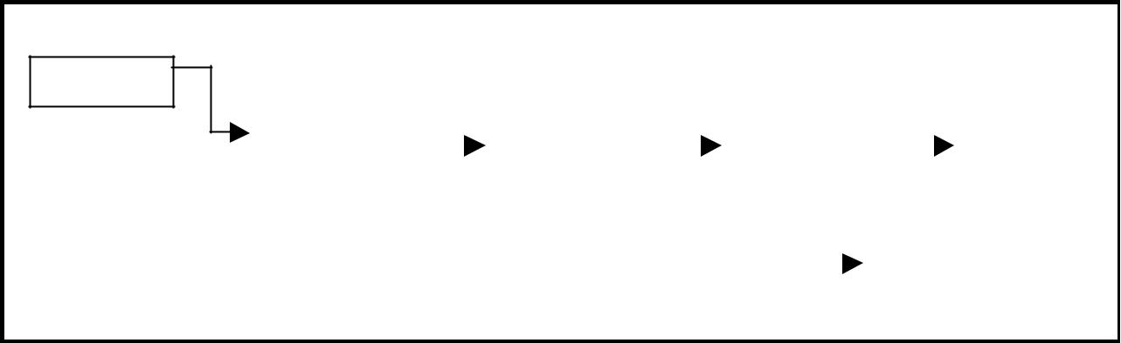

start

100

10 | 200 |  |  | 20 | 300 |  |  | 30 | 400 |  |  |  |  | 40 |  | 500
100 |  |  |  | 200 |  |  |  | 300 |  |  |  |  |  | 400
 |  |  |  |  |  |  |  |  |  |  |  | 50 |  | X
 |  |  |  |  |  |  |  |  |  |  |  | 500

Figure 3.2.6. Inserting a node at the end.

The function insert_at_end(), is used for inserting a node at the end.

void insert_at_end()
{
node *newnode, *temp;
newnode = getnode();

if(start == NULL)
{
start = newnode;
}
else
{
temp = start;
while(temp -> next != NULL)
temp = temp -> next;
temp -> next = newnode;

}
}

Inserting a node at intermediate position:

The following steps are followed, to insert a new node in an intermediate position in the list:

Get the new node using getnode(). newnode = getnode();

Ensure that the specified position is in between first node and last node. If not, specified position is invalid. This is done by countnode() function.

Store the starting address (which is in start pointer) in temp and prev pointers. Then traverse the temp pointer upto the specified position followed by prev pointer.

After reaching the specified position, follow the steps given below:
prev -> next = newnode;
newnode -> next = temp;

Let the intermediate position be 3.

Figure 3.2.7 shows inserting a node into the single linked list at a specified intermediate position other than beginning and end.
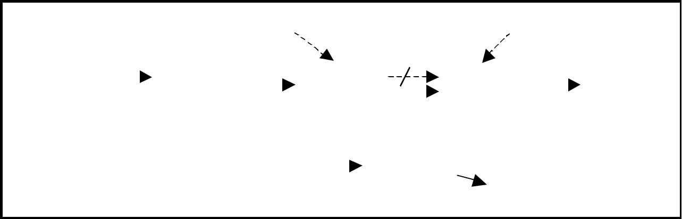

start |  |  |  |  |  |  | prev |  |  |  |  |  |  |  |  |  |  |  |  | temp
100
 |  |  |  | 10 | 200 |  |  | 20 |  | 500 |  |  |  |  |  |  | 30 |  |  | 400 |  |  | 40 | X
 |  |  |  | 100 |  |  |  | 200 |  |  |  |  |  |  |  |  | 300 |  |  |  |  |  | 400
 |  |  |  |  |  |  |  |  |  |  |  | 50 |  |  | 300
 |  |  |  |  |  |  |  |  |  | 500 |  |  |  |  |  |  |  |  |  | new node

Figure 3.2.7. Inserting a node at an intermediate position.

The function insert_at_mid(), is used for inserting a node in the intermediate position.

void insert_at_mid()
{
node *newnode, *temp, *prev;
int pos, nodectr, ctr = 1;
newnode = getnode();
printf("\n Enter the position: ");
scanf("%d", &pos);
nodectr = countnode(start);
if(pos > 1 && pos < nodectr)
{
temp = prev = start;
while(ctr < pos)

{
prev = temp;
temp = temp -> next;
ctr++;
}
prev -> next = newnode;
newnode -> next = temp;
}
else
{

printf("position %d is not a middle position", pos);
}
}

Deletion of a node:

Another primitive operation that can be done in a singly linked list is the deletion of a node. Memory is to be released for the node to be deleted. A node can be deleted from the list from three different places namely.

Deleting a node at the beginning.

Deleting a node at the end.

Deleting a node at intermediate position.

Deleting a node at the beginning:

The following steps are followed, to delete a node at the beginning of the list:

If list is empty then display ‘Empty List’ message.

If the list is not empty, follow the steps given below: temp = start;

start = start -> next; free(temp);

Figure 3.2.8 shows deleting a node at the beginning of a single linked list.
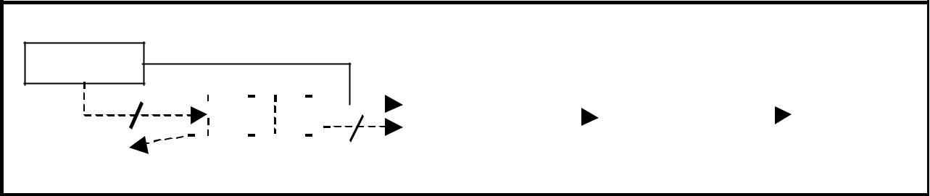

start

200

 |  |  |  |  |  |  |  |  |  |  |  |  |  |  |  |  |  |  |  |  |  |  | X
 |  |  | 10 |  |  | 200 |  |  |  |  |  |  |  | 20 | 300 |  |  | 30 | 400 |  |  | 40 | X
temp |  |  | 100 |  |  |  |  |  |  |  |  |  |  | 200 |  |  |  | 300 |  |  |  | 400

Figure 3.2.8. Deleting a node at the beginning.

The function delete_at_beg(), is used for deleting the first node in the list.

void delete_at_beg()
{
node *temp;
if(start == NULL)
{
printf("\n No nodes are exist..");

return ;
}
else
{
temp = start;
start = temp -> next;
free(temp);
printf("\n Node deleted ");
}
}

Deleting a node at the end:

The following steps are followed to delete a node at the end of the list:

If list is empty then display ‘Empty List’ message.

If the list is not empty, follow the steps given below:

temp = prev = start;

while(temp -> next != NULL)

{
prev = temp;
temp = temp -> next;
}
prev -> next = NULL;
free(temp);

Figure 3.2.9 shows deleting a node at the end of a single linked list.

start
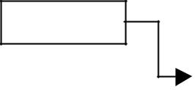

100
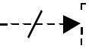

10 | 200 |  |  | 20 | 300 |  |  | 30 | X |  |  |  |  | 40 |  |  |  |  |  |  |  | X
100 |  |  |  | 200 |  |  |  | 300 |  |  |  |  | 400


Figure 3.2.9. Deleting a node at the end.

The function delete_at_last(), is used for deleting the last node in the list.

void delete_at_last()
{
node *temp, *prev;
if(start == NULL)
{
printf("\n Empty List..");
return ;
}
else
{

temp = start;
prev = start;
while(temp -> next != NULL)
{
prev = temp;
temp = temp -> next;
}
prev -> next = NULL;
free(temp);
printf("\n Node deleted ");

}
}

Deleting a node at Intermediate position:

The following steps are followed, to delete a node from an intermediate position in the list (List must contain more than two node).

If list is empty then display ‘Empty List’ message

If the list is not empty, follow the steps given below. if(pos > 1 && pos < nodectr)

{

temp = prev = start; ctr = 1;

while(ctr < pos)
{
prev = temp;

temp = temp -> next; ctr++;
}

prev -> next = temp -> next; free(temp);
printf("\n node deleted..");
}

Figure 3.2.10 shows deleting a node at a specified intermediate position other than beginning and end from a single linked list.

start
100
 |  |  |  | 10 | 300 |  |  |  |  | 20 |  |  |  |  | 300 |  |  |  |  |  |  |  |  |  |  |  |  |  |  |  | 30 | 400 |  |  | 40 | X
 |  |  |  | 100 |  |  |  |  |  | 200 |  |  |  |  |  |  |  |  |  |  |  |  |  |  |  |  |  |  |  |  | 300 |  |  |  | 400

Figure 3.2.10. Deleting a node at an intermediate position.

The function delete_at_mid(), is used for deleting the intermediate node in the list.

void delete_at_mid()
{
int ctr = 1, pos, nodectr;
node *temp, *prev;
if(start == NULL)
{
printf("\n Empty List..");
return ;
}
else
{
printf("\n Enter position of node to delete: ");

scanf("%d", &pos);
nodectr = countnode(start);
if(pos > nodectr)
{
printf("\nThis node doesnot exist");
}
if(pos > 1 && pos < nodectr)
{
temp = prev = start;
while(ctr < pos)
{
prev = temp;

temp = temp -> next;
ctr ++;
}
prev -> next = temp -> next;
free(temp);
printf("\n Node deleted..");
}
else
{
printf("\n Invalid position..");

getch();
}

}
}

Traversal and displaying a list (Left to Right):

To display the information, you have to traverse (move) a linked list, node by node from the first node, until the end of the list is reached. Traversing a list involves the following steps:

Assign the address of start pointer to a temp pointer.

Display the information from the data field of each node.

The function traverse() is used for traversing and displaying the information stored in the list from left to right.


void traverse()

{

node *temp;

temp = start;

printf("\n The contents of List (Left to Right): \n"); if(start == NULL )
printf("\n Empty List");

else

{

while (temp != NULL)

{

printf("%d ->", temp -> data);

temp = temp -> next;

}

}

printf("X");

}

Alternatively there is another way to traverse and display the information. That is in reverse order. The function rev_traverse(), is used for traversing and displaying the information stored in the list from right to left.

void rev_traverse(no de *st)
{
if(st = = NULL)
{
return;
}
else
{
rev_traverse(st - > next);
printf("%d - >", st - > data);
}
}

Counting the Number of Nodes:

The following code will count the number of nodes exist in the list using recursion.

int co untno de(no de *st)
{
if(st = = NULL)
return 0;
else
return(1 + co untno de(st - > next));
}

3.3.1. Source Code for the Implementation of Single Linked List:

# include <stdio.h>
# include <conio.h>

# include <stdlib.h>

struct slinklist
{
int data;
struct slinklist *next;
};

typedef struct slinklist node;

node *start = NULL;
int menu()
{
int ch;

clrscr();
printf("\n 1.Create a list ");
printf("\n--------------------------");
printf("\n 2.Insert a node at beginning ");
printf("\n 3.Insert a node at end");
printf("\n 4.Insert a node at middle");
printf("\n--------------------------");
printf("\n 5.Delete a node from beginning");
printf("\n 6.Delete a node from Last");
printf("\n 7.Delete a node from Middle");

printf("\n--------------------------");
printf("\n 8.Traverse the list (Left to Right)");
printf("\n 9.Traverse the list (Right to Left)");
printf("\n--------------------------");
printf("\n 10. Count nodes ");
printf("\n 11. Exit ");
printf("\n\n Enter your choice: ");
scanf("%d",&ch);
return ch;

}

node* getnode()

{
node * newnode;
newnode = (node *) malloc(sizeof(node));
printf("\n Enter data: ");
scanf("%d", &newnode -> data);
newnode -> next = NULL;
return newnode;

}

int countnode(node *ptr)

{
int count=0;
while(ptr != NULL)
{
count++;
ptr = ptr -> next;
}

return (count);
}

void createlist(int n)
{
int i;
node *newnode;
node *temp;
for(i = 0; i < n; i++)
{

newnode = getnode();
if(start == NULL)
{
start = newnode;
}
else
{
temp = start;
while(temp -> next != NULL)
temp = temp -> next;

temp -> next = newnode;
}
}
}

void traverse()

{
node *temp;
temp = start;
printf("\n The contents of List (Left to Right): \n");

if(start == NULL)
{
printf("\n Empty List");
return;
}
else
{
while(temp != NULL)
{

printf("%d-->", temp -> data);

temp = temp -> next;
}
}
printf(" X ");
}

void rev_traverse(node *start)
{
if(start == NULL)
{
return;
}
else

{
rev_traverse(start -> next);
printf("%d -->", start -> data);
}
}

void insert_at_beg()
{
node *newnode;
newnode = getnode();

if(start == NULL)
{
start = newnode;
}
else
{
newnode -> next = start;
start = newnode;
}
}

void insert_at_end()
{

node *newnode, *temp;
newnode = getnode();
if(start == NULL)
{
start = newnode;
}
else

{
temp = start;
while(temp -> next != NULL)
temp = temp -> next;
temp -> next = newnode;
}
}

void insert_at_mid()
{
node *newnode, *temp, *prev;
int pos, nodectr, ctr = 1;
newnode = getnode();
printf("\n Enter the position: ");
scanf("%d", &pos);
nodectr = countnode(start);
if(pos > 1 && pos < nodectr)
{
temp = prev = start;
while(ctr < pos)
{
prev = temp;

temp = temp -> next;
ctr++;
}
prev -> next = newnode;
newnode -> next = temp;
}
else
printf("position %d is not a middle position", pos);
}

void delete_at_beg()
{
node *temp;
if(start == NULL)
{
printf("\n No nodes are exist..");
return ;
}
else
{

temp = start;
start = temp -> next;
free(temp);
printf("\n Node deleted ");
}
}

void delete_at_last()
{
node *temp, *prev;
if(start == NULL)
{
printf("\n Empty List..");
return ;
}
else
{
temp = start;
prev = start;
while(temp -> next != NULL)

{
prev = temp;
temp = temp -> next;
}
prev -> next = NULL;
free(temp);
printf("\n Node deleted ");
}
}

void delete_at_mid()
{
int ctr = 1, pos, nodectr;
node *temp, *prev;
if(start == NULL)
{
printf("\n Empty List..");
return ;
}
else
{
printf("\n Enter position of node to delete: ");
scanf("%d", &pos);

nodectr = countnode(start);
if(pos > nodectr)
{
printf("\nThis node doesnot exist");

}

if(pos > 1 && pos < nodectr)
{
temp = prev = start;
while(ctr < pos)

{
prev = temp;
temp = temp -> next;
ctr ++;
}
prev -> next = temp -> next;
free(temp);
printf("\n Node deleted..");
}
else

{
printf("\n Invalid position..");
getch();
}
}
}
void main(void)
{
int ch, n;
clrscr();
while(1)
{
ch = menu();
switch(ch)
{
case 1:
if(start == NULL)
{
printf("\n Number of nodes you want to create: ");

scanf("%d", &n);
createlist(n);
printf("\n List created..");
}
else
printf("\n List is already created..");
break;
case 2:
insert_at_beg();
break;

case 3:
insert_at_end();
break;
case 4:
insert_at_mid();
break;
case 5:
delete_at_beg();
break;
case 6:
delete_at_last();
break;

case 7:
delete_at_mid();
break;
case 8:
traverse();
break;
case 9:
printf("\n The contents of List (Right to Left): \n");
rev_traverse(start);
printf(" X ");

break;
case 10:
printf("\n No of nodes : %d ", countnode(start));
break;
case 11 :
exit(0);
}
getch();
}
}
3.4. Using a header node:
A header node is a special dummy node found at the front of the list. The use of header node is an alternative to remove the first node in a list. For example, the picture below shows how the list with data 10, 20 and 30 would be represented using a linked list without and with a header node:
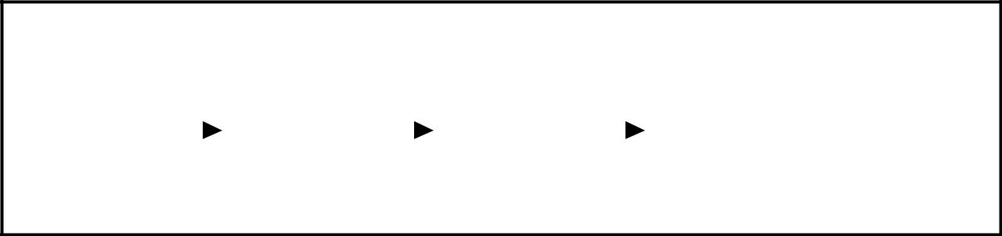

sta rt
100
 |  |  |  | 10 | 200 |  |  | 20 | 300 |  |  | 30 | X
100 |  |  |  |  |  | 200 |  |  |  | 300

Single Linke d List w it ho ut a he a der no de
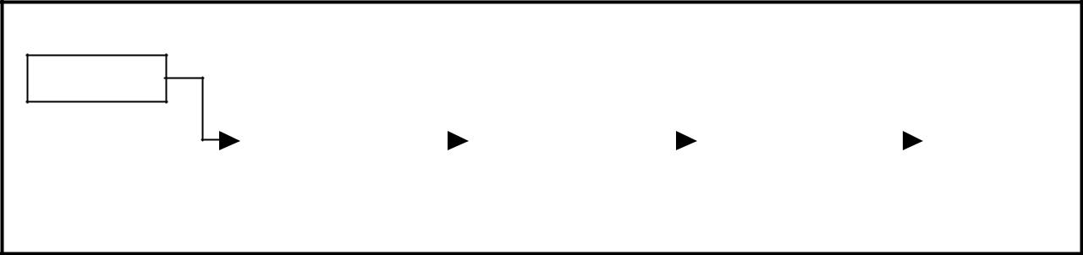

sta rt

400

 | 100 |  |  | 10 | 200 |  |  | 20 | 300 |  |  | 30 | X
400 |  | 100 |  |  |  | 200 |  |  |  | 300

Single Linke d List w it h he a der no de
Note that if your linked lists do include a header node, there is no need for the special case code given above for the remove operation; node n can never be the first node in the list, so there is no need to check for that case. Similarly, having a header node can simplify the code that adds a node before a given node n.

Note that if you do decide to use a header node, you must remember to initialize an empty list to contain one (dummy) node, you must remember not to include the header node in the count of "real" nodes in the list.

It is also useful when information other than that found in each node of the list is needed. For example, imagine an application in which the number of items in a list is often calculated. In a standard linked list, the list function to count the number of nodes has to traverse the entire list every time. However, if the current length is maintained in a header node, that information can be obtained very quickly.

3.5. Array based linked lists:

Another alternative is to allocate the nodes in blocks. In fact, if you know the maximum size of a list a head of time, you can pre-allocate the nodes in a single array. The result is a hybrid structure – an array based linked list. Figure 3.5.1 shows an example of null terminated single linked list where all the nodes are allocated contiguously in an array.
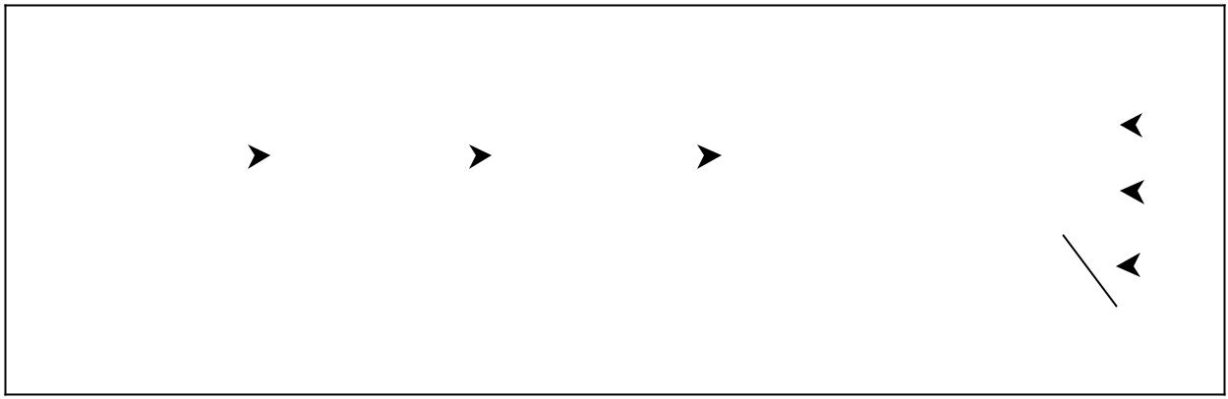

start
start |  |  |  |  |  |  |  |  |  |  |  |  |  |  |  | a
100 |  |  |  |  |  |  |  |  |  |  |  |  |  |  |  | a
 |  |  |  |  |  |  |  |  |  |  |  |  |  |  |  | b
 |  |  |  | a | 200 |  |  |  | b | 300 |  |  | c | X |  | b
100 |  |  |  |  |  | 200 |  |  |  |  |  |  | 300 |  |  | c
 |  |  |  |  |  | Conceptual structure |  |  |  |  |  |  |  |  |  | d

Implementation

Figure 3.5.1. An array based linked list

3.6. Double Linked List:

A double linked list is a two-way list in which all nodes will have two links. This helps in accessing both successor node and predecessor node from the given node position. It provides bi-directional traversing. Each node contains three fields:

Left link.
Data.

Right link.

The left link points to the predecessor node and the right link points to the successor node. The data field stores the required data.

Many applications require searching forward and backward thru nodes of a list. For example searching for a name in a telephone directory would need forward and backward scanning thru a region of the whole list.

The basic operations in a double linked list are:

Creation.

Insertion.

Deletion.

Traversing.

A double linked list is shown in figure 3.3.1.
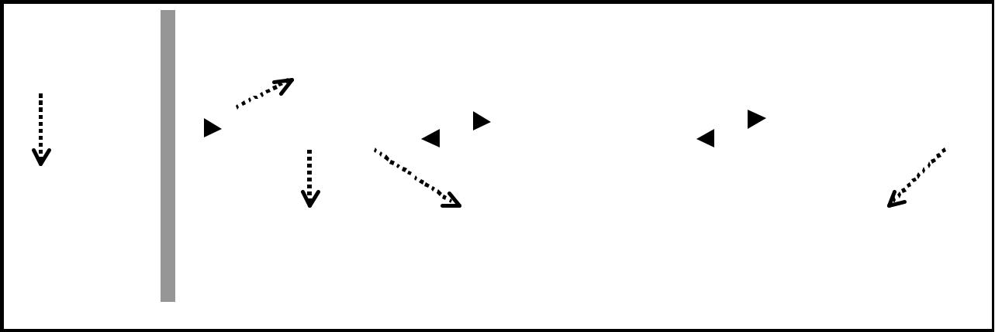

 | STACK |  |  |  |  |  | Stores the previous |  |  |  |  |  |  |  |  |  |  |  | HEAP
 |  |  |  |  |  |  | node address.
 | 100
 | start
 | start |  |  |  |  |  | X |  | 10 |  | 200 |  |  |  |  |  |  | 100 |  | 20 | 300 |  |  |  | 200 | 30 | X
The start |  | 100 |  |  |  |  |  |  |  |  |  | 200 |  |  |  |  |  |  |  |  |  |  |  |  | 300
pointer holds |  |  |  |  | Stores the data. |  |  |  |  |  |  | Stores the next
the address |  |  |  |  |  |  |  |  |  |  |  |  |  |  |  |  |  |  |  |  |  |  |  |  | The right field of the
of the first |  |  |  |  |  |  |  |  |  |  |  | node address. |  |  |  |  |  |  |  |  |  |  |  |  | last node is NULL.
node of the
list.

Figure 3.3.1. Double Linked List

The beginning of the double linked list is stored in a "start" pointer which points to the first node. The first node’s left link and last node’s right link is set to NULL.

The following code gives the structure definition:

struct dlinklist
{ |  | node: | left |  | data | right
struct dlinklist *left;
int data;
struct dlinklist *right;
}; |  |  |  |  | start
typedef struct dlinklist node; |  | Empty list: |  |  | NULL
node *start = NULL;
Figure 3.4.1. Structure definition, double link node and empty list

Creating a node for Double Linked List:

Creating a double linked list starts with creating a node. Sufficient memory has to be allocated for creating a node. The information is stored in the memory, allocated by using the malloc() function. The function getnode(), is used for creating a node, after allocating memory for the structure of type node, the information for the item (i.e., data) has to be read from the user and set left field to NULL and right field also set to NULL (see figure 3.2.2).

node* getnode()
{
node* newnode; |  |  |  | newnode
newnode = (node *) malloc(sizeof(node));
printf("\n Enter data: "); |  |  | X |  | 10 | X
scanf("%d", &newnode -> data);
scanf("%d", &newnode -> data); |  |  | 100
newnode -> left = NULL; |  |  | 100
newnode -> right = NULL;
return newnode;
}
Figure 3.4.2. new node with a value of 10

Creating a Double Linked List with ‘n’ number of nodes:

The following steps are to be followed to create ‘n’ number of nodes:

Get the new node using getnode(). newnode =getnode();

If the list is empty then start = newnode.

If the list is not empty, follow the steps given below:

  - The left field of the new node is made to point the previous node.

  - The previous nodes right field must be assigned with address of the new node.

Repeat the above steps ‘n’ times.

The function createlist(), is used to create ‘n’ number of nodes:

vo id createlist(int n)
{
int i;
no de * new no de;
no de *tem p;
for(i = 0; i < n; i+ +)
{
new no de = getno de();
if(start = = NULL)
{
start = new no de;
}
else
{
tem p = start;
w hile(tem p - > right)
tem p = tem p - > right;
tem p - > right = new no de;
new no de - > left = tem p;
}
}
}

Figure 3.4.3 shows 3 items in a double linked list stored at different locations.
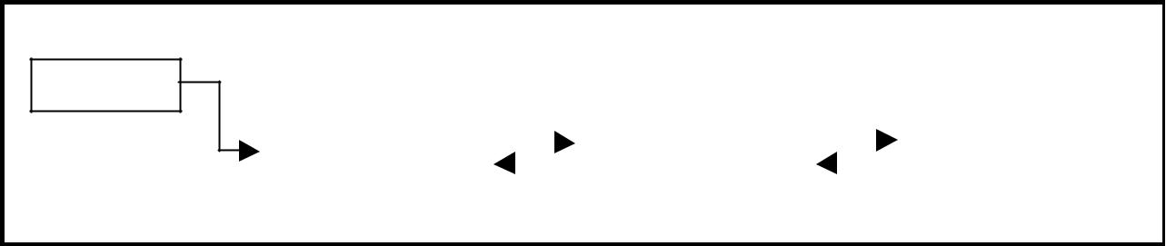

start

100

X | 10 | 200 |  |  |  |  |  | 100 | 20 | 300 |  |  |  | 200 | 30 | X
100 |  |  |  | 200 |  |  |  |  |  |  |  |  |  | 300

Figure 3.4.3. Double Linked List with 3 nodes
Inserting a node at the beginning:

The following steps are to be followed to insert a new node at the beginning of the list:

Get the new node using getnode(). newnode=getnode();

If the list is empty then start = newnode.

If the list is not empty, follow the steps given below:

newnode -> right = start;
start -> left = newnode;
start = newnode;

The function dbl_insert_beg(), is used for inserting a node at the beginning. Figure 3.4.4 shows inserting a node into the double linked list at the beginning.

start
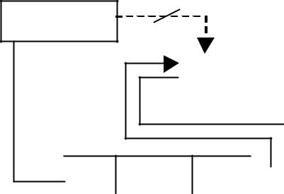

400

400 | 10 | 200 |  |  |  |  |  | 100 | 20 | 300 |  |  |  | 200 | 30 | X
100 |  |  |  | 200 |  |  |  |  |  |  |  |  |  | 300


X 40 100 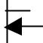

400

Figure 3.4.4. Inserting a node at the beginning

Inserting a node at the end:

The following steps are followed to insert a new node at the end of the list:

Get the new node using getnode() newnode=getnode();
If the list is empty then start = newnode.

If the list is not empty follow the steps given below:

temp = start;
while(temp -> right != NULL)
temp = temp -> right;
temp -> right = newnode;
newnode -> left = temp;

The function dbl_insert_end(), is used for inserting a node at the end. Figure 3.4.5 shows inserting a node into the double linked list at the end.

start
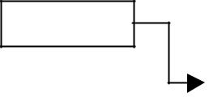

100
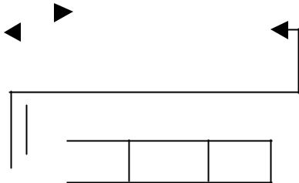

X | 10 | 200 |  |  |  |  |  | 100 | 20 | 300 |  |  |  |  |  | 200 | 30 | 400
100 |  |  |  | 200 |  |  |  |  |  |  |  |  |  |  |  | 300

300 40 X

400

Figure 3.4.5. Inserting a node at the end

Inserting a node at an intermediate position:

The following steps are followed, to insert a new node in an intermediate position in the list:

Get the new node using getnode(). newnode=getnode();

Ensure that the specified position is in between first node and last node. If not, specified position is invalid. This is done by countnode() function.

Store the starting address (which is in start pointer) in temp and prev pointers. Then traverse the temp pointer upto the specified position followed by prev pointer.

After reaching the specified position, follow the steps given below:

newnode -> left = temp;

newnode -> right = temp -> right;
temp -> right -> left = newnode;
temp -> right = newnode;

The function dbl_insert_mid(), is used for inserting a node in the intermediate position. Figure 3.4.6 shows inserting a node into the double linked list at a specified intermediate position other than beginning and end.

 | start
 |  |  |  |  |  |  |  |  |  |  |  |  |  | 100 | 40 | 200
 | 100
 |  |  |  |  |  |  |  |  |  |  |  | 400
 |  |  |  |  |  |  |  |  |  |  |  |  |  |  |  |  |  |  |  |  |  |  | 400 |  | 20 | 300
 |  |  |  |  | X | 10 | 400 |  |  |  |  |  |  |  |  |  |  |  |  |  |  |  |  |  | 20 | 300
 | 100 |  |  |  |  |  |  |  |  |  |  |  |  |  |  | 200
 |  |  |  |  |  |  |  |  |  |  |  |  |  |  |  |  |  |  |  |  |  |  |  | 200 | 30 | X
 |  |  |  |  |  |  |  |  |  |  |  |  |  |  |  | 300
 |  |  |  |  | Figure 3.4.6. Inserting a node at an intermediate position


Deleting a node at the beginning:

The following steps are followed, to delete a node at the beginning of the list:

If list is empty then display ‘Empty List’ message.

If the list is not empty, follow the steps given below:

temp = start;

start = start -> right;

start -> left = NULL;
free(temp);

The function dbl_delete_beg(), is used for deleting the first node in the list. Figure 3.4.6 shows deleting a node at the beginning of a double linked list.
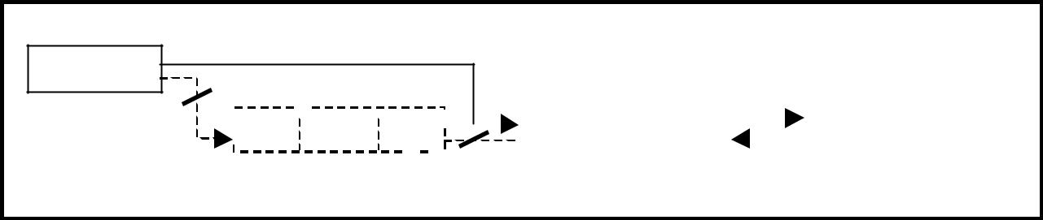

start

200

 | X |  |  | 10 |  | 200 |  |  |  |  |  |  |  | X | 20 | 300 |  |  |  | 200 | 30 | X
100 |  |  |  |  |  |  |  |  | 200 |  |  |  |  |  |  |  |  |  |  | 300

Figure 3.4.6. Deleting a node at beginning

Deleting a node at the end:

The following steps are followed to delete a node at the end of the list:
If list is empty then display ‘Empty List’ message

If the list is not empty, follow the steps given below:

temp = start;
while(temp -> right != NULL)
{
temp = temp -> right;
}
temp -> left -> right = NULL;
free(temp);

The function dbl_delete_last(), is used for deleting the last node in the list. Figure 3.4.7 shows deleting a node at the end of a double linked list.
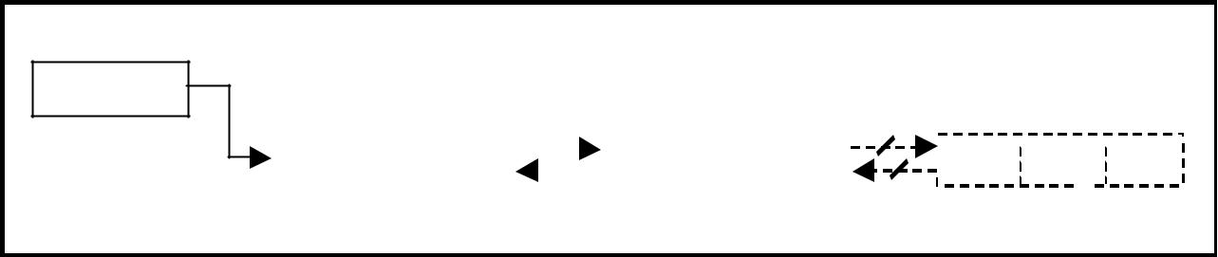

start

100

X |  |  |  |  |  |  |  |  |  | X |  |  |  |  |  | X
X | 10 | 200 |  |  |  |  |  | 100 | 20 | X |  | 20030 |  |  |  | X
100 |  |  |  | 200 |  |  |  |  |  |  |  | 300

Figure 3.4.7. Deleting a node at the end

Deleting a node at Intermediate position:

The following steps are followed, to delete a node from an intermediate position in the list (List must contain more than two nodes).

If list is empty then display ‘Empty List’ message.

If the list is not empty, follow the steps given below:

  - Get the position of the node to delete.

  - Ensure that the specified position is in between first node and last node. If not, specified position is invalid.

  - Then perform the following steps:
if(pos > 1 && pos < nodectr)
{
temp = start;
i = 1;
while(i < pos)
{
temp = temp -> right;
i++;
}
temp -> right -> left = temp -> left;
temp -> left -> right = temp -> right;
free(temp);

printf("\n node deleted..");

}

The function delete_at_mid(), is used for deleting the intermediate node in the list. Figure 3.4.8 shows deleting a node at a specified intermediate position other than beginning and end from a double linked list.

start
 | 100
 |  |  |  |  | X | 10 | 300 |  |  | 100 |  |  |  |  |  |  |  |  |  |  |  |  | 20 |  |  |  |  |  |  |  |  |  |  |  |  |  |  |  |  |  |  |  |  |  |  |  |  |  | 300 |  |  |  |  |  |  |  |  |  |  |  |  |  |  |  |  |  |  |  |  |  |  |  |  |  |  |  |  |  | 100 | 30 | X
 | 100 |  |  |  |  |  |  |  | 200 |  |  |  |  |  |  |  |  |  |  |  |  |  |  |  |  |  |  |  |  |  |  |  |  |  |  |  |  |  |  |  |  |  |  |  |  |  |  |  |  |  |  |  |  |  |  |  |  |  |  |  |  |  |  |  |  |  |  |  |  |  |  |  |  |  |  |  |  |  | 300

Figure 3.4.8 Deleting a node at an intermediate position

Traversal and displaying a list (Left to Right):

To display the information, you have to traverse the list, node by node from the first node, until the end of the list is reached. The function traverse_left_right() is used for traversing and displaying the information stored in the list from left to right.

The following steps are followed, to traverse a list from left to right:

If list is empty then display ‘Empty List’ message.

If the list is not empty, follow the steps given below:

temp = start;

while(temp != NULL)
{
print temp -> data;
temp = temp -> right;
}

Traversal and displaying a list (Right to Left):

To display the information from right to left, you have to traverse the list, node by node from the first node, until the end of the list is reached. The function traverse_right_left() is used for traversing and displaying the information stored in the list from right to left. The following steps are followed, to traverse a list from right to left:

If list is empty then display ‘Empty List’ message.

If the list is not empty, follow the steps given below: temp = start;

while(temp -> right != NULL) temp = temp -> right;
while(temp != NULL)
{
print temp -> data; temp = temp -> left;
}

Counting the Number of Nodes:

The following code will count the number of nodes exist in the list (using recursion).

int co untno de(no de *start)
{
if(start = = NULL)
return 0;
else
return(1 + co untno de(start - >right ));
}

3.5. A Complete Source Code for the Implementation of Double Linked List:

#include <stdio.h>
#include <stdlib.h>
#include <conio.h>

struct dlinklist
{
struct dlinklist *left;
int data;
struct dlinklist *right;
};

typedef struct dlinklist node;

node *start = NULL;

node* getnode()
{
node * newnode;
newnode = (node *) malloc(sizeof(node));
printf("\n Enter data: ");
scanf("%d", &newnode -> data);

newnode -> left = NULL;
newnode -> right = NULL;
return newnode;
}

int countnode(node *start)

{
if(start == NULL)
return 0;
else

return 1 + countnode(start -> right);
}

int menu()
{
int ch;
clrscr();
printf("\n 1.Create");
printf("\n------------------------------");
printf("\n 2. Insert a node at beginning ");

printf("\n 3. Insert a node at end");
printf("\n 4. Insert a node at middle");
printf("\n------------------------------");
printf("\n 5. Delete a node from beginning");
printf("\n 6. Delete a node from Last");
printf("\n 7. Delete a node from Middle");
printf("\n------------------------------");

printf("\n 8. Traverse the list from Left to Right "); printf("\n 9. Traverse the list from Right to Left "); printf("\n------------------------------");

printf("\n 10.Count the Number of nodes in the list"); printf("\n 11.Exit ");

printf("\n\n Enter your choice: ");

scanf("%d", &ch);
return ch;
}

void createlist(int n)
{
int i;
node *newnode;
node *temp;
for(i = 0; i < n; i++)
{
newnode = getnode();
if(start == NULL)
start = newnode;
else
{
temp = start;

while(temp -> right)
temp = temp -> right;
temp -> right = newnode;
newnode -> left = temp;
}
}
}
void traverse_left_to_right()
{
node *temp;
temp = start;
printf("\n The contents of List: ");
if(start == NULL )

printf("\n Empty List");
else
{
while(temp != NULL)
{
printf("\t %d ", temp -> data);
temp = temp -> right;
}
}
}

void traverse_right_to_left()
{
node *temp;
temp = start;
printf("\n The contents of List: ");
if(start == NULL)
printf("\n Empty List");
else
{
while(temp -> right != NULL)

temp = temp -> right;
}
while(temp != NULL)
{
printf("\t%d", temp -> data);
temp = temp -> left;
}
}
void dll_insert_beg()
{

node *newnode;
newnode = getnode();
if(start == NULL)
start = newnode;
else
{
newnode -> right = start;
start -> left = newnode;
start = newnode;
}

}

void dll_insert_end()

{
node *newnode, *temp;
newnode = getnode();
if(start == NULL)
start = newnode;
else
{

temp = start;
while(temp -> right != NULL)
temp = temp -> right;
temp -> right = newnode;
newnode -> left = temp;
}
}
void dll_insert_mid()
{
node *newnode,*temp;
int pos, nodectr, ctr = 1;
newnode = getnode();
printf("\n Enter the position: ");

scanf("%d", &pos);
nodectr = countnode(start);
if(pos - nodectr >= 2)
{
printf("\n Position is out of range..");
return;
}
if(pos > 1 && pos < nodectr)
{
temp = start;

while(ctr < pos - 1)
{
temp = temp -> right;
ctr++;
}
newnode -> left = temp;
newnode -> right = temp -> right;
temp -> right -> left = newnode;
temp -> right = newnode;
}

else
printf("position %d of list is not a middle position ", pos);
}

void dll_delete_beg()

{
node *temp;
if(start == NULL)
{

printf("\n Empty list");
getch();
return ;
}
else
{
temp = start;
start = start -> right;
start -> left = NULL;
free(temp);

}
}
void dll_delete_last()
{
node *temp;
if(start == NULL)
{
printf("\n Empty list");

getch();
return ;
}
else
{
temp = start;
while(temp -> right != NULL)

temp = temp -> right;
temp -> left -> right = NULL;
free(temp);
temp = NULL;
}
}

void dll_delete_mid()
{
int i = 0, pos, nodectr;
node *temp;
if(start == NULL)
{
printf("\n Empty List");
getch();
return;

}
else
{

printf("\n Enter the position of the node to delete: "); scanf("%d", &pos);

nodectr = countnode(start);

if(pos > nodectr)
{
printf("\nthis node does not exist");
getch();

return;
}
if(pos > 1 && pos < nodectr)
{
temp = start;
i = 1;
while(i < pos)
{
temp = temp -> right;
i++;

}
temp -> right -> left = temp -> left;
temp -> left -> right = temp -> right;
free(temp);
printf("\n node deleted..");
}
else
{
printf("\n It is not a middle position..");
getch();

}
}
}

void main(void)
{
int ch, n;
clrscr();
while(1)
{

ch = menu();
switch( ch)
{
case 1 :
printf("\n Enter Number of nodes to create: ");
scanf("%d", &n);
createlist(n);
printf("\n List created..");
break;
case 2 :
dll_insert_beg();
break;
case 3 :

dll_insert_end();
break;
case 4 :
dll_insert_mid();
break;
case 5 :
dll_delete_beg();
break;
case 6 :
dll_delete_last();

break;
case 7 :
dll_delete_mid();
break;
case 8 :
traverse_left_to_right();
break;
case 9 :
traverse_right_to_left();
break;

case 10 :

printf("\n Number of nodes: %d", countnode(start)); break;

case 11:
exit(0);

}
getch();
}
}

3.7. Circular Single Linked List:

It is just a single linked list in which the link field of the last node points back to the address of the first node. A circular linked list has no beginning and no end. It is necessary to establish a special pointer called start pointer always pointing to the first node of the list. Circular linked lists are frequently used instead of ordinary linked list because many operations are much easier to implement. In circular linked list no null pointers are used, hence all pointers contain valid address.

A circular single linked list is shown in figure 3.6.1.

start
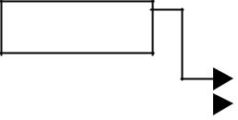

100

 |  | 10 | 200 |  |  | 20 | 300 |  |  | 30 | 400
 |  | 10 | 200 |  |  | 20 | 300 |  |  | 30 | 400 |  |  | 40 | 100
 |  | 100 |  | 200 |  |  |  | 300 |  |  |  | 400



Figure 3.6.1. Circular Single Linked List

The basic operations in a circular single linked list are:

Creation.

Insertion.

Deletion.

Traversing.

Creating a circular single Linked List with ‘n’ number of nodes:

The following steps are to be followed to create ‘n’ number of nodes:

Get the new node using getnode(). newnode = getnode();

If the list is empty, assign new node as start. start = newnode;

If the list is not empty, follow the steps given below:
temp = start;

while(temp -> next != NULL)
temp = temp -> next;
temp -> next = newnode;

Repeat the above steps ‘n’ times.

newnode -> next = start;

The function createlist(), is used to create ‘n’ number of nodes:

Inserting a node at the beginning:

The following steps are to be followed to insert a new node at the beginning of the circular list:

Get the new node using getnode(). newnode = getnode();

If the list is empty, assign new node as start.

start = newnode;

newnode -> next = start;

If the list is not empty, follow the steps given below:

last = start;
while(last -> next != start)
last = last -> next;
newnode -> next = start;
start = newnode;
last -> next = start;

The function cll_insert_beg(), is used for inserting a node at the beginning. Figure 3.6.2 shows inserting a node into the circular single linked list at the beginning.
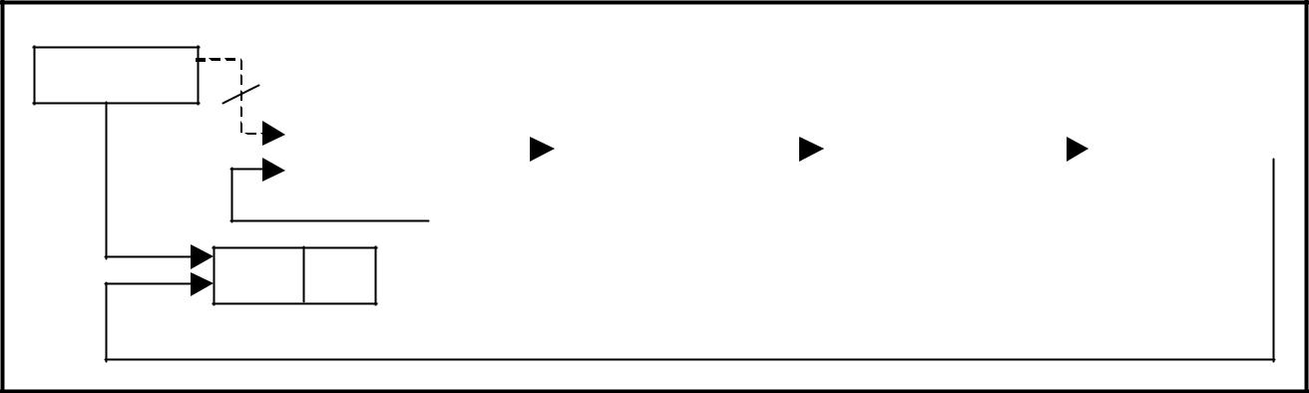

start

500

10 | 200 |  |  |  | 20 | 300 |  |  |  | 30 | 400 |  |  |  | 40 | 500
100 |  |  |  |  | 200 |  |  |  |  | 300 |  |  |  |  | 400

5 100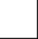

500

Figure 3.6.2. Inserting a node at the beginning

Inserting a node at the end:

The following steps are followed to insert a new node at the end of the list:

Get the new node using getnode(). newnode = getnode();

If the list is empty, assign new node as start.

start = newnode;

newnode -> next = start;

If the list is not empty follow the steps given below:

temp = start;

while(temp -> next != start)
temp = temp -> next;
temp -> next = newnode;
newnode -> next = start;

The function cll_insert_end(), is used for inserting a node at the end.

Figure 3.6.3 shows inserting a node into the circular single linked list at the end.
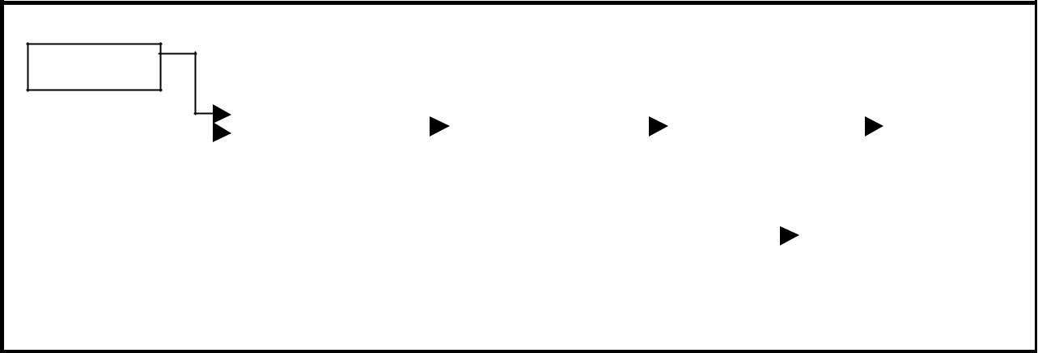

start

100

 |  | 10 | 200 |  |  | 20 | 300 |  |  | 30 | 400 |  |  |  |  | 40 |  | 500
 |  | 100 |  |  |  | 200 |  |  |  | 300 |  |  |  |  |  | 400
 |  |  |  |  |  |  |  |  |  |  |  |  |  | 50 | 100
 |  |  |  |  |  |  |  |  |  |  |  |  |  | 500

Figure 3.6.3 Inserting a node at the end.

Deleting a node at the beginning:

The following steps are followed, to delete a node at the beginning of the list:

If the list is empty, display a message ‘Empty List’.

If the list is not empty, follow the steps given below:

last = temp = start;

while(last -> next != start)

last = last -> next;
start = start -> next;
last -> next = start;

After deleting the node, if the list is empty then start = NULL.

The function cll_delete_beg(), is used for deleting the first node in the list. Figure 3.6.4 shows deleting a node at the beginning of a circular single linked list.

start
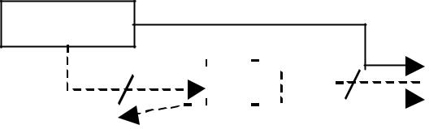

200

 |  |  |  |  |  |  |  |  |  |  |  |  |  |  |  |  |  |  |  |  | 40 | 200
 |  |  | 10 |  | 200 |  |  |  |  |  |  |  | 20 | 300 |  |  | 30 | 400 |  |  | 40 | 200
temp |  | 100 |  |  |  |  |  |  |  |  |  |  | 200 |  |  |  | 300 |  |  |  | 400

Figure 3.6.4. Deleting a node at beginning.

Deleting a node at the end:

The following steps are followed to delete a node at the end of the list:

If the list is empty, display a message ‘Empty List’.

If the list is not empty, follow the steps given below:

temp = start;

prev = start;
while(temp -> next != start)
{
prev = temp;
temp = temp -> next;
}
prev -> next = start;

After deleting the node, if the list is empty then start = NULL.

The function cll_delete_last(), is used for deleting the last node in the list.

Figure 3.6.5 shows deleting a node at the end of a circular single linked list.

start
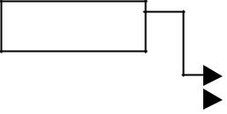

100
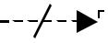

 |  | 10 | 200 |  |  | 20 | 300 |  |  | 30 | 100 |  |  |  | 40 |  |  |  |  |  |  |  |  |  | 100
 |  | 100 |  |  |  | 200 |  |  |  | 300 |  |  |  |  |  | 400
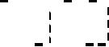

Figure 3.6.5. Deleting a node at the end.

Traversing a circular single linked list from left to right:

The following steps are followed, to traverse a list from left to right:

If list is empty then display ‘Empty List’ message.

If the list is not empty, follow the steps given below:

temp = start;

do
{
printf("%d ", temp -> data);
temp = temp -> next;
} while(temp != start);

3.7.1. Source Code for Circular Single Linked List:

include <stdio.h>
include <conio.h>
include <stdlib.h>

struct cslinklist

{
int data;
struct cslinklist *next;
};

typedef struct cslinklist node;

node *start = NULL;

int nodectr;

node* getnode()
{
node * newnode;
newnode = (node *) malloc(sizeof(node));
printf("\n Enter data: ");
scanf("%d", &newnode -> data);
newnode -> next = NULL;
return newnode;
}

int menu()
{
int ch;
clrscr();
printf("\n 1. Create a list ");
printf("\n\n--------------------------");

printf("\n 2. Insert a node at beginning ");
printf("\n 3. Insert a node at end");
printf("\n 4. Insert a node at middle");
printf("\n\n--------------------------");
printf("\n 5. Delete a node from beginning");
printf("\n 6. Delete a node from Last");
printf("\n 7. Delete a node from Middle");
printf("\n\n--------------------------");
printf("\n 8. Display the list");
printf("\n 9. Exit");

printf("\n\n--------------------------");
printf("\n Enter your choice: ");
scanf("%d", &ch);
return ch;
}

void createlist(int n)
{
int i;
node *newnode;

node *temp;
nodectr = n;
for(i = 0; i < n ; i++)
{
newnode = getnode();
if(start == NULL)
{
start = newnode;
}
else

{
temp = start;
while(temp -> next != NULL)

temp = temp -> next;

temp -> next = newnode;
}

}
newnode ->next = start;

/* last node is pointing to starting node */

}

void display()
{
node *temp;
temp = start;
printf("\n The contents of List (Left to Right): ");
if(start == NULL )
printf("\n Empty List");
else
{
do

{
printf("\t %d ", temp -> data);
temp = temp -> next;

} while(temp != start); printf(" X ");

}

}

void cll_insert_beg()
{
node *newnode, *last;
newnode = getnode();
if(start == NULL)
{

start = newnode;
newnode -> next = start;
}
else
{
last = start;
while(last -> next != start)
last = last -> next;
newnode -> next = start;
start = newnode;

last -> next = start;
}
printf("\n Node inserted at beginning..");
nodectr++;
}

void cll_insert_end()
{
node *newnode, *temp;
newnode = getnode();

if(start == NULL )
{
start = newnode;
newnode -> next = start;
}
else
{
temp = start;
while(temp -> next != start)
temp = temp -> next;

temp -> next = newnode;
newnode -> next = start;
}
printf("\n Node inserted at end..");
nodectr++;
}

void cll_insert_mid()
{
node *newnode, *temp, *prev;
int i, pos ;
newnode = getnode();
printf("\n Enter the position: ");
scanf("%d", &pos);
if(pos > 1 && pos < nodectr)
{
temp = start;
prev = temp;
i = 1;
while(i < pos)

{
prev = temp;
temp = temp -> next;
i++;
}
prev -> next = newnode;
newnode -> next = temp;
nodectr++;
printf("\n Node inserted at middle..");
}
else
{
printf("position %d of list is not a middle position ", pos);

}
}

void cll_delete_beg()
{
node *temp, *last;
if(start == NULL)
{
printf("\n No nodes exist..");
getch();

return ;
}
else
{
last = temp = start;
while(last -> next != start)
last = last -> next;
start = start -> next;
last -> next = start;
free(temp);

nodectr--;
printf("\n Node deleted..");
if(nodectr == 0)
start = NULL;
}
}

void cll_delete_last()
{
node *temp,*prev;
if(start == NULL)
{
printf("\n No nodes exist..");
getch();
return ;
}
else
{
temp = start;
prev = start;

while(temp -> next != start)
{
prev = temp;
temp = temp -> next;
}
prev -> next = start;
free(temp);
nodectr--;
if(nodectr == 0)
start = NULL;

printf("\n Node deleted..");
}
}
void cll_delete_mid()
{
int i = 0, pos;
node *temp, *prev;

if(start == NULL)

{
printf("\n No nodes exist..");
getch();
return ;
}
else
{
printf("\n Which node to delete: ");
scanf("%d", &pos);
if(pos > nodectr)

{
printf("\nThis node does not exist");
getch();
return;
}
if(pos > 1 && pos < nodectr)
{
temp=start;
prev = start;
i = 0;

while(i < pos - 1)
{
prev = temp;
temp = temp -> next ;
i++;
}
prev -> next = temp -> next;
free(temp);
nodectr--;
printf("\n Node Deleted..");

}
else
{
printf("\n It is not a middle position..");
getch();
}
}
}

void main(void)

{
int result;
int ch, n;
clrscr();
while(1)
{
ch = menu();
switch(ch)
{
case 1 :

if(start == NULL)
{
printf("\n Enter Number of nodes to create: ");
scanf("%d", &n);
createlist(n);
printf("\nList created..");
}

else
printf("\n List is already Exist..");
break;
case 2 :
cll_insert_beg();
break;

case 3 :
cll_insert_end();
break;
case 4 :
cll_insert_mid();
break;
case 5 :
cll_delete_beg();
break;
case 6 :

cll_delete_last();
break;
case 7 :
cll_delete_mid();
break;
case 8 :
display();
break;
case 9 :
exit(0);

}
getch();
}
}

3.8. Comparison of Linked List Variations:

The major disadvantage of doubly linked lists (over singly linked lists) is that they require more space (every node has two pointer fields instead of one). Also, the code to manipulate doubly linked lists needs to maintain the prev fields as well as the next fields; the more fields that have to be maintained, the more chance there is for errors.

The major advantage of doubly linked lists is that they make some operations (like the removal of a given node, or a right-to-left traversal of the list) more efficient.

The major advantage of circular lists (over non-circular lists) is that they eliminate some extra-case code for some operations (like deleting last node). Also, some applications lead naturally to circular list representations. For example, a computer network might best be modeled using a circular list.

3.9. Polynomials:

A polynomial is of the form: ^{n} c x ^{i}
∑ _{i}
i = 0

Where, c_{i} is the coefficient of the i^{th} term and n is the degree of the polynomial

Some examples are:

5x² + 3x + 1
12x³ – 4x

5x⁴ – 8x³ + 2x² + 4x¹ + 9x⁰

It is not necessary to write terms of the polynomials in decreasing order of degree. In other words the two polynomials 1 + x and x + 1 are equivalent.

The computer implementation requires implementing polynomials as a list of pairs of coefficient and exponent. Each of these pairs will constitute a structure, so a polynomial will be represented as a list of structures. A linked list structure that represents polynomials 5x⁴ – 8x³ + 2x² + 4x¹ + 9x⁰ illustrates in figure 3.10.1.

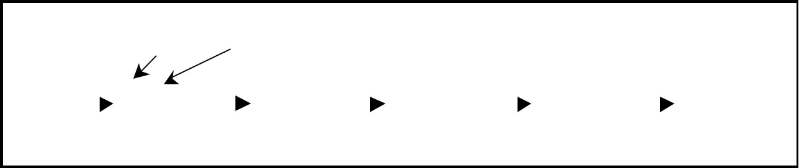
start |  |  |  | Coefficient |  |  |  | Exponent
500
 |  |  |  | 5 | 4 | 100 |  |  | -8 | 3 | 200 |  |  | 2 | 2 | 300 |  |  | 4 | 1 | 400 |  |  | 9 | 0 | X
 | 500 |  |  |  |  |  | 100 |  |  |  |  | 200 |  |  |  |  | 300 |  |  |  |  |  |  | 400

Figure 3.10.1. Single Linked List for the polynomial F(x) = 5x4 – 8x3 + 2x2 + 4x1 + 9x0

3.10.1. Source code for polynomial creation with help of linked list:

#include <conio.h>
#include <stdio.h>
#include <malloc.h>

struct link
{
float coef;
int expo;
struct link *next;
};

typedef struct link node;
node * getnode()
{
node *tmp;
tmp =(node *) malloc( sizeof(node) );
printf("\n Enter Coefficient : ");

fflush(stdin);
scanf("%f",&tmp->coef);
printf("\n Enter Exponent : ");
fflush(stdin);
scanf("%d",&tmp->expo);
tmp->next = NULL;
return tmp;
}
node * create_poly (node *p )
{

char ch;
node *temp,*newnode;
while( 1 )
{
printf ("\n Do U Want polynomial node (y/n): ");
ch = getche();
if(ch == 'n')
break;
newnode = getnode();
if( p == NULL )

p = newnode;
else
{
temp = p;
while(temp->next != NULL )
temp = temp->next;
temp->next = newnode;
}

}

return p;
}

void display (node *p)
{
node *t = p;
while (t != NULL)
{
printf("+ %.2f", t -> coef);

printf("X^ %d", t -> expo);
t =t -> next;
}
}

void main()

{

node *poly1 = NULL ,*poly2 = NULL,*poly3=NULL; clrscr();

printf("\nEnter First Polynomial..(in ascending-order of exponent)"); poly1 = create_poly (poly1);

printf("\nEnter Second Polynomial..(in ascending-order of exponent)");
poly2 = create_poly (poly2);
clrscr();
printf("\n Enter Polynomial 1: ");
display (poly1);
printf("\n Enter Polynomial 2: ");
display (poly2);
getch();
}

3.10.2. Addition of Polynomials:

To add two polynomials we need to scan them once. If we find terms with the same exponent in the two polynomials, then we add the coefficients; otherwise, we copy the term of larger exponent into the sum and go on. When we reach at the end of one of the polynomial, then remaining part of the other is copied into the sum.

To add two polynomials follow the following steps:

Read two polynomials.

Add them.

Display the resultant polynomial.

3.10.3. Source code for polynomial addition with help of linked list:

#include <conio.h>

#include <stdio.h>
#include <malloc.h>

struct link
{
float coef;
int expo;

struct link *next;
};

typedef struct link node;

node * getnode()

{
node *tmp;

tmp =(node *) malloc( sizeof(node) );
printf("\n Enter Coefficient : ");
fflush(stdin);
scanf("%f",&tmp->coef);
printf("\n Enter Exponent : ");
fflush(stdin);

scanf("%d",&tmp->expo);
tmp->next = NULL;
return tmp;
}

node * create_poly (node *p )

{
char ch;
node *temp,*newnode;
while( 1 )

{
printf ("\n Do U Want polynomial node (y/n): ");
ch = getche();
if(ch == 'n')
break;
newnode = getnode();
if( p == NULL )
p = newnode;
else
{

temp = p;
while(temp->next != NULL )
temp = temp->next;
temp->next = newnode;
}

}
return p;
}

void display (node *p)
{
node *t = p;
while (t != NULL)
{
printf("+ %.2f", t -> coef);
printf("X^ %d", t -> expo);
t = t -> next;
}
}

void add_poly(node *p1,node *p2)
{

node *newnode;
while(1)
{
if( p1 == NULL || p2 == NULL )
break;
if(p1->expo == p2->expo )

{

printf("+ %.2f X ^%d",p1->coef+p2->coef,p1->expo); p1 = p1->next; p2 = p2->next;

}
else
{
if(p1->expo < p2->expo)

{
printf("+ %.2f X ^%d",p1->coef,p1->expo);
p1 = p1->next;
}
else
{

printf(" + %.2f X ^%d",p2->coef,p2->expo);
p2 = p2->next;
}
}
}
while(p1 != NULL )
{
printf("+ %.2f X ^%d",p1->coef,p1->expo);
p1 = p1->next;
}

while(p2 != NULL )
{

printf("+ %.2f X ^%d",p2->coef,p2->expo);
p2 = p2->next;
}
}

void main()
{

node *poly1 = NULL ,*poly2 = NULL,*poly3=NULL; clrscr();

printf("\nEnter First Polynomial..(in ascending-order of exponent)"); poly1 = create_poly (poly1);

printf("\nEnter Second Polynomial..(in ascending-order of exponent)");
poly2 = create_poly (poly2);

clrscr();
printf("\n Enter Polynomial 1: ");
display (poly1);
printf("\n Enter Polynomial 2: ");

display (poly2);
printf( "\n Resultant Polynomial : ");
add_poly(poly1, poly2);
display (poly3);
getch();
}
char menu()
{
char ch;
clrscr();
printf("\n \tStack operations using pointers.. ");
printf("\n -----------**********-------------\n");

printf("\n 1. Push ");
printf("\n 2. Pop ");
printf("\n 3. Display");
printf("\n 4. Quit ");
printf("\n Enter your choice: ");
ch = getche();
return ch;
}

void main()

{
char ch;
node *newnode;
do
{
ch = menu();
switch(ch)
{
case '1' :
newnode = getnode();

push(newnode);
break;
case '2' :
pop();
break;
case '3' :
display();
break;
case '4':
return;

}
getch();
} while( ch != '4' );
}

Sparse Matrix and its representations

A matrix is a two-dimensional data object made of m rows and n columns, therefore having total m x n values. If most of the elements of the matrix have 0 value, then it is called a sparse matrix.

Why to use Sparse Matrix instead of simple matrix ?

Storage: There are lesser non-zero elements than zeros and thus lesser memory can be used to store only those elements.
Computing time: Computing time can be saved by logically designing a data structure traversing only non-zero elements..
Example:

0 0 3 0 4
0 0 5 7 0
0 0 0 0 0
0 2 6 0 0
Representing a sparse matrix by a 2D array leads to wastage of lots of memory as zeroes in the matrix are of no use in most of the cases. So, instead of storing zeroes with non-zero elements, we only store non-zero elements. This means storing non-zero elements with triples- (Row, Column, value).

Sparse Matrix Representations can be done in many ways following are two common representations:

Array representation
Linked list representation
Method 1: Using Arrays

2D array is used to represent a sparse matrix in which there are three rows named as

Row: Index of row, where non-zero element is located
Column: Index of column, where non-zero element is located
Value: Value of the non zero element located at index – (row,column)
Sparse Matrix Array Representation

filter_none
edit
play_arrow

brightness_4
// C++ program for Sparse Matrix Representation
// using Array
#include<stdio.h>

int main()
{
// Assume 4x5 sparse matrix
int sparseMatrix[4][5] =
{
{0 , 0 , 3 , 0 , 4 },
{0 , 0 , 5 , 7 , 0 },
{0 , 0 , 0 , 0 , 0 },
{0 , 2 , 6 , 0 , 0 }
};

int size = 0;
for (int i = 0; i < 4; i++)
for (int j = 0; j < 5; j++)
if (sparseMatrix[i][j] != 0)
size++;

// number of columns in compactMatrix (size) must be
// equal to number of non - zero elements in
// sparseMatrix
int compactMatrix[3][size];

// Making of new matrix
int k = 0;
for (int i = 0; i < 4; i++)
for (int j = 0; j < 5; j++)
if (sparseMatrix[i][j] != 0)
{
compactMatrix[0][k] = i;
compactMatrix[1][k] = j;
compactMatrix[2][k] = sparseMatrix[i][j];
k++;
}

for (int i=0; i<3; i++)
{
for (int j=0; j<size; j++)
printf("%d ", compactMatrix[i][j]);

printf("\n");
}
return 0;
}
Output:

0 0 1 1 3 3
2 4 2 3 1 2
3 4 5 7 2 6

Method 2: Using Linked Lists

In linked list, each node has four fields. These four fields are defined as:

Row: Index of row, where non-zero element is located
Column: Index of column, where non-zero element is located
Value: Value of the non zero element located at index – (row,column)
Next node: Address of the next node
Sparse-Matrix-Linked-List 2

filter_none
edit
play_arrow

brightness_4
// C program for Sparse Matrix Representation
// using Linked Lists
#include<stdio.h>
#include<stdlib.h>

// Node to represent sparse matrix
struct Node
{
int value;
int row_position;
int column_postion;
struct Node *next;
};

// Function to create new node
void create_new_node(struct Node** start, int non_zero_element,
int row_index, int column_index )
{
struct Node *temp, *r;
temp = *start;
if (temp == NULL)
{
// Create new node dynamically
temp = (struct Node *) malloc (sizeof(struct Node));
temp->value = non_zero_element;
temp->row_position = row_index;
temp->column_postion = column_index;
temp->next = NULL;
*start = temp;

}
else
{
while (temp->next != NULL)
temp = temp->next;

// Create new node dynamically
r = (struct Node *) malloc (sizeof(struct Node));
r->value = non_zero_element;
r->row_position = row_index;
r->column_postion = column_index;
r->next = NULL;
temp->next = r;

}
}

// This function prints contents of linked list
// starting from start
void PrintList(struct Node* start)
{
struct Node *temp, *r, *s;
temp = r = s = start;

printf("row_position: ");
while(temp != NULL)
{

printf("%d ", temp->row_position);
temp = temp->next;
}
printf("\n");

printf("column_postion: ");
while(r != NULL)
{
printf("%d ", r->column_postion);
r = r->next;
}
printf("\n");
printf("Value: ");
while(s != NULL)
{
printf("%d ", s->value);
s = s->next;
}
printf("\n");
}

// Driver of the program
int main()
{
// Assume 4x5 sparse matrix
int sparseMatric[4][5] =
{
{0 , 0 , 3 , 0 , 4 },
{0 , 0 , 5 , 7 , 0 },
{0 , 0 , 0 , 0 , 0 },
{0 , 2 , 6 , 0 , 0 }
};

/* Start with the empty list */
struct Node* start = NULL;

for (int i = 0; i < 4; i++)
for (int j = 0; j < 5; j++)

// Pass only those values which are non - zero
if (sparseMatric[i][j] != 0)
create_new_node(&start, sparseMatric[i][j], i, j);

PrintList(start);

return 0;
}
Output:

row_position: 0 0 1 1 3 3
column_postion: 2 4 2 3 1 2
Value: 3 4 5 7 2 6

