Introduction to Data Structures:

Data structure is a representation of logical relationship existing between individual elements of data. In other words, a data structure defines a way of organizing all data items that considers not only the elements stored but also their relationship to each other. The term data structure is used to describe the way data is stored.

To develop a program of an algorithm we should select an appropriate data structure for that algorithm. Therefore, data structure is represented as:

Algorithm + Data structure = Program

A data structure is said to be linear if its elements form a sequence or a linear list. The linear data structures like an array, stacks, queues and linked lists organize data in linear order. A data structure is said to be non linear if its elements form a hierarchical classification where, data items appear at various levels.

Trees and Graphs are widely used non-linear data structures. Tree and graph structures represents hierarchical relationship between individual data elements. Graphs are nothing but trees with certain restrictions removed.

Data structures are divided into two types:

Primitive data structures.

  - Non-primitive data structures.

Primitive Data Structures are the basic data structures that directly operate upon the machine instructions. They have different representations on different computers. Integers, floating point numbers, character constants, string constants and pointers come under this category.

Non-primitive data structures are more complicated data structures and are derived from primitive data structures. They emphasize on grouping same or different data items with relationship between each data item. Arrays, lists and files come under this category. Figure 1.1 shows the classification of data structures.

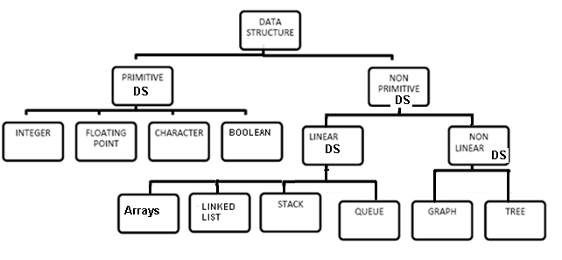
Data structures: Organization of data

The collections of data you work with in a program have some kind of structure or organization. No matter how complex your data structures are they can be broken down into two fundamental types:

- Contiguous

- Non-Contiguous
In contiguous structures, terms of data are kept together in memory (either RAM or in a file). An array is an example of a contiguous structure. Since each element in the array is located next to one or two other elements. In contrast, items in a non-contiguous structure and scattered in memory, but we linked to each other in some way. A linked list is an example of a non-contiguous data structure. Here, the nodes of the list are linked together using pointers stored in each node. Figure 1.2 below illustrates the difference between contiguous and non-contiguous structures.
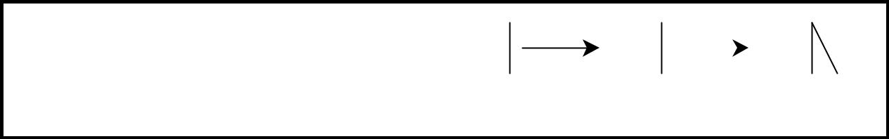

1 |  | 2 |  | 3 |  | 1 |  | 2 |  |  |  | 3
 | (a) Contiguous |  |  |  |  |  | (b) non-contiguous
Figure 1.2 Contiguous and Non-contiguous structures compared

Contiguous structures:

Contiguous structures can be broken drawn further into two kinds: those that contain data items of all the same size, and those where the size may differ. Figure 1.2 shows example of each kind. The first kind is called the array. Figure 1.3(a) shows an example of an array of numbers. In an array, each element is of the same type, and thus has the same size.

The second kind of contiguous structure is called structure, figure 1.3(b) shows a simple structure consisting of a person’s name and age. In a struct, elements may be of different data types and thus may have different sizes.

For example, a person’s age can be represented with a simple integer that occupies two bytes of memory. But his or her name, represented as a string of characters, may require many bytes and may even be of varying length.

Couples with the atomic types (that is, the single data-item built-in types such as integer, float and pointers), arrays and structs provide all the “mortar” you need to built more exotic form of data structure, including the non-contiguous forms.

int arr[3] = {1, 2, 3}; |  |  |  |  |  |  | struct cust_data
 |  |  |  |  |  | {
 |  |  |  |  |  |  |  | int age;
 | 1 |  | 2 |  | 3 |  |  | char name[20];
 | 1 |  | 2 |  | 3 |  | };
 |  |  |  |  |  |  | cust_data bill= {21, “bill the student”};
 |  | (a) Array
 |  |  |  |  |  |  |  | 21 |  | (b) struct
 |  |  |  |  |  |  |  | “bill the student”
 |  |  |  |  |  | Figure 1.3 Examples of contiguous structures.

Non-contiguous structures:

Non-contiguous structures are implemented as a collection of data-items, called nodes, where each node can point to one or more other nodes in the collection. The simplest kind of non-contiguous structure is linked list.

A linked list represents a linear, one-dimension type of non-contiguous structure, where there is only the notation of backwards and forwards. A tree such as shown in figure 1.4(b) is an example of a two-dimensional non-contiguous structure. Here, there is the notion of up and down and left and right.

In a tree each node has only one link that leads into the node and links can only go down the tree. The most general type of non-contiguous structure, called a graph has no such restrictions. Figure 1.4(c) is an example of a graph.
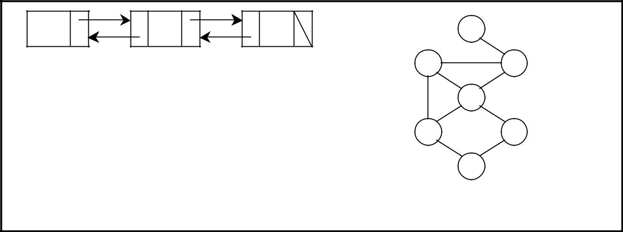

A | B | C | A
 | (a) Linked List | B |  | C
 | A |  | D
 |  | E |  | G
 | B | C
 |  | (b) Tree | F | (c) graph
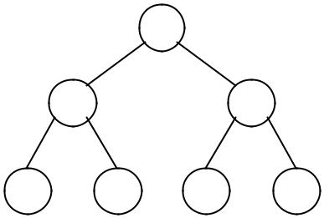

D E F G
Figure 1.4. Examples of non-contiguous structures

Hybrid structures:

If two basic types of structures are mixed then it is a hybrid form. Then one part contiguous and another part non-contiguous. For example, figure 1.5 shows how to implement a double– linked list using three parallel arrays, possibly stored a past from each other in memory.
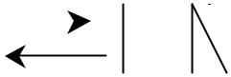

 | A |  |  |  |  |  |  |  | B |  |  |  |  |  |  | C |  |  | (a) Conceptual Structure
 |  |  |  |  |  |  |  |  | D |  |  |  | P |  |  |  |  | N
1 |  |  |  |  |  |  |  |  | A |  |  |  | 3 |  |  |  |  | 4
2 |  |  |  |  |  |  |  |  | B |  |  |  | 4 |  |  |  |  | 0 | (b) Hybrid Implementation
3 |  |  |  |  |  |  |  |  | C |  |  |  | 0 |  |  |  |  | 1
4 |  |  |  |  |  |  |  |  | D |  |  |  | 1 |  |  |  |  | 2
List Head
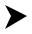
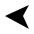
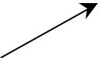

Figure 1.5. A double linked list via a hybrid data structure

The array D contains the data for the list, whereas the array P and N hold the previous and next “pointers’’. The pointers are actually nothing more than indexes into the D array. For instance, D[i] holds the data for node i and p[i] holds the index to the node previous to i, where may or may not reside at position i–1. Like wise, N[i] holds the index to the next node in the list.

1.1. Algorithm

An algorithm is a finite sequence of instructions, each of which has a clear meaning and can be performed with a finite amount of effort in a finite length of time. No matter what the input values may be, an algorithm terminates after executing a finite number of instructions. In addition every algorithm must satisfy the following criteria:

Input: there are zero or more quantities, which are externally supplied;

Output: at least one quantity is produced;

Definiteness: each instruction must be clear and unambiguous;

Finiteness: if we trace out the instructions of an algorithm, then for all cases the algorithm will terminate after a finite number of steps;

Effectiveness: every instruction must be sufficiently basic that it can in principle be carried out by a person using only pencil and paper. It is not enough that each operation be definite, but it must also be feasible.

In formal computer science, one distinguishes between an algorithm, and a program. A program does not necessarily satisfy the fourth condition. One important example of such a program for a computer is its operating system, which never terminates (except for system crashes) but continues in a wait loop until more jobs are entered.

We represent an algorithm using pseudo language that is a combination of the constructs of a programming language together with informal English statements.

1.1.2. Practical Algorithm design issues:

Choosing an efficient algorithm or data structure is just one part of the design process. Next, will look at some design issues that are broader in scope. There are three basic design goals that we should strive for in a program:

- Try to save time (Time complexity).
- Try to save space (Space complexity).
- Try to have face.

A program that runs faster is a better program, so saving time is an obvious goal. Like wise, a program that saves space over a competing program is considered desirable. We want to “save face” by preventing the program from locking up or generating reams of garbled data.

1.1.3. Performance of a program:

The performance of a program is the amount of computer memory and time needed to run a program. We use two approaches to determine the performance of a program. One is analytical, and the other experimental. In performance analysis we use analytical methods, while in performance measurement we conduct experiments.

Time Complexity:

The time needed by an algorithm expressed as a function of the size of a problem is called the TIME COMPLEXITY of the algorithm. The time complexity of a program is the amount of computer time it needs to run to completion.

The limiting behavior of the complexity as size increases is called the asymptotic time complexity. It is the asymptotic complexity of an algorithm, which ultimately determines the size of problems that can be solved by the algorithm.

Space Complexity:

The space complexity of a program is the amount of memory it needs to run to completion. The space need by a program has the following components:

Instruction space: Instruction space is the space needed to store the compiled version of the program instructions.

Data space: Data space is the space needed to store all constant and variable values. Data space has two components:

- Space needed by constants and simple variables in program.

- Space needed by dynamically allocated objects such as arrays and class instances.

Environment stack space: The environment stack is used to save information needed to resume execution of partially completed functions.

Instruction Space: The amount of instructions space that is needed depends on factors such as:
- The compiler used to complete the program into machine code.

- The compiler options in effect at the time of compilation

- The target computer.

1.1.4. Classification of Algorithms

If ‘n’ is the number of data items to be processed or degree of polynomial or the size of the file to be sorted or searched or the number of nodes in a graph etc.

- Next instructions of most programs are executed once or at most only a few times. If all the instructions of a program have this property, we say that its running time is a constant.

Log n When the running time of a program is logarithmic, the program gets slightly slower as n grows. This running time commonly occurs in programs that solve a big problem by transforming it into a smaller problem, cutting the size by some constant fraction., When n is a million, log n is a doubled whenever n doubles, log n increases by a constant, but log n does not double until n increases to n².

n. log n When the running time of a program is linear, it is generally the case that a
small amount of processing is done on each input element. This is the optimal
situation for an algorithm that must process n inputs.

 | This running time arises for algorithms but solve a problem by breaking it up into smaller sub-problems, solving them independently, and then combining the solutions. When n doubles, the running time more than doubles.
n²
 | When the running time of an algorithm is quadratic, it is practical for use only on relatively small problems. Quadratic running times typically arise in algorithms that process all pairs of data items (perhaps in a double nested loop) whenever n doubles, the running time increases four fold.
_{n}3 | Similarly, an algorithm that process triples of data items (perhaps in a triple–
 | nested loop) has a cubic running time and is practical for use only on small
 | problems. Whenever n doubles, the running time increases eight fold.
2^{n} | Few algorithms with exponential running time are likely to be appropriate for
 | practical use, such algorithms arise naturally as “brute–force” solutions to problems. Whenever n doubles, the running time squares.
1.1.5. Complexity of Algorithms

The complexity of an algorithm M is the function f(n) which gives the running time and/or storage space requirement of the algorithm in terms of the size ‘n’ of the input data. Mostly, the storage space required by an algorithm is simply a multiple of the data size ‘n’. Complexity shall refer to the running time of the algorithm.

The function f(n), gives the running time of an algorithm, depends not only on the size ‘n’ of the input data but also on the particular data. The complexity function f(n) for certain cases are:

1. | Best Case | : The minimum possible value of f(n) is called the best case.
2. | Average Case | : | The expected value of f(n).
3. | Worst Case | : | The maximum value of f(n) for any key possible input.

The field of computer science, which studies efficiency of algorithms, is known as analysis of algorithms.

Algorithms can be evaluated by a variety of criteria. Most often we shall be interested in the rate of growth of the time or space required to solve larger and larger instances of a problem. We will associate with the problem an integer, called the size of the problem, which is a measure of the quantity of input data.

1.1.6. Rate of Growth

Big–Oh (O), Big–Omega (Ω), Big–Theta (Θ) and Little–Oh

- T(n) = O(f(n)), (pronounced order of or big oh), says that the growth rate of T(n) is less than or equal (<) that of f(n)

- T(n) = Ω(g(n)) (pronounced omega), says that the growth rate of T(n) is greater than or equal to (>) that of g(n)

- T(n) = Θ(h(n)) (pronounced theta), says that the growth rate of T(n) equals (=) the growth rate of h(n) [if T(n) = O(h(n)) and T(n) = Ω (h(n)]

- T(n) = o(p(n)) (pronounced little oh), says that the growth rate of T(n) is less than the growth rate of p(n) [if T(n) = O(p(n)) and T(n) ≠ Θ (p(n))].

Some Examples:
2n² | + 5n – | 6 | = O(2^{n}) | 2n² | + 5n – 6 ≠ |  | Θ(2^{n})
2n² | + 5n – | 6 | = O(n³) | 2n² | + 5n – 6 ≠ |  | Θ(n³)
2n² | + 5n – | 6 | = O(n²) | 2n² | + 5n – 6 = Θ(n²)
2n² | + 5n – | 6 | ≠ O(n) | 2n² | + 5n – 6 ≠ |  | Θ(n)
2n² | + 5n – | 6 | ≠ Ω(2^{n}) | 2n² | + 5n – 6 | = o(2^{n})
2n² | + 5n – | 6 | ≠ Ω(n³) | 2n² | + 5n – 6 | = o(n³)
2n² | + 5n – | 6 | = Ω(n²) | 2n² | + 5n – 6 | ≠ | o(n²)
2n² | + 5n – | 6 | = Ω(n) | 2n² | + 5n – 6 | ≠ | o(n)
1.1.7. Analyzing Algorithms

Suppose ‘M’ is an algorithm, and suppose ‘n’ is the size of the input data. Clearly the complexity f(n) of M increases as n increases. It is usually the rate of increase of f(n) we want to examine. This is usually done by comparing f(n) with some standard functions. The most common computing times are:

O(1), O(log₂ n), O(n), O(n. log₂ n), O(n²), O(n³), O(2^{n}), n! and n^{n}

Numerical Comparison of Different Algorithms

The execution time for six of the typical functions is given below:

 | S.No | log n | n | n. log n | n² | n³ | 2^{n}
 | 1 | 0 | 1 | 1 | 1 | 1 | 2
 | 2 | 1 | 2 | 2 | 4 | 8 | 4
 | 3 | 2 | 4 | 8 | 16 | 64 | 16
 | 4 | 3 | 8 | 24 | 64 | 512 | 256
 | 5 | 4 | 16 | 64 | 256 | 4096 | 65536

Graph of log n, n, n log n, n², n³, 2^{n}, n! and n^{n}
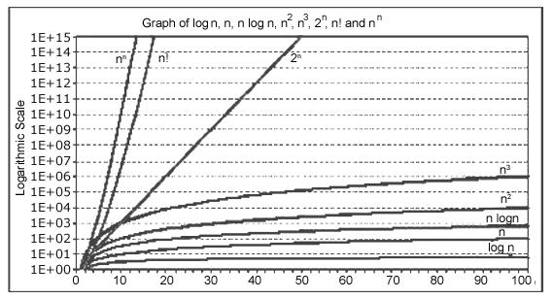

O(log n) does not depend on the base of the logarithm. To simplify the analysis, the convention will not have any particular units of time. Thus we throw away leading constants. We will also throw away low–order terms while computing a Big–Oh running time. Since Big-Oh is an upper bound, the answer provided is a guarantee that the program will terminate within a certain time period. The program may stop earlier than this, but never later.

One way to compare the function f(n) with these standard function is to use the functional ‘O’ notation, suppose f(n) and g(n) are functions defined on the positive integers with the property that f(n) is bounded by some multiple g(n) for almost all ‘n’. Then,

f(n) = O(g(n))

Which is read as “f(n) is of order g(n)”. For example, the order of complexity for:

- Linear search is O(n)

- Binary search is O(log n)

- Bubble sort is O(n²)
- Quick sort is O(n log n)

For example, if the first program takes 100n² milliseconds. While the second taken 5n³ milliseconds. Then might not 5n³ program better than 100n² program?

As the programs can be evaluated by comparing their running time functions, with constants by proportionality neglected. So, 5n³ program be better than the 100n² program.

5 n³/100 n² = n/20

for inputs n < 20, the program with running time 5n³ will be faster those the one with running time 100 n².

Therefore, if the program is to be run mainly on inputs of small size, we would indeed prefer the program whose running time was O(n³)

However, as ‘n’ gets large, the ratio of the running times, which is n/20, gets arbitrarily larger. Thus, as the size of the input increases, the O(n³) program will take significantly more time than the O(n²) program. So it is always better to prefer a program whose running time with the lower growth rate. The low growth rate function’s such as O(n) or O(n log n) are always better.

1.2. Pseudocode

Pseudocode is a simple way of writing programming code in English. Pseudocode is not actual programming language. It uses short phrases to write code for programs before you actually create it in a specific language. Once you know what the program is about and how it will function, then you can use pseudocode to create statements to achieve the required results for your program.
Example of Pseudocode

Create a program to add 2 numbers together and then display the result.

Start Program
Enter two numbers, A, B
Add the numbers together
Print Sum
End Program

1.3. The Abstract Data Type

An ADT is a mathematical model of a data structure that specifies the type of data stored, the operations supported on them, and the types of parameters of the operations. An ADT specifies what each operation does, but not how it does it. Typically, an ADT can be implemented using one of many different data structures. A useful first step in deciding what data structure to use in a program is to specify an ADT for the program.
In general, the steps of building ADT to data structures are:

- Understand and clarify the nature of the target information unit.
- Identify and determine which data objects and operations to include in the models.
- Express this property somewhat formally so that it can be understood and communicate well.
- Translate this formal specification into proper language. In C++, this becomes a .h file. In Java, this is called "user interface".
- Upon finalized specification, write necessary implementation. This includes storage scheme and operational detail. Operational detail is expressed as separate functions (methods).

1.4 Model for an Abstract Data Type

The ADT model is shown in Figure 1-2. The colored area with an irregular out-line represents the ADT. Inside the ADT are two different aspects of the model: data structures and functions (public and private). Both are entirely contained in the model and are not within the application program scope. However, the data structures are available to all of the ADT’s functions as needed, and a function may call on other functions to accomplish its task. In other words, the data structures and the functions are within scope of each other.
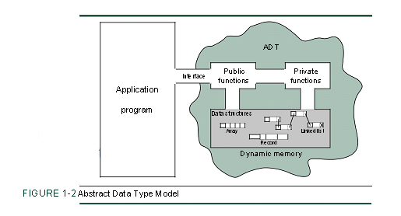
ADT Operations

Data are entered, accessed, modified, and deleted through the external inter-face drawn as a passageway partially in and partially out of the ADT. Only the public functions are accessible through this interface. For each ADT operation there is an algorithm that performs its specific task. Only the operation name and its parameters are available to the application, and they provide the only interface to the ADT.

ADT Data Structure
When a list is controlled entirely by the program, it is often implemented using simple structures similar to those used in your programming class. Because the abstract data type must hide the implementation from the user, however, all data about the structure must be maintained inside the ADT. Just encapsulating the structure in an ADT is not sufficient. It is also necessary for multiple versions of the structure to be able to coexist. Consequently, we must hide the implementation from the user while being able to store different data.

1.5 ADT Implementations
Consider two alternate data structures for the above ADT:
(1) an unordered array of records and
(2) an ordered array of records, ordered by IDs.
These different data structures greatly influence the implementation details and how fast and efficient the program runs.
First let us look at using an unordered array. Assume that the student records are stored in an array with no particular order. We can use a variable n to keep track of the number of students currently in the array.
- ADD: Simply take the record and store it in slot n of the array and increment n. This takes constant amount of time since the time is independent of n.
- SEARCH: Since the array is not ordered, we have to scan through the whole array to find the requested record. The result could be either the record is found or the record doesn't exist. The time taken to perform the search is proportional to n and the worst case scenario is n. Of course, if the record I am looking for happens to be the first item in the array, it only takes constant time. However, when determining the running time of an algorithm, we are often interested in worst case analysis.
- DELETE: This operation requires us to first search for the given record. Once it is found, the algorithm can simply replace it by the last record and decrement n. Once the record is found, it only takes a constant amount of time to delete it. But time spent searching for the record is the same as above, proportional to n. Therefore, in all, this operation also takes time proportional to n, in the worst case.
Now let us consider using an ordered array. Assume that the student records are sorted in an array, with an increasing order of student IDs. We can also use a variable n to keep track of the number of students currently in the array.
- ADD: Since the array is sorted, we first need to find out where should we insert the record. This can be done by scanning through the array, comparing the current record in the array with the record we want to insert, and finding the smallest index i of the record whose ID is larger than the new ID. Then the new record should be put to the ith slot in the array. To do that, all the records in slots i, i+1, i+2, ..., n need to be moved down one slot to create an empty slot for the new record. We can then put the new record into the ith slot and increment n. This operation takes time proportional to n.
- SEARCH: Since the array of records is sorted by IDs, we can use a binary search to find the given record. In general, a binary search algorithm first compares the given ID with the ID in the middle of the array (with index n/2 or (n+1)/2). Then the algorithm branches based on different conditions: if the two IDs are the same, we find the record; if the given ID is smaller, the algorithm continues to search the first half of the current array, ignoring the second half; otherwise, the algorithm continues to search the second half of the current array, ignoring the first half. The operation time is log₂n. Finding the time for binary search will be discussed in the future.
- DELETE: This operation requires us to first search for the given record. This can be done in log₂n time as shown above. Since the array is ordered, we need to fill in the empty slot i with a record, which means the records in slots i+1, i+2, ..., n need to be moved up one slot to cover the empty one. The time is also proportional to n. In all, this operation takes time proportional to n, in the worst case.
1.6. Concepts of Stack:

A stack is a list of elements in which an element may be inserted or deleted only at one end, called the top of the stack. Stacks are sometimes known as LIFO (last in, first out) lists.

As the items can be added or removed only from the top i.e. the last item to be added to a stack is the first item to be removed.

1.7. Basic Stack Operations

The two basic operations associated with stacks are:

Push: is the term used to insert an element into a stack.

Pop: is the term used to delete an element from a stack.

“Push” is the term used to insert an element into a stack. “Pop” is the term used to delete an element from the stack.

All insertions and deletions take place at the same end, so the last element added to the stack will be the first element removed from the stack. When a stack is created, the stack base remains fixed while the stack top changes as elements are added and removed. The most accessible element is the top and the least accessible element is the bottom of the stack.

1.8. Representation of Stack using arrays:

Let us consider a stack with 6 elements capacity. This is called as the size of the stack. The number of elements to be added should not exceed the maximum size of the stack. If we attempt to add new element beyond the maximum size, we will encounter a stack overflow condition. Similarly, you cannot remove elements beyond the base of the stack. If such is the case, we will reach a stack underflow condition.

When an element is added to a stack, the operation is performed by push(). Figure shows the creation of a stack and addition of elements using push().

 |  |  |  | 4 |  |  |  |  |  | 4 |  |  |  |  |  | 4 |  |  |  |  |  | 4
 |  |  |  | 3 |  |  |  |  |  | 3 |  |  |  |  |  | 3 |  |  |  |  |  | 3
 |  |  |  |  |  |  |  |  |  |  |  |  |  |  |  |  |  | TOP
 |  |  |  | 2 |  |  |  |  |  | 2 |  |  |  |  |  | 2 |  |  |  |  | 33 | 2
 |  |  |  |  |  |  |  |  |  |  |  | TOP |  |  |  |  |  |  |  |  | 33
 |  |  |  | 1 |  |  |  |  |  | 1 |  |  |  |  | 22 | 1 |  |  |  |  | 22 | 1
 |  |  |  |  |  | TOP |  |  |  |  |  |  |  |  | 22 |  |  |  |  |  | 22
 |  |  |  | 0 |  |  |  |  | 11 | 0 |  |  |  |  | 11 | 0 |  |  |  |  | 11 | 0
TOP |  |  |  |  |  |  |  |  | 11 |  |  |  |  |  | 11 |  |  |  |  |  | 11
 |  |  | Empty |  |  |  |  |  | Insert |  |  |  |  |  | Insert |  |  |  |  |  | Insert
 |  |  | Stack |  |  |  |  |  | 11 |  |  |  |  |  | 22 |  |  |  |  |  | 33




Figure: Push operations on stack

When an element is taken off from the stack, the operation is performed by pop(). Figure shows a stack initially with three elements and shows the deletion of elements using pop().
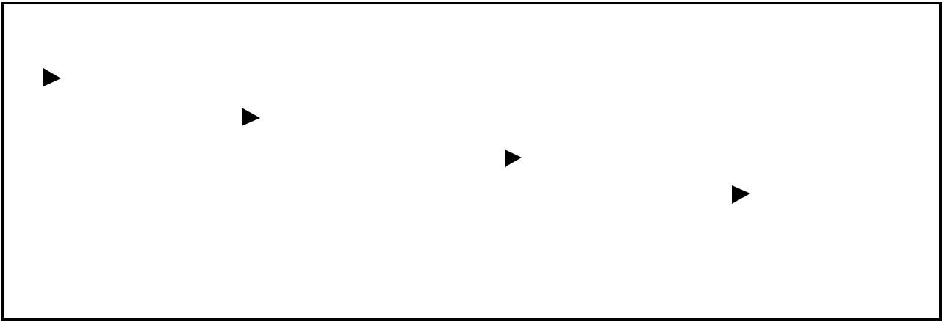

 |  |  |  | 4 |  |  |  |  |  | 4 |  |  |  |  |  | 4 |  |  |  |  |  | 4
 |  |  |  | 3 |  |  |  |  |  | 3 |  |  |  |  |  | 3 |  |  |  |  |  | 3
TOP
 |  |  | 33 | 2 |  |  |  |  |  | 2 |  |  |  |  |  | 2 |  |  |  |  |  | 2
 |  |  | 33 |  |  | TOP
 |  |  | 22 | 1 |  |  |  |  | 22 | 1 |  |  |  |  |  | 1 |  |  |  |  |  | 1
 |  |  | 22 |  |  |  |  |  | 22 |  |  | TOP
 |  |  | 11 |  |  |  |  |  | 11 |  |  |  |  |  | 11
 |  |  | 11 | 0 |  |  |  |  | 11 | 0 |  |  |  |  | 11 | 0 |  | TOP |  |  |  | 0
 |  |  | Initial |  |  |  |  |  | POP |  |  |  |  |  | POP |  |  |  |  |  | POP
 |  |  | Stack |  |  |  |  |  |  |  |  |  |  |  |  |  |  |  |  |  | Empty
Stack

Figure: Pop operations on stack

1.9. Applications

1.9.1. Recursion:

A function is recursive if a statement in the body of the function calls itself. Recursion is the process of defining something in terms of itself. For a computer language to be recursive, a function must be able to call itself.

For example, let us consider the function factr() shown below, which computers the factorial of an integer.

#include <stdio.h>

int factorial (int);
main()
{
int num, fact;
printf (“Enter a positive integer value: ");
scanf (“%d”, &num);
fact = factorial (num);
printf ("\n Factorial of %d =%5d\n", num, fact);
}

int factorial (int n)

{
int result;
if (n == 0)
return (1);
else
result = n * factorial (n-1);

return (result);
}

A non-recursive or iterative version for finding the factorial is as follows:

factorial (int n)

{

int i, result = 1;
if (n == 0)
return (result);

else
{
for (i=1; i<=n; i++)
result = result * i;
}
return (result);
}

The operation of the non-recursive version is clear as it uses a loop starting at 1 and ending at the target value and progressively multiplies each number by the moving product.

When a function calls itself, new local variables and parameters are allocated storage on the stack and the function code is executed with these new variables from the start. A recursive call does not make a new copy of the function. Only the arguments and variables are new. As each recursive call returns, the old local variables and parameters are removed from the stack and execution resumes at the point of the function call inside the function.

When writing recursive functions, you must have a exit condition somewhere to force the function to return without the recursive call being executed. If you do not have an exit condition, the recursive function will recurse forever until you run out of stack space and indicate error about lack of memory, or stack overflow.

Differences between recursion and iteration:

• Both involve repetition.
• Both involve a termination test.

• Both can occur infinitely.

Iteration | Recursion
Iteration explicitly user a repetition | Recursion achieves repetition through
structure. | repeated function calls.
Iteration terminates when the loop | Recursion terminates when a base case
continuation. | is recognized.
Iteration keeps modifying the counter | Recursion keeps producing simple
until the loop continuation condition | versions of the original problem until
fails. | the base case is reached.
Iteration normally occurs within a loop | Recursion causes another copy of the
so the extra memory assigned is | function and hence a considerable
omitted. | memory space’s occupied.
It reduces the processor’s operating | It increases the processor’s operating
time. | time.

Algebraic Expressions:

An algebraic expression is a legal combination of operators and operands. Operand is the quantity on which a mathematical operation is performed. Operand may be a variable like x, y, z or a constant like 5, 4, 6 etc. Operator is a symbol which signifies a mathematical or logical operation between the operands. Examples of familiar operators include +, -, *, /, ^ etc.

An algebraic expression can be represented using three different notations. They are infix, postfix and prefix notations:

Infix: It is the form of an arithmetic expression in which we fix (place) the arithmetic operator in between the two operands.

Example: (A + B) * (C - D)

Prefix: It is the form of an arithmetic notation in which we fix (place) the arithmetic operator before (pre) its two operands. The prefix notation is called as
polish notation (due to the polish mathematician Jan Lukasiewicz in the
year 1920).

Example: * + A B – C D

Postfix: It is the form of an arithmetic expression in which we fix (place) the arithmetic operator after (post) its two operands. The postfix notation is called as suffix notation and is also referred to reverse polish notation.

Example: A B + C D - *

The three important features of postfix expression are:

The operands maintain the same order as in the equivalent infix expression.

The parentheses are not needed to designate the expression un-ambiguously.

While evaluating the postfix expression the priority of the operators is no longer relevant.

We consider five binary operations: +, -, *, / and $ or ↑ (exponentiation). For these binary operations, the following in the order of precedence (highest to lowest):

OPERATOR | PRECEDENCE | VALUE
Exponentiation ($ or ↑ or ^) | Highest | 3
*, / | Next highest | 2
+, - | Lowest | 1

Converting expressions using Stack:
Let us convert the expressions from one type to another. These can be done as follows:

Infix to postfix
Infix to prefix
Postfix to infix
Postfix to prefix
Prefix to infix
Prefix to postfix

1.9.2. Conversion from infix to postfix:

Procedure to convert from infix expression to postfix expression is as follows:

Scan the infix expression from left to right.

- If the scanned symbol is left parenthesis, push it onto the stack.

If the scanned symbol is an operand, then place directly in the postfix
expression (output).

If the symbol scanned is a right parenthesis, then go on popping all the items from the stack and place them in the postfix expression till we get the matching left parenthesis.

If the scanned symbol is an operator, then go on removing all the operators from the stack and place them in the postfix expression, if and only if the precedence of the operator which is on the top of the stack is greater than (or greater than or equal) to the precedence of the scanned operator and push the scanned operator onto the stack otherwise, push the scanned operator onto the stack.

Example 1:

Convert ((A – (B + C)) * D) ↑ (E + F) infix expression to postfix form:

SYMBOL | POSTFIX STRING | STACK | REMARKS
( |  | (
( |  | ( (
A | A | ( (
- | A | ( ( -
( | A | ( ( - (
B | A B | ( ( - (
+ | A B | ( ( - ( +
C | A B C | ( ( - ( +
) | A B C + | ( ( -
) | A B C + - | (
* | A B C + - | ( *
D | A B C + - D | ( *
) | A B C + - D *
↑ | A B C + - D * | ↑
( | A B C + - D * | ↑ (
E | A B C + - D * E | ↑ (
+ | A B C + - D * E | ↑ ( +
F | A B C + - D * E F | ↑ ( +
) | A B C + - D * E F + | ↑
End of |  | The input is now empty. Pop the output symbols
string | A B C + - D * E F + ↑ | from the stack until it is empty.

Example 2:

Convert a + b * c + (d * e + f) * g the infix expression into postfix form.

SYMBOL | POSTFIX STRING | STACK | REMARKS
a | a
+ | a | +
b | a b | +
* | a b | + *
c | a b c | + *
+ | a b c * + | +
( | a b c * + | + (
d | a b c * + d | + (
* | a b c * + d | + ( *
e | a b c * + d e | + ( *
+ | a b c * + d e * | + ( +
f | a b c * + d e * f | + ( +
) | a b c * + d e * f + | +
* | a b c * + d e * f + | + *
g | a b c * + d e * f + g | + *
End of  string | a b c * + d e * f + g * + | The input is now empty. Pop the output symbols from the stack until it is empty.

Example 3:
Convert the following infix expression A + B * C – D / E * H into its equivalent postfix expression.
SYMBOL | POSTFIX STRING | STACK |  | REMARKS
A | A
+ | A | +
B | A B | +
* | A B | + *
C | A B C | + *
- | A B C * + | -
D | A B C * + D | -
/ | A B C * + D | - /
E | A B C * + D E | - /
* | A B C * + D E / | - *
H | A B C * + D E / H | - *
End of |  | The input is now empty. Pop the output symbols from the stack until it is empty.
string | A B C * + D E / H * -
Example 4:

Convert the following infix expression A + (B * C – (D / E ↑ F) * G) * H into its equivalent postfix expression.

SYMBOL | POSTFIX STRING | STACK | REMARKS
A | A
+ | A | +
( | A | + (
B | A B | + (
* | A B | + ( *
C | A B C | + ( *
- | A B C * | + ( -
( | A B C * | + ( - (
D | A B C * D | + ( - (
/ | A B C * D | + ( - ( /
E | A B C * D E | + ( - ( /
↑ | A B C * D E | + ( - ( / ↑
F | A B C * D E F | + ( - ( / ↑
) | A B C * D E F ↑ / | + ( -
* | A B C * D E F ↑ / | + ( - *
G | A B C * D E F ↑ / G | + ( - *
) | A B C * D E F ↑ / G * - | +
* | A B C * D E F ↑ / G * - | + *
H | A B C * D E F ↑ / G * - H | + *
End of | A B C * D E F ↑ / G * - H * + | The input is now empty. Pop the output
string |  | symbols from the stack until it is empty.

1.9.3. Evaluation of postfix expression:

The postfix expression is evaluated easily by the use of a stack. When a number is seen, it is pushed onto the stack; when an operator is seen, the operator is applied to the two numbers that are popped from the stack and the result is pushed onto the stack. When an expression is given in postfix notation, there is no need to know any precedence rules; this is our obvious advantage.

Example 1:

Evaluate the postfix expression: 6 5 2 3 + 8 * + 3 + *

 | SYMBOL | OPERAND | OPERAND 2 | VALUE | STACK | REMARKS
 | SYMBOL | 1
 | 6 |  |  |  | 6
 | 5 |  |  |  | 6, 5
 | 2 |  |  |  | 6, 5, 2
 | 3 |  |  |  | 6, 5, 2, 3 | The first four symbols are placed on
 | 3 |  |  |  | 6, 5, 2, 3 | the stack.
 |  |  |  |  |  | Next a ‘+’ is read, so 3 and 2 are
 | + | 2 | 3 | 5 | 6, 5, 5 | popped from the stack and their
 |  |  |  |  |  | sum 5, is pushed

 | 8 | 2 | 3 | 5 | 6, 5, 5, 8 | Next 8 is pushed
 | * | 5 | 8 | 40 | 6, 5, 40 | Now a ‘*’ is seen, so 8 and 5 are
 |  |  |  |  |  | popped as 8 * 5 = 40 is pushed
 | + | 5 | 40 | 45 | 6, 45 | Next, a ‘+’ is seen, so 40 and 5 are
 |  |  |  |  |  | popped and 40 + 5 = 45 is pushed
 | 3 | 5 | 40 | 45 | 6, 45, 3 | Now, 3 is pushed
 | + | 45 | 3 | 48 | 6, 48 | Next, ‘+’ pops 3 and 45 and pushes
 |  |  |  |  |  | 45 + 3 = 48 is pushed
 |  |  |  |  |  | Finally, a ‘*’ is seen and 48 and 6
 | * | 6 | 48 | 288 | 288 | are popped, the result 6 * 48 =
 |  |  |  |  |  | 288 is pushed

Example 2:

Evaluate the following postfix expression: 6 2 3 + - 3 8 2 / + * 2 ↑ 3 +

SYMBOL | OPERAND 1 | OPERAND 2 | VALUE | STACK
6 |  |  |  | 6
2 |  |  |  | 6, 2
3 |  |  |  | 6, 2, 3
+ | 2 | 3 | 5 | 6, 5
- | 6 | 5 | 1 | 1
3 | 6 | 5 | 1 | 1, 3
8 | 6 | 5 | 1 | 1, 3, 8
2 | 6 | 5 | 1 | 1, 3, 8, 2
/ | 8 | 2 | 4 | 1, 3, 4
+ | 3 | 4 | 7 | 1, 7
* | 1 | 7 | 7 | 7
2 | 1 | 7 | 7 | 7, 2
↑ | 7 | 2 | 49 | 49
3 | 7 | 2 | 49 | 49, 3
+ | 49 | 3 | 52 | 52

