Definition of Bubble Sort
Bubble sort is the simplest iterative algorithm operates by comparing each item or element with the item next to it and swapping them if needed. In simple words, it compares the first and second element of the list and swaps it unless they are out of specific order. Similarly, Second and third element are compared and swapped, and this comparing and swapping go on to the end of the list. The number of comparisons in the first iteration are n-1 where n is the number elements in an array. The largest element would be at nth position after the first iteration. And after each iteration, the number of comparisons decreases and at last iteration only one comparison takes place.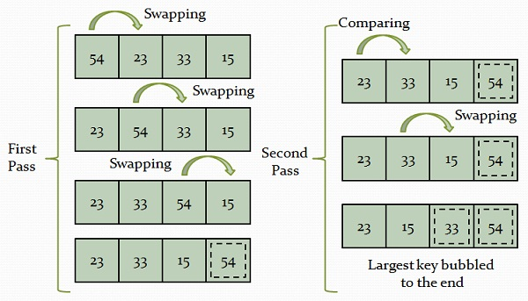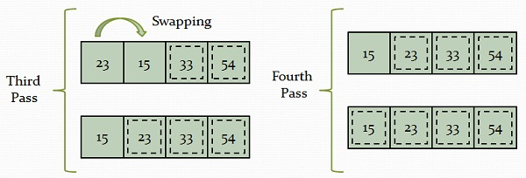
This algorithm is the slowest sorting algorithm. The best case complexity (When the list is in order) of the Bubble sort is of order n (O(n)), and worst case complexity is O(n²). In the best case, it is of order n because it just compares the elements and doesn’t swap them. This technique also requires additional space to store the temporary variable.

Definition of Insertion Sort
Insertion sort works by inserting the set of values in the existing sorted file. It constructs the sorted array by inserting a single element at a time. This process continues until whole array is sorted in some order. The primary concept behind insertion sort is to insert each item into its appropriate place in the final list. The insertion sort method saves an effective amount of memory.
Working of the Insertion sort
- It uses two sets of arrays where one stores the sorted data and other on unsorted data.
- The sorting algorithm works until there are elements in the unsorted set.
- Let’s assume there are ‘n’ number elements in the array. Initially, the element with index 0 (LB = 0) exists in the sorted set. Remaining elements are in the unsorted partition of the list.
- The first element of the unsorted portion has array index 1 (If LB = 0).
- After each iteration, it chooses the first element of the unsorted partition and inserts it into the proper place in the sorted set.
Advantages of Insertion sort
- Easily implemented and very efficient when used with small sets of data.
- The additional memory space requirement of insertion sort is less (i.e., O(1)).
- It is considered to be live sorting technique as the list can be sorted as the new elements are received.
- It is faster than other sorting algorithms.
Example :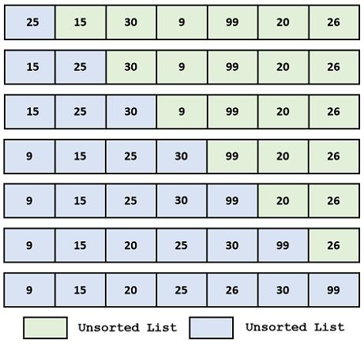

Definition of Selection Sort
Selection sort has achieved slightly better performance and is efficient than bubble sort algorithm. Suppose we want to arrange an array in ascending order then it functions by finding the largest element and exchanging it with the last element, and repeat the following process on the sub-arrays till the whole list is sorted.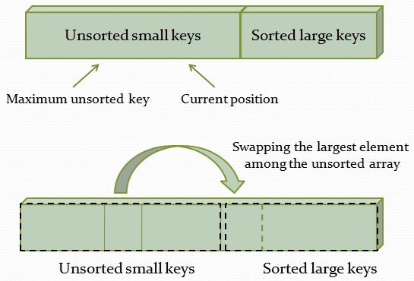In selection sort, the sorted and unsorted array doesn’t make any difference and consumes an order of n² (O(n²)) in both best and worst case complexity. Selection sort is faster than Bubble sort.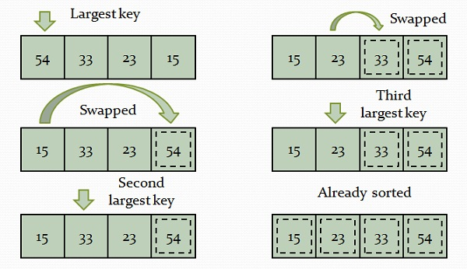

Definition of Quick Sort

Quick sort is pervasively used sorting algorithm as it is fast for the short arrays. The set of the elements is divided into parts repeatedly until it is not possible to divide it further. Quick sort is also known as partition exchange sort. It uses a key element (known as the pivot) for partitioning the elements. One partition contains those elements that are smaller than the key element. Another partition contains those elements that are greater than the key element. The elements are sorted recursively.
Suppose A is an array A[1], A[2], A[3],…….., A[n] of n number which have to be sorted. The quick sort algorithm comprised of the following steps.
- The first element or any random element selected as the key, assume key = A(1).
- The “low” pointer is placed at the second and “up” pointer is positioned at the last element of the array, i.e. low=2 and up=n;
- Consistently, increment the “low” pointer by one position until (A[low]>key).
- Constantly, decrement the “up” pointer by one position until (A[up]<=key).
- If up is greater than low interchange A[low] with A[up].
- Repeat the step 3,4, and 5 until the condition in step 5 fails (i.e. up<=low) then interchange A[up] with the key.
- If the elements left of the key are smaller than the key and the elements right of the key are greater than the key then the array is partitioned into two sub-arrays.
- The above procedure is repeatedly applied to the subarrays until the entire array is sorted.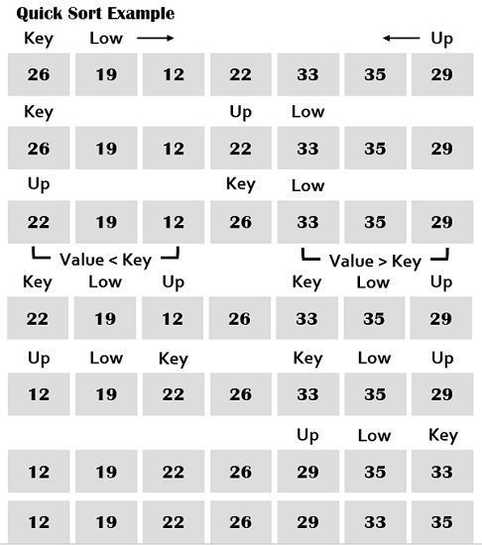
Advantages and Disadvantages
It possesses a good average case behavior. The running time complexity of the quick sort is good that is it is faster than algorithms such as bubble sort, insertion sort and selection sort. However, it is complex and very recursive that is the reason it is not suitable for large arrays.

Merge sort is an external algorithm which is also based on divide and conquers strategy. The elements are split into sub-arrays (n/2) again and again until only one element is left, which significantly decreases the sorting time. It uses additional storage for storing the auxiliary array. Merge sort uses three arrays where two are used for storing each half, and the third one is used to store the final sorted list. Each array is then sorted recursively. At last, the subarrays are merged to make it n element size of the array. The list always divided into just half (n/2) dissimilar to quick sort.
Let A be the array of n number of elements to be sorted A[1], A[2], ………, A[n]. The merge sort follows the given steps.
- Split the array A into approximately n/2 sorted sub-array by 2, which means that the elements in the (A[1], A[2]), (A[3], A[4]), (A[k],A[k+1]), (A[n-1], A[n]) sub-arrays must be in sorted order.
- Combine each pair of pairs to obtain the list of sorted subarrays of size 4; the elements in the subarrays are also in sorted order, (A[1], A[2], A[3], A[4]),……,(A[k-1], A[k], A[k+1], A[k+2]),……., (A[n-3], A[n-2], A[n-1], A[n]).
- The step 2 is repeatedly performed until there is only one sorted array of size 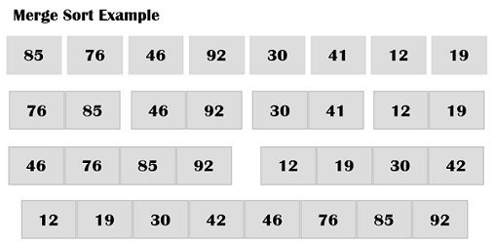
Advantages and Disadvantages
The merge sort algorithm performs in the exact same and precise manner regardless of the number of elements involved in the sorting. It works fine even with the large data set. However, it consumes larger part of memory.

Heap Sort
Heaps can be used in sorting an array. In max-heaps, maximum element will always be at the root. Heap Sort uses this property of heap to sort the array.
Consider an array Arr which is to be sorted using Heap Sort.
- Initially build a max heap of elements in Arr.
- The root element, that is Arr[1], will contain maximum element of Arr. After that, swap this element with the last element of Arr and heapify the max heap excluding the last element which is already in its correct position and then decrease the length of heap by one.
- Repeat the step 2, until all the elements are in their correct position.
Implementation:
void heap_sort(int Arr[ ])
{
int heap_size = N;
build_maxheap(Arr);
for(int i = N; i >= 2 ; i-- )
{
swap|(Arr[ 1 ], Arr[ i ]);
heap_size = heap_size - 1;
max_heapify(Arr, 1, heap_size);
}
}
Complexity:
max_heapify has complexity O(logN), build_maxheap has complexity O(N) and we run
max_heapify N−1 times in heap_sort function, therefore complexity of heap_sort function

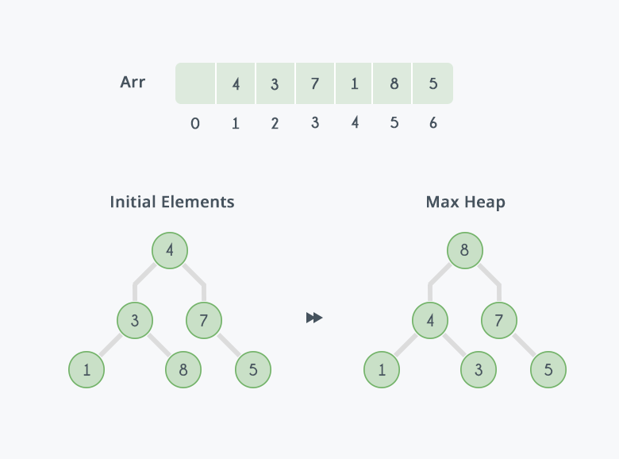
After building max-heap, the elements in the array Arr will be:
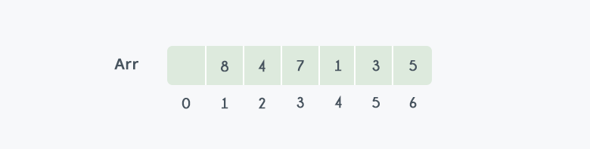
Step 1: 8 is swapped with 5.
Step 2: 8 is disconnected from heap as 8 is in correct position now and.
Step 3: Max-heap is created and 7 is swapped with 3.
Step 4: 7 is disconnected from heap.
Step 5: Max heap is created and 5 is swapped with 1.
Step 6: 5 is disconnected from heap.
Step 7: Max heap is created and 4 is swapped with 3.
Step 8: 4 is disconnected from heap.
Step 9: Max heap is created and 3 is swapped with 1.
Step 10: 3 is disconnected.
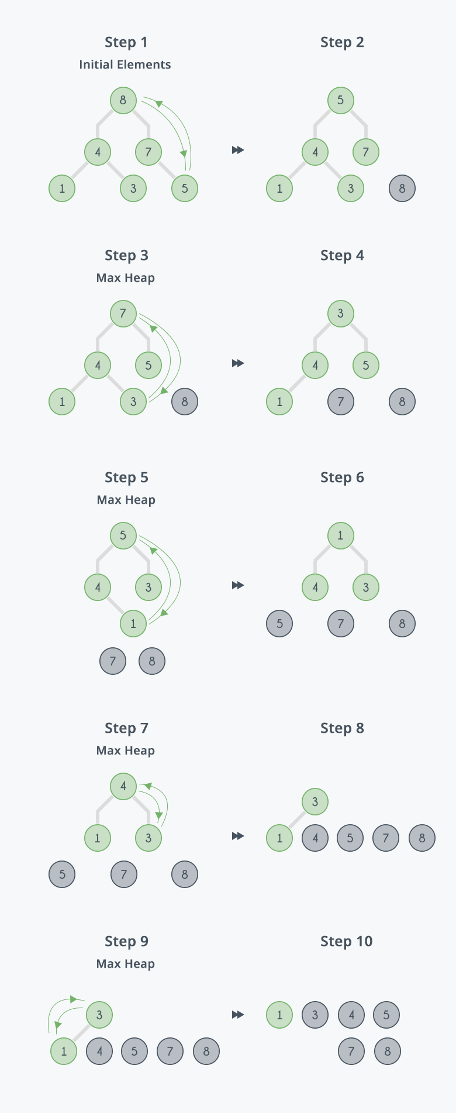
After all the steps, we will get a sorted array.
