Project Design Phase-II
Technology Stack (Architecture & Stack)
Date | 19 October 2026
Team ID
Project Name | Medical Diagnostic Test Center Service Portal(ServiceNow)
Maximum Marks | 4 Marks

Technical Architecture:
The architecture below shows the patient-facing Service Portal, application logic, automation, custom data tables, notifications and staff access in the ServiceNow cloud. Details are summarized in Table-1 and Table-2.
Example: Patient diagnostic test booking and report management through ServiceNow
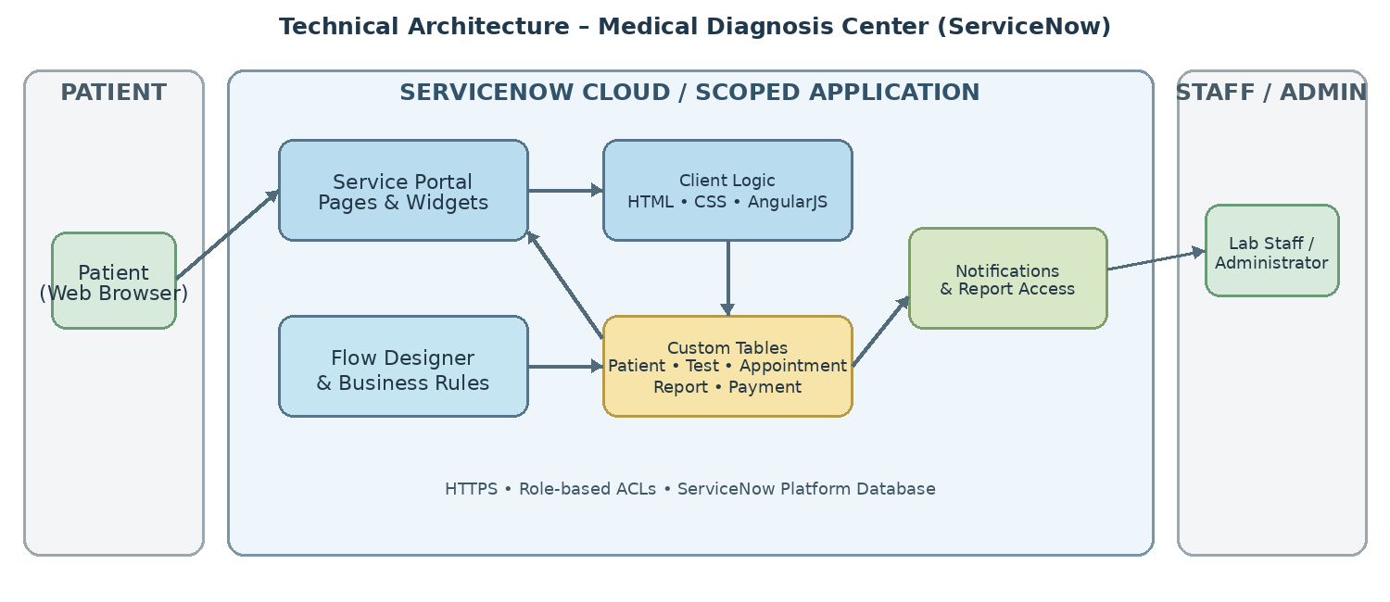

Table-1 : Components & Technologies:
S.No | Component | Description | Technology
1 | User Interface | Patients use the portal to browse tests, book appointments, track status and access reports. | ServiceNow Service Portal, HTML, CSS, AngularJS
2 | Portal Widgets | Custom pages/widgets support test selection, slot availability, booking summary and report access. | Service Portal widgets, HTML templates, CSS, client/server scripts
3 | Client-Side Logic | Dynamic form behavior includes field visibility, price display and appointment-date validation. | AngularJS, Client Scripts, UI Policies
4 | Application Logic | Server-side logic retrieves, inserts and updates records and validates booking data. | GlideRecord, Business Rules, Script Includes
5 | Workflow Automation | Automates appointment submission, optional approvals, payment updates, cancellations and report notifications. | Flow Designer, Business Rules, Scheduled Jobs
6 | Data Storage | Stores patient details, diagnostic tests, appointments, reports and payment transactions in related custom tables. | ServiceNow platform database, scoped application tables
7 | Data Relationships | Reference fields connect patients to appointments, appointments to tests and reports, and related payment records. | ServiceNow reference fields, table relationships
8 | Reports & Dashboards | Provides appointment and operational summaries for administrative monitoring. | ServiceNow Reports, Dashboards, charts
9 | Notifications | Sends appointment confirmations, approval updates, reminders, payment updates and report-availability alerts. | Email Notifications, notification templates, event triggers
10 | Security & Access | Restricts patient data and staff actions according to user roles and permissions. | ServiceNow authentication, roles, ACLs, HTTPS/TLS
11 | Infrastructure | Application runs in the ServiceNow cloud development instance; no separate local server is required. | ServiceNow Personal Developer Instance (PDI)

Table-2: Application Characteristics:
S.No | Characteristics | Description | Technology
1 | Frameworks | Portal widgets use web technologies supported by ServiceNow Service Portal. | HTML, CSS, AngularJS
2 | Security | Role-based access and ACLs control access to patient, appointment, payment and report records. | ServiceNow roles and ACLs, HTTPS/TLS
3 | Scalability | Modular widgets, scoped tables and configurable flows support future feature additions. | ServiceNow scoped application, Flow Designer
4 | Availability | The application is hosted on the ServiceNow cloud; development instances may hibernate after inactivity. | ServiceNow cloud / PDI
5 | Performance | Client-side validation and platform-side queries/automation support responsive booking and record processing. | Service Portal, GlideRecord, platform caching

References:
https://www.servicenow.com/docs
https://developer.servicenow.com/
Project documentation: Medical Diagnosis Center Service Portal

