# **Final Web Application- Feature 3**

Step1: Move to branch Feature3-Calendar for feature 3.

Step2: Install the files and open in PyCharm.

Step3: To Set up the project, run “npm install”. This command is going to download all the necessary packages for the website to run on your local.

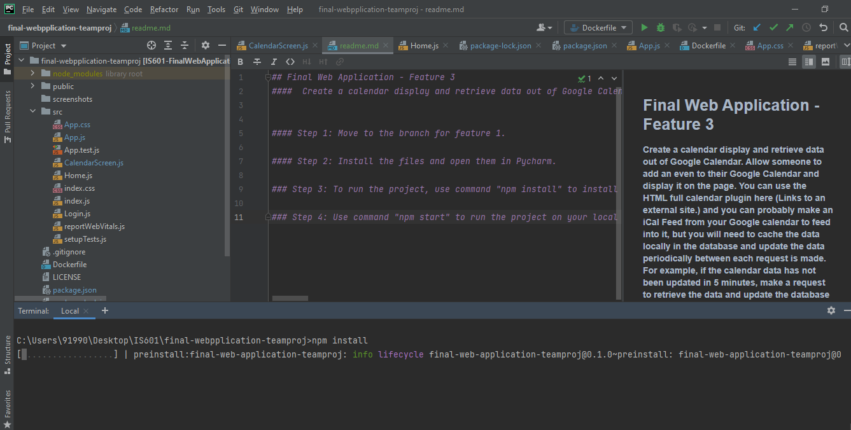

Step4: Next, use command “npm start” to run the feature on your local.

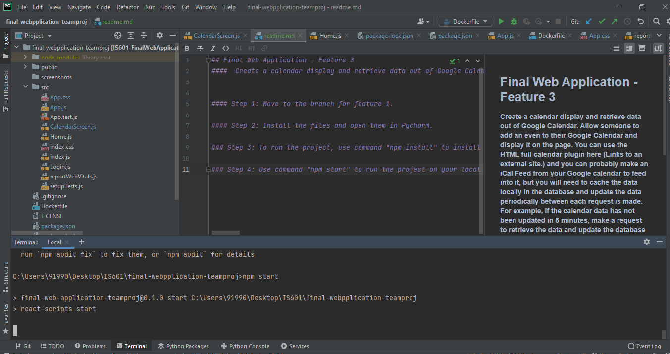

The calendar page opening up on local with current date.

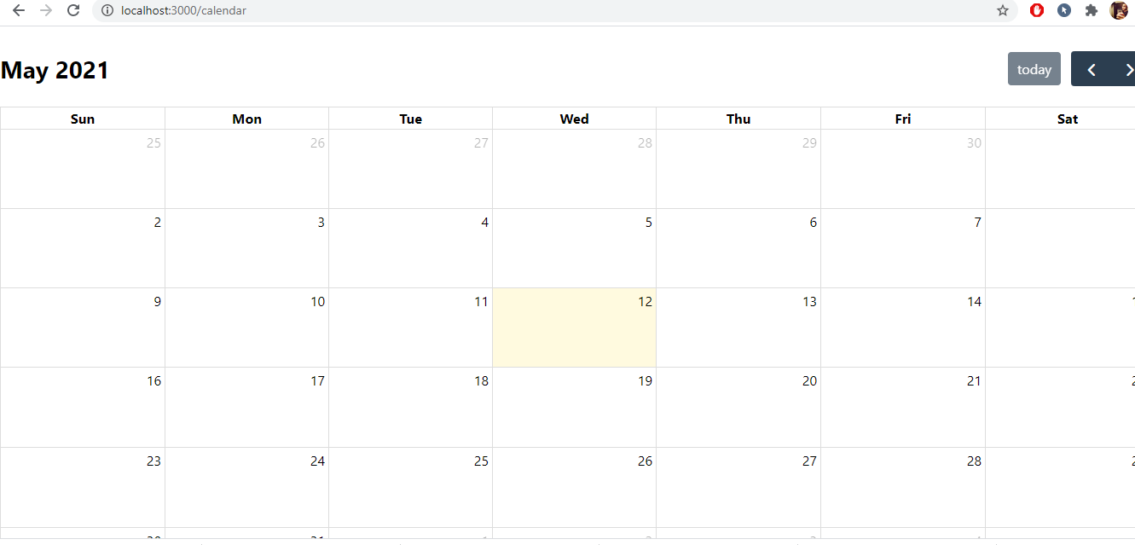

You can scroll to a previous date and a date in the future easily.

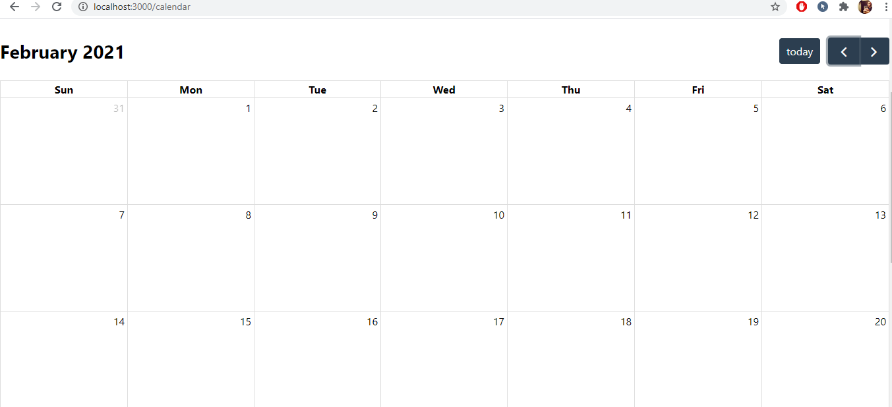

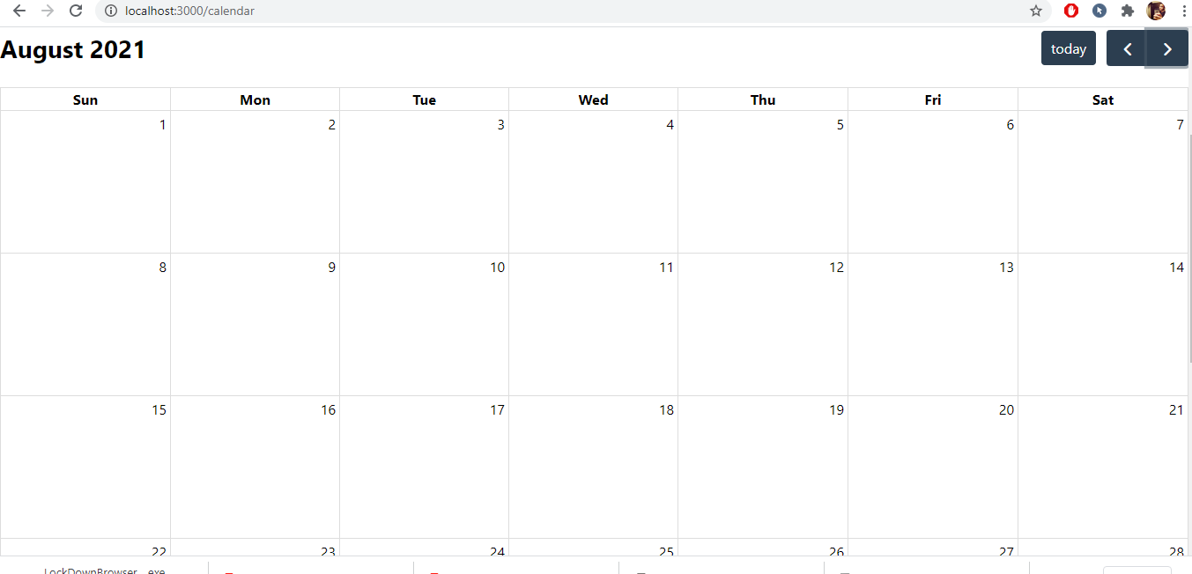

Credentials required to add events in the calendar. If not, pop up message will be displayed.

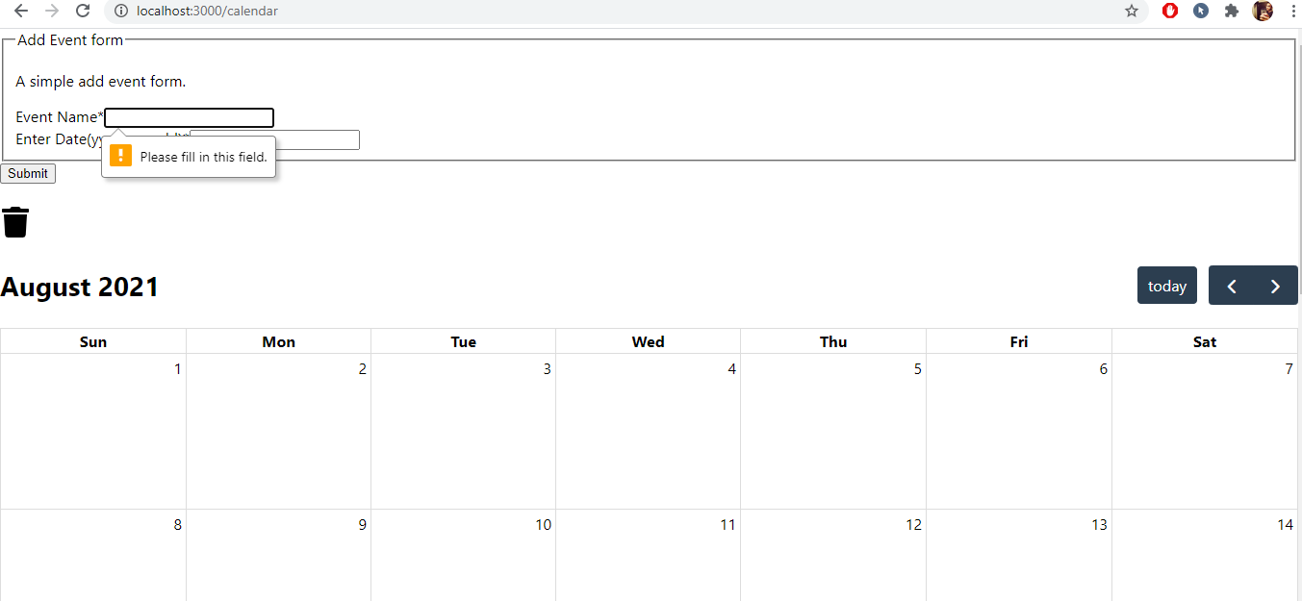

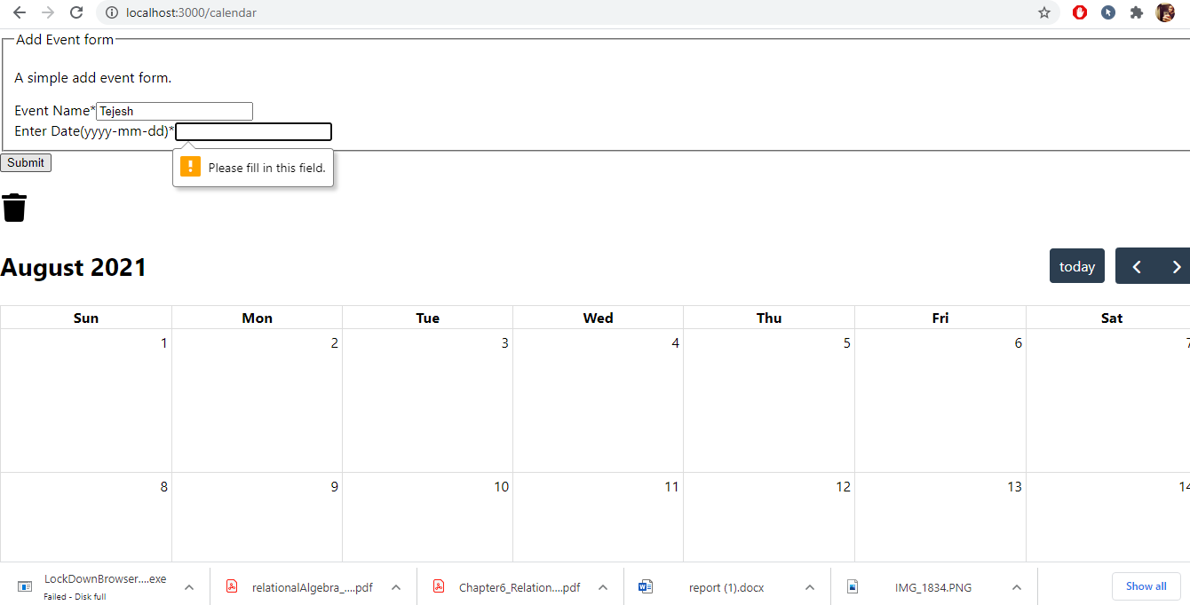

Adding an event in the calendar

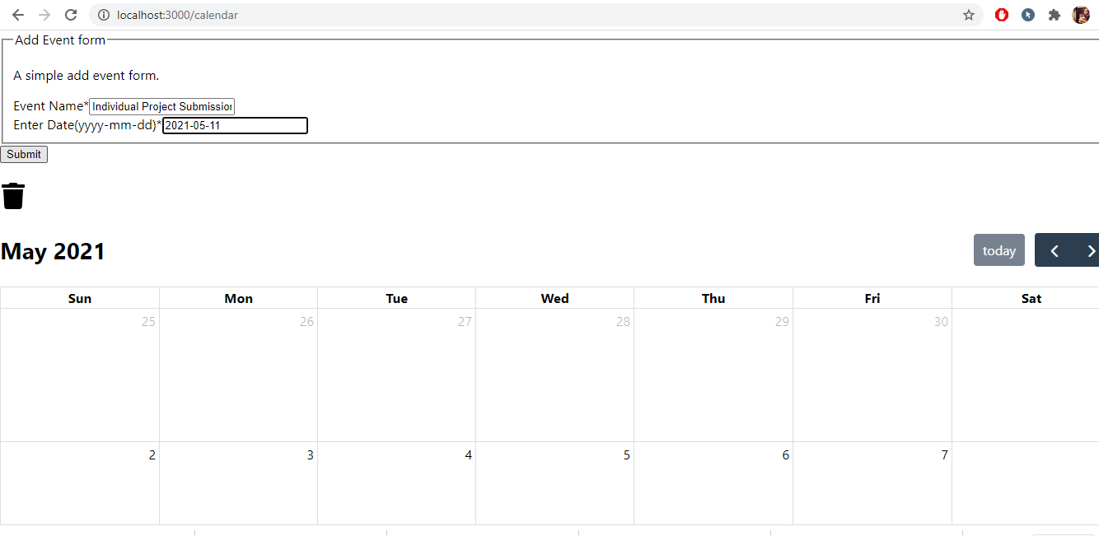

Event Being Added

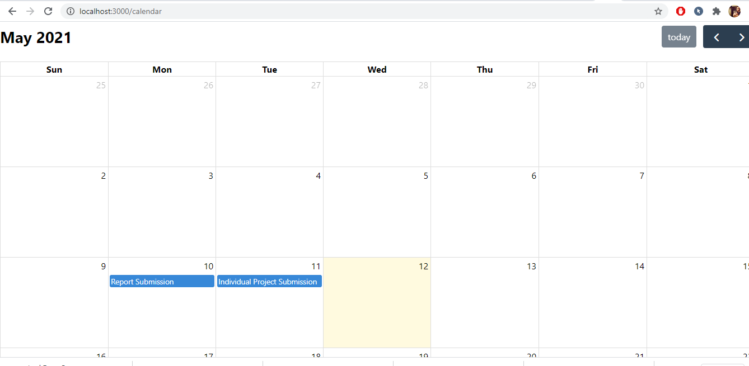

Adding multiple events on the same day in the calendar

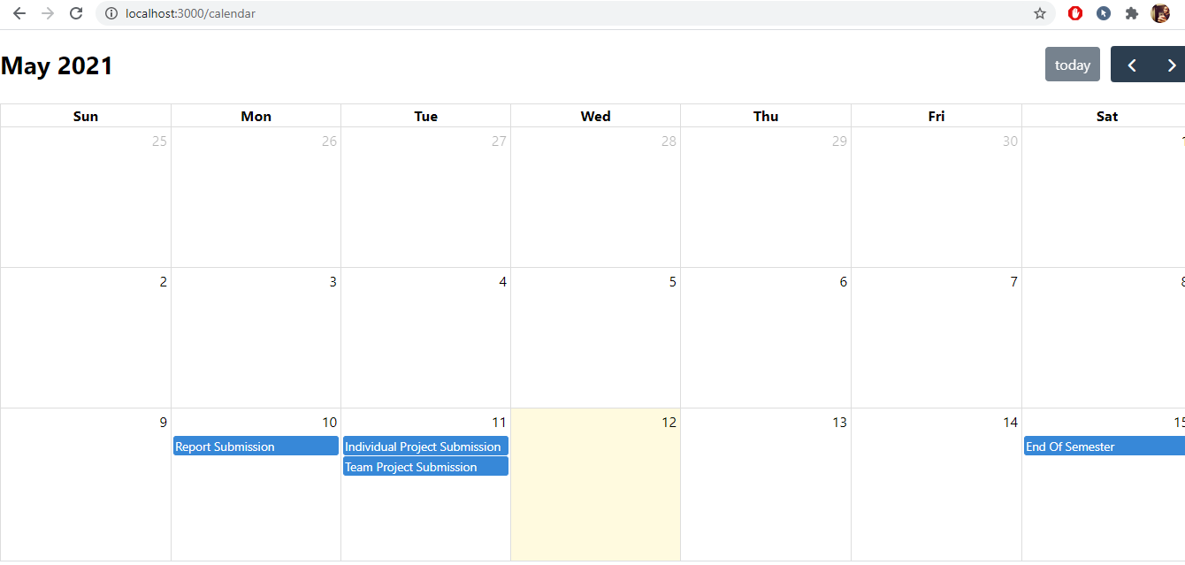

Deleting an event in the calendar

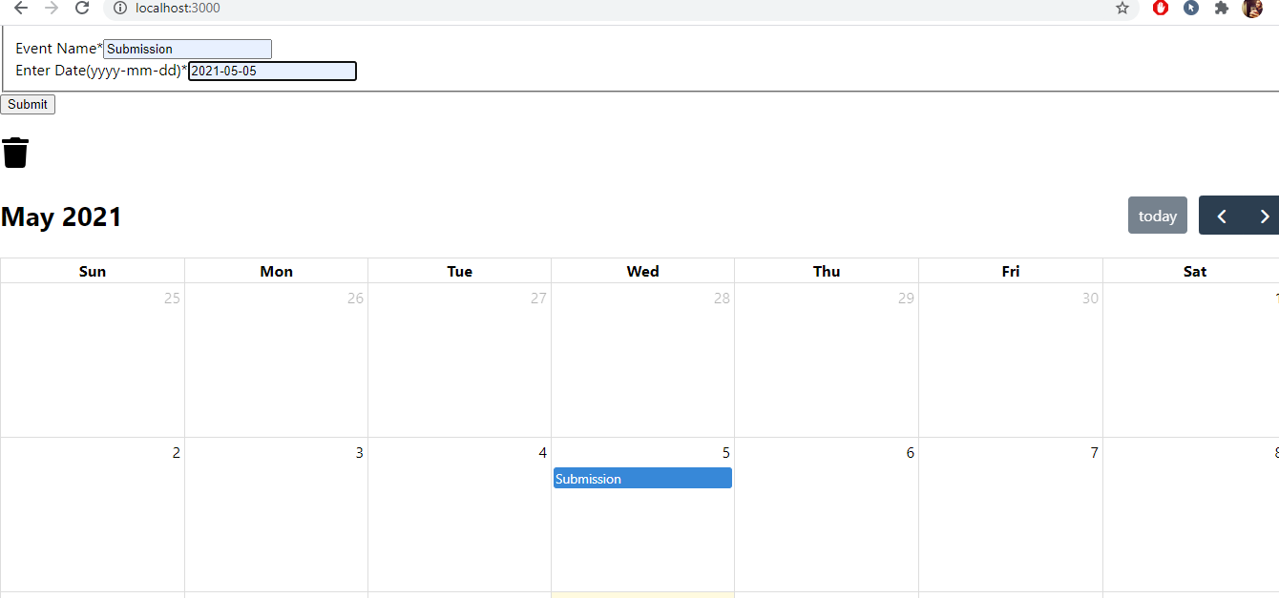

Selected Event Deleted

