**Name: KANDRU SOWMYA SRI**

**Roll number: 23481A0596**

**Course: Data Analytics with tableau**

**Assignment: 2**

**Assignment 2: Data Analytics with Tableau**

**Supermarket Sales Visualization**

This assignment focuses on analyzing the historical sales data of a supermarket company operating in three different branches over a period of three months. Various Tableau visualizations were created to understand customer behavior, sales trends, and product performance.

The following charts were developed using Tableau:

**1.Donut Chart - Payment Distribution**

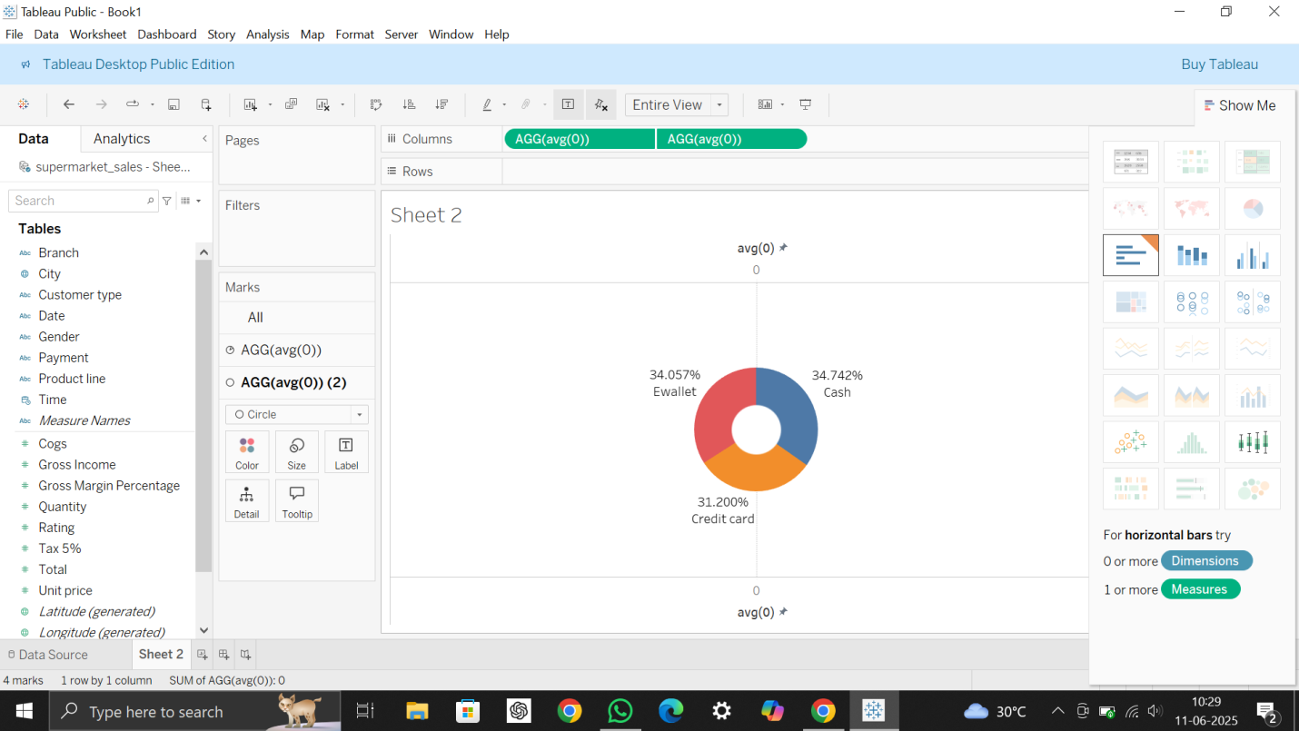

This chart shows the distribution of payment methods used by customers. It helps us understand which payment option (Cash, Credit Card, or E-Wallet) is most popular in the supermarket.

**2.Area Chart - Sales Over Time**

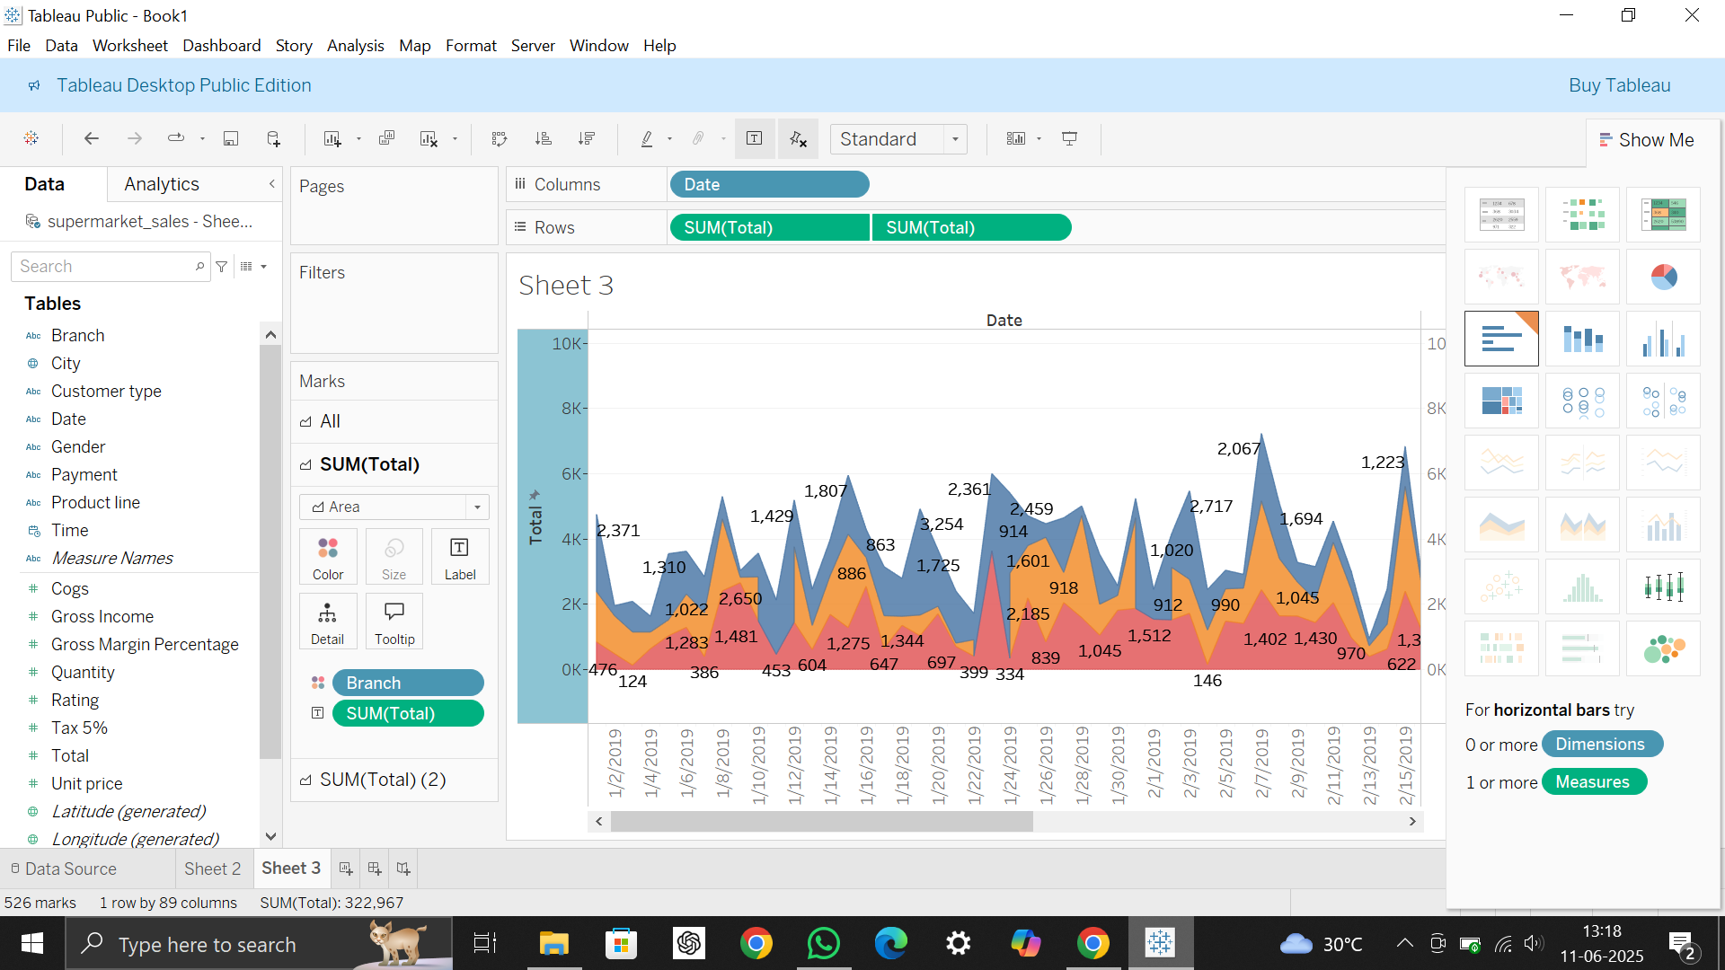

The area chart displays how total sales have changed over time. It helps to track sales performance across different days or months.

**3. Text Table - Sales by Product Line**

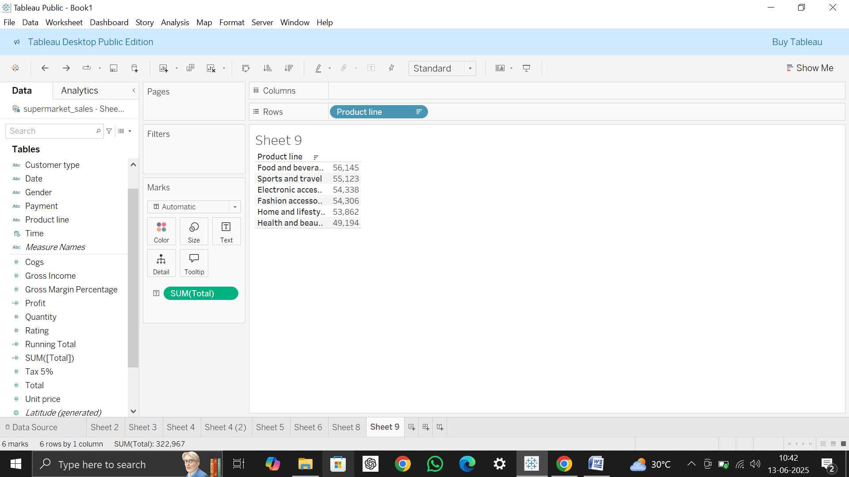

The text table shows the total sales for each product line. It provides exact numerical sales values, which helps in comparing the performance of different product categories.

**4. Highlighted Table - Sales Comparison by City and Product Line**

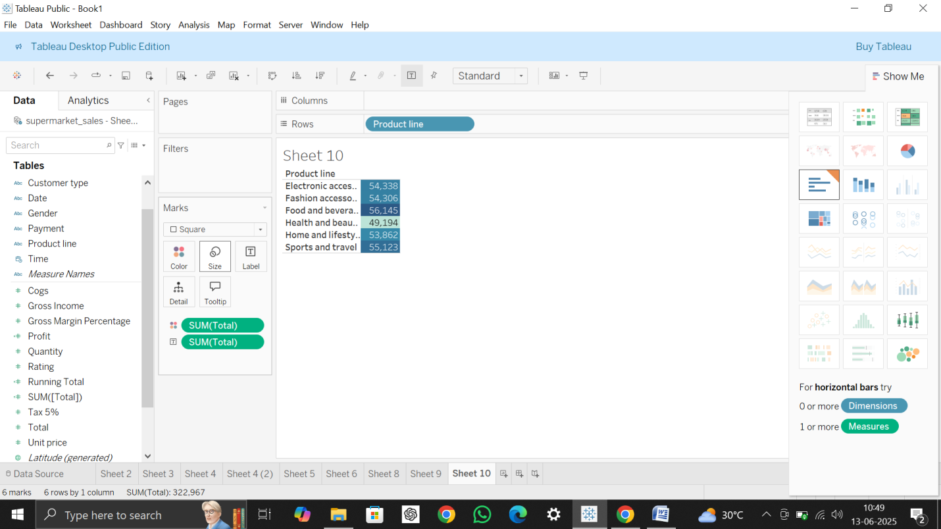

The highlighted table visually compares sales across cities and product lines. The color highlights make it easy to see which products sold best in each city.

**5. Word Cloud - Product Line Frequency**

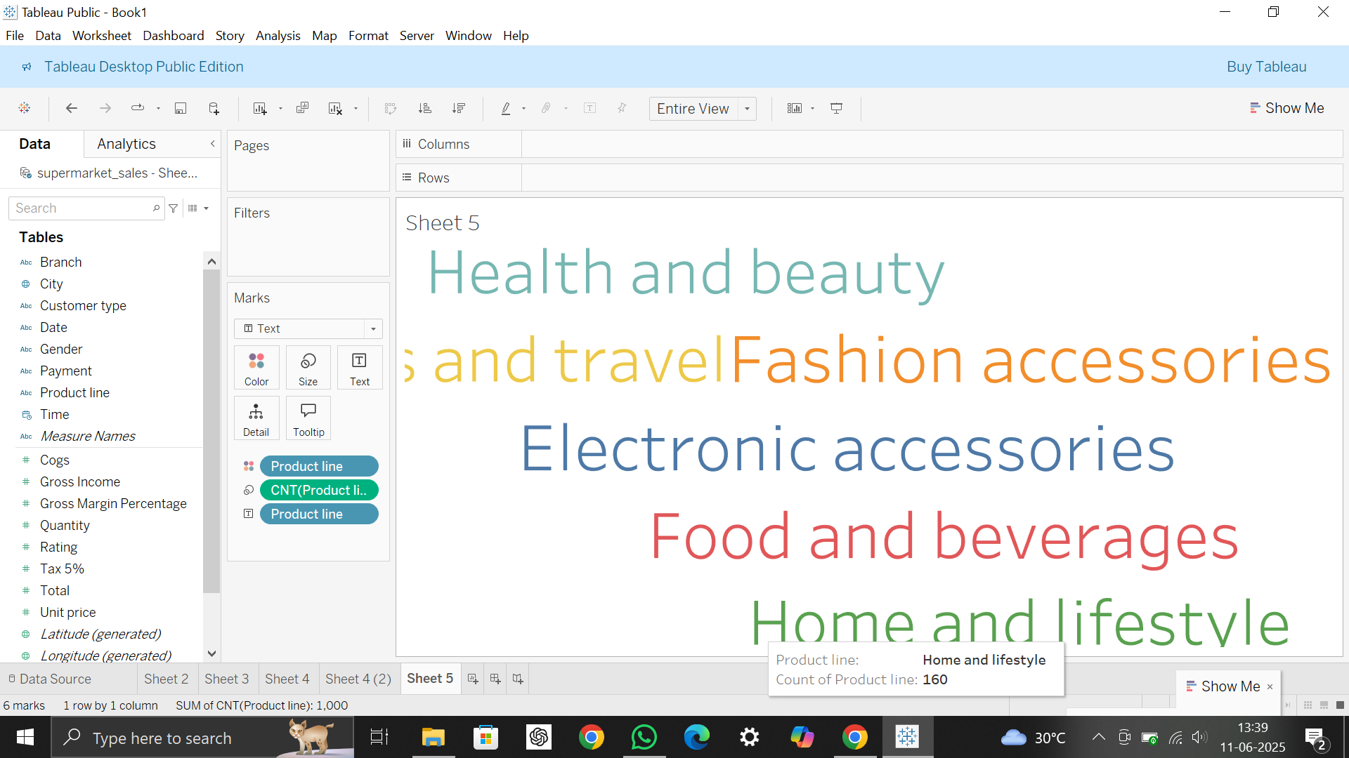

The word cloud represents the most frequent product lines purchased by customers. Larger words indicate more sales or higher frequency.

**6. Funnel Chart - Sales by Product Line**

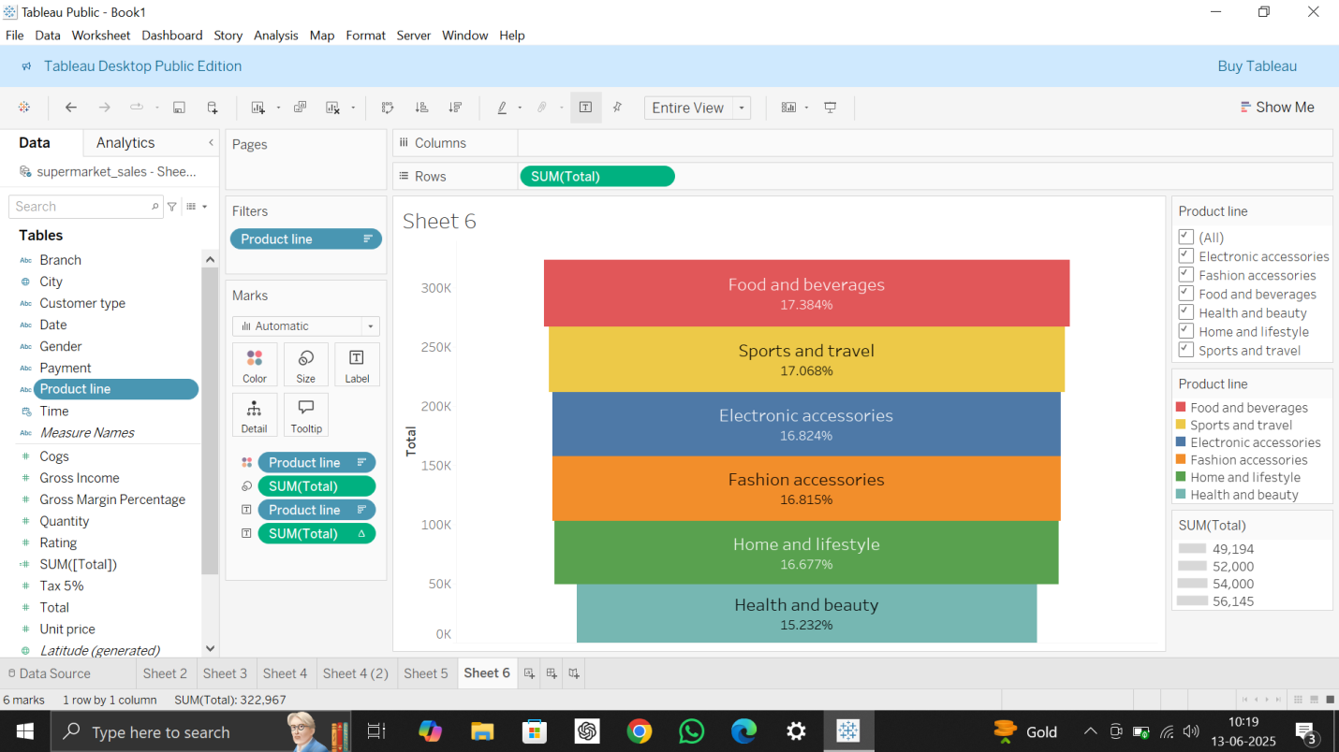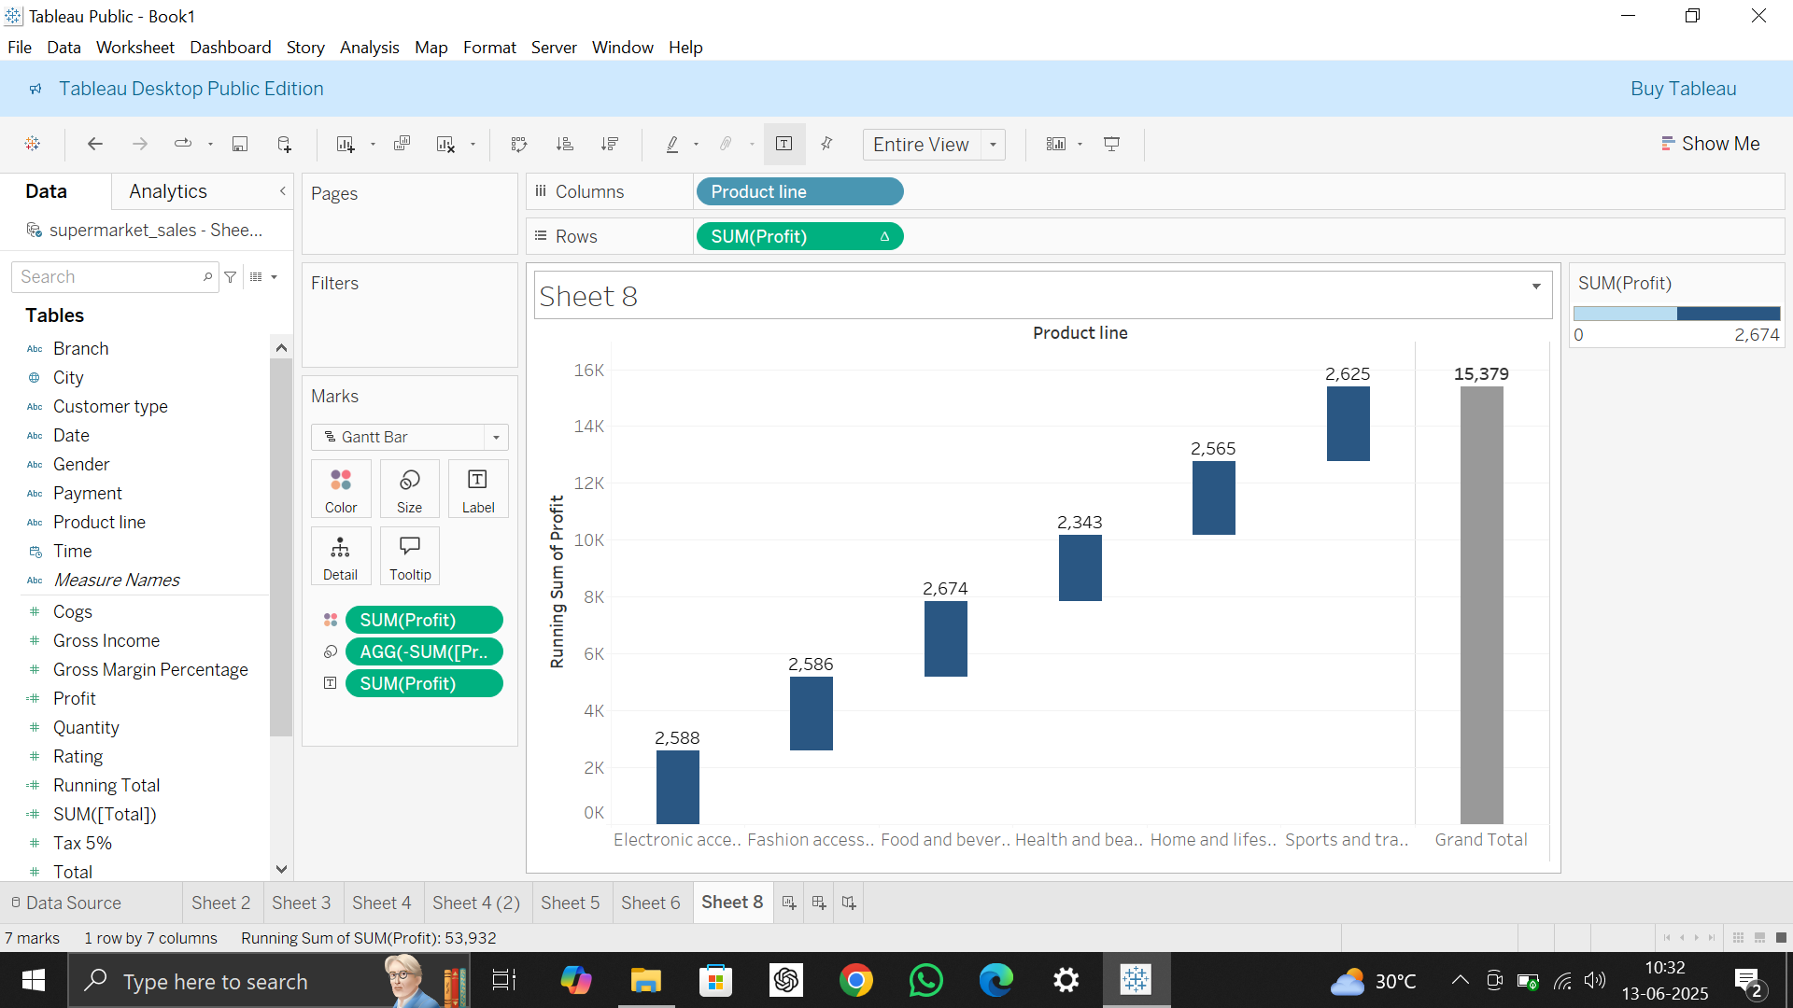

The funnel chart shows the step-by-step reduction in sales across different product lines. It helps to visualize which product categories have the highest or lowest sales.

**7. Waterfall Chart - Sales Flow using Total**

The waterfall chart displays how sales (Total) increase or decrease across different product lines. It helps to understand the flow and changes in sales step by step.