**Data Analytics - Assignment 3**

**Supermarket Sales Dashboard**

**Name : KANDRU SOWMYA SRI**

**Roll Number : 23481A0596  
Course : Data Analytics with Tableau**

**Objective:**

The objective of this assignment is to analyze supermarket sales data collected from three different branches over a three-month period. The analysis focuses on understanding sales distribution, trends over time, and payment patterns to assist in better decision-making in a competitive market.

**Process Followed:**

1. Imported the provided supermarket sales dataset into Tableau.
2. Removed unnecessary columns that were not useful for the analysis.
3. Created four individual charts:
   * **Sales per Branch:** Comparison of total sales among branches A, B, and C.
   * **Sales by Product Line:** Sales distribution across different product categories.
   * **Sales Trend Over Time:** Monthly sales trends over the three-month period.
   * **Payment Distribution:** Sales split by payment methods like Cash, Credit Card, and E-wallet.
4. Combined all charts into a single interactive dashboard using containers for proper layout.

**Dashboard:**

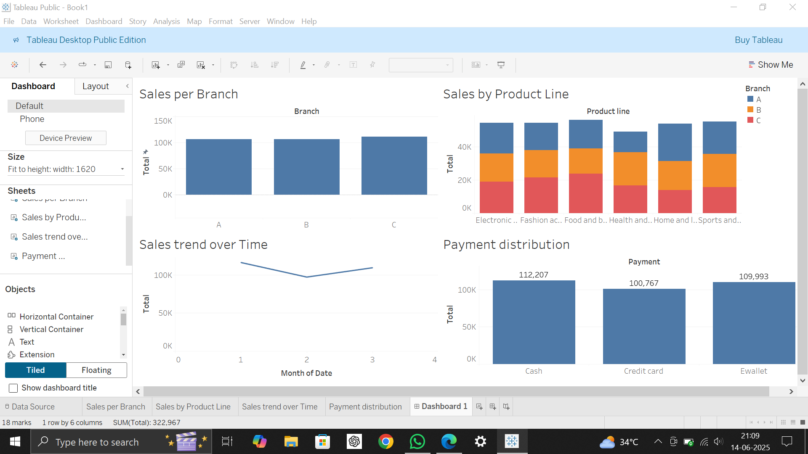

The dashboard provides a clear overview of:

* Which branch performs best.
* Which product lines generate higher sales.
* The trend of sales over the selected period.
* Preferred customer payment methods.