

**Object Oriented Programming**

**Assignment 1**

Name : Ganta Sowmya Kranthi

Roll no : 201210019

Year : 2nd year

Semester :4th Sem

Group : 1

**Q 1 .** Write a basic c++ program to declare some data types like integer, string, long, double and accept the input for that variables through user.

**Code:**

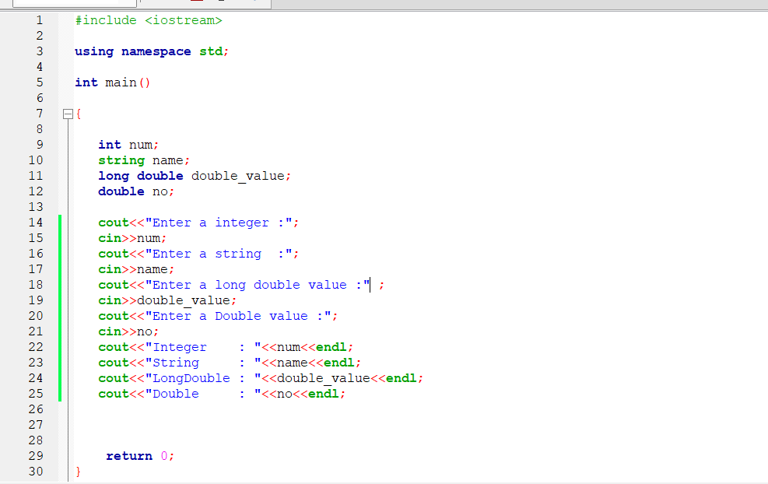

Output:

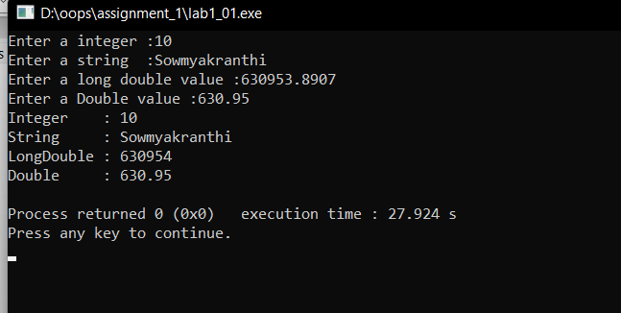

Q 2 . Write a c++ program to declare a string variable with your name as input and print the ASCII value of your name in decimal.

**Code:**

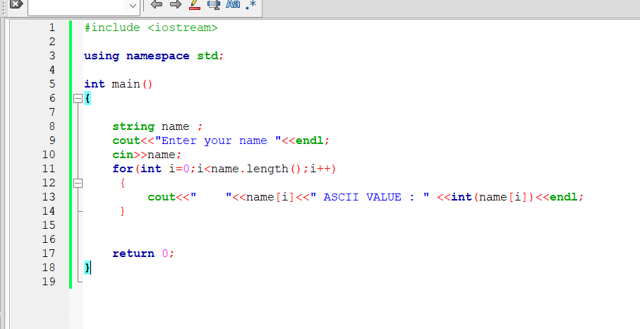

Output:

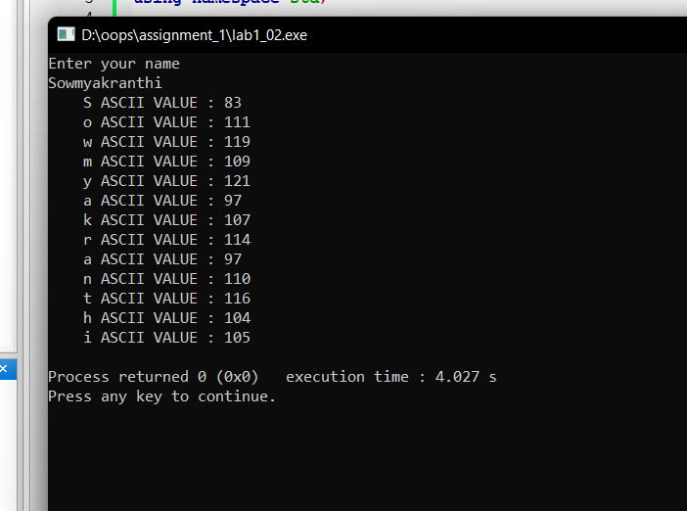

Q 3. write a c++ program to swap two numbers without using the third or any extra variable

**Code:**

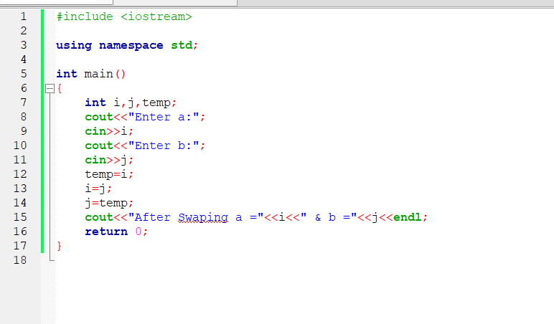

Output:

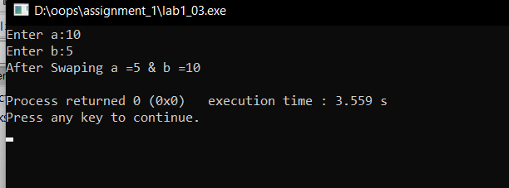

Without Using Third Variable:

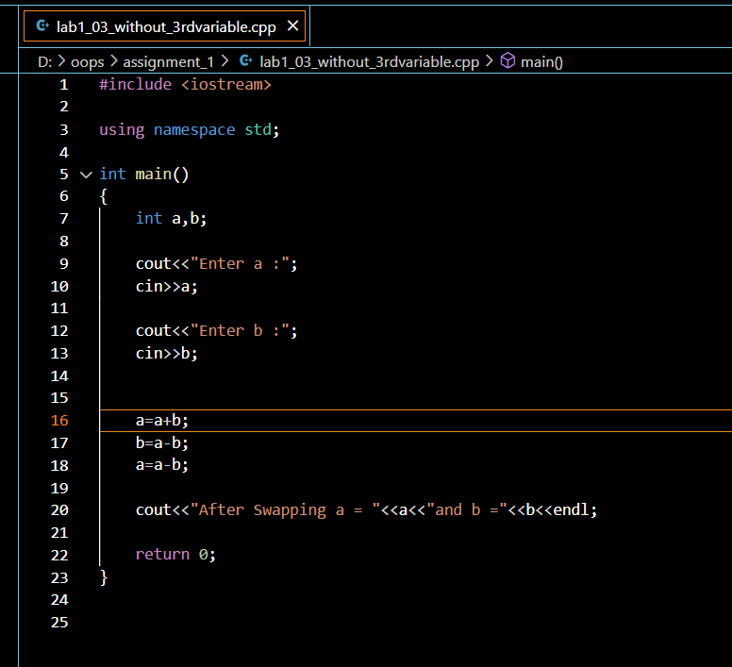

Output:

