

**Object oriented Programming**

**WEEK 3 ASSIGNMENT 3**

Name : Ganta Sowmya Kranthi

Roll no : 201210019

Year : 2nd year

Semester :4th Sem

Group : 1

Q 1. Write a c++ program to generate all the prime numbers between 1 and n, where n is the value supplied by the user.

Code:

#include <iostream>

using namespace std;

class prime_numbers

{

public:

int n;

void print_prime()

{

for(int i=2;i<=n;i++)

{

    int isprime = 0;

    for(int j=2;j<=i/2;j++)

    {

        if(i%j==0){

            isprime =1;

            break;

        }

    }

    if(isprime==0 && n!=1)

    cout<<i<<" ";

}

}

};

int main()

{   int m;

    cout<<"Enter the value of n\n";

    cin>>m;

    prime_numbers input;

    input.n = m;

    input.print_prime();

    return 0;

}

Output:

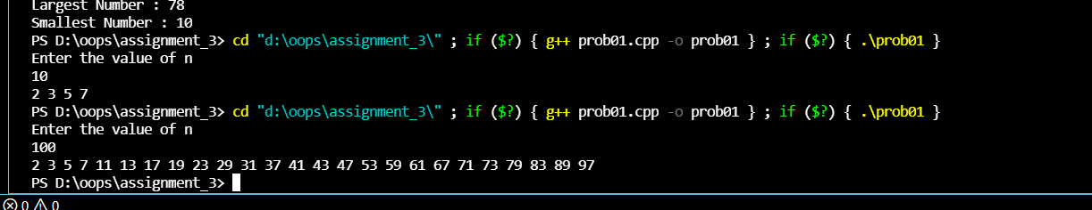

Q 2. Write a c++ program to find the largest and smallest number from a list. Take the input for the list from the user . Implement it in O(n) time.

Code:

#include<iostream>

using namespace std;

class number

{

    public:

    void findnumber(int *a,int n)

    {

        int min=a[0];

        int max=a[0];

        for(int i=0;i<n;i++)

        {

            if(a[i]>max)

            {

                max=a[i];

            }

            if(a[i]<min)

            {

                min=a[i];

            }

        }

        a[0]=max;

        a[1]=min;

    }

};

int main()

{

    cout << "Enter the size of Array : ";

    int n;

    cin >> n;

    int a[n];

    cout << "Enter the values of Array : "<< endl;

    for(int i=0;i<n;i++)

    {

        cout << i << " : ";

        cin >> a[i];

    }

    number p;

    p.findnumber(a,n);

    cout << "Largest Number : " << a[0] << endl;

    cout << "Smallest Number : " << a[1] << endl;

    return 0;

}

Output:

