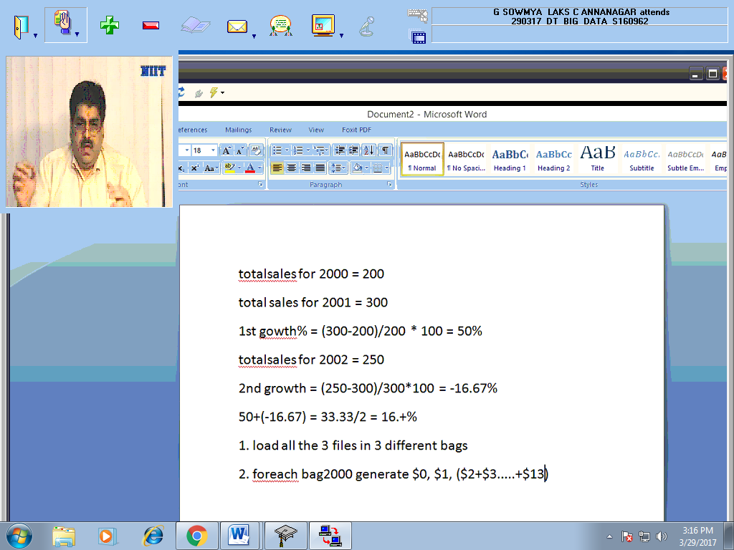

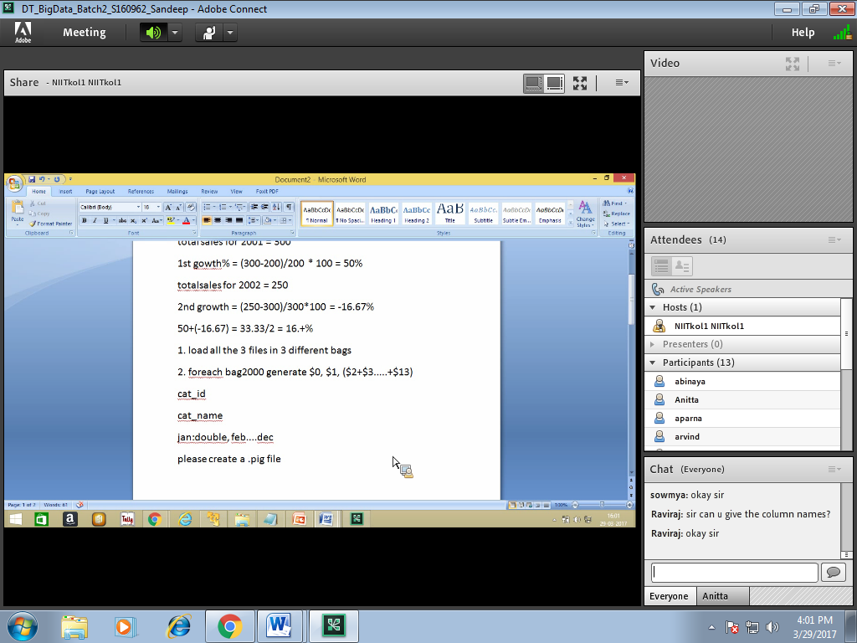

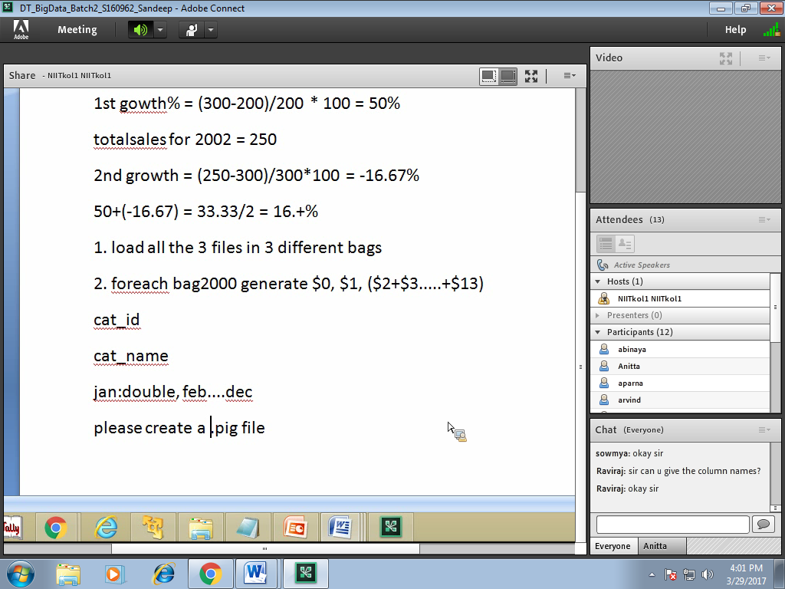

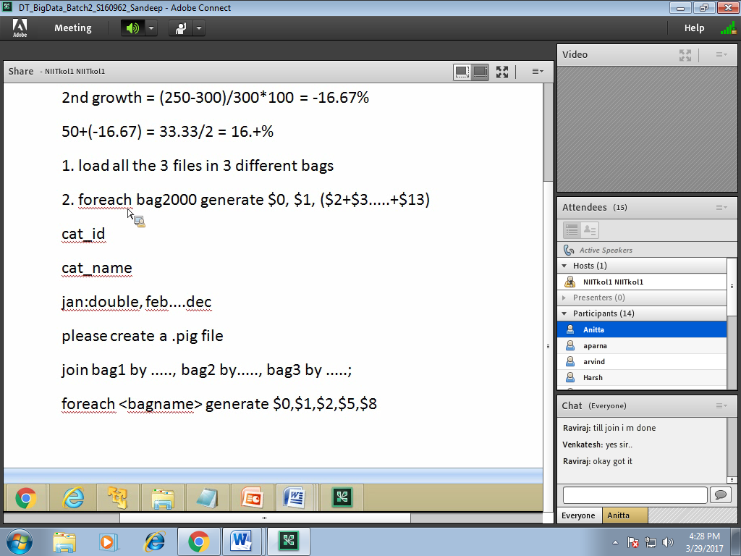

growth_avg_1 = foreach generate ROUND_TO(((total_2001.$0-total_2000.$0)/total_2000.$0)*100,2); (mistake)

after for each bag name should come.

Ans: avg growth more than 10 (warehouse club ,17.37)

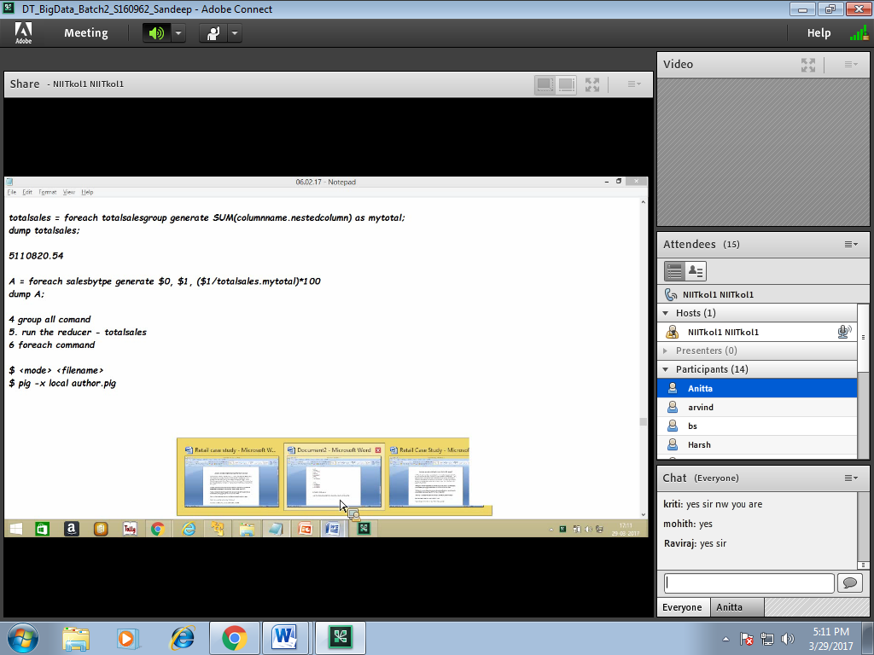

(44811,Men's clothing stores,26322.0)(4482,Shoe stores,68943.0)(44831,Jewelery stores,73148.0)(45431,Fuel dealers,76884.0)(4453,Beer wine and liquor stores,87976.0) ans