**COVID-19 Analysis on African Countries**

**ABSTRACT**

A vast quantity of data has been created and gathered in the present big data age from a wide range of rich data sources. These huge data include significant knowledge and practical information. In this study, I provide a visual analytics and large data visualization tool for viewing and interpreting COVID-19 data in Africa Continent. According to the WHO, there is a vaccine deficit on the continent and supply to Africa are nearly at a stop. The organization hopes for new delivery under the worldwide Covax program in the upcoming months, including a commitment of 80 million doses from the United States. Currently, only 2% of Africans have had at least one vaccination shot, compared to 24% of the global population. Four of the six nations that have not begun vaccination are in Africa: Tanzania, Burundi, Chad, and Eritrea. Therefore, having tools for visualizing and analyzing this enormous data makes it simple to understand the data and newly learned information. With the use of the tool, users may better comprehend the details of the COVID-19 confirmed instances. Even though this tool was created for the visualization and visual analysis of epidemiological data, it may also be used for the visualization and visual analysis of large data from a variety of other practical applications and services.

**INTRODUCTION**

Coronavirus disease (COVID-19) is an infectious disease caused by the SARS-CoV-2 virus. Most infected individuals may only suffer mild to moderate respiratory symptoms and will recover without the need for special care. On the other hand, some people will get quite sick and need medical care. The likelihood of developing a major illness is higher among older persons and those with underlying medical disorders including cancer, diabetes, cardiovascular disease, or chronic respiratory diseases. With COVID-19, anyone can become unwell and could pass away at any age or become extremely ill.

Being well-informed on the illness and how the virus spreads is the greatest method to stop and sluggish transmission. Many families have lost the family head and faced severe financial crisis. Countries faced very bad economic phases. Millions of jobs were lost, and implementation of sudden lockdown crashed stock markets and all the small businesses. It created physical and mental impacts on all aspects all over the world.

By making simple planning and adjustments accordingly using the previous cycle of the covid we can minimize the covid cases across the world and can overcome the hazards in the next wave with minimum impact on people’s life and global economy. This project focuses on COVID-19 and its effect on African countries by using datasets in the Kaggle.

**RELATED WORK**

The COVID-19 epidemic has been shown to be a difficulty that artificial intelligence can overcome. Machine learning, natural language processing (NLP), and computer vision applications are required for artificial intelligence. Computers are taught to spot patterns, make predictions, and other tasks using these models. With the use of data visualization and predictions made using polynomial regression and support vector regression, this research aims to forecast the COVID-19 pandemic. To adopt measures before the issue gets out of hand, predictions might be helpful in determining the future count of COVID-19 cases. To develop models against COVID-19, AI still requires a lot of accurate data and constant human-AI interaction, but it has emerged as a source of hope for technological progress to protect humanity from this global epidemic.

This paper makes predictions using support vector regression. This article displays a bar graph of the data reflecting the top 10 nations that have been severely impacted by the epidemic and line graph prediction for upcoming cases in India's next 20 days by using linear regression and Support vector method [1]

 In every region of India, the coronavirus is displaying its power and growing quickly. The majority of COVID19 (Corona Virus Disease 2019) cases are found in the Indian state of Maharashtra, which is also one of the most affected states. As a result, the purpose of this work is to use geo-visualization techniques to examine the present situation of COVID19 cases in the state of Maharashtra. In addition to presenting a detailed hospital map of COVID19 cases in Mumbai city, which has the greatest number of cases in Maharashtra state, the study discusses the district-by-district current circumstances. This review briefly discusses the introduction, current cases, recovered cases, deceased cases, predictions, supports, and preventive measures implemented by authorities, and some fundamental advice and suggestions however, these are subject to change over time, just like the incidence of cases and mortality [2].

**MOTIVATION**

Africa is the second largest continent and is underdeveloped. By its history we can know that it is affected by SARS, MERS, EBOLA viruses and now COVID. This analysis would help people to understand the rate of growth of COVID-19 in Africa and take necessary steps for prevention.

**METHODOLOGY**

I have taken the dataset from Kaggle. I have chosen the dataset covid-19 of Africa.

I imported the dataset by using pandas library.

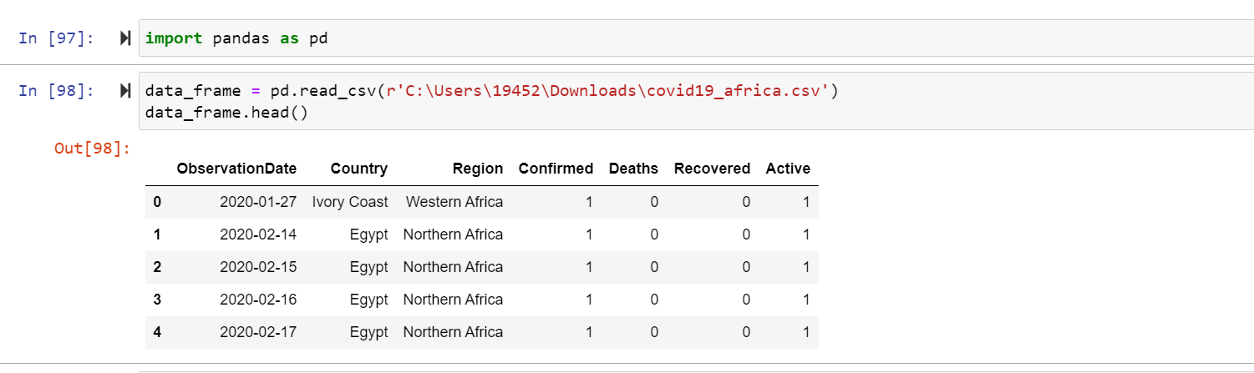

I have preprocessed the data by using python.

I have checked the null values in the dataset.

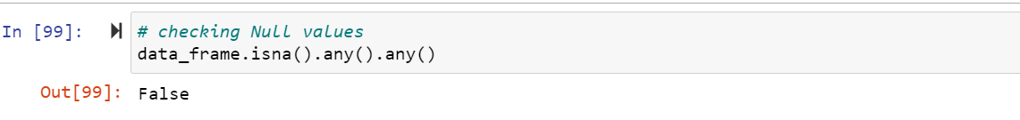

There are no null values in the dataset

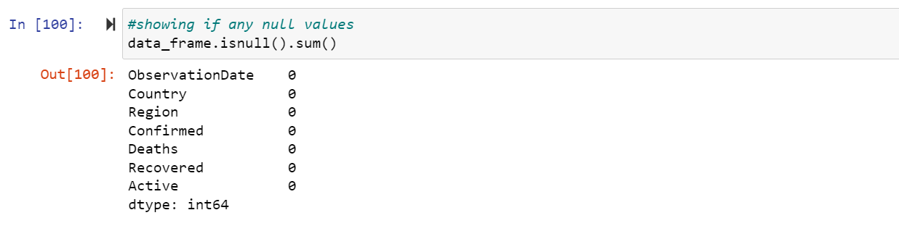

The dataset has 7 columns and 15454 column’s and no column has null values.

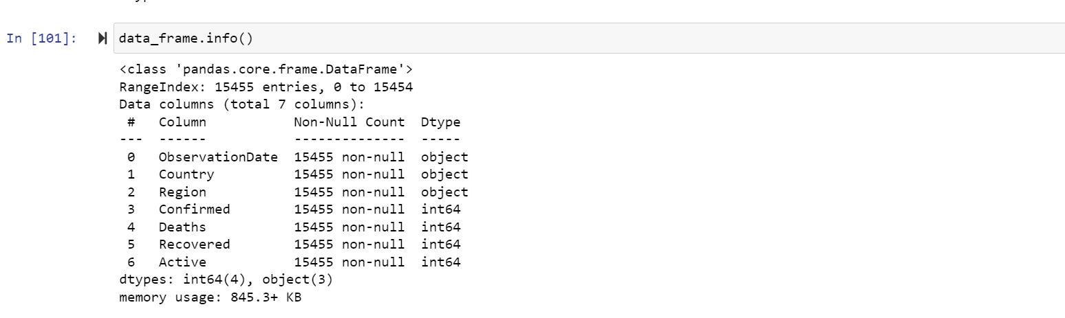

Imported the matplotlib library which is commonly used to show the charts.



I used the matplotlib to represent the pie chart. There are 5 regions in the dataset namely:

1. Eastern Africa
2. Northern Africa
3. Southern Africa
4. Western Africa
5. Central Africa.

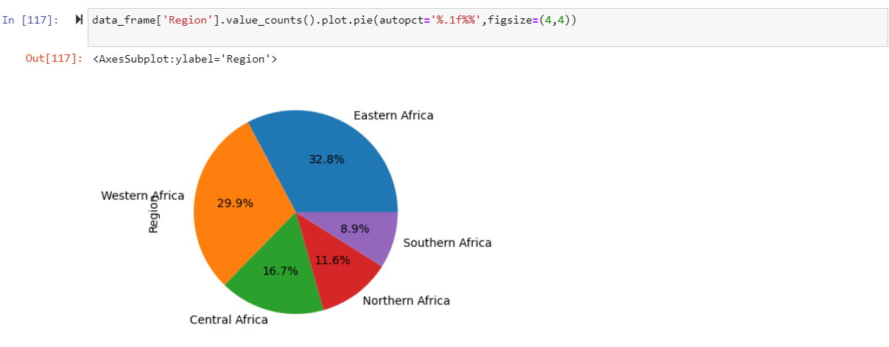

I have loaded the data of western Africa into a data frame ‘data_frame_WA’.

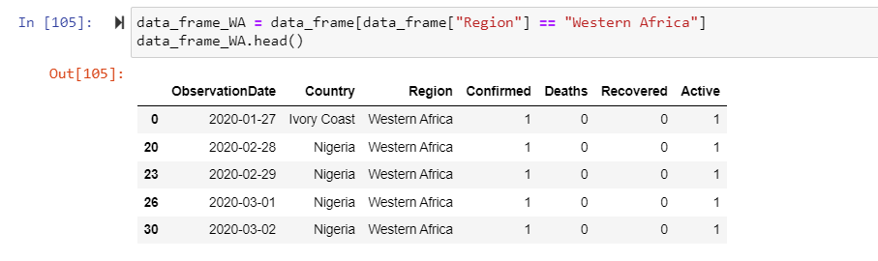

Used unique function to show the unique countries in the west Africa.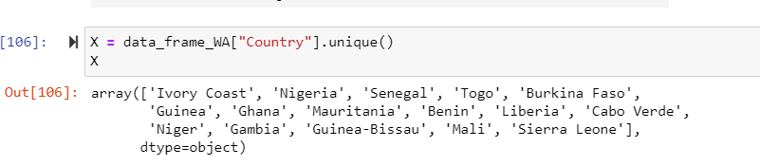

I have created the lists confirmed_Y, deaths_Y, recovered_Y, active_Y and imported numpy library to plot axis.

I have plotted the bar graph for western Africa.

On X-axis I have plotted the countries of Western Africa and on Y-axis I have plotted the Number of active, recovered, deceased, Confirmed cases of Covid-19.

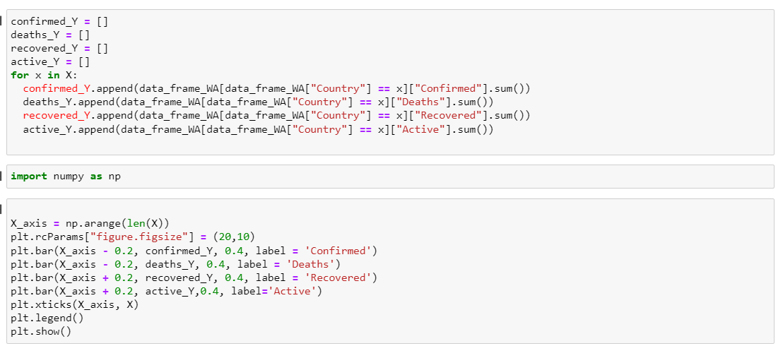

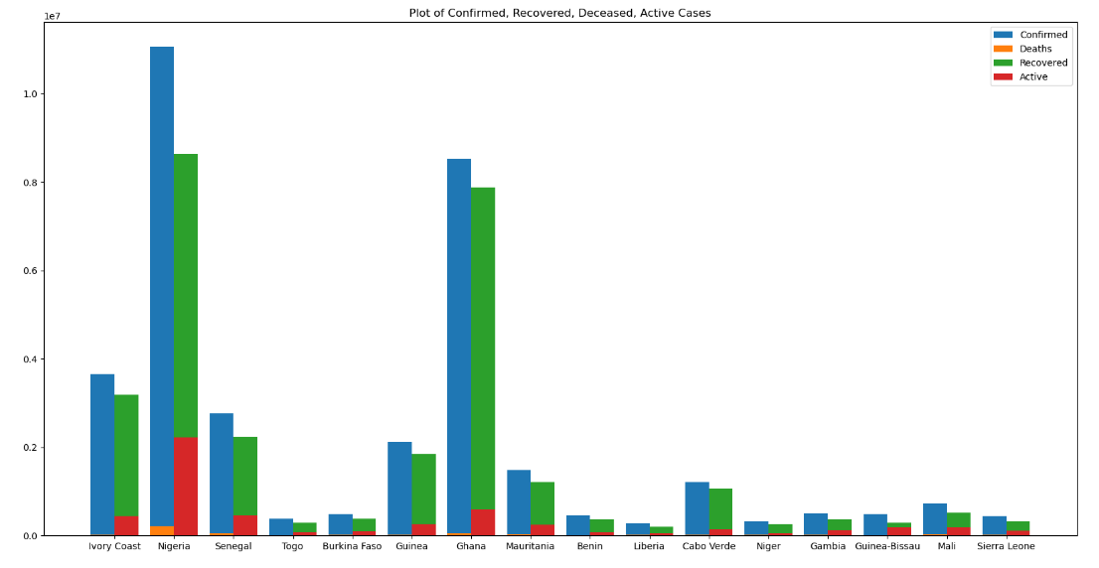

I have loaded the data of Central Africa into the data frame.

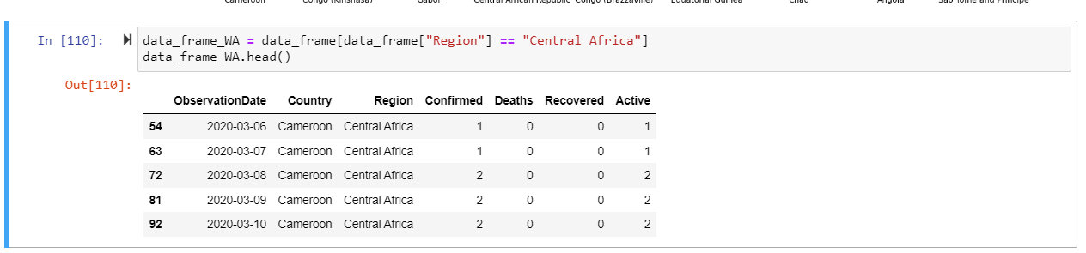

By using unique function, I have showed the countries associated with the Central Africa.

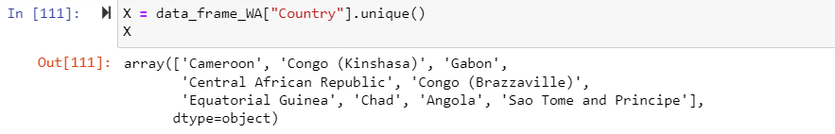

I have plotted the line graph of Confirmed, Recovered, Deceased, Active cases of covid-19 in different countries in Central Africa.

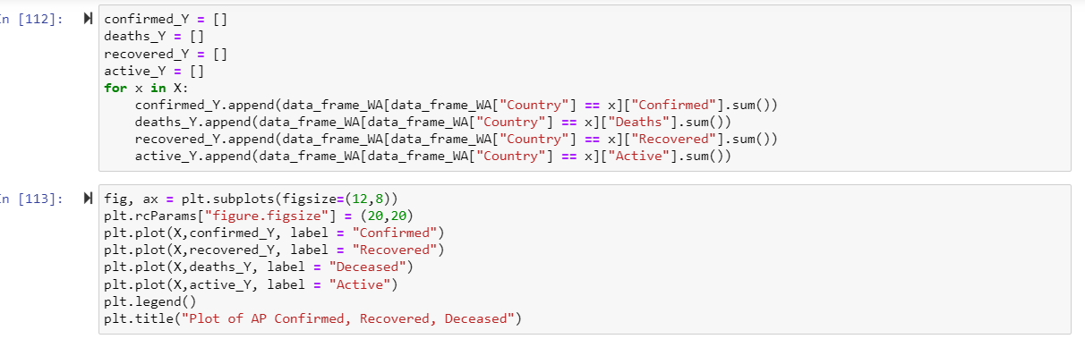

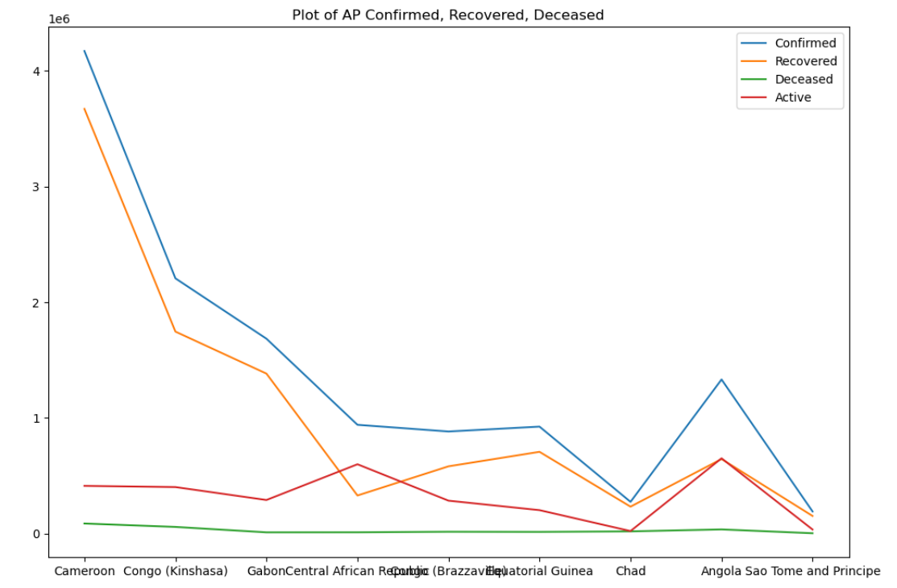

I have loaded the Eastern Africa data into the data frame

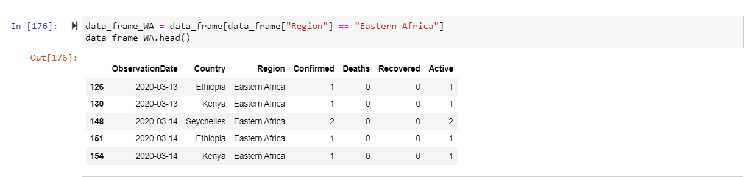

By using unique function, I have showed the countries associated with the Eastern Africa.

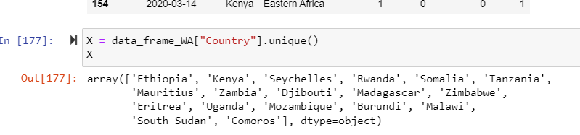

I have created the lists confirmed_Y, deaths_Y, recovered_Y, active_Y and imported numpy library to plot axis.

I have plotted the bar graph for Eastern Africa.

On X-axis I have plotted the countries of Eastern Africa and on Y-axis I have plotted the Number of active, recovered, deceased, Confirmed cases of Covid-19.

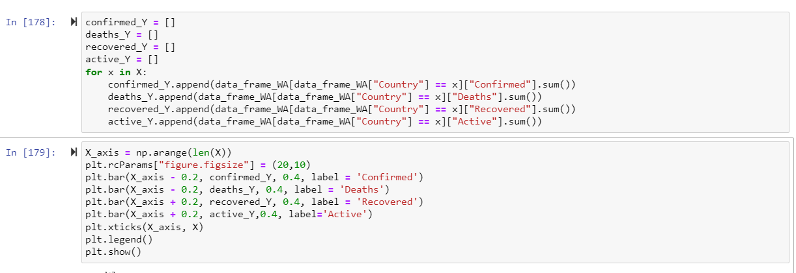

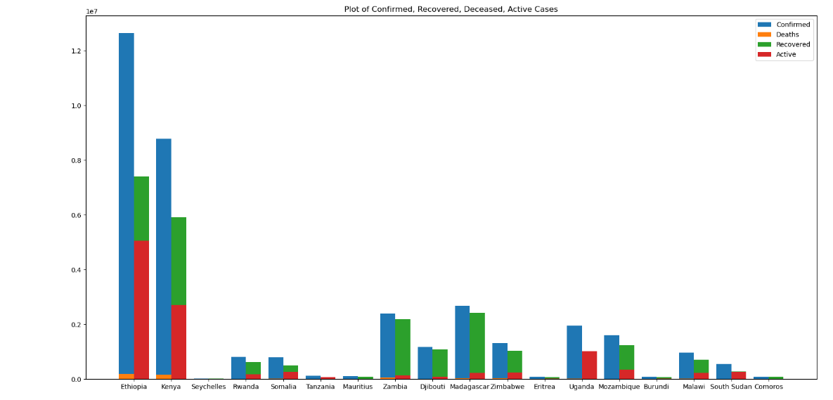

**RESULTS:**

The pie chart shows that the Eastern Africa is the most affected region when compared to the other 4 regions.



In Eastern Africa the most affected country due to Covid-19 is Ethiopia which has around half recovered cases of Confirmed cases. Zambia has almost same confirmed and recovered cases which is the country that has more recovery rate while Uganda has less recovered cases.



The below line chart shows the data of Central Africa. Cameroon is the most affected country in the Central Africa, but it has good recovery rate too. Angola and central Republic Africa has less recovered cases.



In Western Africa Nigeria is the mostly affected country and it has good recovery rate, but Ivory Coast and Ghana is having the best recovery rate. Niger has the less cases compared to other countries.

