**1) Setup**

import pandas as pd  
import numpy as npanime = pd.read_csv('anime-recommendations-database/anime.csv')  
rating = pd.read_csv('anime-recommendations-database/rating.csv')anime_modified = anime.set_index('name')

**2) Importing**

**Load CSV**

Convert a CSV directly into a data frame. Sometimes loading data from a CSV also requires specifying an encoding (ie:encoding='ISO-8859–1'). It’s the first thing you should try if your data frame contains unreadable characters.

Another similar function also exists called pd.read_excel for excel files.

anime = pd.read_csv('anime-recommendations-database/anime.csv')

**Build data frame from inputted data**

Useful when you want to manually instantiate simple data so that you can see how it changes as it flows through a pipeline.

df = pd.DataFrame([[1,'Bob', 'Builder'],  
 [2,'Sally', 'Baker'],  
 [3,'Scott', 'Candle Stick Maker']],   
columns=['id','name', 'occupation'])

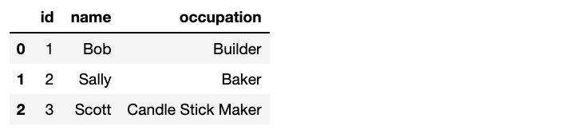

df.head()

**Copy a data frame**

Useful when you want to make changes to a data frame while maintaining a copy of the original. It’s good practise to copy all data frames immediately after loading them.

anime_copy = anime.copy(deep=True)

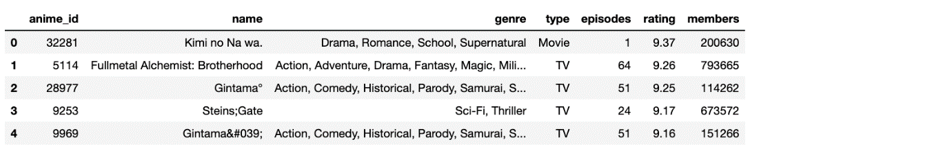

**3) Exporting**

**Save to CSV**

This dumps to the same directory as the notebook. I’m only saving the 1st 10 rows below but you don’t need to do that. Again, df.to_excel() also exists and functions basically the same for excel files.

rating[:10].to_csv('saved_ratings.csv', index=False)

**4) Viewing and Inspecting**

**Get top or bottom**n**records**

Display the first n records from a data frame. I often print the top record of a data frame somewhere in my notebook so I can refer back to it if I forget what’s inside.

anime.head(3)  
rating.tail(1)

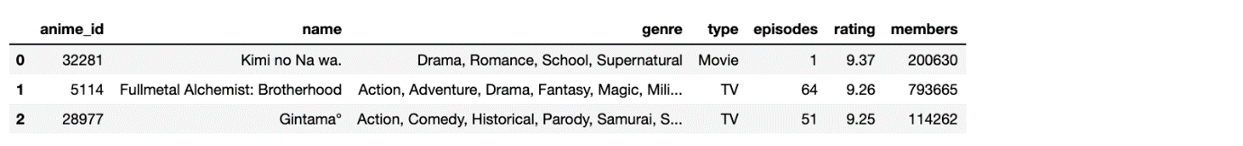



**Count rows**

This is not a pandas function per se but len() counts rows and can be saved to a variable and used elsewhere.

len(df)  
#=> 3

**Count unique rows**

Count unique values in a column.

len(ratings['user_id'].unique())

**Get data frame info**

Useful for getting some general information like header, number of values and datatype by column. A similar but less useful function is df.dtypes which just gives column data types.

anime.info()

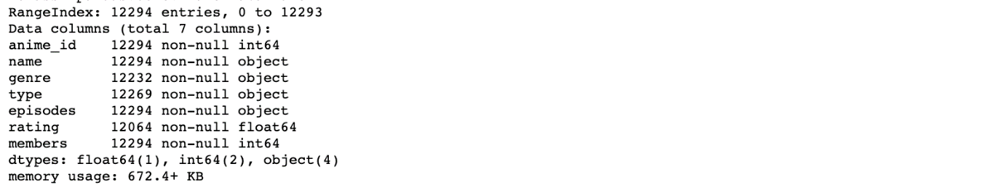

**Get statistics**

Really useful if the data frame has a lot of numeric values. Knowing the mean, min and max of the rating column give us a sense of how the data frame looks overall.

anime.describe()

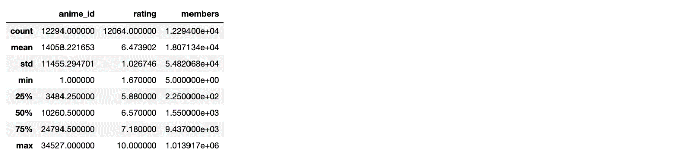

**Get counts of values**

Get counts of values for a particular column.

anime.type.value_counts()

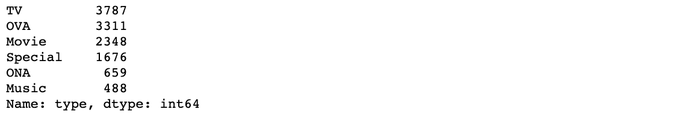

**5) Selecting**

**Get a list or series of values for a column**

This works if you need to pull the values in columns into X and y variables so you can fit a machine learning model.

anime['genre'].tolist()  
anime['genre']



anime[‘genre’].tolist()



anime[‘genre’]

**Get a list of index values**

Create a list of values from index. Note I’ve used anime_modified data frame here as the index values are more interesting.

anime_modified.index.tolist()



**Get a list of column values**

anime.columns.tolist()

Image for post

Image for post

**6) Adding / Dropping**

**Append new column with a set value**

I do this on occasion when I have test and train sets in 2 separate data frames and want to mark which rows are related to what set before combining them.

anime['train set'] = True

**Create new data frame from a subset of columns**

Useful when you only want to keep a few columns from a giant data frame and don’t want to specify each that you want to drop.

anime[['name','episodes']]

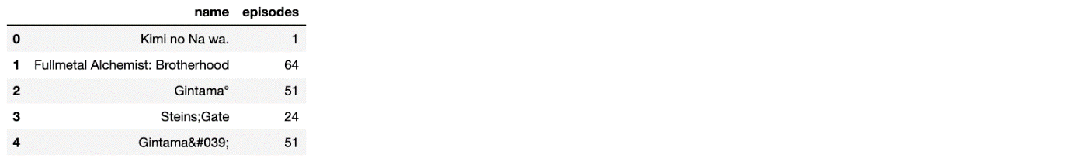

**Drop specified columns**

Useful when you only need to drop a few columns. Otherwise, it can be tedious to write them all out and I prefer the previous option.

anime.drop(['anime_id', 'genre', 'members'], axis=1).head()

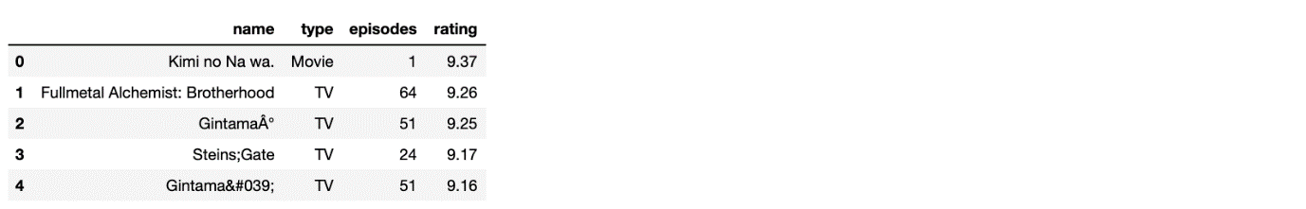

**Add a row with sum of other rows**

We’ll manually create a small data frame here because it’s easier to look at. The interesting part here is df.sum(axis=0) which adds the values across rows. Alternatively df.sum(axis=1) adds values across columns.

The same logic applies when calculating counts or means, ie: df.mean(axis=0).

df = pd.DataFrame([[1,'Bob', 8000],  
 [2,'Sally', 9000],  
 [3,'Scott', 20]], columns=['id','name', 'power level'])df.append(df.sum(axis=0), ignore_index=True)

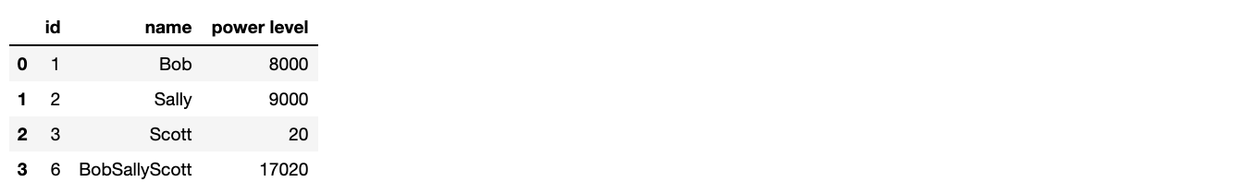

**7) Combining**

**Concatenate 2 dataframes**

Use this if you have 2 data frames with the same columns and want to combine them.

Here we split a data frame in 2 them add them back together.

df1 = anime[0:2]df2 = anime[2:4]pd.concat([df1, df2], ignore_index=True)





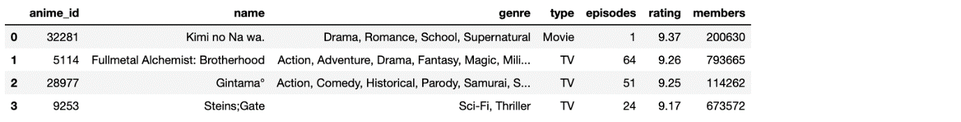

**Merge dataframes**

This functions like a SQL left join, when you have 2 data frames and want to join on a column.

rating.merge(anime, left_on=’anime_id’, right_on=’anime_id’, suffixes=(‘_left’, ‘_right’))

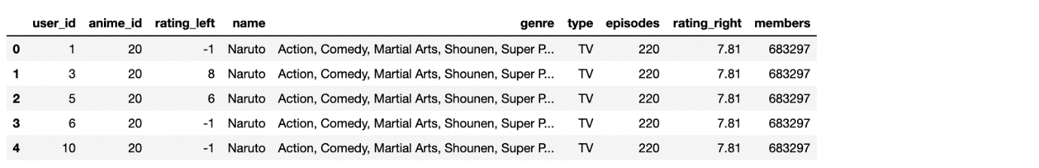

**8) Filtering**

**Retrieve rows with matching index values**

The index values in anime_modified are the names of the anime. Notice how we’ve used those names to grab specific columns.

anime_modified.loc[['Haikyuu!! Second Season','Gintama']]



**Retrieve rows by numbered index values**

This differs from the previous function. Using iloc, the 1st row has an index of 0, the 2nd row has an index of 1, and so on… even if you’ve modified the data frame and are now using string values in the index column.

Use this is you want the first 3 rows in a data frame.

anime_modified.iloc[0:3]

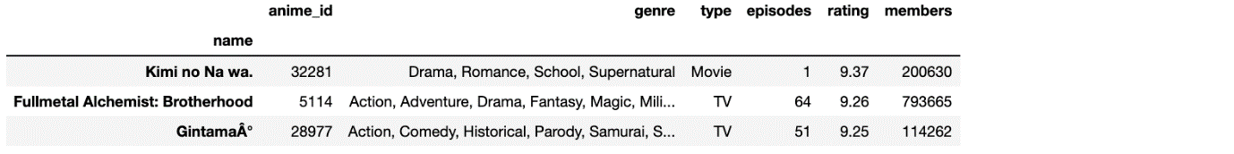

**Get rows**

Retrieve rows where a column’s value is in a given list. anime[anime[‘type’] == 'TV'] also works when matching on a single value.

anime[anime['type'].isin(['TV', 'Movie'])]

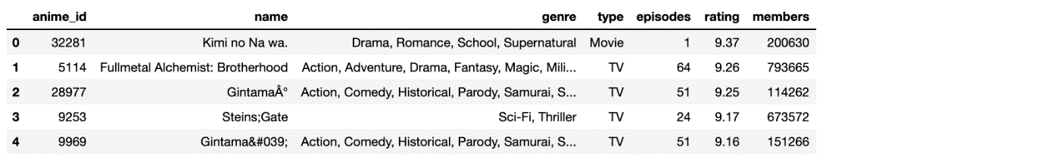

**Slice a dataframe**

This is just like slicing a list. Slice a data frame to get all rows before/between/after specified indices.

anime[1:3]



**Filter by value**

Filter data frame for rows that meet a condition. Note this maintains existing index values.

anime[anime['rating'] > 8]

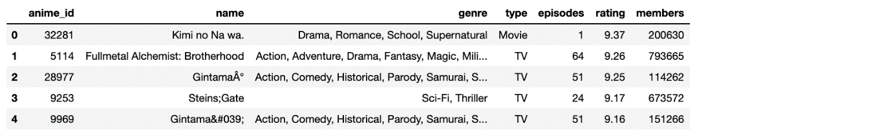

**9) Sorting**

**sort_values**

Sort data frame by values in a column.

anime.sort_values('rating', ascending=False)

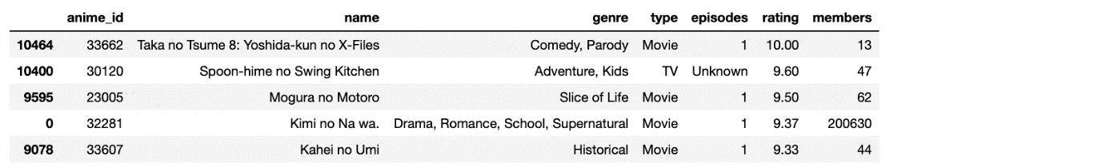

**10) Aggregating**

**Groupby and count**

Count number of records for each distinct value in a column.

anime.groupby('type').count()

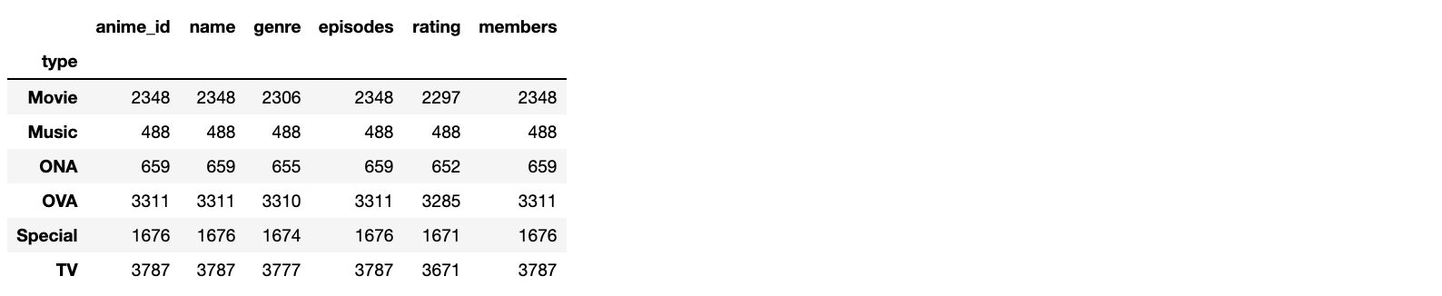

**Groupby and aggregate columns in different ways**

Note I added reset_index() otherwise the type column becomes the index column — I recommend doing the same in most cases.

anime.groupby(["type"]).agg({  
 "rating": "sum",  
 "episodes": "count",  
 "name": "last"  
}).reset_index()

**Create a pivot table**

Nothing better than a pivot table for pulling a subset of data from a data frame.

Note I’ve heavily filtered the data frame so it’s quicker to build the pivot table.

tmp_df = rating.copy()  
tmp_df.sort_values('user_id', ascending=True, inplace=True)  
tmp_df = tmp_df[tmp_df.user_id < 10]   
tmp_df = tmp_df[tmp_df.anime_id < 30]  
tmp_df = tmp_df[tmp_df.rating != -1]pd.pivot_table(tmp_df, values='rating', index=['user_id'], columns=['anime_id'], aggfunc=np.sum, fill_value=0)

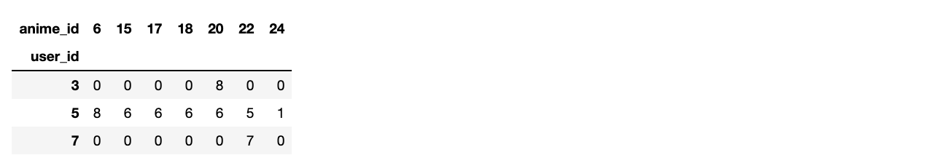

**11) Cleaning**

**Set NaN cells to some value**

Set cells with NaN value to 0 . In the example we create the same pivot table as before but without fill_value=0 then use fillna(0) to fill them in afterwards.

pivot = pd.pivot_table(tmp_df, values='rating', index=['user_id'], columns=['anime_id'], aggfunc=np.sum)pivot.fillna(0)

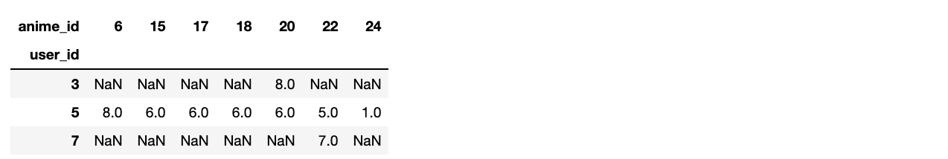

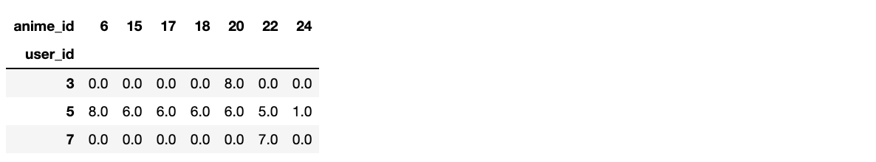

**12) Other**

**Sample a data frame**

I use this all the time taking a small sample from a larger data frame. It allows randomly rearranging rows while maintaining indices if frac=1.

anime.sample(frac=0.25)

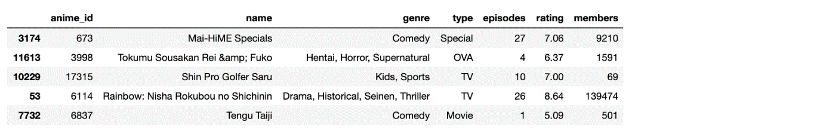

**Iterate over row indices**

Iterate over index and rows in data frame.

for idx,row in anime[:2].iterrows():  
 print(idx, row)

