# SELINIUM-TESTING

CC-1

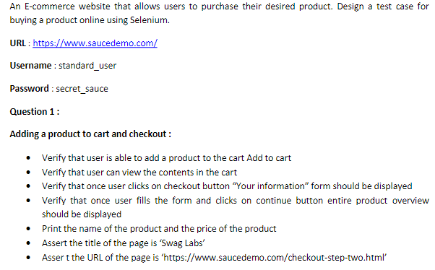

Code:

**package** cc1;

**import** org.openqa.selenium.By;

**import** org.openqa.selenium.WebDriver;

**import** org.openqa.selenium.chrome.ChromeDriver;

**import** org.openqa.selenium.chrome.ChromeOptions;

**import** io.github.bonigarcia.wdm.WebDriverManager;

**public** **class** Question_1 {

**public** **static** **void** main(String[] args) {

ChromeOptions co=**new** ChromeOptions();

co.addArguments ("--remote-allow-origins=*");

WebDriverManager.*chromedriver*().setup ();

WebDriver driver=**new** ChromeDriver();

driver.get ("https://www.saucedemo.com/");

driver.findElement(By.*xpath*("//*[@id=\"user-name\"]")).sendKeys("standard_user");

driver.findElement(By.*xpath*("//*[@id=\"password\"]")).sendKeys("secret_sauce");

driver.findElement(By.*xpath*("//*[@id=\"login-button\"]")).click();

driver.findElement(By.*xpath*("//*[@id=\"add-to-cart-sauce-labs-backpack\"]")).click();

String initial = driver.findElement(By.*xpath*("//*[@id=\"item_4_title_link\"]/div")).getText();

driver.findElement(By.*xpath*("//*[@id=\"shopping_cart_container\"]/a")).click();

String cart = driver.findElement(By.*xpath*("//*[@id=\"item_4_title_link\"]/div")).getText();

**if**(cart.equals(initial)) {

System.***out***.println("successfully product added to the cart");

}

**else** {

System.***out***.println("oops");

}

String check_cart = driver.findElement(By.*xpath*("//*[@id=\"continue-shopping\"]")).getText();

System.***out***.println(check_cart);

**if**(check_cart.equals("Continue Shopping")) {

System.***out***.println("hey ! cart is open smoothly ");

}

**else** {

System.***out***.println("oops");

}

driver.findElement(By.*xpath*("//*[@id=\"checkout\"]")).click();

String checkout = driver.findElement(By.*xpath*("//*[@id=\"header_container\"]/div[2]/span")).getText();

**if**(checkout.equals("Checkout: Your Information")) {

System.***out***.println("my information displayed");

}

**else** {

System.***out***.println("oops");

}

driver.findElement(By.*xpath*("//*[@id=\"first-name\"]")).sendKeys("sara");

driver.findElement(By.*xpath*("//*[@id=\"last-name\"]")).sendKeys("s");

driver.findElement(By.*xpath*("//*[@id=\"postal-code\"]")).sendKeys("645 543");

driver.findElement(By.*xpath*("//*[@id=\"continue\"]")).click();

String product_name = driver.findElement(By.*xpath*("//*[@id=\"item_4_title_link\"]/div")).getText();

String product_price = driver.findElement(By.*xpath*("//*[@id=\"item_4_title_link\"]/div")).getText();

**if**(product_name.equals(cart)) {

System.***out***.println("entire product overview is displayed");

System.***out***.println("product Name"+product_name);

System.***out***.println("product price"+product_price);

}

**else** {

System.***out***.println(cart);

System.***out***.println(product_name);

}

String title = driver.getTitle();

**if**(title.equals("Swag Labs")) {

System.***out***.println("title matched");

}

**else** {

System.***out***.println("title mismatched");

}

**if**(driver.getCurrentUrl().equals("https://www.saucedemo.com/checkout-step-two.html")) {

System.***out***.println("url matched");

}

**else** {

System.***out***.println("url mismatched");

}

}

}

Output:

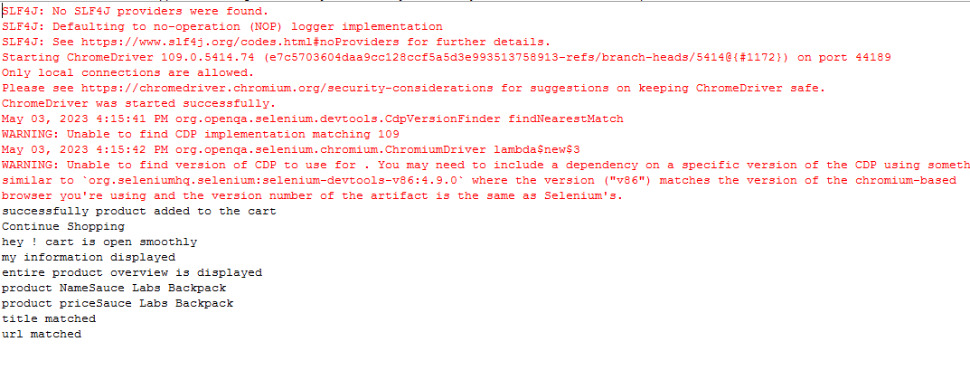

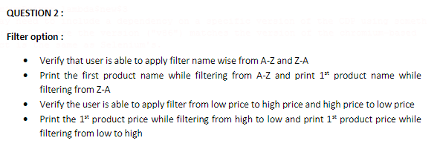

Code:

**package** cc1;

**import** org.openqa.selenium.By;

**import** org.openqa.selenium.WebDriver;

**import** org.openqa.selenium.WebElement;

**import** org.openqa.selenium.chrome.ChromeDriver;

**import** org.openqa.selenium.chrome.ChromeOptions;

**import** io.github.bonigarcia.wdm.WebDriverManager;

**public** **class** Question_2 {

**public** **static** **void** main(String[] args) **throws** InterruptedException {

// **TODO** Auto-generated method stub

ChromeOptions co=**new** ChromeOptions();

co.addArguments ("--remote-allow-origins=*");

WebDriverManager.*chromedriver*().setup ();

WebDriver driver=**new** ChromeDriver(co);

driver.get ("https://www.saucedemo.com/");

driver.manage().window().maximize() ;

WebElement txtBoxl=driver.findElement(By.*xpath*("//*[@id=\"user-name\"]"));

txtBoxl.sendKeys("standard_user");

WebElement txtBox2=driver.findElement(By.*xpath*("//*[@id=\"password\"]"));

txtBox2.sendKeys("secret_sauce");

driver.findElement(By.*xpath*("//*[@id=\"login-button\"]")).click();

String txt1=driver.findElement(By.*xpath*("//*[@id=\"item_4_title_link\"]/div")).getText();

System.***out***.println(txt1);

driver.findElement(By.*xpath*("//*[@id=\"header_container\"]/div[2]/div/span/select")).click();

driver.findElement(By.*xpath*("//*[@id=\"header_container\"]/div[2]/div/span/select/option[2]")).click();

String txt2=driver.findElement(By.*xpath*("//*[@id=\"item_3_title_link\"]/div")).getText();

System.***out***.println(txt2);

System.***out***.println("filter (A-Z and Z-A) used smoothly");

driver.findElement(By.*xpath*("//*[@id=\"header_container\"]/div[2]/div/span/select")).click();

driver.findElement(By.*xpath*("//*[@id=\"header_container\"]/div[2]/div/span/select/option[3]")).click();

String txt3=driver.findElement(By.*xpath*("//*[@id=\"item_2_title_link\"]/div")).getText();

System.***out***.println(txt3);

driver.findElement(By.*xpath*("//*[@id=\"header_container\"]/div[2]/div/span/select")).click();

driver.findElement(By.*xpath*("//*[@id=\"header_container\"]/div[2]/div/span/select/option[4]")).click();

String txt4=driver.findElement(By.*xpath*("//*[@id=\"item_5_title_link\"]/div")).getText();

System.***out***.println(txt4);

System.***out***.println("filter (low price- high price and high price - low price )used smoothly");

Thread.*sleep*(5000);

}

}

Output:

