Sprint Retrospective:

Sprint Retrospective held at end of each sprint, in this internal team discuss about the sprint and get any changes in the next cycle.

Why we need Sprint Retrospective?

->For Co-ordination, tools used, and various process helps to complete the planned sprint.

->To create friendly environment to get feedback.

->To analyze the previous sprint, what need to change in previous sprint. So that the next sprint will be effective.

Retrospective Meeting:

This is the improvement meeting which held to identify the potential problems, the past mistake and incorporate the new methods to create the new sprint effectively.

Who runs?

->Product Owner

->Scrum Master

->Team Member

Good Retrospective meeting should follow:

->Identify the goal of sprint

->Pre -planning sprint planning

->Prioritize the problem

->Analyze the result

->Decompose the task

What is Sprint Cycle:

A Sprint Cycle refers to a time-boxed iteration in the Scrum framework, which is an agile project management methodology. Scrum divides the development process into a series of fixed-length iterations called "sprints," typically lasting two to four weeks.

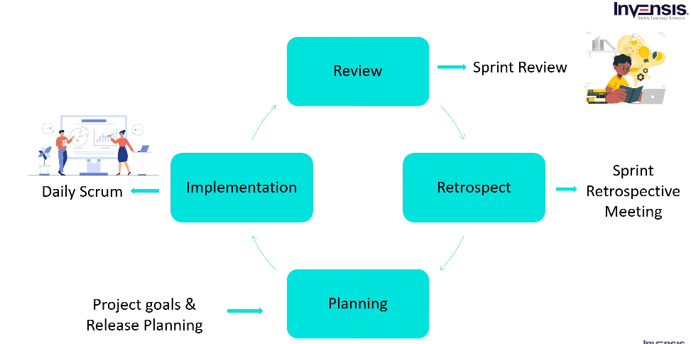

What is Sprint Cycle?

A release cycle refers to the process and timeline followed by a software development team to plan, develop, test, and release a new version of their software or product. It encompasses the stages and activities involved in bringing a software product from conception to deployment.

-------------------------------------------------------------------------------------------------------------------------------

<https://www.youtube.com/watch?v=de6qHLe37EQ&t=29s> – Sprint Retrospective