Assignment 11.1

1. Write a Hive program to find the number of medals won by each country in

swimming.

1.Create a table and load the data into it.

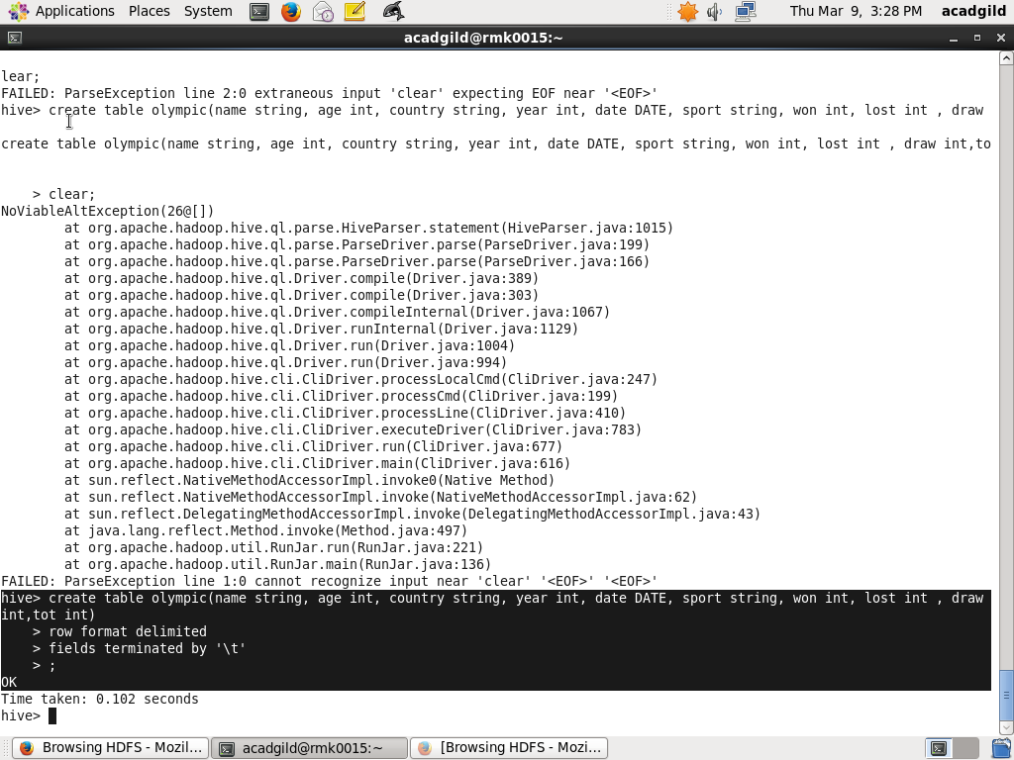

2.Write the query to find

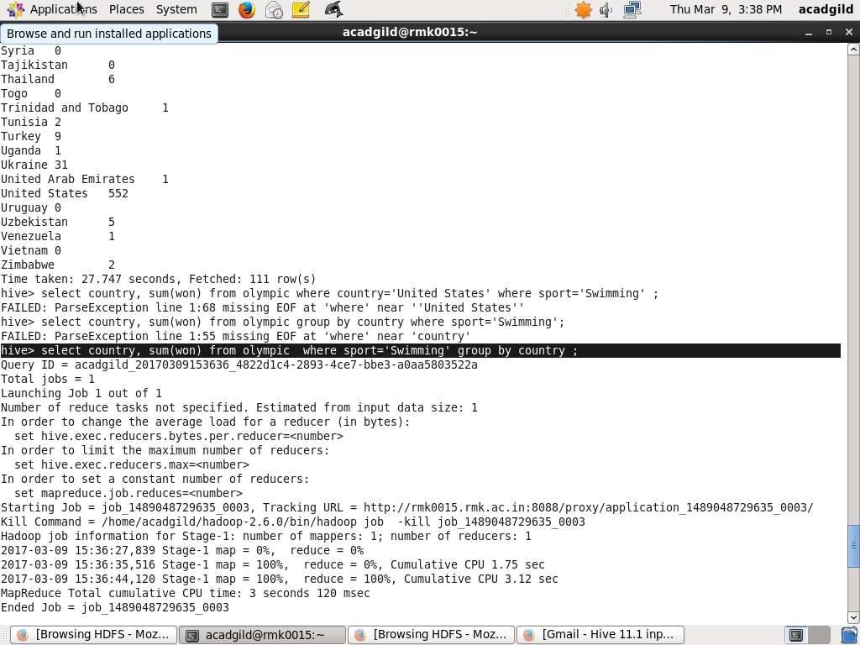

3.The OUTPUT is

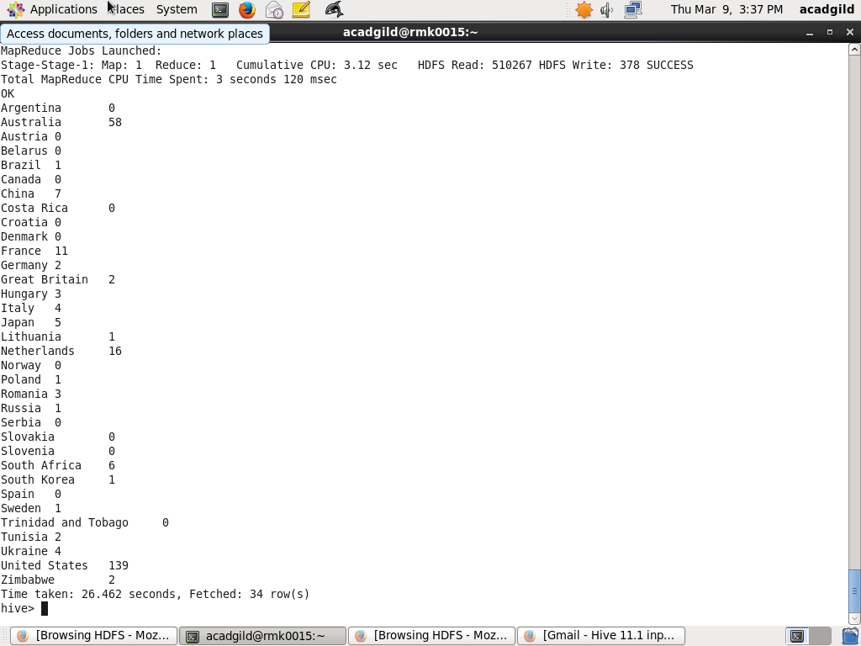

2. Write a Hive program to find the number of medals that India won year wise.

1.Write and execute the query

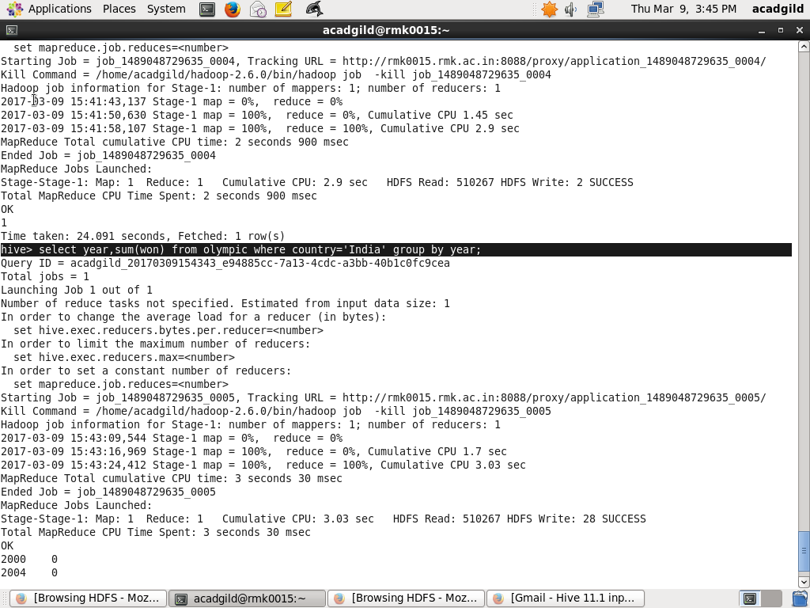

2.The OUTPUT is

