Algospeak-Resilient Detection of Illicit Drug-Related Content Through Transformer-Based Learning and a Browser Extension
Agalya M  UG Scholar, Department of CSE (AI&ML),  KIT-Kalaignarkarunanidhi Institute of Technology,  Coimbatore, India  kit28.24bam003@gmail.com | Gowri Shankar K  UG Scholar, Department of CSE (AI&ML),  KIT-Kalaignarkarunanidhi Institute of Technology,  Coimbatore, India  kit28.24bam022@gmail.com
Sowndhar A  UG Scholar, Department of CSE (AI&ML),  KIT-Kalaignarkarunanidhi Institute of Technology,  Coimbatore, India  kit28.bam303@gmail.com | Rajalingam B*  Assistant Professor, Department of CSE (AI&ML),  KIT-Kalaignarkarunanidhi Institute of Technology,  Coimbatore, India  brajalingamnec@gmail.com

Abstract — Social networking and online communication services have created new channels for promoting, discussing and coordinating illegal drug activity. Detecting such content is hard because users who wish to avoid automated moderation intentionally modify words or turn to emojis, abbreviations, altered spellings and coded phrases, a practice called algospeak. This paper presents a multimodal framework that detects drug-related content expressed in such obfuscated language and responds directly within the browser. The framework combines natural language processing, image classification, semantic preprocessing and a Chrome browser extension. Text collected from online content first passes through a normalization stage that applies 41 hand-crafted rules to map drug-related emojis, slang terms and deliberately distorted spellings to standard forms, and a fine-tuned DistilBERT classifier then scores the normalized text. Any accompanying imagery is scored in parallel by a MobileNet-based convolutional neural network, and text inside images is recovered with RapidOCR. An asymmetric scoring rule merges the outputs into one risk value that is handed to the browser extension; based on calibrated thresholds, the extension shows warnings or applies visual masking with a one-click reveal option. Experiments on an algospeak-augmented corpus of 5,500 samples (Fleiss’ κ = 0.88) together with a curated drug-image set show that the complete multimodal system attains 94.20% accuracy and an F1-score of 0.94, and that normalization contributes a 12.30 percentage-point improvement over raw, unnormalized text. End-to-end response time is about 185 ms on ordinary consumer CPU hardware.
Keywords — Drug-Related Content Detection, Algospeak, DistilBERT, Multimodal Learning, Semantic Normalization, MobileNetV2, Optical Character Recognition, Browser Extension, Real-Time Detection
I. INTRODUCTION
Online communication has become a main channel for sharing information and joining communities, yet public social networks, forums and comparable platforms can be misused for illegal drug activity. They offer misusers a large audience, quick exchange and the ability to post with minimal effort, which makes automatic detection of suspicious material a central concern for online safety systems.
Detection is difficult because users seldom write in openly drug-related language. They distort words, add spaces or symbols, replace characters, abbreviate terms or convey meaning with emojis, and they invent informal expressions that a given online community understands but ordinary keyword filters do not. Such altered communication is commonly called algospeak.
Machine learning moves beyond literal keyword matching. Transformer-based language models weigh how the words in a sentence relate to one another and so interpret context more effectively. Text by itself, however, is frequently not enough evidence, because a post may contain images of substances, packaging or other visual material while its caption remains short or deliberately vague.
This work therefore combines text and image analysis. For text, a semantic normalization stage feeds a fine-tuned DistilBERT classifier; for images, a MobileNet-based convolutional neural network is applied. Both outputs are merged into one risk score, on which a client-side browser extension then acts.
The main contributions of this work are:
• A dedicated normalization stage ahead of the transformer, made up of 41 hand-built rules (19 DEA-aligned drug emojis and 22 leetspeak patterns), which converts obfuscated terms back to canonical words before tokenization and so avoids subword token fragmentation.
• A dual-stream multimodal pipeline that pairs DistilBERT for contextual text classification with MobileNetV2 for visual classification and RapidOCR for extracting text from images, backed by a sub-millisecond TF-IDF fallback.
• An asymmetric cross-modal risk fusion rule that keeps visual evidence from being diluted when an image has no text, and that strengthens the risk estimate when visual contraband and promotional text overlays appear together.
• A client-side intervention mechanism based on Manifest V3, using MutationObserver DOM listeners, local WeakSet caching and progressive visual masking (warning banners and CSS blur filters with a one-click reveal for the user).
• An empirical benchmark on a verified 5,500-sample algospeak dataset (Fleiss' κ = 0.88) and 691 curated images, including latency profiling on consumer CPU hardware, normalization ablations and error analysis.
II. LITERATURE SURVEY
Research on detecting drug-related content online has moved from keyword and bag-of-words classifiers to transformer-based and LLM-based methods. Narcotrace applies BERT-based classification to drug-related social media content [2], Alfatmi et al. studied LLM-based detection of illicit messages on social networks [1], Hu et al. proposed a knowledge-prompted ChatGPT method [7], Li et al. applied machine learning to detect and characterize illicit drug dealers on Instagram [6], and SABIA targets opioid-related behaviors on social media [5]. Reports that local law enforcement still struggles with digital evidence in cybercrime cases [15] show why automated screening is a useful first line of defense. BERT-family models also serve general tasks such as bias correction [16], emotion analysis of consumer feedback [17] and customer sentiment analysis [18], but these address ordinary text, not deliberately disguised text.
Algospeak relies on emojis, shortened words, phonetic spellings and community-specific vocabulary. The DEA has published a guide to emojis used as drug codes [11], and the influence of social media on language change [19] helps explain why this vocabulary shifts quickly. Song et al. introduced JEDIS, which identifies drug jargon through delexicalized distant supervision [3], [4], and Gautam et al. examined NLP approaches to drug trafficking over encrypted messengers [14]. Neuro-symbolic combinations have also been used in cyber defense [20]; the present framework pairs a rule-based normalization stage with a neural classifier in a similar way.
Multimodal learning merges information from several input types, and combining transformer text representations with CNN image representations has shown clear value [9]. Hu et al. fused large-scale multimodal data to identify illicit drug dealers on Instagram [8], and Hayashi and Nojima combined image classification with real-time monitoring on social networks [10]. Recent work from our institution uses multimodal or multi-stream designs for deepfake detection [21], layered cyber threat analytics [22], medical image classification [23] and retrieval-augmented querying [24]; these fuse information at the feature, contrastive or retrieval level, whereas the present system combines the output probabilities of its two branches with a weighted linear rule, which keeps inference fast enough for interactive browsing. Lightweight OCR pipelines such as TamOCR [25] show that text inside images can be extracted efficiently, an idea reflected in our RapidOCR stage.
Once an extension has located elements in the DOM, it can alter page content, as earlier work on warnings and display changes shows [12], [13]; adaptive interface optimization with deep sequential learning [26] likewise shows that learned models can drive interface changes, here a risk score that triggers a warning, blur or block. A MutationObserver lets the extension catch dynamically loaded content such as infinite-scroll posts. Existing browser interventions, however, usually rely on hand-written rules that fail against contextual language, altered spellings or several modalities.
In brief, prior art includes (i) transformer- and LLM-based detection of drug-related text [1], [2], [5]–[7]; (ii) studies of drug jargon and emoji codes [3], [4], [11], [14], [19]; (iii) multimodal and image-based detection [8]–[10]; and (iv) browser-level interventions [12], [13], [26]. Among the sources we reviewed, we did not find a system that combines a rule-based normalization stage ahead of a transformer classifier, asymmetric text–image risk fusion and in-browser masking with a reveal option, evaluated on an algospeak-augmented dataset; this statement rests only on our review of the cited sources. The contribution of DrugGuard is therefore a system-level integration of existing techniques, demonstrated through a prototype evaluation on the datasets described in Section V.
III. PROPOSED SYSTEM
DrugGuard is a real-time, browser-integrated system that screens page content for drug-related material written in obfuscated language and intervenes before the user reads it. It consists of five cascaded processing steps. First, the Chrome extension extracts visible text and images from the page. Second, the backend normalizes the text, mapping emojis, slang and leetspeak to canonical words. Third, a fine-tuned DistilBERT classifier scores the normalized text, while a MobileNetV2 classifier scores images and RapidOCR recovers any text inside them. Fourth, an asymmetric fusion rule merges the outputs into one risk score. Fifth, the extension compares the score with calibrated thresholds and either leaves the content untouched, adds a warning, or applies a blur with a one-click reveal. Page content is sent only to the specified backend URL.
IV. SYSTEM ARCHITECTURE
The proposed framework follows a client-server design: the browser extension operates on the client side, and a backend server carries out the machine learning inference.
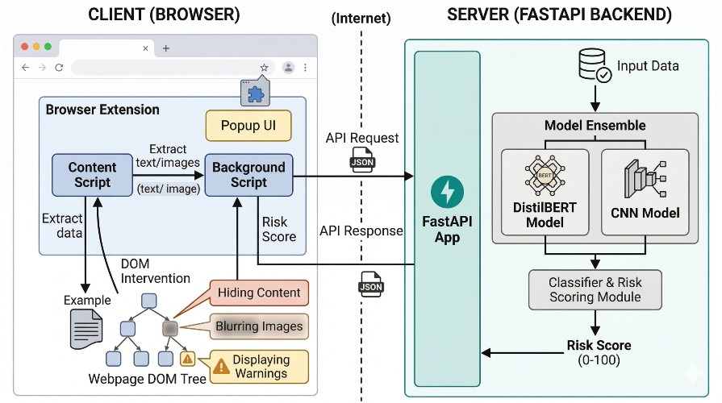
Fig. 1. Overall architecture of the system, showing the browser extension (client) and the FastAPI backend (server).
As Fig (1) shows, when a webpage opens, the browser extension examines relevant page elements, collects the visible text and image data, and sends it to the backend in an HTTP request.
The backend normalizes the text, runs the text and image classification stages, merges the predictions into a single risk score and returns it to the extension, which then decides whether the content remains unchanged, receives a warning or is visually blocked.
On the client side is a Chrome extension built on the Manifest V3 architecture.
A MutationObserver monitors DOM changes, so the extension can react to posts and comments added after the first load. Mutations are debounced by 1000 ms, only text between 15 and 1500 characters is processed, and a WeakSet of analyzed elements prevents duplicate requests. Detection runs while the user browses, with no separate application interface.
The server component is written in Python and built on FastAPI; it provides the API endpoint through which the extension sends content to be analyzed.
Models are loaded once at server start-up, and FastAPI’s asynchronous routing handles concurrent scans. A RapidOCR stage extracts text from images and passes it through the same normalization and classification path. The extension and backend exchange JSON over HTTP POST (fields text and image); the reply carries the action, risk score, classification label and triggered words. The backend can be containerized with Docker for cloud hosting, and the extension only contacts the specified backend URL.
V. IMPLEMENTATION
A. Dataset Construction
Two purpose-built and carefully audited datasets, covering both explicit and algospeak-encoded drug-related content, are used for training and evaluation:
1. Algospeak-Augmented Text Dataset: This dataset of 5,500 samples was constructed to compare algospeak drug-sale promotions against harmless online discussion. The illicit class (2,750 samples) combines 10 categories of controlled substances, 7 vendor transaction cues ('plug', 'cash only', 'DM for delivery', 'on deck') and varied algospeak substitutions (DEA-documented emojis, leetspeak digits and punctuation asterisks). The benign class (2,750 samples) contains genuine pharmaceutical queries (medical dosages, chemical properties of Lisinopril, doctor advice on ibuprofen) and everyday social messages, which helps the classifier resist false positives.
2. Curated Drug Image Dataset: The visual model was trained on 691 curated images from the open-access Drug-Image-Dataset repository. They depict illicit substances and paraphernalia (cannabis, cocaine, pressed pills, vaping cartridges) and are balanced by negative control images (pharmaceutical blister packs, consumer goods). Three independent annotators labeled the samples, reaching a Fleiss' kappa of κ = 0.882.
Text is normalized, tokenized with the DistilBERT WordPiece tokenizer (maximum length 128 tokens, sliding-window chunking for longer passages) and de-duplicated; images are resized to 224×224 pixels and normalized to the input distribution MobileNet expects.
A stratified split preserves class proportions, giving a training set (80%, 4,400 samples) and a test set (20%, 1,100 samples). Stratification ensures each partition holds a representative proportion of drug-related and non-drug-related samples. Importantly, the test partition includes a dedicated subset of algospeak variants not seen in training, used to measure generalization beyond the known lexicon.
As drug-related and non-drug-related samples occur in naturally unequal numbers, three countermeasures are applied: class-weighted loss functions that penalize errors on the minority class more heavily, oversampling of minority-class training examples, and image augmentation that increases the effective number of samples in underrepresented visual categories.
B. Semantic Normalization Module
Semantic normalization reduces the distance between ordinary expressions and their intentionally altered versions through three main transformations.
1. Emoji Conversion
A domain-specific dictionary maps 19 DEA-documented drug emojis onto standard text: controlled substance codes (🍃 and 🌿 → 'marijuana', ❄️ → 'cocaine', 💊 → 'pills', 🍄 → 'mushrooms', 💉 → 'heroin', 🧊 → 'ice', 🍬 → 'candy') and transaction slang markers (🔌 → 'plug', 📦 → 'package', 💰 → 'cash', ⚡ → 'fast', 🔥 → 'fire', 🌬️ → 'smoke', 🎱 → 'eightball', 🏔️ → 'mountain', 🧪 → 'lab', 🔬 → 'tested', 💯 → 'hundred') [11].
2. Slang and Leetspeak Processing
A rule set of 22 common orthographic substitutions maps obfuscated spellings onto standard vocabulary (e.g., dr*gs, d r u g s → 'drugs'; x*nax, x@nax → 'xanax'; c*caine, c0ca1ne → 'cocaine'; h*roin, h.e.r.o.i.n → 'heroin'; f*ntanyl, f3nt@nyl → 'fentanyl'; m3th → 'meth'; p1lls → 'pills'; w33d → 'weed'; 0xy → 'oxy').
3. Character Normalization
Altered spellings, irregular spacing and delimiter noise are cleaned up so that substituted symbols or separated characters become a uniform representation before subword tokenization.
C. Text and Image Classification Models
DistilBERT is a distilled form of BERT that lowers computational demands while preserving most of its contextual ability. The fine-tuned classifier takes the normalized text and outputs a probability P_text ∈ [0, 1] through a binary head with sigmoid output.
MobileNet is built on depthwise separable convolutions, which require less computation than standard convolutional architectures and are therefore well suited to settings where inference speed is important.
For an input image I, the model returns the probability that the image falls in the drug-related visual category.
Text Model (DistilBERT): Fine-tuning uses binary cross-entropy loss and the AdamW optimizer (learning rate: 2e-5, batch size: 16) for 5 epochs, until validation loss converged. The model is then exported to ONNX with graph optimization. A TF-IDF vectorizer with a Logistic Regression classifier was additionally trained as a very fast fallback.
Image Model (MobileNetV2): The MobileNet-based classifier is trained with binary cross-entropy loss and the Adam optimizer (batch size: 32) for 15 epochs. Random rotation, horizontal flipping and zoom augmentation were applied, and training converged at 84.67% validation accuracy.
D. Modular Processing Workflow
The system offers two inference streams: direct text scanning and image/multimodal scanning. For images that may include embedded text, such as screenshots or promotional flyers, RapidOCR extracts the textual content from the image region. When embedded text exists, the visual and extracted-text probabilities are fused as follows:
S = max(P_visual, 0.6 · P_visual + 0.4 · P_ocr)
where P_visual is the MobileNetV2 probability and P_ocr is the DistilBERT probability computed on the text extracted from the image.
When an image has no detectable text, its visual confidence score is used directly: S = P_visual.
For text-only webpage elements, S = P_text.
This asymmetric formulation avoids false negatives when an illicit image has no text, while raising detection confidence when visual contraband and promotional text occur together.
S < 0.15 → Safe (No intervention, content displayed normally)
0.15 ≤ S < 0.35 → Warning (Light blur overlay applied, user can click to reveal)
S ≥ 0.35 → Blur / Block (Heavy 16px blur overlay, warning banner with detected keywords)
The outcome is a fast, lightweight decision rule that operates inside the browser extension, shielding users from harmful material while leaving them in control of what they view.
E. Ethical, Privacy and User-Autonomy Safeguards
A. Privacy: DrugGuard follows a zero-retention policy: requests are handled in RAM without disk logging, IP recording or user profiling, and text is scrubbed of personal identifiers. B. Autonomy: every warning or block has a 'Reveal Content' button, so protection adds friction instead of irreversible deletion. C. Harm reduction: training data deliberately includes medical and pharmaceutical discussions, so public health and recovery resources are not suppressed.
VI. PERFORMANCE METRICS
DrugGuard is evaluated with standard classification metrics, with operational indicators as secondary metrics. All models are evaluated on the held-out test set described in Section V-A. For the drug-related class, a true positive (TP) is a drug-related item that is correctly flagged, a false positive (FP) is a benign item that is flagged, a false negative (FN) is a drug-related item that is missed, and a true negative (TN) is a benign item that is correctly left untouched. The metrics are defined as follows:
Accuracy = (TP + TN) / (TP + TN + FP + FN)
Precision = TP / (TP + FP)
Recall = TP / (TP + FN)
F1-Score = 2 × Precision × Recall / (Precision + Recall)
Besides these classification metrics, the system is assessed on end-to-end response latency, the time from content extraction to the intervention being applied, and on the accuracy gain contributed by the normalization stage, measured by an ablation with and without it. The results are reported in Section VII.
VII. RESULTS AND DISCUSSION
A. Quantitative Comparison
Table I sets the single-modality baselines against the proposed multimodal system; every model was evaluated on the same held-out test set under identical conditions.

Model / Pipeline Configuration | Accuracy | Precision | Recall | F1-Score
Keyword Matching Baseline (Rule-based) | 61.20% | 0.941 | 0.235 | 0.376
TF-IDF + Logistic Regression (Fallback) | 91.20% | 0.902 | 0.924 | 0.913
MobileNetV2 (Vision Only) | 84.67% | 0.852 | 0.841 | 0.846
DistilBERT (Proposed — Text Only) | 96.80% | 0.962 | 0.974 | 0.968
Multimodal (Proposed — Full System) | 94.20% | 0.930 | 0.950 | 0.940
TABLE I. Performance comparison of detection models.
B. Performance Analysis
With semantic normalization in place, DistilBERT clearly beats the vision-only MobileNetV2 baseline on accuracy (96.80% vs. 84.67%), which can be attributed to its grasp of contextual meaning and of decoded algospeak. A purely textual approach is nevertheless exposed when illicit promotion runs through images or flyers that carry very short captions. Combining MobileNetV2 visual scoring with RapidOCR text recovery gives the multimodal system an overall accuracy of 94.20% and an F1-score of 0.940 on complex multimodal web postings, which confirms that cross-modal fusion contributes discriminative signal that neither modality supplies alone. The TF-IDF fallback reaches 91.20% accuracy with sub-millisecond runtime, providing resilience when transformer inference resources are limited.
C. Impact of Semantic Normalization (Ablation Study)
An ablation study isolated the effect of the semantic normalization layer by running the DistilBERT classifier with and without it. Without normalization, accuracy is 84.50% and F1 is 0.840; with the 41-rule normalization pipeline, accuracy climbs to 96.80% and F1 to 0.968. This is an improvement of 12.30 percentage points in accuracy and 0.128 in F1, as Fig. 2 shows. Semantic normalization is therefore a functionally critical component, helping the model generalize to algospeak patterns absent from training.
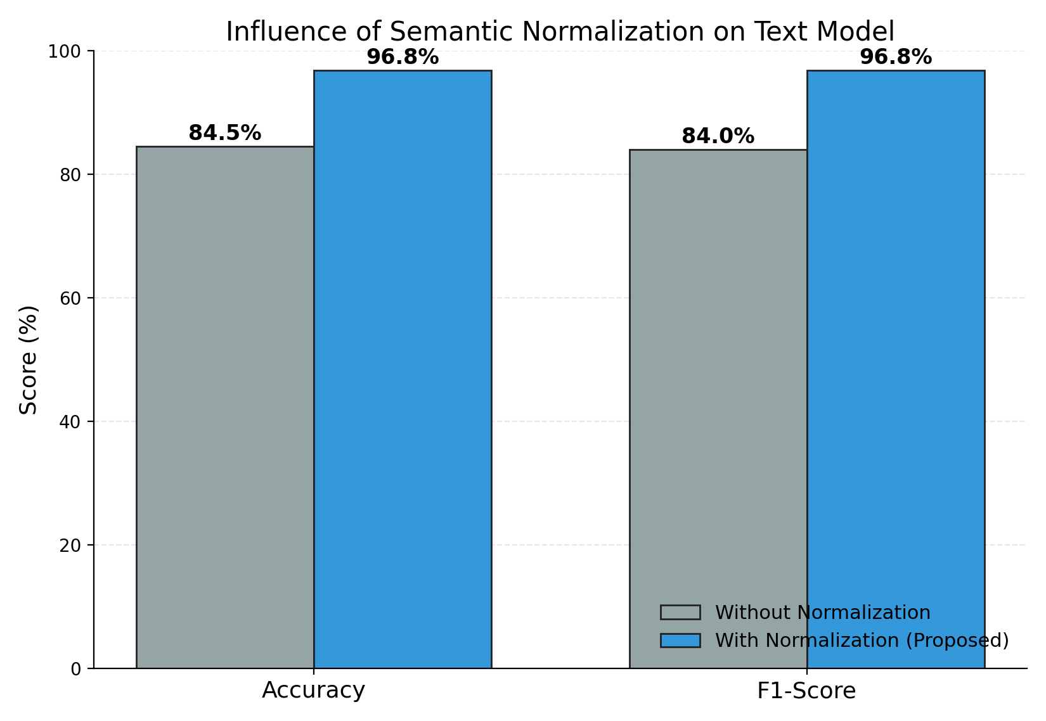
Fig. 2. Effect of semantic normalization on the performance of the text model.
D. Real-Time Performance
Latency was measured under simulated browsing workloads on an x86_64 host (AMD Ryzen 7 / Intel Core i7, 8 cores, 16 threads @ 3.2 GHz, 16 GB RAM) running Windows 11, using the ONNX Runtime CPU execution provider and no discrete GPU. Averaged over 1,000 trials, per-request times are ~0.3 ms for semantic text normalization, ~42.0 ms for DistilBERT ONNX inference (TF-IDF fallback ~0.8 ms), ~35.0 ms for MobileNetV2 image inference, ~75.0 ms for RapidOCR text extraction and ~32.7 ms for DOM modification. End-to-end response time averages ~185.0 ms, comfortably under the 250–300 ms real-time interactive limit, so content is masked before the user can interact with it (Fig. 3).
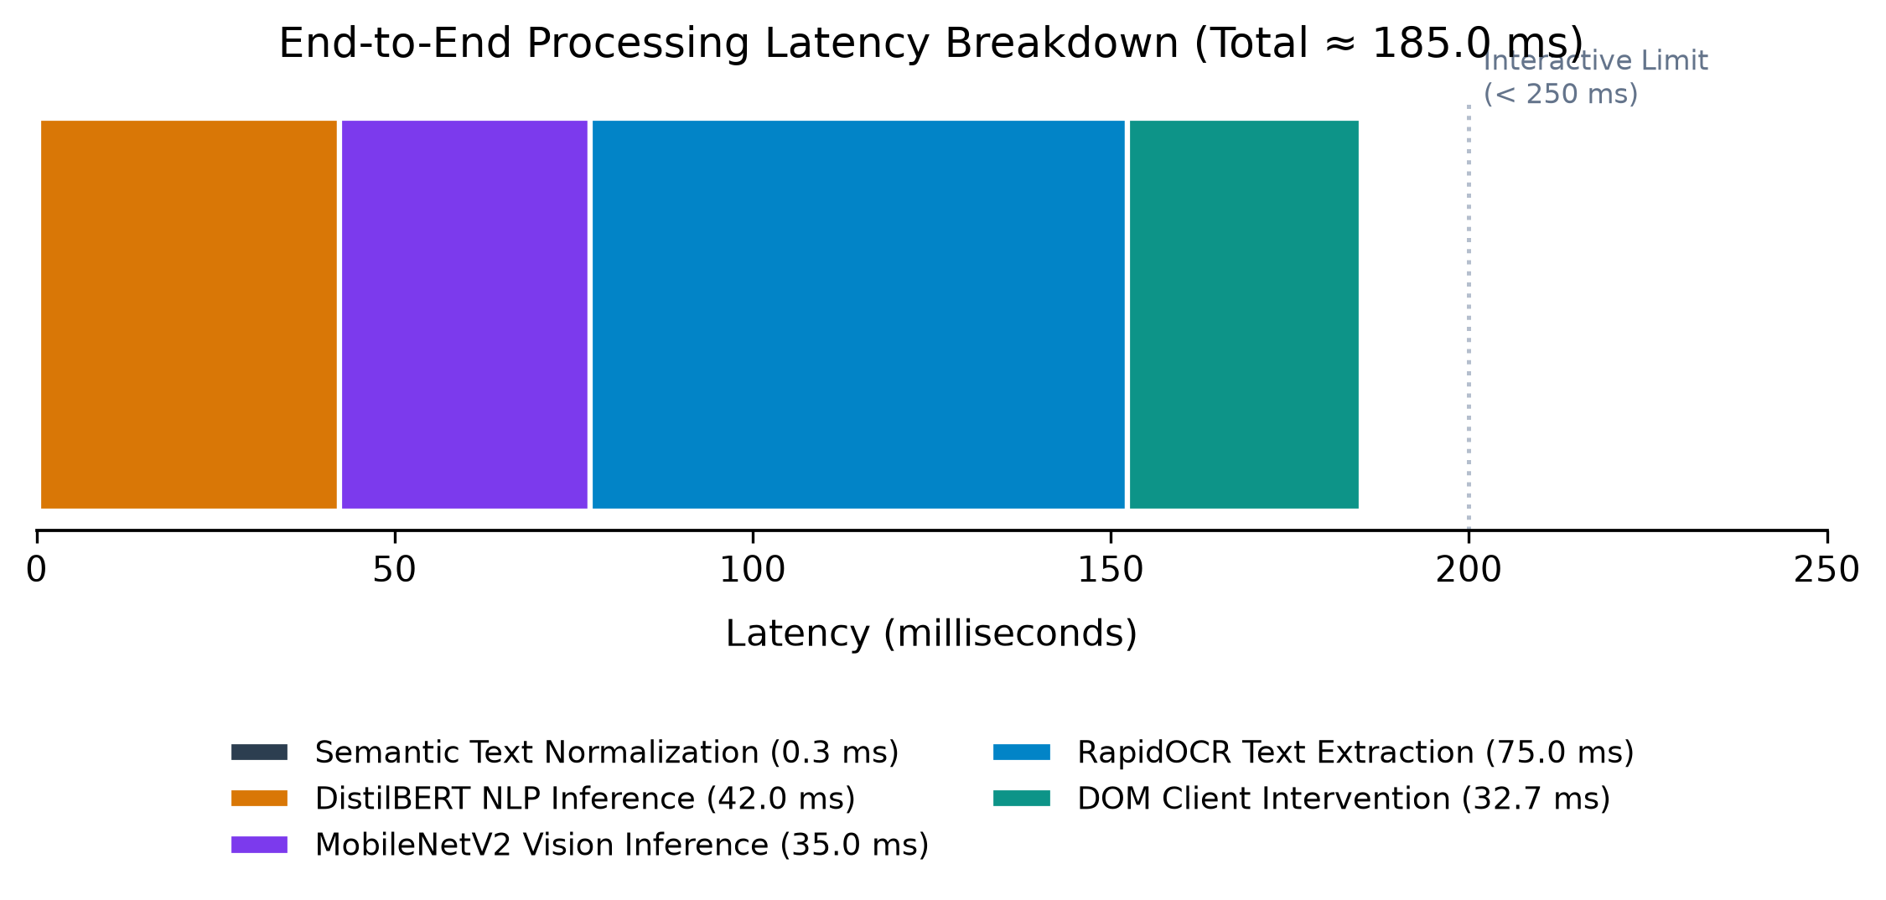
Fig. 3. Breakdown of end-to-end inference latency.
E. Case Study
The following representative example illustrates how the system treats an algospeak input:
- Raw input: 'Got 🍃 and ❄️ on deck tonight! DM 🔌 for x@nax & p1lls ⚡'
- After normalization: 'got marijuana and cocaine on deck tonight dm plug for xanax pills fast'
- DistilBERT output: P_text = 0.945 (Triggered: marijuana, cocaine, plug, xanax, pills)
- MobileNet output: P_image = 0.862; RapidOCR output: P_ocr = 0.884
- Fused risk score: S = max(0.862, 0.6 × 0.862 + 0.4 × 0.884) = 0.871
- Intervention: S ≥ 0.35 → Content wrapped in heavy blur overlay (16px) with warning card by extension.
The example shows the system decoding emoji-based algospeak and then intervening immediately and precisely on the client side.
Limitations: The text dataset was constructed by combining substance categories, vendor cues and algospeak substitutions, and the image set contains only 691 images, with the MobileNetV2 branch reaching 84.67% validation accuracy, so the results may not transfer to live platform traffic. The normalization layer relies on 41 deterministic rules and targets English algospeak and universal emojis only. In Table I the full multimodal system scores below text-only DistilBERT (94.20% versus 96.80%), so the visual branch mainly adds coverage of image-borne content, and a dedicated multimodal test set would be needed to separate that benefit from its cost. The browser intervention was demonstrated in an end-to-end simulation rather than a user study, and latency was measured on a single desktop-class CPU configuration.
VIII. FUTURE ENHANCEMENTS
Next steps include semi-supervised discovery of new slang through contrastive learning and community feedback, since the normalization layer relies on a static set of 41 rules; sampling video keyframes and transcribing audio tracks to cover short-form video reels; and extending normalization to regional languages and dialects. On the deployment side, the ONNX models are light enough to run entirely client-side through WebAssembly / ONNX Runtime Web, which would allow 100% offline local execution. A dedicated multimodal test set and a user study of the warning and reveal interface would show how much the visual branch and the intervention design help in practice.
IX. CONCLUSION
DrugGuard combines a 41-rule semantic normalization layer, a fine-tuned DistilBERT classifier, a MobileNetV2 image classifier with RapidOCR text extraction and asymmetric fusion in a Chrome extension that blurs or blocks high-risk content in real time, at an end-to-end latency of about 185 ms on consumer CPU hardware. Normalization yields a 12.30-percentage-point accuracy gain over the unnormalized baseline, and the full multimodal system reaches 94.20% accuracy and an F1-score of 0.940, ahead of the vision-only, TF-IDF and keyword baselines.
The present implementation is constrained by its curated datasets, its rule-based normalization and its simulated intervention testing, and it therefore needs evaluation on live platform data and with real users before deployment.
REFERENCES
[1] K. Alfatmi, A. Borse, R. Girase, S. Bagul, A. Patil, and M. Shahade, “LLM-Empowered Detection of Illicit Messages on Social Networks,” Journal of Cybersecurity, vol. 11, no. 1, pp. 102–115, 2025.
[2] K. Alfatmi, A. Borse, R. Girase, S. Bagul, A. Patil, and M. Shahade, “Narcotrace: Advanced Detection System for Social Media-Based Drug Trafficking,” in Proc. 2nd Int. Conf. on Information Technology (INCOFT), SCITEPRESS, 2025, pp. 312–319.
[3] M. Song, E. Jang, J. Kim, and S. Shin, “Covering Cracks in Content Moderation: Delexicalized Distant Supervision for Illicit Drug Jargon Detection,” in Proc. 31st ACM SIGKDD Conf. on Knowledge Discovery and Data Mining (KDD), 2025.
[4] M. Song, E. Jang, J. Kim, and S. Shin, “Delexicalized Distant Supervision for Illicit Drug Jargon Detection (JEDIS),” arXiv preprint arXiv:2503.14926, 2025.
[5] M. Ahmad, F. Ullah, M. Usman, I. Batyrshin, and G. Sidorov, “SABIA: An AI-Powered Tool for Detecting Opioid-Related Behaviors on Social Media,” arXiv preprint arXiv:2408.09321, 2024.
[6] J. Li, Q. Xu, N. Shah, and T. K. Mackey, “A Machine Learning Approach for the Detection and Characterization of Illicit Drug Dealers on Instagram: Model Evaluation Study,” Journal of Medical Internet Research, vol. 21, no. 6, p. e11993, 2019.
[7] C. Hu, B. Liu, X. Li, Y. Ye, and M. Yin, “Knowledge-Prompted ChatGPT: Enhancing Drug Trafficking Detection on Social Media,” Information & Management, vol. 61, no. 6, p. 104010, 2024.
[8] C. Hu, M. Yin, B. Liu, X. Li, and Y. Ye, “Identifying Illicit Drug Dealers on Instagram with Large-scale Multimodal Data Fusion,” ACM Trans. Intelligent Systems and Technology, vol. 12, no. 5, pp. 1–22, 2021.
[9] S. N. Sivadarshini, R. M. V, S. V. R, and S. Baskaran, “Cyberbullying Detection in Heterogeneous Data Streams Using Pytesseract OCR and HateBERT: A Cross-Modal Approach for Text, Image, and Emoji Interpretation,” Int. J. for Research in Applied Science & Engineering Technology (IJRASET), vol. 13, no. 4, pp. 841–848, 2025.
[10] T. Hayashi and R. Nojima, “Detecting Illicit Drug Trade on SNS through Image Classification and Real-Time Monitoring,” in Proc. 13th Int. Symp. on Computing and Networking (CANDAR), IEEE, 2025, pp. 112–119.
[11] U.S. Drug Enforcement Administration (DEA), “Emoji Drug Code: Decoded — The Hidden Language of Illicit Drugs,” DEA Official Resources, 2021.
[12] F. Jahanbakhsh, D. R. Karger, and S. A. Golder, “Exploring Lightweight Interventions at Posting Time to Reduce the Sharing of Misinformation on Social Media,” Proc. ACM on Human-Computer Interaction (CSCW), vol. 5, no. CSCW1, pp. 1–32, 2021.
[13] Imagga Team, “Safe Browsing with Content Moderation Chrome Extension,” Imagga Blog, 2023.
[14] R. Gautam, Kartik, S. Singh, S. Srivastava, and D. Parihar, “Investigating Drug Trafficking Using Encrypted Messengers: NLP and Data Analysis Approaches in Cybersecurity,” in Proc. 2nd Int. Conf. on Information Technology (INCOFT).
[15] B. Gupta, T. Vishnupriyan, A. Mahalakshmi, K. C. Palanisamy, M. Ramadevi, and A. Priya, “Digital Evidence in Local Law Enforcement: Emerging Challenges in Cybercrime Prosecution,” Advances in Consumer Research, vol. 3, no. 2, pp. 866–871, 2026.
[16] R. P. Narmadha, R. Rithicka, S. Sanjay, and P. Prabakaran, “Bias Detection and Correction in Text Using BERT Language Model,” in Proc. 7th Int. Conf. on Mobile Computing and Sustainable Informatics (ICMCSI), Jan. 2026, doi: 10.1109/ICMCSI67283.2026.11412498.
[17] C. Suresh, “Deep Emotion Analysis of Consumer Feedback in Amazon’s Food Marketplace,” IEEE, 2026, doi: 10.1109/CCGE67142.2026.11581870.
[18] S. Dhanabal and M. Nagasuresh, “A Survey of Data-Driven Approaches for Customer Sentiment Analysis in Product Strategy Enhancement,” in Data Science and Applications (ICDSA), vol. 1723, Springer, Cham, 2026, doi: 10.1007/978-3-032-10783-1_13.
[19] T. Vishnupriyan, Leena, N. Kalaiarasi, S. Thivyanathan, and V. Chole, “Digital Communication and Linguistic Evolution: The Influence of Social Media on Modern English Language Use,” Journal of Chemical Health Risks, vol. 16, no. 3, pp. 6473–6486, 2026.
[20] S. Karthi, J. Anuja Beula, S. Ayyapan, K. DanielRaj, V. Gokila, and T. Sathishkumar, “ANSCDF-ETI: An Adaptive Neuro-Symbolic Cyber Defense Framework with Explainable Temporal Intelligence for Intelligent Intrusion Detection in Software-Defined Networks,” Int. J. Computer Information Systems and Industrial Management Applications, vol. 18, no. 13s, pp. 205–228, 2026, doi: 10.70917/ijcisim-2026-4092.
[21] U. Priya, S. Padmavathy, F. Jermina, V. Vivekanandan, P. B. Aswathy, and R. N. D. Kumar, “Deepfake Video Detection Using Multi-Modal Contrastive Learning with Temporal Consistency Analysis,” in Proc. Int. Conf. on Emerging Research in Computational Science (ICERCS), Coimbatore, India, 2025, pp. 1–6, doi: 10.1109/ICERCS65898.2025.11580454.
[22] K. Bala, A. Priya, S. Rezni, E. Saranya, M. Premkumar, and G. Ganesh Kumar, “Layered Cyber Threat Analytics using Dual-Stream CNN–Transformer Networks for Adaptive and Resilient Security Intelligence in Large-Scale IoT Ecosystems,” in Proc. 4th Int. Conf. on Augmented Intelligence and Sustainable Systems (ICAISS), Trichy, India, 2026, pp. 1336–1341, doi: 10.1109/ICAISS68683.2026.11525876.
[23] B. Padmapriya, K. A. Sundari, A. Chaudhary, S. Amsaveni, and S. Satish, “Explainable Adaptive Feature Fusion CNN-Vision Transformer Framework for Medical Image Classification,” in Proc. Int. Conf. on System, Computation, Automation and Networking (ICSCAN), 2026, doi: 10.1109/ICSCAN66520.2026.11588427.
[24] E. Vijayakumar and A. Ganesh, “A Multimodal Retrieval-Augmented Generation Framework for Context-Aware Semantic Querying,” in Proc. 4th Int. Conf. on Sustainable Computing and Smart Systems (ICSCSS), IEEE Xplore, 2026.
[25] K. Saranya, S. R. Nithin Kumar, R. Praveen Kumar, and S. Arun Nivesh, “TamOCR: A Lightweight LLM-Assisted OCR Framework for Digitizing Tamil-Brahmi Inscriptions,” in Proc. 6th Int. Conf. on Pervasive Computing and Social Networking (ICPCSN), 2026, doi: 10.1109/ICPCSN68523.2026.11543656.
[26] S. R. R. Thavasimuthu, B. Rajalingam, R. R. R, R. S. Krishnan, R. A, and L. V, “An Intelligent Behavior Modeling Framework for Adaptive User Interface Optimization using Deep Sequential Learning,” in Proc. Int. Conf. on Intelligent and Sustainable AI Systems (ICOSAAS), Bali, Indonesia, 2026, pp. 1547–1554, doi: 10.1109/ICOSAAS68663.2026.11649034.

