

**PROJECT NAME: PERSONAL BLOG USING IBM CLOUD STATIC WEB APPS**

**PHASE 3 : DEVELOPMENT PART 1**

## PROJECT MEMBERS :

NAME REGISTER NO

ANNE AKSHAYA R 210621205003

GOWSIKA R 210621205017

SOWNDHARYA K 210621205049

SRUTHIKA N 210621205050

VIJAYALAKSHMI J 210621205055

**INDEX**

# 1. Project Objective------------------------------------------------ 03

# 2. recap of our pre works in phases---------------------- 03

## 3. phase 3 : development –part 1----------------------------- 03

## 4. Data sets------------------------------------------------------------- 04

## 5. coding------------------------------------------------------------------- 09

## 6. output------------------------------------------------------------------- 15

PERSONAL BLOG USING IBM CLOUD STATIC WEB APPS

## Project Objective:

Our goal is creating a personal travel blog hosted on IBM Cloud Static Web Apps to share travel adventures, tips, and captivating photos.

## recap of our pre works in phases:

In Phase 1, we established the problem statement and outlined the design thinking concept for our personal travel blog project. We identified the need for an easily updatable blog hosted on IBM Cloud Static Web Apps to document travel experiences and inspire others to explore the beauty of the world.

In Phase 2 we include ideas to enhance user engagement and interaction by integrating key features such as social media sharing buttons, interactive maps, and comment sections.

## phase 3 : development - part 1 :

Now In Phase 3 we started designing and developing the static travel blog website using HTML and CSS & Creating engaging content with captivating photos and travel stories.also in this phase we are providing our data sets , coding of our travel blog website & also our ouput of our initial development pages.

## Data sets:

**Coimbatore**

1. Arulmigu Koniamman Temple, Coimbatore: The Koniamman Temple is revered as the guardian deity of Coimbatore, with special prayers conducted on Fridays and Sundays. The annual chariot festival in the third week of Masi draws devotees from both the local area and beyond.
2. The objective of Phase 2 is to enhance user engagement and interaction by integrating key features such as social media sharing buttons, interactive maps, and comment sections.
3. Ranganathaswamy Temple, Karamadai: Situated on the route from Coimbatore to Mettupalayam, the KaramadaiRanganatha Temple boasts an ancient and exquisite lingam. It was established by the Vijayanagara kings.
4. Anamalai Wildlife Sanctuary and Anaimalai Tiger Reserve: TheAnaimalai Wildlife Sanctuary near Pollachi spans approximately 1000 square kilometers and is home to diverse wildlife, including leopards, tigers, and elephants. Visitors can enjoy elephant safaris for a separate fee and appreciate the natural beauty of the region, including waterfalls, tea plantations, and the Amaravati Dam.
5. Marudhamalai Subramanya Swamy Murugan Temple : Located around 13 km from Coimbatore, Marudhamalai Murugan Temple is a renowned hill station dedicated to Lord Murugan. The temple opens at 6 AM and closes at 8.30 PM, offering a serene and ancient setting.

**Kanyakumari:**

1. Kanyakumari Beach: This exquisite coastal destination offers awe-inspiring views of both sunrise and sunset. A remarkable feature is the ability to witness both the moon and the sun simultaneously on full moon days. The beach, however, is not suitable for swimming due to its turbulent waves and rocky terrain.
2. Mahatma Gandhi Memorial (Mahatma Gandhi Mandapam): Nestled along the coastline, the Gandhi Memorial in Kanyakumari showcases remarkable architectural techniques. It was erected on the very spot where Mahatma Gandhi's ashes were placed for cremation in 1948. A unique facet of this memorial is the way sunlight bathes the plinth on Gandhi's birthday, October 2, at noon.
3. Vivekananda Rock Memorial: Located approximately 210 meters from Kanyakumari Beach, this memorial is accessible by boat. It stands on the rocky outcrop where Swami Vivekananda meditated during his lifetime, adding to its historical significance.
4. Thiruvalluvar Statue: Another rocky outcrop near the Vivekananda Rock Memorial is home to the towering Thiruvalluvar Statue. Rising 97 feet above a 36-foot pedestal, it symbolizes the 133 chapters of Thirukkural, a revered Tamil text. Visitors can reach this iconic statue via powerboat.

**Pudukkottai:**

1. Government Museum: Thirukokarnam: Situated approximately 6 kilometers from Pudukottai city, the Government Museum is a hub for the study and exhibition of various species. It houses a rich collection of ancient documents, artifacts, sculptures, and more. The museum is open for visitors from 9 AM to 5 PM, with Fridays being a designated holiday.
2. Sithanavasal: Located about 15 kilometers from Pudukottai route to Viralimalai, Sithanavasal is home to a cave temple that preserves 19-century-old wall paintings. These paintings bear a striking resemblance to the Ajanta painting style and depict a wide array of subjects, including people, animals, flowers, and dance scenes. Colorful paintings adorn the roof of the Arthamandapam within the temple.
3. Tirumayam: Often referred to as Thirumayam, this town is situated around 20 kilometers from Pudukottai on the road to Madurai. The town's fort, built in the late 16th century, covers about 41 acres and boasts a unique circular design. A Shiva temple crowns the hill within the fort, and at its base, you'll find exquisitely carved umbrella temples dedicated to Shiva and Vishnu.
4. Pudukkottai Palace: Constructed by King Raghunath Thondaiman Pallavaraya of Pudukottai, this palace is located just 1 kilometer away from the new bus stand. Currently, the district collector's office and government offices are housed within this expansive fort, showcasing a rich historical legacy.

**Madurai**

1. Meenakshi Amman Temple: This splendid temple, known as ArulmiguMeenakshiSundaraswarar Temple, is situated at the heart of Madurai city and was commissioned by King Kulasekhara Pandya. Notable for its stunning Raja Gopuram and the sacred PotramaraiKulam, this temple is a true highlight. It's conveniently located near the Madurai city bus stand.
2. Thirumalai Nayakkar Palace: Located a short distance from the Madurai Meenakshi temple, the ThirumalaiNayakkar Mahal boasts exquisite architecture dating back around 370 years. Visitors are welcome between 9 am and 5 pm, and they can explore the history of ThirumalaiNayakkar through an audio-visual presentation.
3. Gandhi Museum: The Rani Mangammal Palace was renovated to create a memorial to Mahatma Gandhi. The same premises also house the Government Museum, established in 1981, which safeguards various art objects, sculptures, and documents. Visitors can explore these treasures from 10 am to 6 pm, with Fridays as a designated holiday.
4. Rajaji Park: Situated near the Madurai Corporation Office, Rajaji Park is a beautifully designed space suitable for visitors of all ages. The park offers a range of features for both children and adults to enjoy and is accessible from 10 am to 8 pm

## coding :

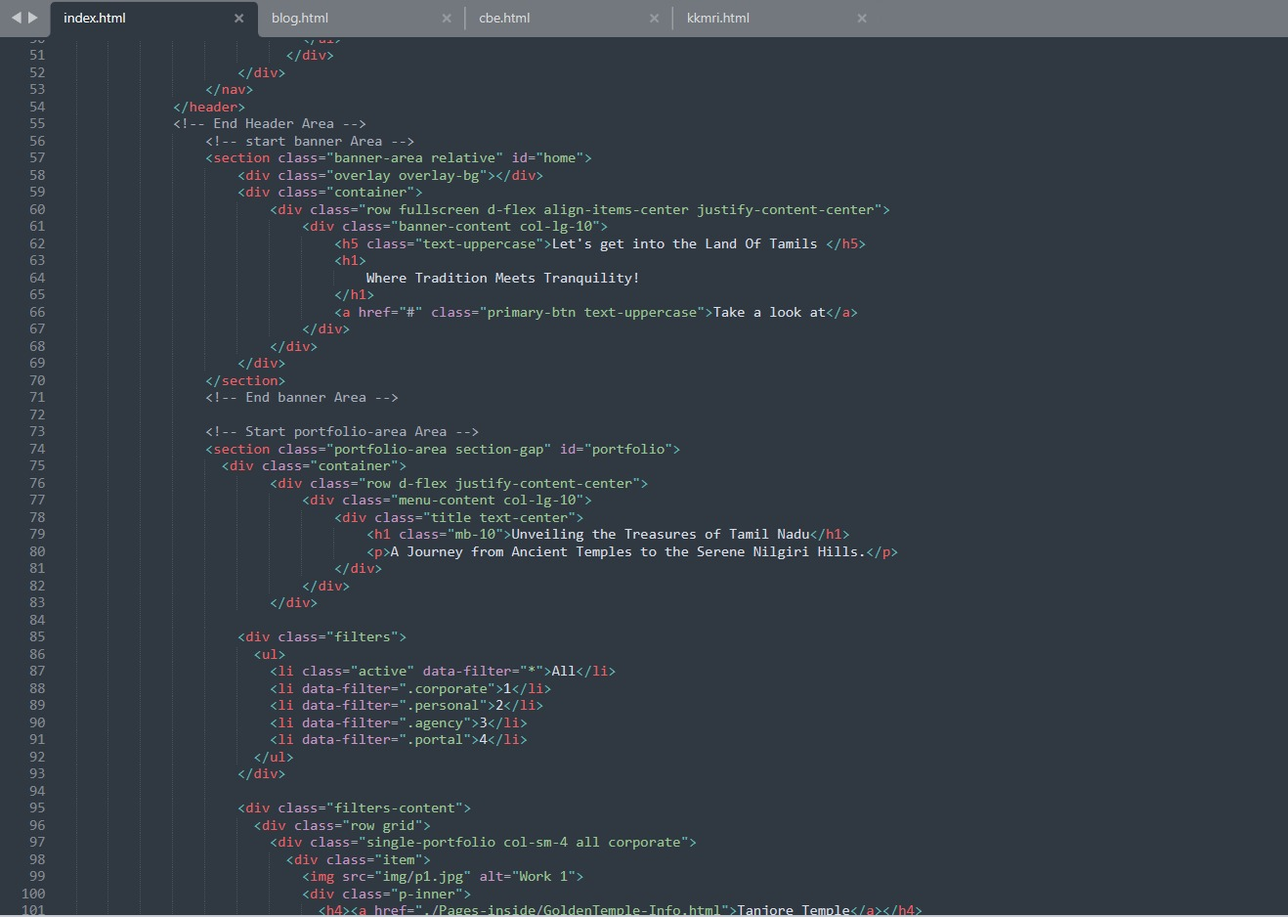

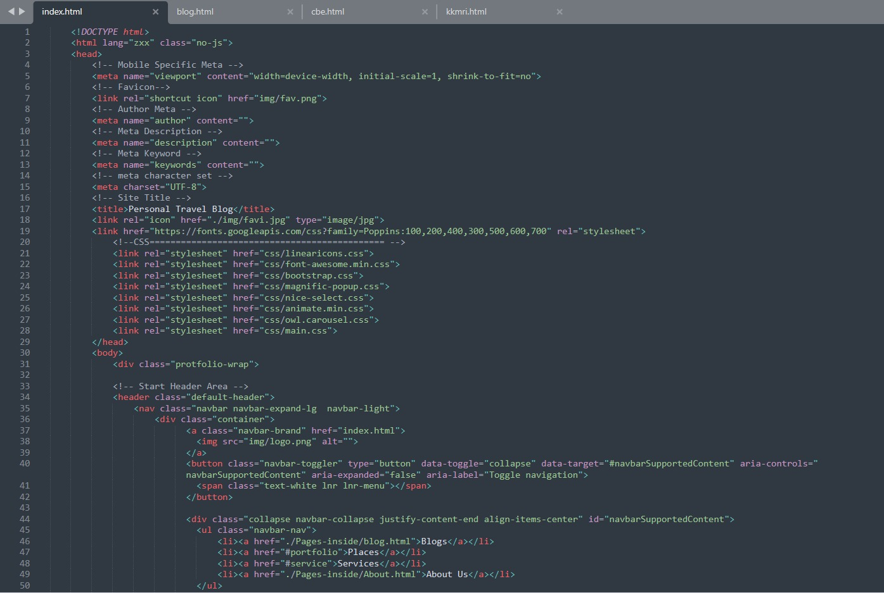

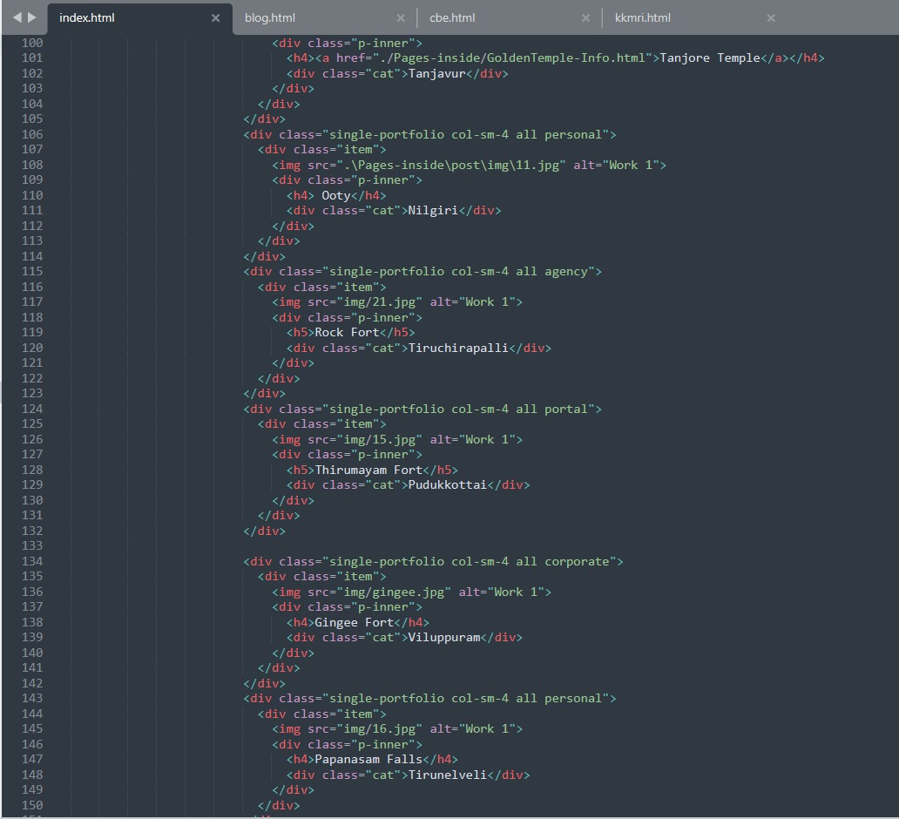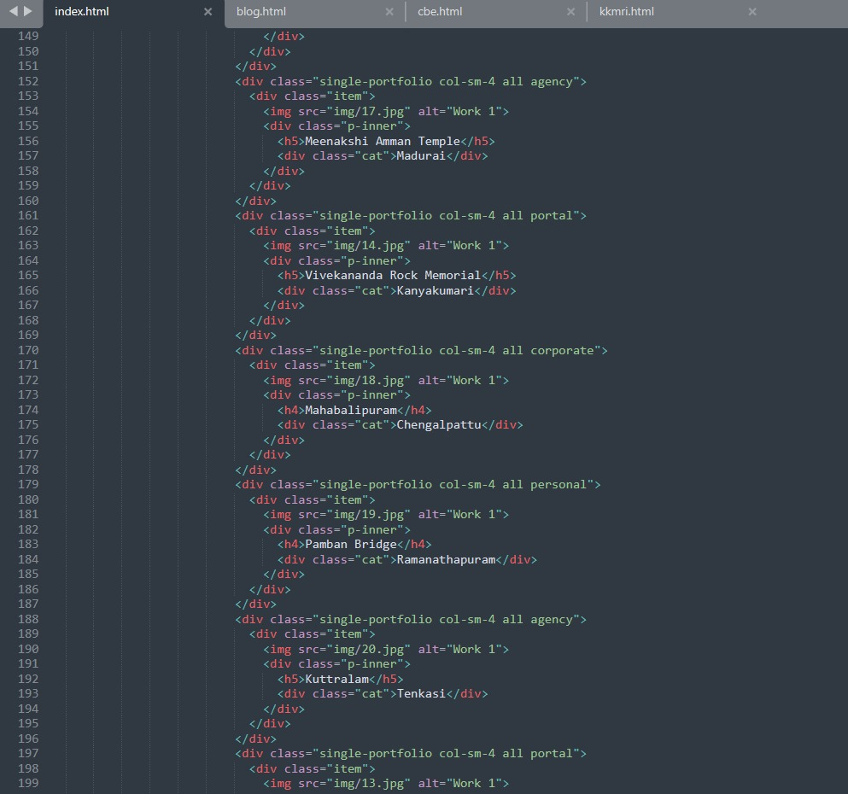

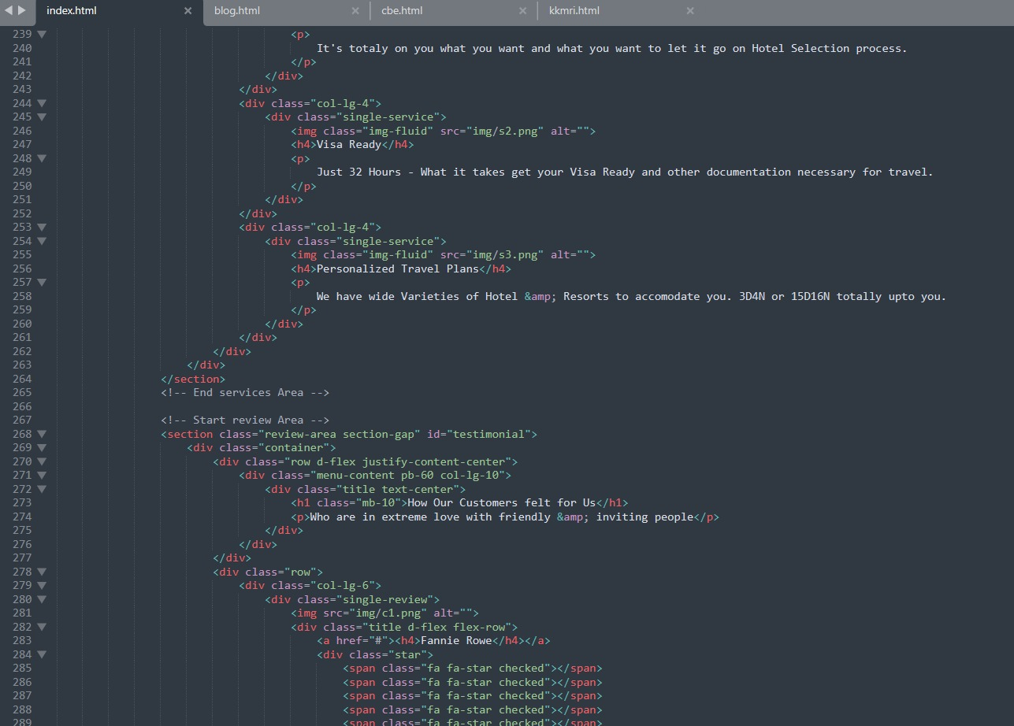

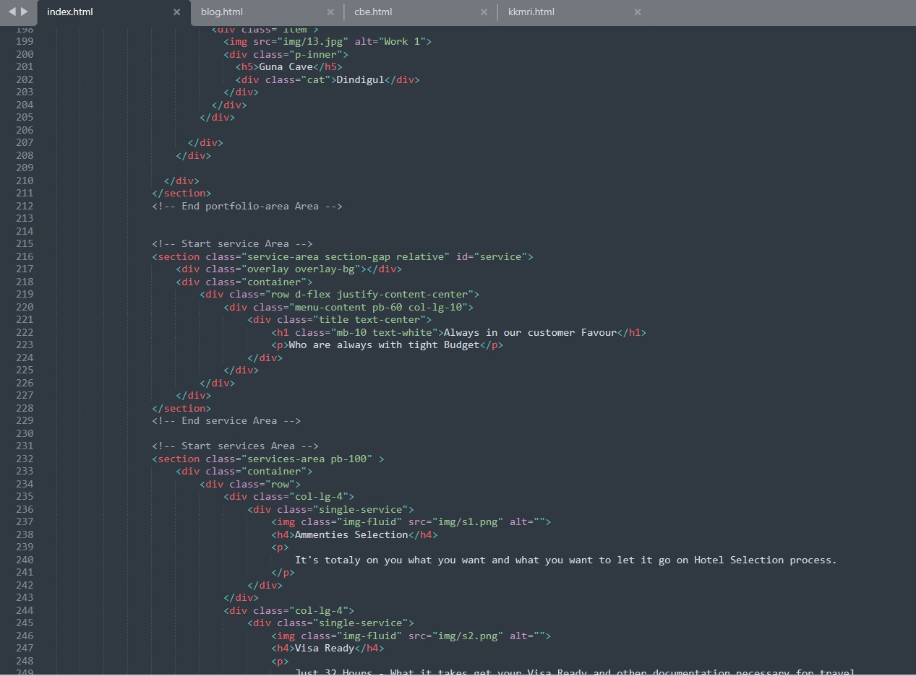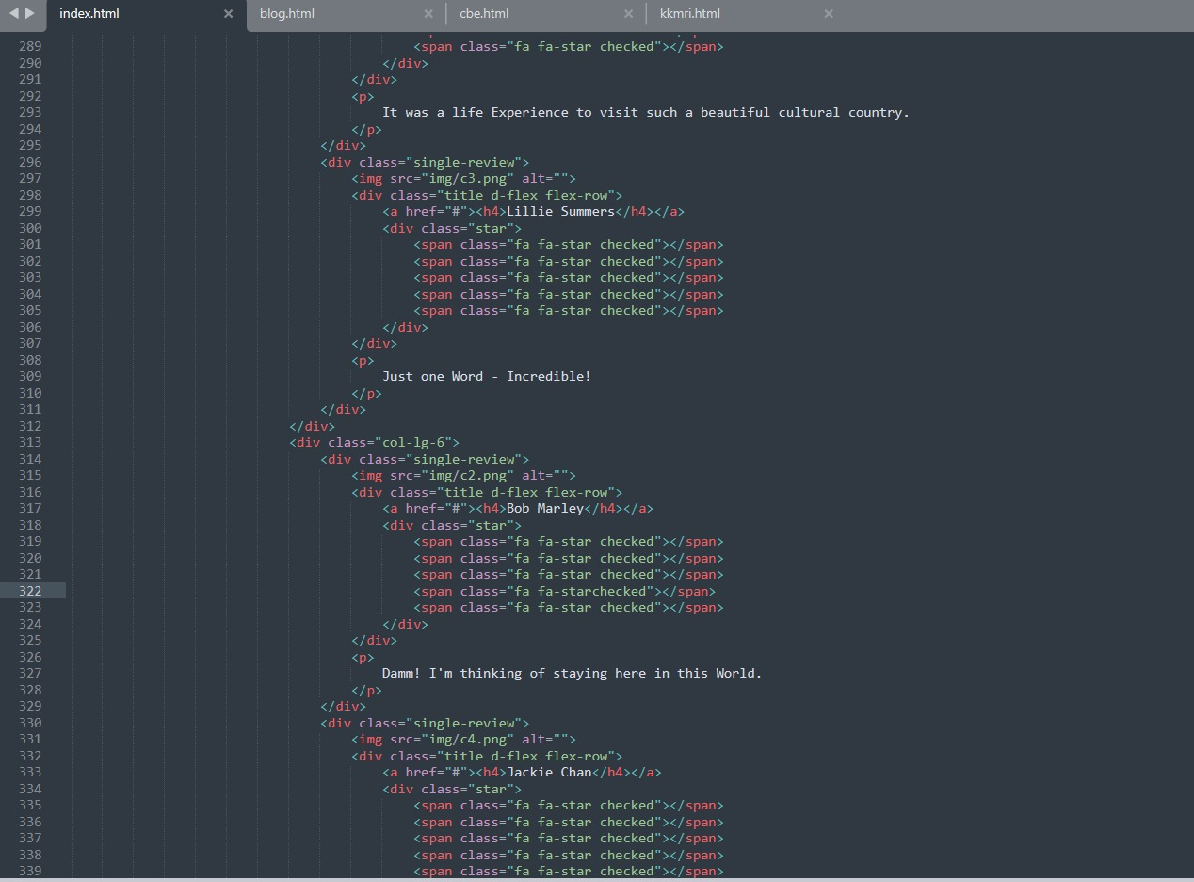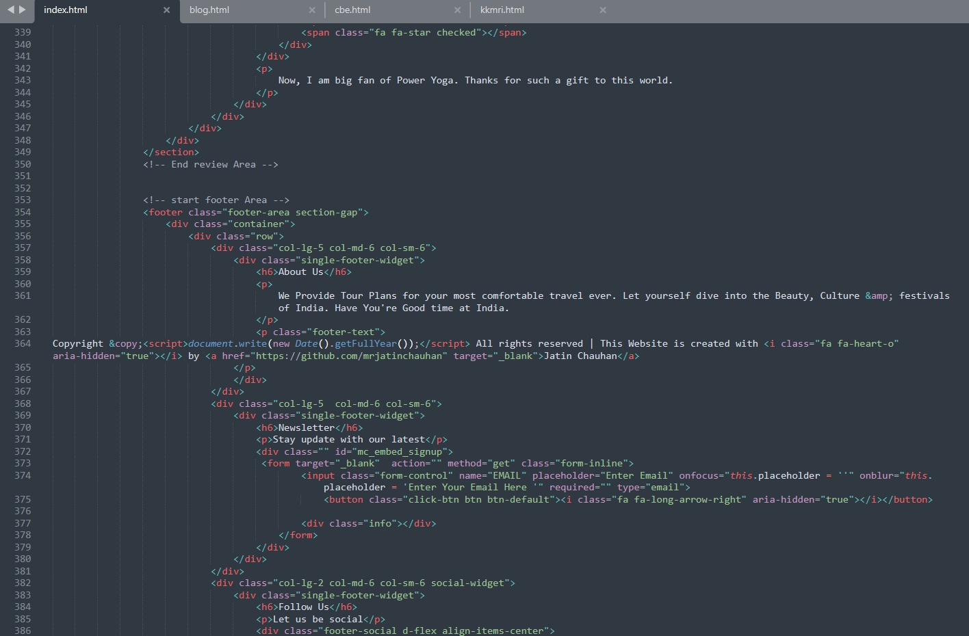

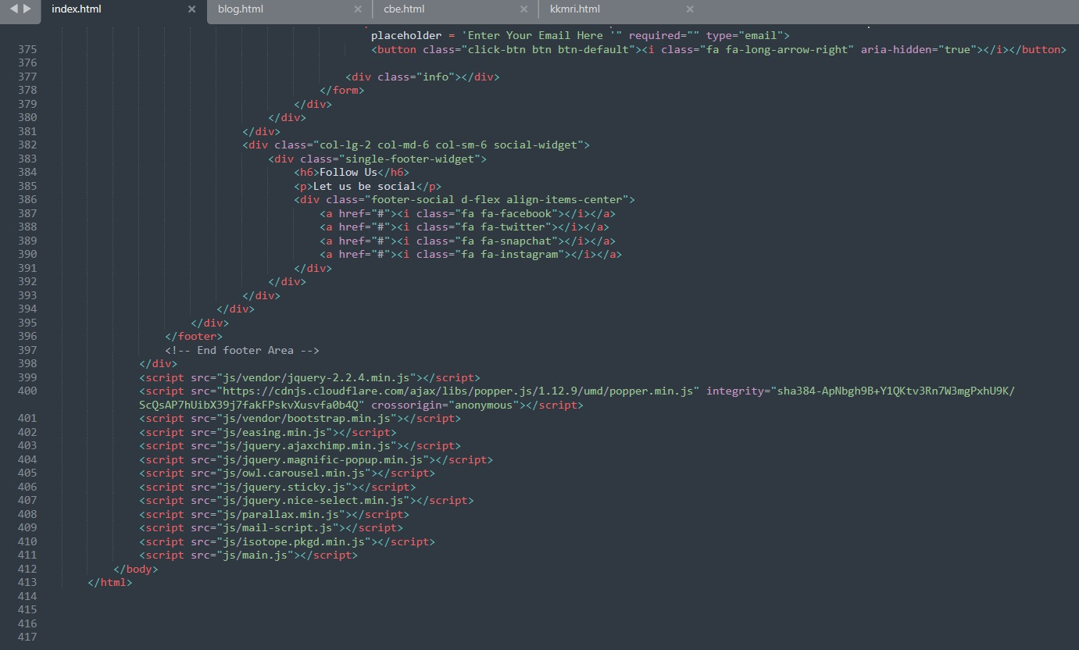

## output:

