**Agile Scrum methodology**

* In our current project, we are following agile methodology.
* Agile is a continuous iteration of development and testing in the software development process whereas Scrum is an Agile process to focus on delivering the business value in the shortest time
* In Agile model, we are getting all the requirements in the form of user stories with acceptance criteria and story points , Later we will also get detailed BRD & FRD documents from BA’s and Designers.
* We have 2 sprints and 1 release for every month. The Sprint duration is 2 weeks
* We will start our Testing from the requirement phase itself. Frequent requirement/design changes will be there in scrum methodology. So we have to update Test scenario’s and Test cases accordingly and we have to give Test scenario’s walk trough’s to BA & Designers and final version of Test Scenario& Test cases will updated in share point . All Test cases will be uploaded in HP ALM
* Daily we have scrum call meeting s and these will be conducted by scrum master in that we will discuss about sprint backlog items, Product backlog items and sprint grooming activities.

**Sprint backlog** is a list of user story tasks identified by the **Scrum** team to be completed in a sprint. During the **sprint** planning meeting, the team selects some number of product **backlog** items, usually in the form of user stories, and identifies the tasks necessary to complete each user story”

* **Product backlog** is a list of prioritized deliverables (such as new features) that should be implemented as part of a project or product development. Product Owner owns the product backlog,(s)he is the one who prioritize it based on the customers feedback or business value. .The product owner prepares and maintains the product backlog. It is prioritized by the product owner, and anyone can add to it with approval from the product owner.
* **Grooming** (or refinement) is a meeting of the Scrum team in which the product **backlog** items are discussed and the next **sprint** planning is prepared. Product **grooming** is critical in product management because it means keeping the **backlog** up to date and getting **backlog** items ready for upcoming sprints.
* **Release Backlog:** The product owner co-ordinates with the scrum master to decide which stories should be targeted for a release. Stories in the release backlog are targeted to be completed in a release.

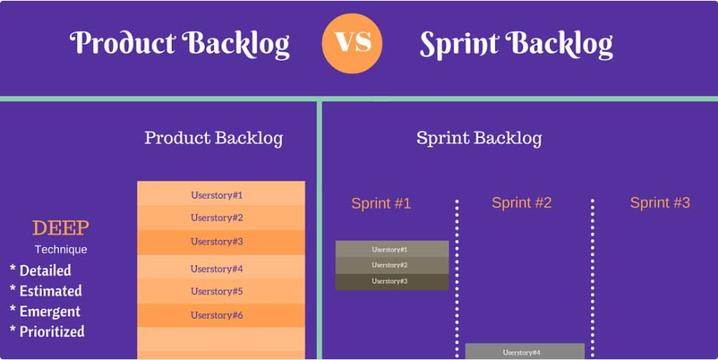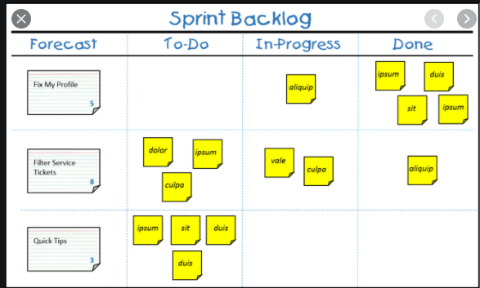

* 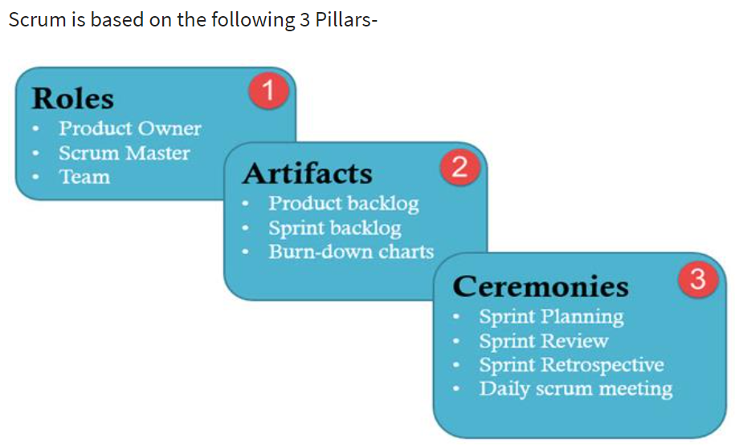

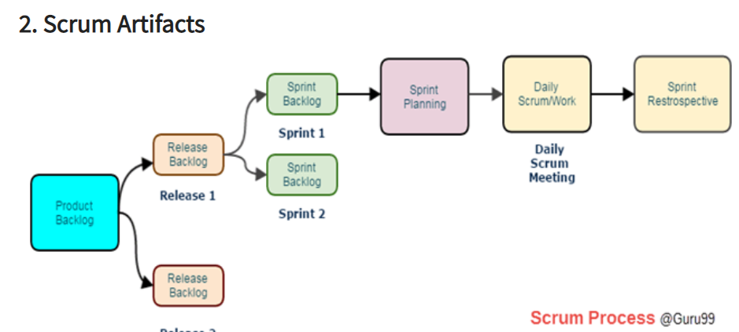 https://www.guru99.com/scrum-testing-beginner-guide.html

* **Block List:**It is a list of blocks and unmade decisions owned by scrum master and updated daily
* **Burndown chart:**Burn-down chart represents overall progress of the work in progress and work completed throughout the process. It represents in a graph format the stories and features not completed
* 