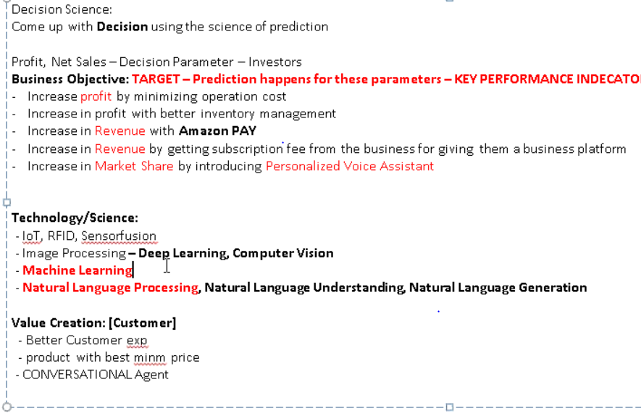

https://www.hackerearth.com/

from Deepak Kumar Behera to All Participants:

<https://www.hackerrank.com/>

