Windows Sub system for Linux:

Steps for Ubuntu in Windows Installation (Windows Subsystem for Linux):

1) Enable the Administrator access
2) In Windows Search - Select : "Turn Windows features on or Off"

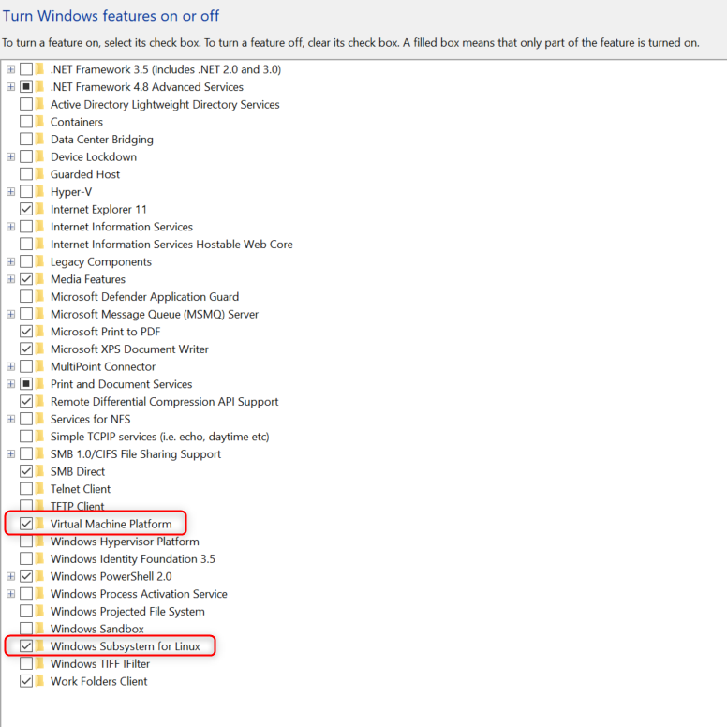
Select the “Virtual Machine Platform” and “Windows Subsystem for Linux” and Press OK

3) Go to Microsoft Store and Install Ubuntu 20.4.2
4) Once Installed go to window command prompt and type wsl -l -v

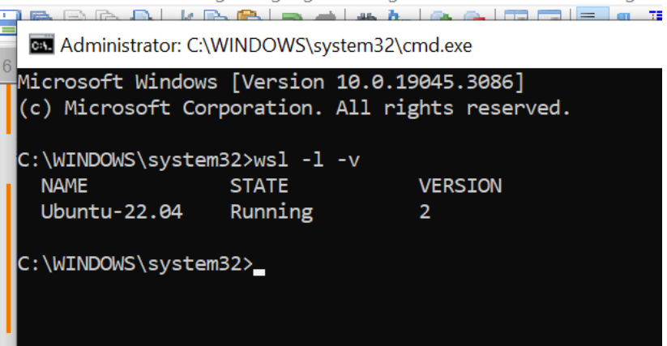
and Ensure version is display as 2.
Note: If the version is displayed as 1 then run this command wsl –set-version Ubuntu-22.04 2

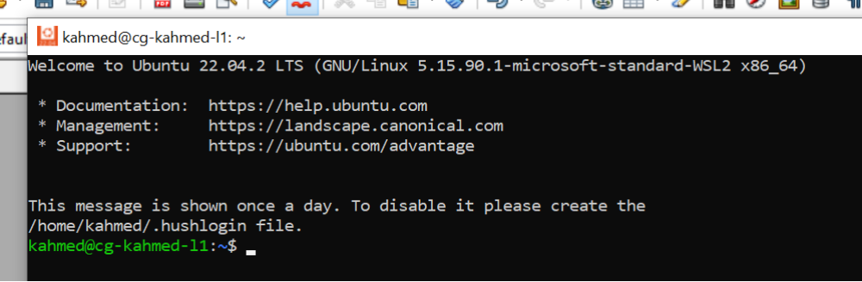
5) Click the installed Ubuntu shell and provide user name and password of windows.

In Ubuntu Command Shell execute the following command one by one:

sudo dpkg --add-architecture i386
sudo apt-get update
sudo apt-get install libstdc++6:i386 libgtk2.0-0:i386 libxtst6:i386
sudo apt-get install gtk2-engines-murrine:i386 libcanberra-gtk-module:i386 libatk-adaptor:i386
sudo apt install libpango1.0-dev:i386
sudo apt install libpangox-1.0-dev:i386
sudo apt-get install libswt-gtk-4-java

wget http://ftp.us.debian.org/debian/pool/main/p/pangox-compat/libpangox-1.0-0_0.0.2-5.1_amd64.deb
wget http://ftp.us.debian.org/debian/pool/main/p/pangox-compat/libpangox-1.0-0_0.0.2-5.1_i386.deb

sudo apt install ./libpangox-1.0-0_0.0.2-5.1_amd64.deb
sudo apt install ./libpangox-1.0-0_0.0.2-5.1_i386.deb

At the end of WSL installation, an additional Linux drive enabled as below.

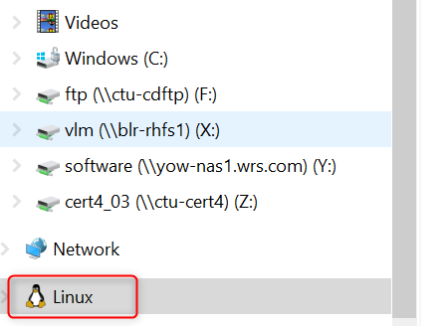
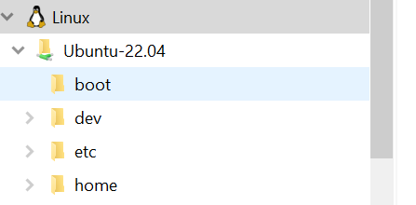

-Go to the windriver gallery portal, select the required VxWorks product.
-Select online installation for Linux
-Place the downloaded files into Linux home drive(/home/username).
-Run the setup_linux file after changing the mode(for setup_linux and setup_linux32).

