Computer Science ACTOR BOX Lab Value - 100

Lab Goal : This lab was designed to teach you more about the GridWorld case study.

Lab Description : Add Actors to the World to make a Box of Actors.

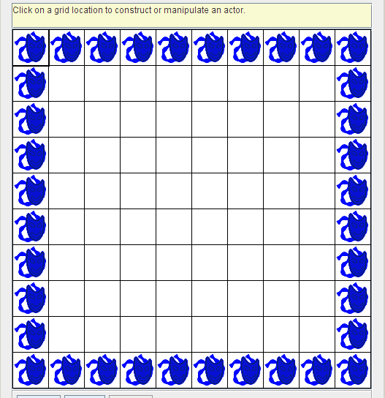
Sample Output :
Files Needed ::
ActorBox.java
GridWorld project

EXTRA OPTIONS :

Import Rock and Flower and use rocks and flowers in your design.

Add in code statements to set the color ( setColor() ) of the actors to a color other than blue.
You must import Color.

Bonus Output :
