Name : ___________________________ Date : _________________

GridWorld Activity One – Setting up a GridWorld Project

Directions : Follow the instructions below to setup a GridWorld project.
How do I make a folder?
Open your student drive.
Right-click inside of your student drive.
Select New
Select Folder
Name the new Folder appropriately.

1. Make a folder on your student drive and call it ComputerScience.
2. Make a sub-folder called labs inside of your ComputerScience folder.
3. Make a sub-folder called slides inside of your ComputerScience folder.
4. Make a sub-folder called activities_worksheets inside of your ComputerScience folder.


5. Make a sub-folder called GridWorld inside of your activities_worksheets folder.

6. Open JCreator on your student computer. You should have an icon on the desktop or under all programs.

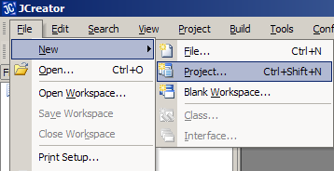
NOTICE ::
You must download the gridworld.jar and BugRunner.java files from the AP Central website.

7. Select File.

8. Select New.

9. Select Project.
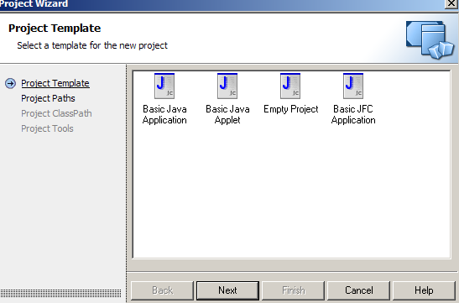

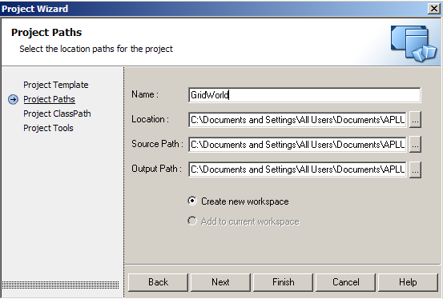
10. Select Empty Project.
Hit Next.

11. Path to your activities_worksheets \ GridWorld folder.
Click the button with 4 dots . . . . to the right of Location.

12. Name your project GridWorld.
Hit Finish.

13. Copy your gridworld.jar file and paste it into your newly created GridWorld project.

14. From your GridWorld project, select Project – Add Files – Files of type – All files – select gridworld.jar
15. Copy BugRunner.java and all other example gridworld .java files and paste them into your GridWorld project.

16. From your GridWorld project, select Project – Add Files – select the .java files you wish to add.

