__________________________________________________________________________

SCHOOL OF SCIENCE AND TECHNOLOGY

COURSEWORK FOR THE BSC (HONS) INFORMATION SYSTEMS (BUSINESS ANALYTICS); YEAR 2

ACADEMIC SESSION AUGUST 2019; SEMESTER 4,5,6

IST2334: WEB AND NETWORK ANALYTICS

DEADLINE: 27th NOVEMBER 2019 12:00pm

STUDENT NAME: _YEO YEE WEN__

STUDENT NO: 18076950

INSTRUCTIONS TO CANDIDATES

This assignment will contribute 20% to your final grade. It is an individual assignment.

IMPORTANT

The University requires students to adhere to submission deadlines for any form of assessment. Penalties are applied in relation to unauthorized late submission of work.

Coursework submitted after the deadline but within 1 week will be accepted for a maximum mark of 40%.

Work handed in following the extension of 1 week after the original deadline will be regarded as a non-submission and marked zero.
Lecturer’s Remark (Use additional sheet if required)

I....................................... (Name) ...................std. ID received the assignment and read the

comments....................................... (Signature/date)

Academic Honesty Acknowledgement

“I .....Yeo Yee Wen.....(student name). verify that this paper contains entirely my own work. I have not consulted with any outside person or materials other than what was specified (an interviewee, for example) in the assignment or the syllabus requirements. Further, I have not copied or inadvertently copied ideas, sentences, or paragraphs from another student. I realize the penalties (refer to page 16, 5.5, Appendix 2, page 44 of the student handbook diploma and undergraduate programme) for any kind of copying or collaboration on any assignment.”

…........YEO YEE WEN........... (Student’s signature / Date)

[This paper contains ONE questions printed on TWO pages]

Description of the assignment (100 marks)
For this assignment, you are required to select and analyse a dataset from https://www.freecodecamp.org/news/https-medium-freecodecamp-org-best-free-open-data-sources-anyone-can-use-a65b514b0f2d/. Based on your own interests, select THREE distinctive areas of analysis. The areas should be pre-agreed with the subject lecturer before 8th November 2019. Based on the selected analysis, additional datasets can be added to assist the analysis.

For each area, explain the rationale of the selection. Use suitable techniques to process and analyse the data. Take a good look at the obtained results and explain them critically. (Hint: you can explain them from different perspective, such as observable trends, significance of the result, meaningful anomalies etc.).

The report of the assignment should consist of the following:
- Introduction and motivation of the work (10 marks)
- Elaboration of the data sets (10 marks)
- Presentation of the three analysis – techniques used, rationale, results and explanation (10 marks each – total 30)
- Lessons learned and Conclusion (10 marks)
- A reflection on the learning and appreciation of the techniques used and analysis carried out in this project. (20 marks)

On top of the above, 10 marks will be graded based on the code quality, and 10 marks for the language quality of the report.

Submission:
Both source code and WORD document report should be uploaded to the assignment link in Elearn in a ZIP file. File name please follow the convention IST2334-student_id.zip. Attach the cover page to front of the WORD document report.

Web and Network Analytics Assignment Marking Rubrics

 | Excellent | Good | Adequate | Unsatisfactory
 | 10/9 | 8/7/6 | 3/4/5 | 1/2
A. Introduction and motivation of the work [10%]
 | 10/9 | 8/7/6 | 3/4/5 | 1/2
B. Elaboration of the data sets [10%]
 | 10/9 | 8/7/6 | 3/4/5 | 1/2
C. Presentation of the analysis – techniques used, rationale, results and explanation
[10% x 3]
 | 10/9 | 8/7/6 | 3/4/5 | 1/2
D. Lesson learned
[10%]
 | 20/19/18 | 16/14/12 | 6 / 8/ 10 | 2/4
E. Reflections [20%]
 | 10/9 | 8/7/6 | 3/4/5 | 1/2
F. Formatting, grammar, and style of writing [10%]
 | 10/9 | 8/7/6 | 3/4/5 | 1/2
G. Code quality [10%]

A rough guide on timing:
21st Oct to 31st October 2019
- Selection of dataset and identification of the analysis you may wish to perform
- Draft report content (A) and (B)

31st October 2019 to 8th November 2019
- Communicate with subject lecturer on your plans and the analysis. Seek confirmation before start of analysis

8th November 2019 to 22nd November 2019
- Start analysis work by coding the script and exploring the different possibilities
- Draft report section (C) as you work on the analysis
- Seek feedback from subject lecturer if unsure, especially regarding what you can write for section (D) and (E)

22nd November to 27th November 2019
- Write section (D) and (E)
- Submit work as soon as it is completed – do not wait until 27th November 11:59am ☺

Report Contents
 | Dataset Names | episode_info, scripts
 | Title | Seinfeld Text Mining Analysis word relationships along with a slight Sentiment approach
 | Datasets Description | These data from these datasets has been downloaded from kaggle and it emphasizes providing episodic analysis of the series including the entire script and significant amount of information about each episode.
 | Introduction | "The Seinfeld Chronicles" (also known as "Good News, Bad News" or "Pilot") is the pilot episode of the American sitcom Seinfeld, which first aired on NBC on July 5, 1989.  The first of the 180 Seinfeld episodes, the pilot was written by show creators Larry David and Jerry Seinfeld, and directed by Art Wolff. The episode revolves around a fictionalized version of Seinfeld, who is unsure about the romantic intentions of a woman he met, and frets about the meaning of her signals with his friend George (Jason Alexander) and neighbor Kessler (Michael Richards, whose character would later be renamed "Kramer").  Though they had been asked to put together a 90-minute TV special, Seinfeld and David wrote a TV pilot as they felt their "show about nothing" concept would fit better in the shorter, more conventional half-hour format. The storyline, and the main characters, were inspired by real-life events and people. Though the NBC executives were unsure about the show, they, as Warren Littlefield would later state, "all said, ah what the hell, let's try a pilot on this thing and see what happens". The test audiences, however, reacted extremely negatively. Although NBC would still broadcast the episode to see how audiences and TV critics would react, the network had already decided not to pick up the show, as a result of the test results. Castle Rock Entertainment, which produced this pilot (and the series proper), also had another pilot produced for NBC featuring actress Ann Jillian in her own eponymous series. After the poor reception of The Seinfeld Chronicles, the production company turned to Jillian's series, which tested better and had earned a full-season order; it would only last a single 13-episode season before being cancelled by the end of 1990.  When The Seinfeld Chronicles aired, it was watched by nearly 11% of American households, and received generally favorable reviews from critics, who reacted with disappointment that NBC did not order a first season. Convinced that the show had potential, and supported by the positive reviews, NBC executive Rick Ludwin managed to convince his superiors to order a four-episode first season (the smallest order in US TV history), by offering a part of his personal budget in return. The show, renamed Seinfeld, would go on to become the most successful sitcom in television history.
 | Motivation | I have chosen to work with this Seinfeld Chronicles dataset since I feel it is one of the funniest and sarcastic comedy series that I have ever seen. Laughter is eminent each time you watch one of the episodes of each season. The synopsis about the series is about Jerry Seinfeld and Larry David whom were less about character development and narrative than having their four main players learn absolutely no life lessons. One example is when you know those saccharine moments that leave you gagging on the couch such as when Ross and Rachel had their first kiss, Chandler's proposal to Monica and etc. Its almost like walking into a room, forgetting what you went in there for, then remembering, then getting the thing you went in there for, then telling three friends about it, then somehow ending up naked on a boat. These are the reasons why I chose Seinfeld for my analysis. Also, Seinfeld has none of that schlock and is far funnier from it.  In the datasets, I have data of all the episodes, seasons, titles, airdates, characters, dialogues and etc. The consumption of whom are funniest along with what they say to make it funny makes this data set interesting not only for me but data scientists or analysts. From the dataset, I have explored a few insights that would later be explained in my analysis.
 | Elaboration | The reason based on why I am motivated to perform analysis on this dataset Seinfeld is due to the amount of relevant data is much larger in this dataset as compared to when I was performing a sentiment analysis based on Avengers Endgame movie reviews based from twitter tweets. As of this analysis for Seinfeld, a text analytics along with an sentiment approach is combined to examine the data. Text analytics is the process of analysing unstructured text, extracting relevant information, and transforming it into useful business intelligence while Sentiment analysis determines if an expression is positive, negative, or neutral, and to what degree. In other words, text analytics studies the face value of the words, including the grammar and the relationships among the words. Simply put, text analytics gives you the meaning. Sentiment analysis gives you insight into the emotion behind the words. Therefore, I chose to incorporate both type of analysis as I believe both will be able to tell significance story as both datasets contain textual and emotional related data based on the dialogue’s variable in the dataset.
 | Significance | Also, the significance of performing text and sentiment analysis of the Seinfeld series can be classified as highly recommended due to various public bias opinions in the macro-scale socioeconomic environment. The reason for this is because many people tend to have unpopular bias opinions of each character in the series. Therefore, performing a textual and sentiment analysis will show people around the world through an estimation analysis statistically regarding each character, who is funniest, who said most words and emotional words said through each character and etc. For example, estimating how funny a character is can be done through favourable responses in which a response is emotionally happy, sad, angry and etc.
 | Curiosity | As one of the most popular shows of all time, Seinfeld, a show about nothing, is the topic of today’s infographics. Those whom grew up in the 90s would probably have watched Seinfeld, and though those whom were not old enough to appreciate it then, watching it now I understand why it is so popular. Currently in syndication, Seinfeld had its last episode on May 14, 1998 after 9 seasons. For its last episode Seinfeld drew in 76 million viewers, 58% of all television viewers for that night. Therefore analyzing this dataset would show its comedy significance left today as I and believe the general public whom watched Seinfeld too am curious to know how the series still varies today.
 |  | ELABORATION OF THE DATASET
 | Dataset Provider | Kaggle
 |  | KAGGLE is an online network community of information researchers and machine learning students, owned by Google. Kaggle enables clients to discover and distribute informational indexes, investigate and manufacture models in an electronic information science condition, work with other information researchers and AI builds, and enter rivalries to illuminate information science challenges. Kaggle got its beginning by offering AI rivalries and now likewise offers an open information stage, a cloud-based workbench for information science, and short structure AI training. On 8 March 2017, Google declared that they were procuring Kaggle.
 | Source URL | https://www.kaggle.com/thec03u5/seinfeld-chronicles
 | No. of records | Episode = 174 observations  Scripts = 54616 observations
 | No of variables | Episode = 8 variables  Scripts = 6 variables
 | Dataset file format | Csv
 | Background of Data Source | Both datasets are for people who love data science and Seinfeld. It contains details about all the episodes including attributes such as the director, episode name, and etc. Moreover, the data was scraped and crawled from the fan’s Seinfeld website http://www.seinology.com/.
Metadata Information of episode_info dataset
Attribute | Description | Missing Value | Valid Observations | Mismatched. V
X1 | Attribute Number | 0 | 174 | 0
Season | The season number of the episodes | 0 | 174 | 0
Episode_No | The episode number of the season | 0 | 174 | 0
Title | The title of the episode | 0 | 174 | 0
AirDate | Date when the episode was aired | 0 | 174 | 0
Writers | Writers of the seasonal episode | 0 | 174 | 0
Director | Director of each episode’s season | 0 | 174 | 0
SEID | The season ID | 0 | 174 | 0

Metadata Information of scripts dataset
Attribute | Description | Missing Value | Valid Observations | Mismatched. V
X | Attribute Number | 0 | 54616 | 0
Character | The dataset’s characters from Seinfeld Chronicles | 0 | 54616 | 0
Dialogue | Dialogue of each character | 10 | 54606 | 0
Episode_No | The episode number of the season | 0 | 54616 | 0
SEID | The season ID | 0 | 54616 | 0
Season | The season number of the episodes | 0 | 54616 | 0

Presentation of the analysis – techniques used, rationale, results and explanation
Analysis Question 1: Which characters spoke a lot along with how much and with what words did they speak among other characters?
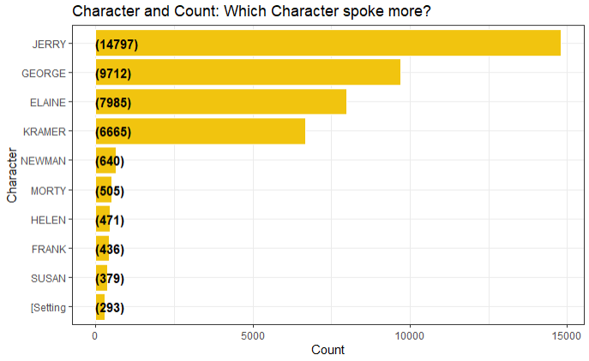 | 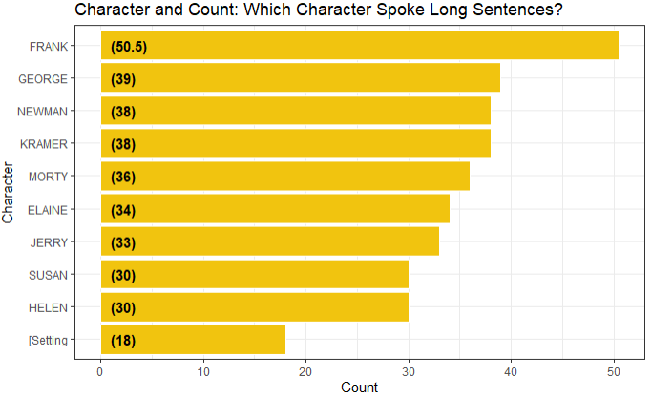
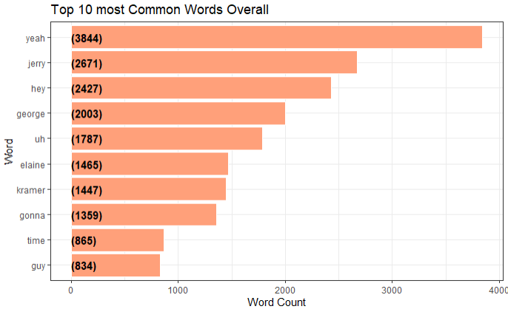 | 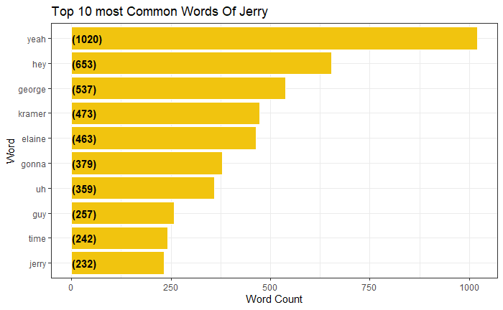
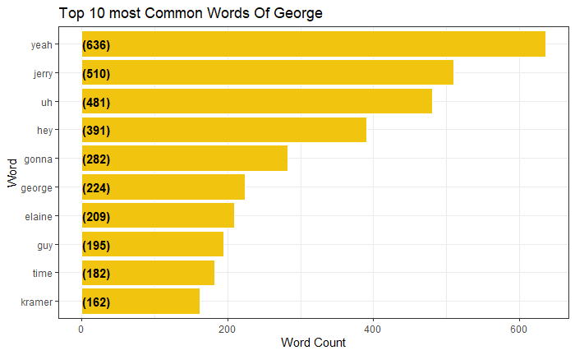 | 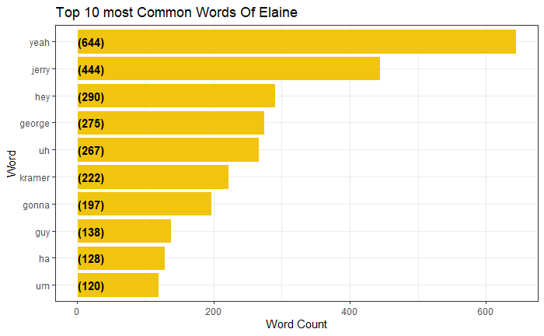
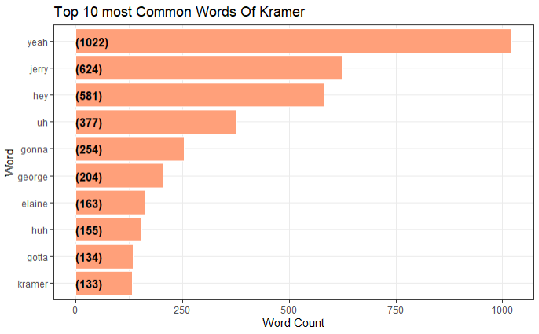 | Tokenization - Process
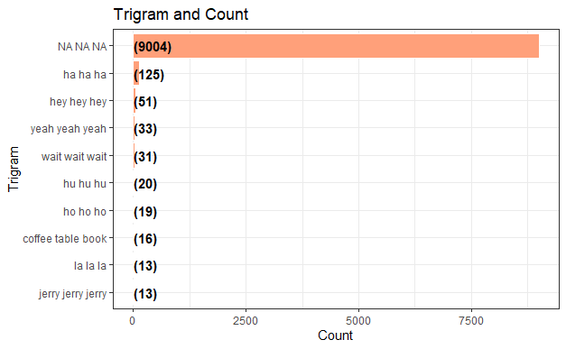 |  | 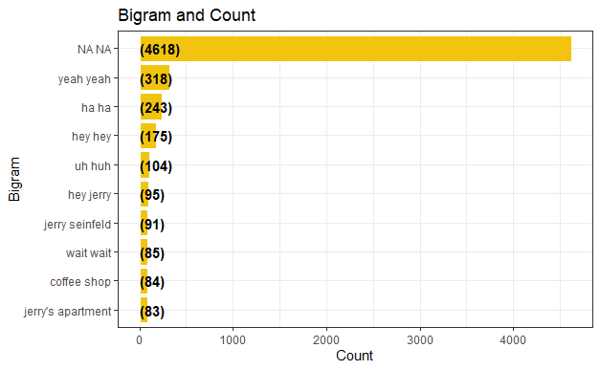
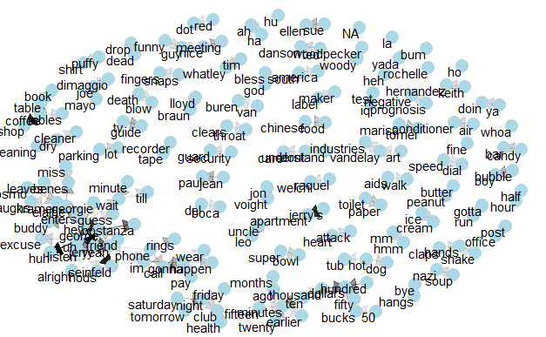 |  | 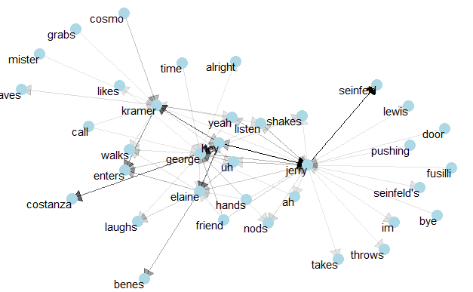
Based on the descriptive analysis shown under the sorted barcharts, the charts regulate and show the number of words of each character along with how much do they speak. Based on what they are speaking, the charts regulate and explain what common words do each of these characters speak. For example, overall used words spoken by all characters include the word ’yeah’. Also this canbe displayed when common words are grouped among each character. The reason why a sorted barchart was used to show the distribution is because the data in their respective variables contain different class variables which can be sorted and counted individually. Also, it is easier to view which attribute from the variable is higher. From this, the process of tokenisation was used to separate and classify the coerces/text in a list of characters based on class objects to become simple individual words which in this case were the words that were spoken by them in their scripts. As a result of classifying the words individually, Both groups in the trigram and bigram words that were spoken in the scripts by the characters were able to be listed. From this, we know that all words are categorized and specified as unique values individually. From here, the most important individual words since all words have been tokenized are explored and now a relationship network has been created for all types of words in the respective script of each character. Before proceeding, what is a relationship network? In general, they are graphs with vertices and edges which show links among each other forming defined intersections. The two primary aspects of networks are a multitude of separate entities and the connections between them. The vocabulary can be a bit technical and even inconsistent between different disciplines, packages, and software. The entities are referred to as nodes or vertices of a graph, while the connections are edges or links.. Therefore, since we are clear, based on the distribution of the words, one would analyse on them between Jerry, George, Elaine and Kramer(characters from the dataset) to explore their relationships among words. Therefore, with the distribution of words, embedding their names and analysing which likely words they use is easier as shown in the 2nd diagram of the network distribution analysis. The reason why this makes it easier is because of the ability to obtain measures of centrality for each node among the fifty nodes with the highest degree of centrality. Will network plots and measures of centrality lead us to the people with the power. In the dataset’s case, that person in this social network is Jerry. Lastly, with this information regarding characters, one can analyse using the networks improvising how each text spoken by a character is being spoken to whom as everyone in the network circle whom speaks can be identified as they have a relationship among each other. This is the finding from this distribution that has been collected in this research question as in its degree distribution, each node in an undirected/relationship network has obtained a degree or number of links to other nodes. This degree distribution shows the degree to which nodes are connected to one another. For example, in the Seinfeld series, one can conclude one scenario where Jerry, George, Elaine and Kramer may say the same words among each other. In conclusion, this method of analysing words is very good to determine whom talks to whom is very good as an overview of visualization, this analysis shows in the network shows its utility as a technology for understanding social networks and the structure of organizations which in this case is how the characters are interacting.
Analysis Question 2: How often would a character conquer speaking a majority of different words across seasons in an interaction along with how a character feels emotionally and what words would he/she use during that period of being emotional?
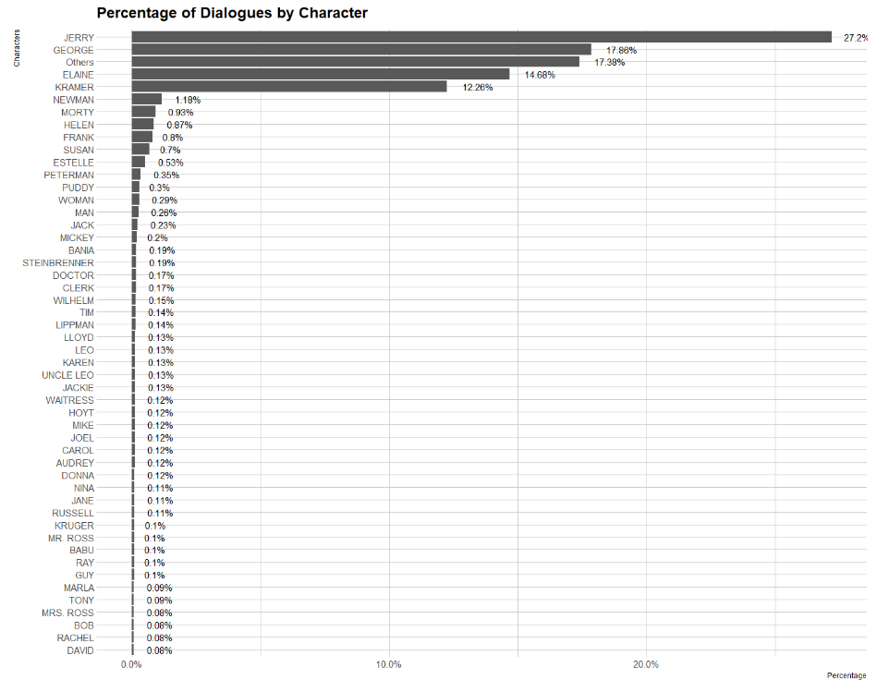
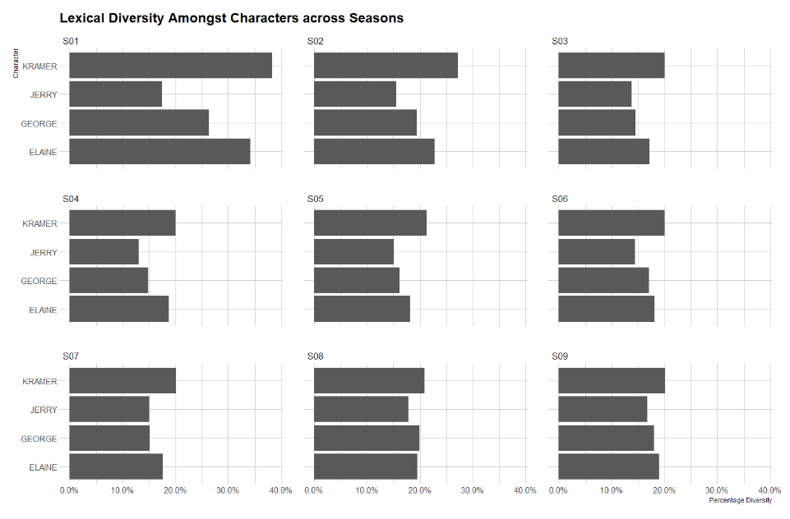
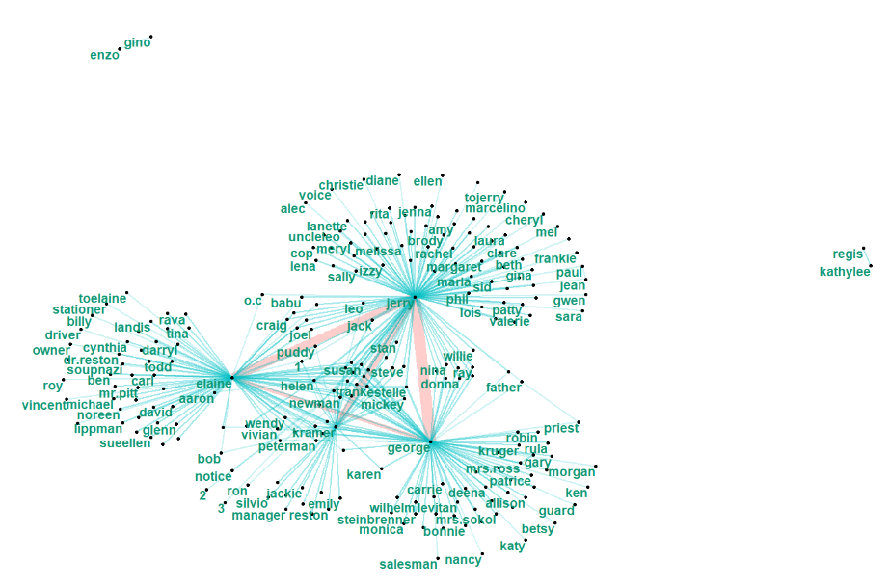
Sentiment Analysis using NRC LEXICON

Fear for Jerry | Joy for jerry
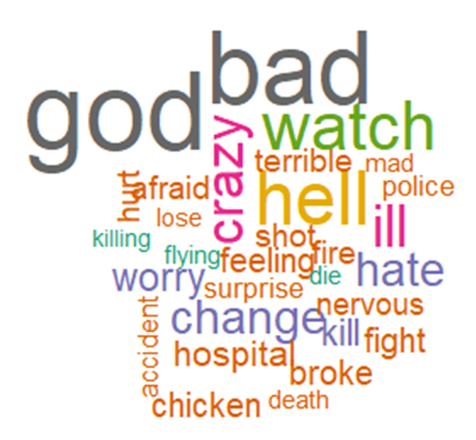 | 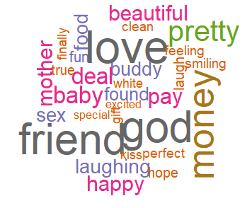
Surprise For jerry
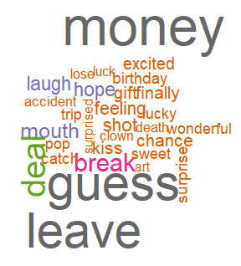 | ………………………………………(BLANK)………………………………
Speaking a lot does not mean one emotionally feels good. Based on the sorted barchart, one can examine the percentage of dialogues by each character from the series and one identify that Jerry is the character which shows the highest percentage of dialogue’s from the series. Mainly, this is due to his high number of script texts in the dataset but it also means that he is the main character of the series. This probably also means he might be the actual star of the series due to pressure from directors. However, being physically able to speak a lot is one but having the ability to comprehend in lexical and diversified languages are difficult. Based on the stacked sorted barchart examining the lexical diversity among characters across the seasons, assuming that Jerry is no.1 but as one can see that in season 1, he did not have the greatest display in showing why characters are mostly diversified. Take Kramer as an example, one may assume he is the most lexically diversified person among all characters and also throughout among all seasons. Therefore, one should analyze how close the characters are among all the other characters are inorder to identify how much relationship there are between other characters. If you examine elaine, george, and jerry are close to almost everyone except regis, kathylee, enzo and gino. Therefore, to go into detail on how a character may feel, a sentiment analysis approach is used. So, what is sentiment analysis? It refers to the process of computationally identifying and categorizing opinions expressed in a piece of text, especially in order to determine whether what a person’s attitude is towards a particular topic, product, etc. is positive, negative, or neutral. Based on psychology studies, one can determine a persons overall feelings based on what they speak. Analyzing sentimently using a lexicon will be able to pin point more or less how a person feels based on words that are spoken in their scripts. Lets take Jerry for an example, as we can see, we can analyze the emotional sentiments of him based on what words mainly appear in his speech. For example, in the script dataset, he would say ‘Oh God’ in a scenario. This in all sense demonstrates based on the sentiment lexicon that Jerry is in shock/fearful for something. In conclusion, speaking a lot statistically does not show overall happiness but what a person says better determines what a person is going through. If we go back to the network diagram, we can also say based on Jerry’s sentiments that despite having a huge relationship with others, his relationships are full of both positive and negative types as he may know a lot of people but are enemys and friends with some of the other characters.
Analysis Question 3: How many times would an episode be mentioned throughout the episode series in a season along with which character is being prioritized as a main character in the seasonal episodes along with how this main character feels based on sentimental words from his speech?
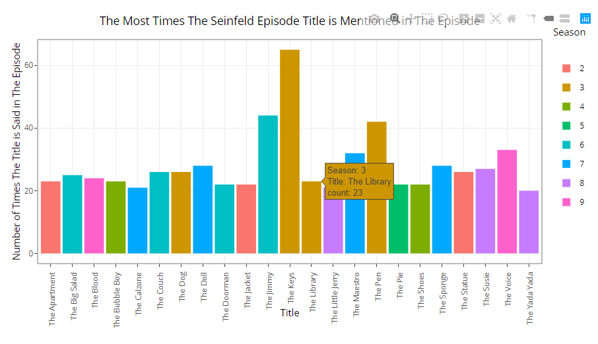
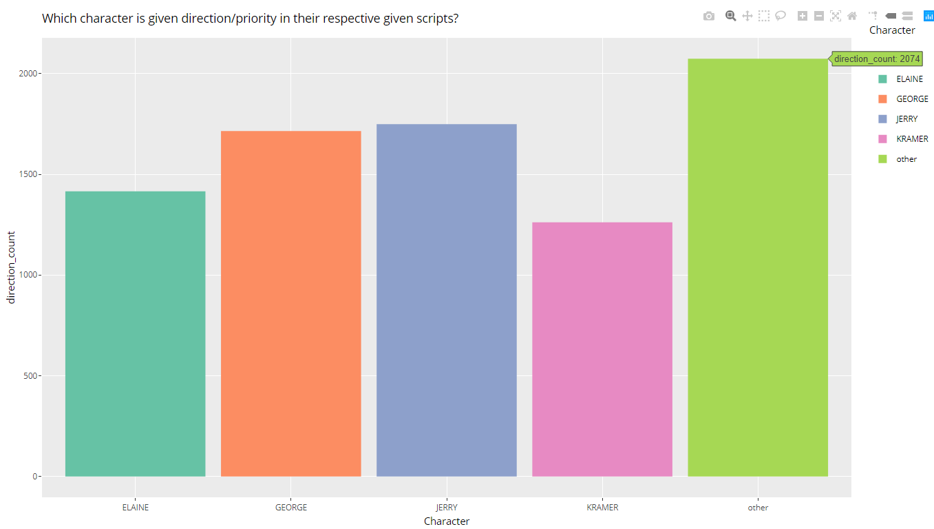 | 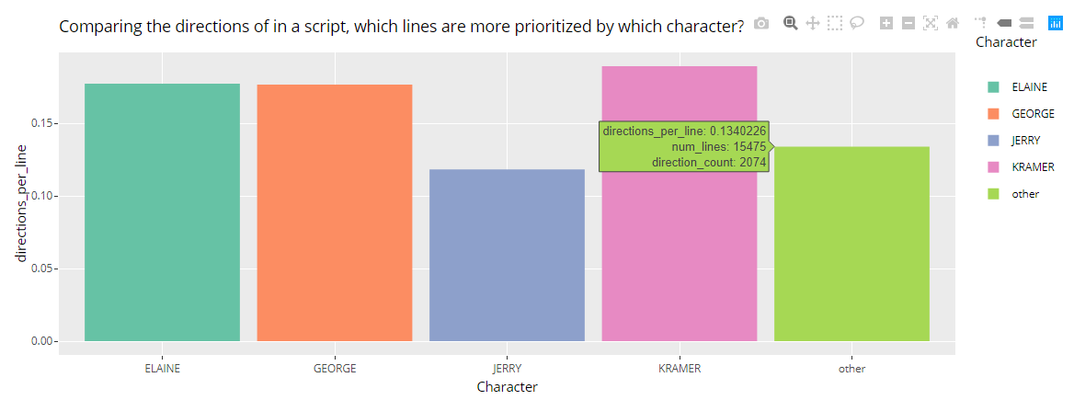
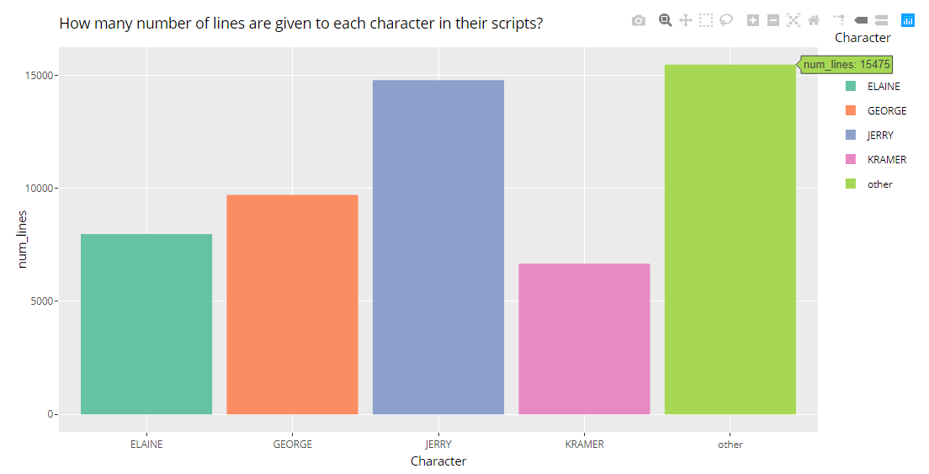 | 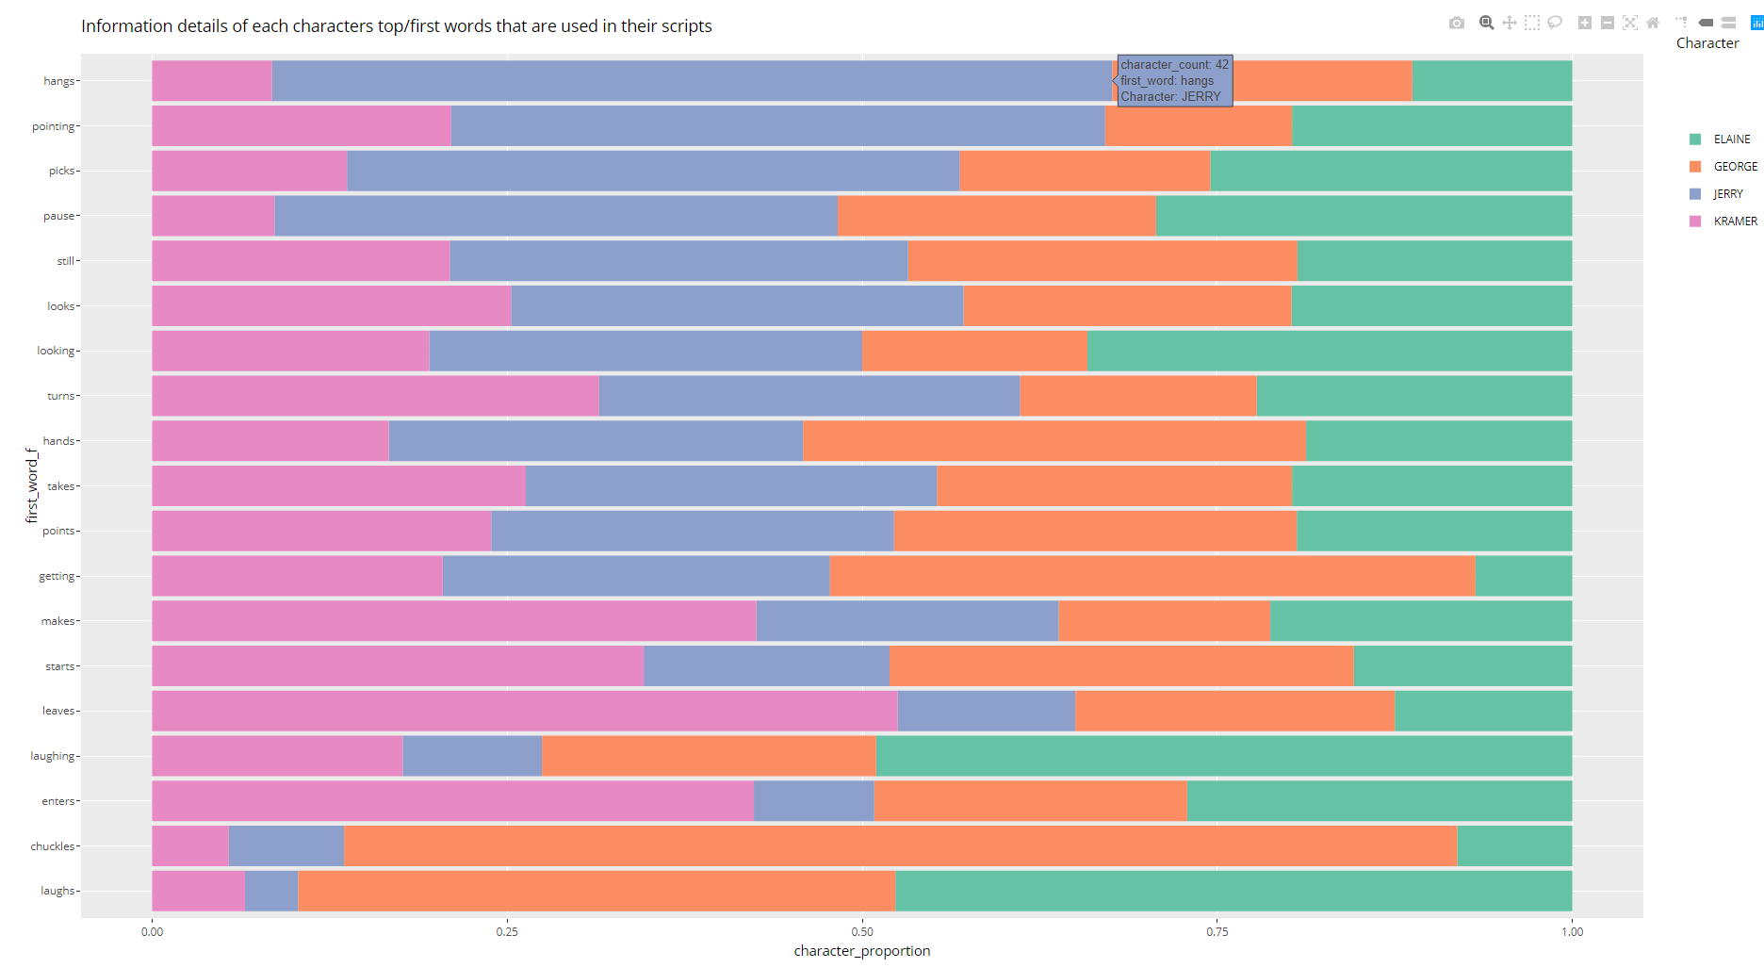
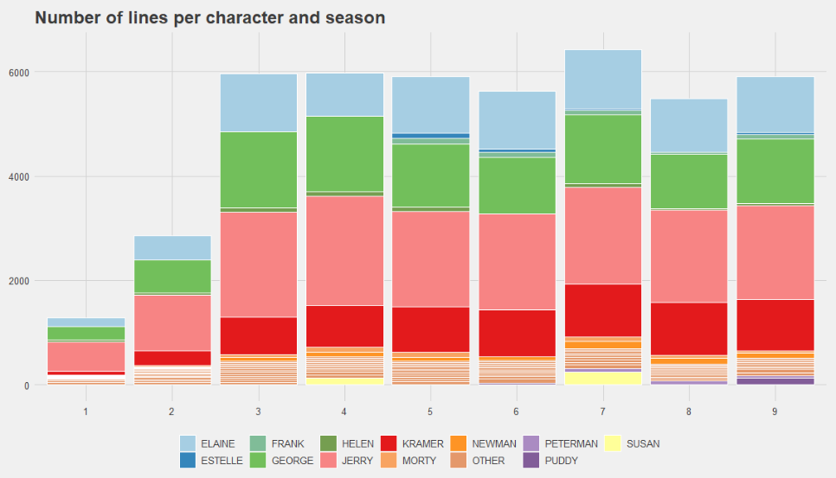
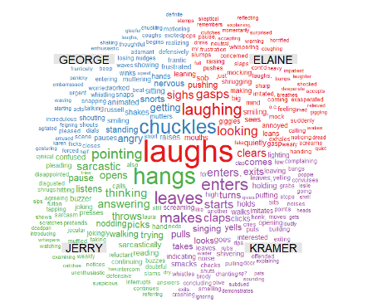
Through text and sentiment analysis approach, based on the dataset, one is able to examine which episode is mostly appreciated among others which is ‘the keys’ from season 3. Statistically, the title of this movie is recalled over 60 times which is more than the conseemable amount compared to others. This means that it is highly popular compared to the other seasonal episodes. Going indept to the episode, we assume it being the best due to its content of the episode. For example, the reason why that episode is continuously being recalled may be due to it being funny, motivational and etc. As we can see, the number of lines which the main character would speak in their scripts are not goverend by the main characters but most probably are depicted based on other characters overall script. Therefore, if we specify directly into 1 main character, Jerry wins as he is the one with the highest script lines along with how much priority is given to him in the episode. This proves theoreticallly that he is the main character of the episodes. However, when we look at his performance by comparing his line rates based on how they were prioritized, he would score the lowest. This may indicate that he is in a lot of pressure or does not seem to have sufficient time to get ready for his parts due to maybe conflicting schedules not just seasonally, but through each and a majority of the episodes. As we can see also, based on the stacked bar charts, the number of lines for each season depicts Jerry as most. So, does this mean he is depressed despite having a large workload? Now, we would analyze his word sentiments based on what he says in his script. From the wordcloud, we can see that Jerry’s words are somehow positive with words such as hangs, thinking and sarcastic. From the words, the analysis does not depict him as being fully positive but it shows that he is slightly happy but also feels neutral based on his word sentiments. Why? The analysis does not depict it but assuming that from the majority of his work, he depicts with the largest workload. So, it may indicate that he feels somehow tired but trys to look at the positive side and be sarcastic about it.

Lessons learned
This task depicted in this assignment was completed during the outdoor sessions of my class with students and I discussing theoretically about what we can do and learn from this assignment. Despite choosing different datasets from my peers, we conducted online and in-class discussions aiming on how we can work together indirectly to synthesize findings and create meaningful analysis to story tell. From linking our online lectures and in class discussions, we followed and learnt new principles through blended learning designs as we were able to lay out clear links between in and out of class activities. With the sequence of this assignment where I can depict any form of analysis, I originally chose twitter as my choice before changing to this dataset. The reason for doing so is because I wanted to learn how can I use an API to depict/scrape tweets from a particular website. As a result, I have learnt how to do it. However, due to the lack of time and inconsistencies that I was pertaining to create analysis based on my scraped dataset, I chose to move on to another dataset which was this. With this new assignment, I had decided to perform a text mining with a slight sentimental approach with this new dataset. However, my approached doing this analysis had made me curious in Rshiny. According to my lecturer, Dr Lau Sian Lun, shiny is used when we would like to visualize something categorically. For example, with a wordcloud, one can depict the size of wordcloud using a slicer.

What mistakes I have made and how will I do things differently?
Throughout this assignment, I guess I have made many mistakes such as writing my code without planning. High-quality written content, in general, cannot be created easily as It requires careful thinking and research. Since writing good algorithms come with a process flow where one should think, research, plan, write , validate and modify, I learnt that I should evaluate my written code based on if I have planned for that to happen or not. For example, I listed lots of online sources to refer from to do my analysis for this assignment but sadly, I did not use all of them. Therefore, high-quality programs are no exception. Also, another mistake is I have planned too much and coded way more than the required amount. As a result of coding too much, a lot of my work is left wasted as I did not use them. Sometimes, I wonder why I would do this but mainly it is because I fear that I may lack sufficient materials for analysis, evaluation and etc. Therefore, at this near end of the assignment, I would construct flowcharts more often so that I would be able to depict what I need to program accordingly without creating wasted effort.

Did you see something that should be improved?
Based on the assignment, the one thing that I see needs improvement in my code is better visualization details. As it is, Rshiny is very good for visualization. Therefore, using Rshiny for wordclouds, charts and etc will help create frequency distributions between charts through the usage of slicers.
What Went Right
Based on the assignment, the one thing that I would say that has turned out right is I have managed to learn about the usage of the twitter API. Despite not using the scraped dataset that I have created via using the twitter developer account, I am glad that I have learnt this as I believe in the future upcoming subjects of my degree such as social media analytics, Final Year Project, this will be useful. Moreover, not just in my student life, but this may be crucial too if I work for twitter in the future.
Reflections on the learning and appreciation of the techniques used and analysis done
First and foremost, I have always been somebody who is interested in many things at a single time but I cannot be good at so many things, but I plan to be good enough for the specific purposes for specific period sof time. My practice with programming has been the same.I learned C, C++ from my mum and these are the 2 languages that I am most familiar with even though I have learnt others. Throughout this course, I have been introduced to a new programming language called R. As my interest in open data programming is strong, I was able to learn this languages just enough to finish tasks at hand despite it being slightly difficult due to time constraints. Throughout this semester, I have used R for my homework along with other assignment projects. Although I was able to finish what I had to when I had to, I had a feeling that my programming methods were non-elegant nor efficient as I still lacked experience in this language. Just about a month ago, this assignment was released and from this assignment, I have learnt many new R techniques used for analysis. For example, API, Rshiny, text mining, sentiment analysis and many more. A part from this, the R conference which was scheduled this semester had helped me increase my general knowledge about R as I have been introduced to various new R programming techniques via data analysis. A couple of weeks ago, I was making a graph for an academic assignment, Analytics Engineering and I was using R to help solve my data cleaning problems. The way I made it work took more than 60 lines of script for a simple visualization. Even so, the visualizations included in the images that I have made included maps and etc. Also, I believed there are other good packages used for data processing. I searched around for various methods to process data like I had, and I found out that it could be done by a package ‘dplyr’ with a few lines of code. I used to do the task by repeating a command for all rows. However, It made a clunky script that worked fine but failed to satisfy the programmer in me. For programming in R and other languages as well, I believe there are only a few ways I learn properly which is by starting from scratch, taking enough time to learn, practicing and producing something out of the knowledge and etc. I rarely follow standard learning tracks like online courses or books as I believe that there are no specific solutions to code anything but there are various techniques applicable for students.
In contrast to this, after having the opportunity to explore the use of text mining along with a sentiment approach, I have learnt to analyze information in more depictable manner which is by planning my research questions first before analyzing different various variations of code. A part from this, data-mining techniques through text mining base is what I have done for my assignment I believe are flexible and powerful even the tool has several limitations. The bag-of-words approach/sentiment analysis is one of the analysis used in my assignment. Both text mining and sentiment overlook a great deal of information that might have been relevant to help tease apart more nuanced hypotheses based on relevant examples. Furthermore, while the bag-of-words is one text mining approach, it is not the only computerized technique available. Indeed, other more powerful tools can supplement or replace such an approach. For instance, some computerized linguistic analyses exist that can provide measures of coherence and cohesion in text documents. One such technique is the Coh-Metrix (Graesser, McNamara, Louwerse, & Cai, 2004), a free online tool that provides more than a hundred different indices with text characteristics. In concluaion, with this tool one can supplement the findings about differences and similarities between the students’ and experts’ analytics and etc.
Reference | Graesser, A. C., McNamara, D. S., Louwerse, M. M., & Cai, Z. (2004). Coh-Metrix: Analysis of text on cohesion and language. Behavior Research Methods, Instruments, & Computers, 36(2), 193-202.

