Tower of Hanoi (Using Python language. Implemented through Stack Data Structure)

⟫ Team Members

- Isaiah Andrei Noda
- Hannali Olayvar

⟫ Development Process Overview

October 4, 2025 – Planning and Setup
Objective: Discuss setup on how to collaborate
Actions Taken:
- Created a GitHub repository for version control and remote collaboration.
- Selected Live Share extension in Visual Studio Code for collaborative coding.
- Initialized and cloned the repository locally for each team member.
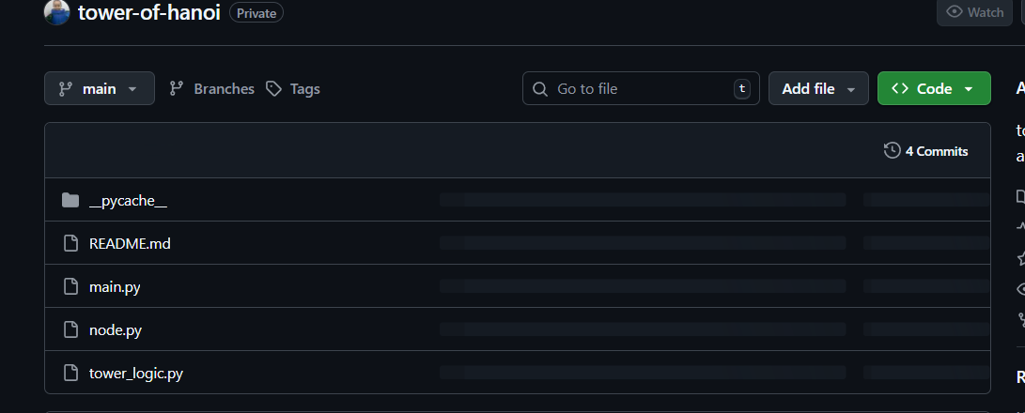
- Discussed git controls

October 5, 2025 – Initial Design and Logic Planning
Objective: Finalize implementation logic and plan data representation.
Ideas Made:
- Idea: Initially considered storing numerical values in stack and converting them to asterisks during display.
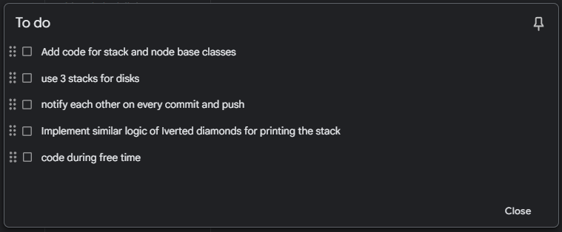
- Idea: To use list for printing and splitting each list based on newline separator.

October 6, 2025 – Coding and Implementation
Objective: Implement code for logic without stack first (we used stack immediately)
Actions Taken:
- Reused Stack and Node classes from tower logic module.
- Created three main stacks (A, B, C) instances.
- Created initializeStacks() to create towers.
- Created display () to print stacks side-by-side with stacks centered. Lists were not used, and opted to use stack directly to lessen memory usage. Stored asterisks directly instead of numbers to lessen code.
- Added validation for user disk input (3–10).
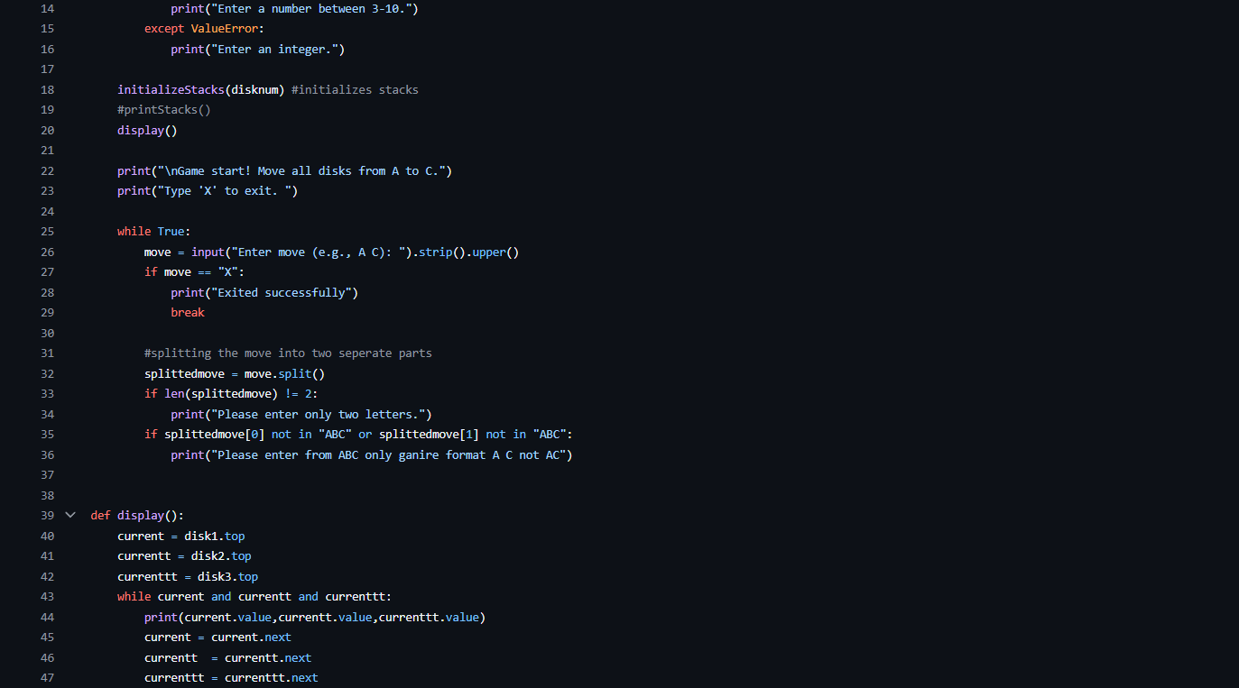
- Used Live Share for 3-hour joint coding session.

⟫ Technical Specifications
Main Components:
- Three Stack instances (disk1, disk2, disk3) represent towers A, B, and C.
- Main class handles program flow.
- Node class contains structure of a Node,
- Stack class contains structure of a class and operations.
- initializeStacks() fills the stacks with disks represented by strings of asterisks (*).
- display() prints the towers side by side
Tools and Environment
GitHub – Version control and remote collaboration.
Visual Studio Code – IDE
(Live Share) – Real-time collaborative coding Extension.
Python 3 – Programming language used.
tower_logic.py – Contains Stack and Node class definitions.

