YOUR TITLE：

Student name（中文+名字拼音：举例：张三）
张三 San Zhang

School name:中英文：举例：厦门大学
Xiamen University

Research Problem and Objectives

1.1 Research problems

1.3 Research objectives
The research aims to ...

The primary objectives of this research are:
A
B
B
D

Literature review

Research Methodology

Expected Results and Significance

It is expected that...

The significance of this research...

References

1.
2.
3.
4.
5.
...

Appendix

Figure 1: Kinaxis User interface (example)
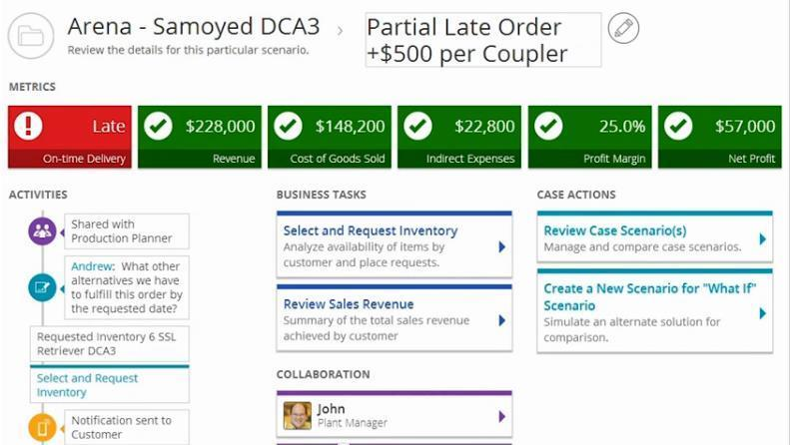
Source: Computer Economics, 2014
Figure 2: Summary of social media usage in the agile supply chain (example)
Virtual Integration | Market Sensitivity | Process Integration | Network Based
- Fast identification and communication of risks.  - Easier SCP.  - Tracking of shipments.  - End-to-end visibility.  - Increased Supply Chain Risk Management.  - Collaborative planning.  Kinaxis, Twitter, Source Map | - Two-way conversations with internal and external customers.  - Monitoring of user-generated information.  - Facilitates speed-to-market.  - Better prediction and capturing of emerging trends.  Twitter, Facebook, Blogs, Youtube. | - Seamless integration of processes  - Useful during product design.  - Encourages innovation.  - Collaborative design.  - Allows for transparency.  Yammer, Source Map, Social Enterprise Resource Planning, Freight Friend. | - Training of stakeholders.  - Facilitates  SRM.  - Improved performance of suppliers.  Google+, Supplier Wire, Yammer, Source Map, Social Text, Blogs.

