

1. 概念说明
GumballState 是状态模式的经典例子：糖果机在不同状态下对投入硬币、退币、转动曲柄和补货的响应不同。
本次改写采用 GUI 形式，把命令行交互改为按钮操作；状态转移逻辑仍由原来的状态类负责。

2. 改写思路
GUI 层用 Swing 实现，提供投入硬币、退回硬币、转动曲柄、补充库存等按钮。同时把 System.out 重定向到文本区，从而把状态类原本输出到控制台的信息显示在窗口中。
这样改写后，既保留了原始状态机行为，又让交互更直观，适合演示状态变化过程。

3. 源码
===== GumballMachine.java =====
//package headfirst.designpatterns.state.gumballstate;
public class GumballMachine {
State soldOutState;
State noQuarterState;
State hasQuarterState;
State soldState;
State state;
int count = 0;
public GumballMachine(int numberGumballs) {
soldOutState = new SoldOutState(this);
noQuarterState = new NoQuarterState(this);
hasQuarterState = new HasQuarterState(this);
soldState = new SoldState(this);
this.count = numberGumballs;
if (numberGumballs > 0) {
state = noQuarterState;
} else {
state = soldOutState;
}
}
public void insertQuarter() {
state.insertQuarter();
}
public void ejectQuarter() {
state.ejectQuarter();
}
public void turnCrank() {
state.turnCrank();
state.dispense();
}
void releaseBall() {
System.out.println("A gumball comes rolling out the slot...");
if (count != 0) {
count = count - 1;
}
}
int getCount() {
return count;
}
void refill(int count) {
this.count += count;
System.out.println("The gumball machine was just refilled; it's new count is: " + this.count);
state.refill();
}
void setState(State state) {
this.state = state;
}
public State getState() {
return state;
}
public State getSoldOutState() {
return soldOutState;
}
public State getNoQuarterState() {
return noQuarterState;
}
public State getHasQuarterState() {
return hasQuarterState;
}
public State getSoldState() {
return soldState;
}
public String toString() {
StringBuffer result = new StringBuffer();
result.append("\nMighty Gumball, Inc.");
result.append("\nJava-enabled Standing Gumball Model #2004");
result.append("\nInventory: " + count + " gumball");
if (count != 1) {
result.append("s");
}
result.append("\n");
result.append("Machine is " + state + "\n");
return result.toString();
}
}
===== State.java =====
//package headfirst.designpatterns.state.gumballstate;
public interface State {
public void insertQuarter();
public void ejectQuarter();
public void turnCrank();
public void dispense();
public void refill();
}
===== NoQuarterState.java =====
//package headfirst.designpatterns.state.gumballstate;
public class NoQuarterState implements State {
GumballMachine gumballMachine;
public NoQuarterState(GumballMachine gumballMachine) {
this.gumballMachine = gumballMachine;
}
public void insertQuarter() {
System.out.println("You inserted a quarter");
gumballMachine.setState(gumballMachine.getHasQuarterState());
}
public void ejectQuarter() {
System.out.println("You haven't inserted a quarter");
}
public void turnCrank() {
System.out.println("You turned, but there's no quarter");
}
public void dispense() {
System.out.println("You need to pay first");
}
public void refill() { }
public String toString() {
return "waiting for quarter";
}
}
===== HasQuarterState.java =====
//package headfirst.designpatterns.state.gumballstate;
//import java.util.Random;
public class HasQuarterState implements State {
GumballMachine gumballMachine;
public HasQuarterState(GumballMachine gumballMachine) {
this.gumballMachine = gumballMachine;
}
public void insertQuarter() {
System.out.println("You can't insert another quarter");
}
public void ejectQuarter() {
System.out.println("Quarter returned");
gumballMachine.setState(gumballMachine.getNoQuarterState());
}
public void turnCrank() {
System.out.println("You turned...");
gumballMachine.setState(gumballMachine.getSoldState());
}
public void dispense() {
System.out.println("No gumball dispensed");
}
public void refill() { }
public String toString() {
return "waiting for turn of crank";
}
}
===== SoldState.java =====
//package headfirst.designpatterns.state.gumballstate;
public class SoldState implements State {
GumballMachine gumballMachine;
public SoldState(GumballMachine gumballMachine) {
this.gumballMachine = gumballMachine;
}
public void insertQuarter() {
System.out.println("Please wait, we're already giving you a gumball");
}
public void ejectQuarter() {
System.out.println("Sorry, you already turned the crank");
}
public void turnCrank() {
System.out.println("Turning twice doesn't get you another gumball!");
}
public void dispense() {
gumballMachine.releaseBall();
if (gumballMachine.getCount() > 0) {
gumballMachine.setState(gumballMachine.getNoQuarterState());
} else {
System.out.println("Oops, out of gumballs!");
gumballMachine.setState(gumballMachine.getSoldOutState());
}
}
public void refill() { }
public String toString() {
return "dispensing a gumball";
}
}
===== SoldOutState.java =====
//package headfirst.designpatterns.state.gumballstate;
public class SoldOutState implements State {
GumballMachine gumballMachine;
public SoldOutState(GumballMachine gumballMachine) {
this.gumballMachine = gumballMachine;
}
public void insertQuarter() {
System.out.println("You can't insert a quarter, the machine is sold out");
}
public void ejectQuarter() {
System.out.println("You can't eject, you haven't inserted a quarter yet");
}
public void turnCrank() {
System.out.println("You turned, but there are no gumballs");
}
public void dispense() {
System.out.println("No gumball dispensed");
}
public void refill() {
gumballMachine.setState(gumballMachine.getNoQuarterState());
}
public String toString() {
return "sold out";
}
}
===== GumballGuiApp.java =====
import javax.swing.*;
import java.awt.*;
import java.io.OutputStream;
import java.io.PrintStream;
import java.nio.charset.StandardCharsets;
class TextAreaOutputStream extends OutputStream {
private final JTextArea textArea;
public TextAreaOutputStream(JTextArea textArea) {
this.textArea = textArea;
}
@Override
public void write(int b) {
textArea.append(String.valueOf((char) b));
}
@Override
public void write(byte[] b, int off, int len) {
textArea.append(new String(b, off, len, StandardCharsets.UTF_8));
}
}
public class GumballGuiApp {
private final GumballMachine gumballMachine;
private final JTextArea logArea;
private final JLabel statusLabel;
private final JLabel countLabel;
public GumballGuiApp() {
gumballMachine = new GumballMachine(3);
logArea = new JTextArea(18, 42);
statusLabel = new JLabel();
countLabel = new JLabel();
redirectStdOut();
}
private void redirectStdOut() {
PrintStream guiStream = new PrintStream(new TextAreaOutputStream(logArea), true, StandardCharsets.UTF_8);
System.setOut(guiStream);
}
private void refreshStatus() {
statusLabel.setText("状态: " + gumballMachine.getState());
countLabel.setText("糖果球数量: " + gumballMachine.getCount());
}
private void appendMachineState() {
System.out.println(gumballMachine);
refreshStatus();
}
private JPanel buildButtonPanel(JFrame frame) {
JPanel panel = new JPanel(new GridLayout(2, 2, 10, 10));
JButton insertButton = new JButton("投入25分");
insertButton.addActionListener(e -> {
gumballMachine.insertQuarter();
appendMachineState();
});
JButton ejectButton = new JButton("退回25分");
ejectButton.addActionListener(e -> {
gumballMachine.ejectQuarter();
appendMachineState();
});
JButton turnButton = new JButton("转动曲柄");
turnButton.addActionListener(e -> {
gumballMachine.turnCrank();
appendMachineState();
});
JButton refillButton = new JButton("补充5个");
refillButton.addActionListener(e -> {
gumballMachine.refill(5);
appendMachineState();
});
panel.add(insertButton);
panel.add(ejectButton);
panel.add(turnButton);
panel.add(refillButton);
return panel;
}
public void show() {
JFrame frame = new JFrame("Gumball State GUI");
frame.setDefaultCloseOperation(WindowConstants.EXIT_ON_CLOSE);
frame.setLayout(new BorderLayout(12, 12));
JTextArea machineArea = new JTextArea();
machineArea.setEditable(false);
machineArea.setFont(new Font(Font.MONOSPACED, Font.PLAIN, 14));
logArea.setEditable(false);
logArea.setFont(new Font(Font.MONOSPACED, Font.PLAIN, 13));
JPanel topPanel = new JPanel(new GridLayout(2, 1, 6, 6));
topPanel.add(statusLabel);
topPanel.add(countLabel);
frame.add(topPanel, BorderLayout.NORTH);
frame.add(buildButtonPanel(frame), BorderLayout.WEST);
frame.add(new JScrollPane(logArea), BorderLayout.CENTER);
appendMachineState();
frame.setSize(980, 520);
frame.setLocationRelativeTo(null);
frame.setVisible(true);
}
public static void main(String[] args) {
SwingUtilities.invokeLater(() -> new GumballGuiApp().show());
}
}

4. 系统运行截图
运行窗口展示按钮操作、状态信息和状态类输出日志。
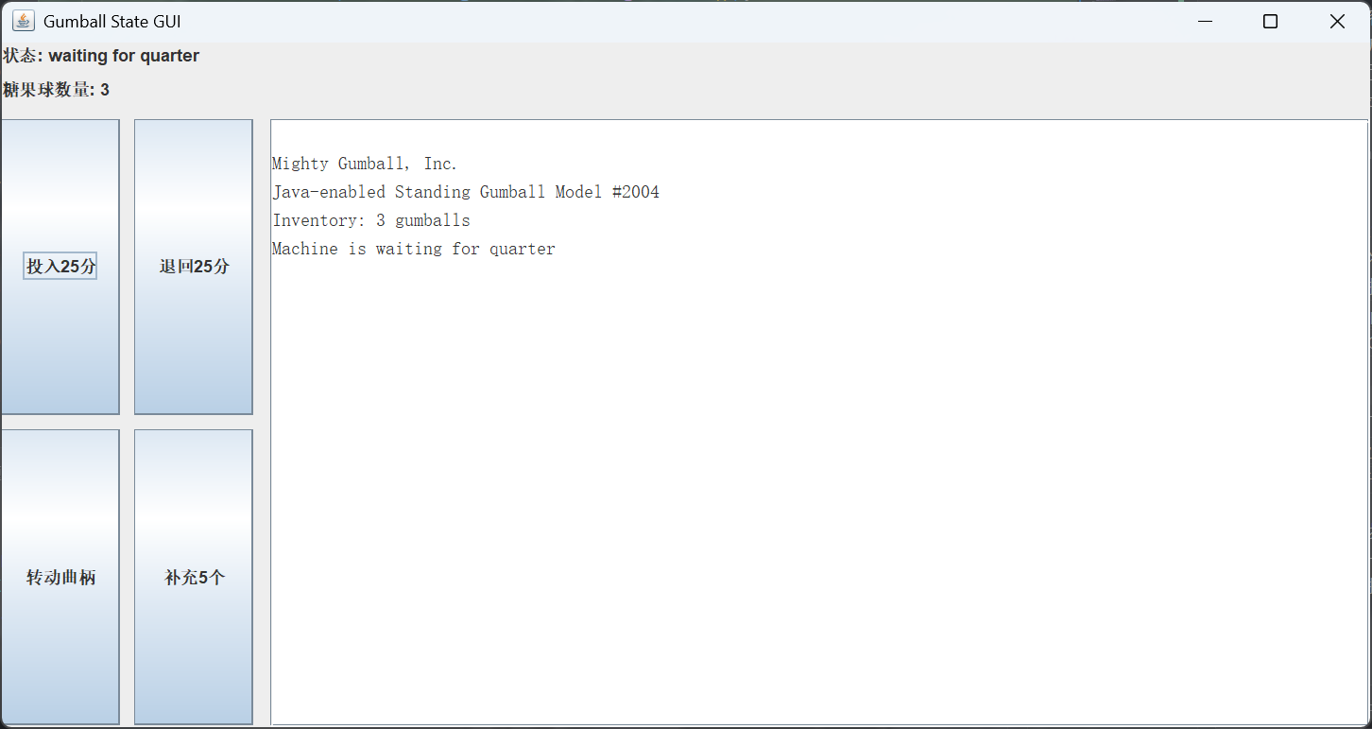

5. 运行结果
操作 | 界面表现
投入硬币 | 状态从 waiting for quarter 变为 waiting for turn of crank
转动曲柄 | 状态切换并出球
补充库存 | 库存增加并恢复可售状态
投入硬币：
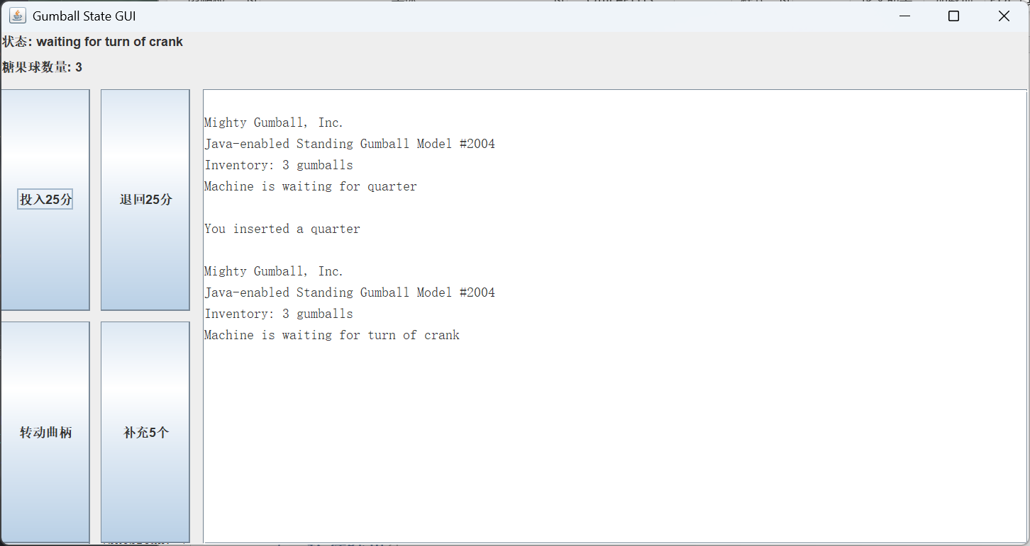
转动曲柄：
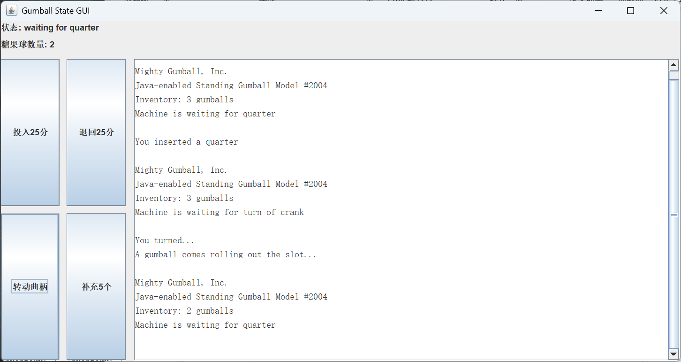
补充：
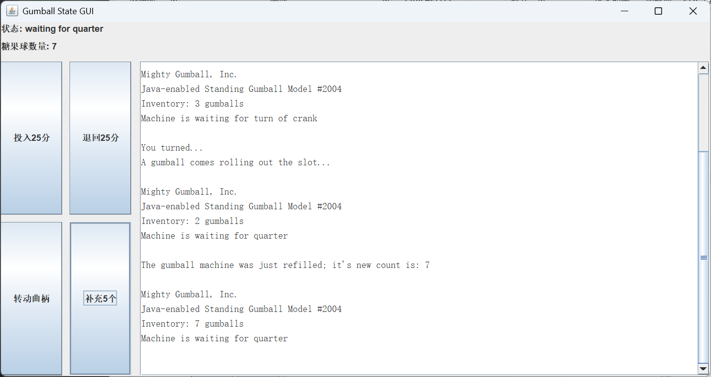
回退：
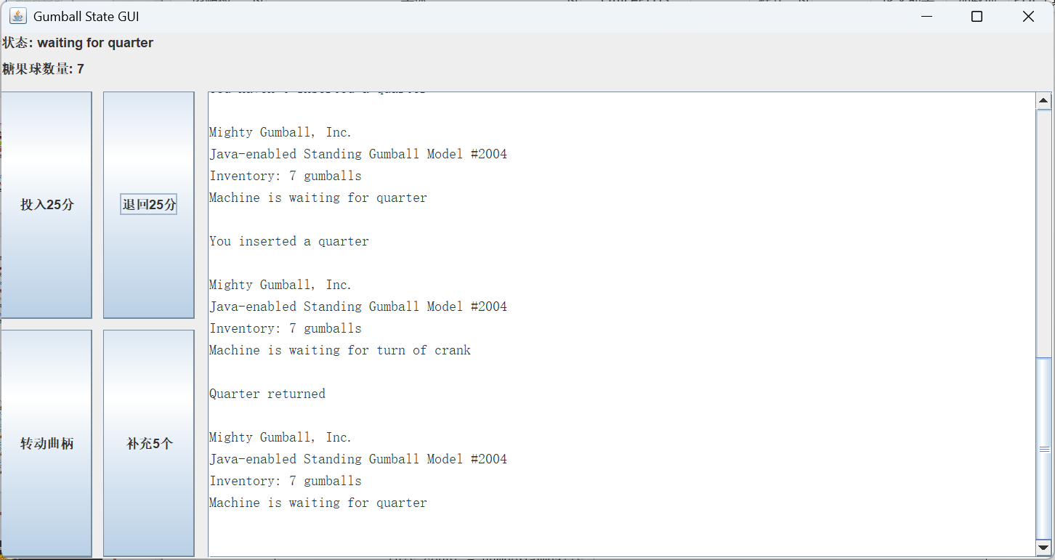
结论：GUI 改写让状态模式的行为更容易观察，同时不改变状态类内部的转移规则。

