1. 实现说明
本例使用 JDK 自带的 Observable 作为被观察者，Observer 作为观察者接口，在随机数变化时通知多个观察者输出不同形式的结果。
在课堂例子的基础上，我增加了 StatisticsObserver，用于统计已观察到的数值个数、最小值、最大值和平均值，让示例更完整。

2. 程序结构
NumberGenerator 负责抽象出通知机制，RandomNumberGenerator 负责生成随机数。
DigitObserver 直接输出数字，GraphObserver 用星号显示数量，StatisticsObserver 输出统计信息。

3. 源码
===== NumberGenerator.java =====
import java.util.Observable;
@SuppressWarnings("deprecation")
public abstract class NumberGenerator extends Observable {
public abstract int getNumber();
public abstract void execute();
}
===== RandomNumberGenerator.java =====
import java.util.Random;
@SuppressWarnings("deprecation")
public class RandomNumberGenerator extends NumberGenerator {
private final Random random = new Random(20260523L);
private int number;
@Override
public int getNumber() {
return number;
}
@Override
public void execute() {
for (int i = 0; i < 10; i++) {
number = random.nextInt(50) + 1;
setChanged();
notifyObservers();
}
}
}
===== DigitObserver.java =====
import java.util.Observable;
import java.util.Observer;
@SuppressWarnings("deprecation")
public class DigitObserver implements Observer {
@Override
public void update(Observable observable, Object argument) {
NumberGenerator generator = (NumberGenerator) observable;
System.out.println("DigitObserver: " + generator.getNumber());
try {
Thread.sleep(100);
} catch (InterruptedException exception) {
Thread.currentThread().interrupt();
}
}
}
===== GraphObserver.java =====
import java.util.Observable;
import java.util.Observer;
@SuppressWarnings("deprecation")
public class GraphObserver implements Observer {
@Override
public void update(Observable observable, Object argument) {
NumberGenerator generator = (NumberGenerator) observable;
int number = generator.getNumber();
StringBuilder builder = new StringBuilder("GraphObserver: ");
for (int i = 0; i < number; i++) {
builder.append('*');
}
System.out.println(builder);
try {
Thread.sleep(100);
} catch (InterruptedException exception) {
Thread.currentThread().interrupt();
}
}
}
===== StatisticsObserver.java =====
import java.util.ArrayList;
import java.util.List;
import java.util.Locale;
import java.util.Observable;
import java.util.Observer;
@SuppressWarnings("deprecation")
public class StatisticsObserver implements Observer {
private final List<Integer> history = new ArrayList<>();
@Override
public void update(Observable observable, Object argument) {
NumberGenerator generator = (NumberGenerator) observable;
int number = generator.getNumber();
history.add(number);
int min = history.stream().mapToInt(Integer::intValue).min().orElse(number);
int max = history.stream().mapToInt(Integer::intValue).max().orElse(number);
double average = history.stream().mapToInt(Integer::intValue).average().orElse(number);
System.out.printf(Locale.US, "StatisticsObserver: count=%d, min=%d, max=%d, avg=%.2f%n",
history.size(), min, max, average);
}
}
===== Main.java =====
public class Main {
public static void main(String[] args) {
RandomNumberGenerator generator = new RandomNumberGenerator();
generator.addObserver(new DigitObserver());
generator.addObserver(new GraphObserver());
generator.addObserver(new StatisticsObserver());
generator.execute();
}
}

4. 系统运行截图
下图为程序运行时的控制台输出截图。
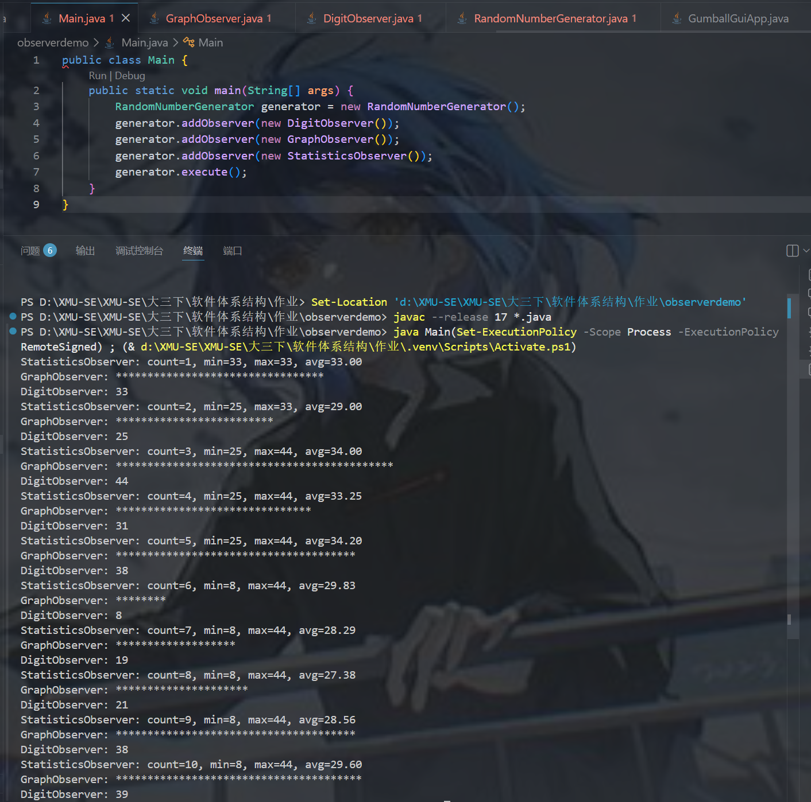

5. 运行结果
观察者 | 输出效果
DigitObserver | 输出随机数值
GraphObserver | 按数值大小输出对应数量的星号
StatisticsObserver | 输出当前观察次数及统计结果
结论：程序使用 Observable/Observer 完成了经典课堂例子，并在此基础上增加了统计观察者。

