

1. 课堂例子说明
课堂中的策略模式例子通常以剪刀、石头、布游戏为背景，Player 持有 Strategy 接口，具体策略负责决定下一手出什么。
我保留了 Hand、Strategy、WinningStrategy、ProbStrategy、Player 这些核心角色，只把命令行输出改成了 Swing GUI。

2. GUI 改写思路
界面上提供种子输入框、策略选择、开始/重置按钮和下一局按钮。点击按钮后，玩家会按照当前策略出拳，并在日志区显示每一局的结果。
这样既符合策略模式“算法可替换”的核心，也让用户能直接看到策略切换后的对战过程。

3. 源码
===== Hand.java =====
public class Hand {
public static final int HANDVALUE_GUU = 0;
public static final int HANDVALUE_CHO = 1;
public static final int HANDVALUE_PAA = 2;
private static final Hand[] hands = {
new Hand(HANDVALUE_GUU),
new Hand(HANDVALUE_CHO),
new Hand(HANDVALUE_PAA)
};
private static final String[] names = {"石头", "剪刀", "布"};
private final int handValue;
private Hand(int handValue) {
this.handValue = handValue;
}
public static Hand getHand(int handValue) {
return hands[handValue];
}
public boolean isStrongerThan(Hand other) {
return fight(other) == 1;
}
public boolean isWeakerThan(Hand other) {
return fight(other) == -1;
}
private int fight(Hand other) {
if (this == other) {
return 0;
}
if ((this.handValue + 1) % 3 == other.handValue) {
return 1;
}
return -1;
}
@Override
public String toString() {
return names[handValue];
}
}
===== Strategy.java =====
public interface Strategy {
Hand nextHand();
void study(boolean win);
}
===== WinningStrategy.java =====
import java.util.Random;
public class WinningStrategy implements Strategy {
private final Random random;
private boolean won = false;
private Hand prevHand;
public WinningStrategy(int seed) {
this.random = new Random(seed);
}
@Override
public Hand nextHand() {
if (!won) {
prevHand = Hand.getHand(random.nextInt(3));
}
return prevHand;
}
@Override
public void study(boolean win) {
won = win;
}
}
===== ProbStrategy.java =====
import java.util.Random;
public class ProbStrategy implements Strategy {
private final Random random;
private int prevHandValue = 0;
private int currentHandValue = 0;
private final int[][] history = {
{1, 1, 1},
{1, 1, 1},
{1, 1, 1}
};
public ProbStrategy(int seed) {
this.random = new Random(seed);
}
@Override
public Hand nextHand() {
int bet = random.nextInt(getSum(currentHandValue));
int handValue = 0;
if (bet < history[currentHandValue][0]) {
handValue = 0;
} else if (bet < history[currentHandValue][0] + history[currentHandValue][1]) {
handValue = 1;
} else {
handValue = 2;
}
prevHandValue = currentHandValue;
currentHandValue = handValue;
return Hand.getHand(handValue);
}
private int getSum(int handValue) {
int sum = 0;
for (int i = 0; i < 3; i++) {
sum += history[handValue][i];
}
return sum;
}
@Override
public void study(boolean win) {
if (win) {
history[prevHandValue][currentHandValue]++;
} else {
history[prevHandValue][(currentHandValue + 1) % 3]++;
history[prevHandValue][(currentHandValue + 2) % 3]++;
}
}
}
===== Player.java =====
public class Player {
private final String name;
private final Strategy strategy;
private int winCount;
private int loseCount;
private int gameCount;
public Player(String name, Strategy strategy) {
this.name = name;
this.strategy = strategy;
}
public Hand nextHand() {
return strategy.nextHand();
}
public void win() {
strategy.study(true);
winCount++;
gameCount++;
}
public void lose() {
strategy.study(false);
loseCount++;
gameCount++;
}
public void even() {
gameCount++;
}
public int getWinCount() {
return winCount;
}
public int getLoseCount() {
return loseCount;
}
public int getGameCount() {
return gameCount;
}
@Override
public String toString() {
return "[" + name + ": " + gameCount + "场, " + winCount + "胜, " + loseCount + "负]";
}
}
===== StrategyGameFrame.java =====
import javax.swing.*;
import java.awt.*;
import java.util.Locale;
public class StrategyGameFrame extends JFrame {
private final JTextField seed1Field = new JTextField("314", 8);
private final JTextField seed2Field = new JTextField("15", 8);
private final JRadioButton winningRadio = new JRadioButton("WinningStrategy", true);
private final JRadioButton probRadio = new JRadioButton("ProbStrategy");
private final JTextArea logArea = new JTextArea(18, 56);
private final JLabel summaryLabel = new JLabel("准备开始对战");
private Player player1;
private Player player2;
private int round = 0;
public StrategyGameFrame() {
super("Strategy Pattern GUI");
setDefaultCloseOperation(WindowConstants.EXIT_ON_CLOSE);
setLayout(new BorderLayout(12, 12));
logArea.setEditable(false);
logArea.setFont(new Font(Font.MONOSPACED, Font.PLAIN, 14));
summaryLabel.setFont(summaryLabel.getFont().deriveFont(Font.BOLD, 15f));
add(buildTopPanel(), BorderLayout.NORTH);
add(new JScrollPane(logArea), BorderLayout.CENTER);
add(buildBottomPanel(), BorderLayout.SOUTH);
setSize(1060, 650);
setLocationRelativeTo(null);
}
private JPanel buildTopPanel() {
JPanel panel = new JPanel(new GridLayout(3, 1, 8, 8));
JPanel seedPanel = new JPanel(new FlowLayout(FlowLayout.LEFT));
seedPanel.add(new JLabel("种子1:"));
seedPanel.add(seed1Field);
seedPanel.add(new JLabel("种子2:"));
seedPanel.add(seed2Field);
JPanel strategyPanel = new JPanel(new FlowLayout(FlowLayout.LEFT));
ButtonGroup group = new ButtonGroup();
group.add(winningRadio);
group.add(probRadio);
strategyPanel.add(new JLabel("玩家1策略:"));
strategyPanel.add(winningRadio);
strategyPanel.add(probRadio);
JPanel buttonPanel = new JPanel(new FlowLayout(FlowLayout.LEFT));
JButton startButton = new JButton("开始/重置");
JButton nextButton = new JButton("下一局");
startButton.addActionListener(e -> startGame());
nextButton.addActionListener(e -> playOneRound());
buttonPanel.add(startButton);
buttonPanel.add(nextButton);
panel.add(seedPanel);
panel.add(strategyPanel);
panel.add(buttonPanel);
return panel;
}
private JPanel buildBottomPanel() {
JPanel panel = new JPanel(new BorderLayout());
panel.add(summaryLabel, BorderLayout.CENTER);
return panel;
}
private Strategy createStrategy(boolean useWinning, int seed) {
return useWinning ? new WinningStrategy(seed) : new ProbStrategy(seed);
}
private void startGame() {
try {
int seed1 = Integer.parseInt(seed1Field.getText().trim());
int seed2 = Integer.parseInt(seed2Field.getText().trim());
boolean useWinning = winningRadio.isSelected();
player1 = new Player("Taro", createStrategy(useWinning, seed1));
player2 = new Player("Hana", createStrategy(!useWinning, seed2));
round = 0;
logArea.setText("");
summaryLabel.setText("已重置，点击“下一局”开始比赛");
appendLog(String.format(Locale.US, "初始化：player1=%s, player2=%s", strategyName(useWinning), strategyName(!useWinning)));
appendLog(player1.toString());
appendLog(player2.toString());
} catch (NumberFormatException exception) {
JOptionPane.showMessageDialog(this, "请输入合法整数种子", "输入错误", JOptionPane.ERROR_MESSAGE);
}
}
private String strategyName(boolean useWinning) {
return useWinning ? "WinningStrategy" : "ProbStrategy";
}
private void playOneRound() {
if (player1 == null || player2 == null) {
startGame();
if (player1 == null || player2 == null) {
return;
}
}
round++;
Hand hand1 = player1.nextHand();
Hand hand2 = player2.nextHand();
appendLog(String.format(Locale.US, "第 %d 局: %s vs %s", round, hand1, hand2));
if (hand1.isStrongerThan(hand2)) {
player1.win();
player2.lose();
appendLog("结果: Player1 胜");
} else if (hand2.isStrongerThan(hand1)) {
player1.lose();
player2.win();
appendLog("结果: Player2 胜");
} else {
player1.even();
player2.even();
appendLog("结果: 平局");
}
appendLog(player1.toString());
appendLog(player2.toString());
summaryLabel.setText(String.format(Locale.US, "当前轮次：%d | %s | %s", round, player1, player2));
}
private void appendLog(String text) {
logArea.append(text + System.lineSeparator());
}
public static void main(String[] args) {
SwingUtilities.invokeLater(() -> new StrategyGameFrame().setVisible(true));
}
}

4. 系统运行截图
下图为 GUI 程序的运行界面与对战日志。
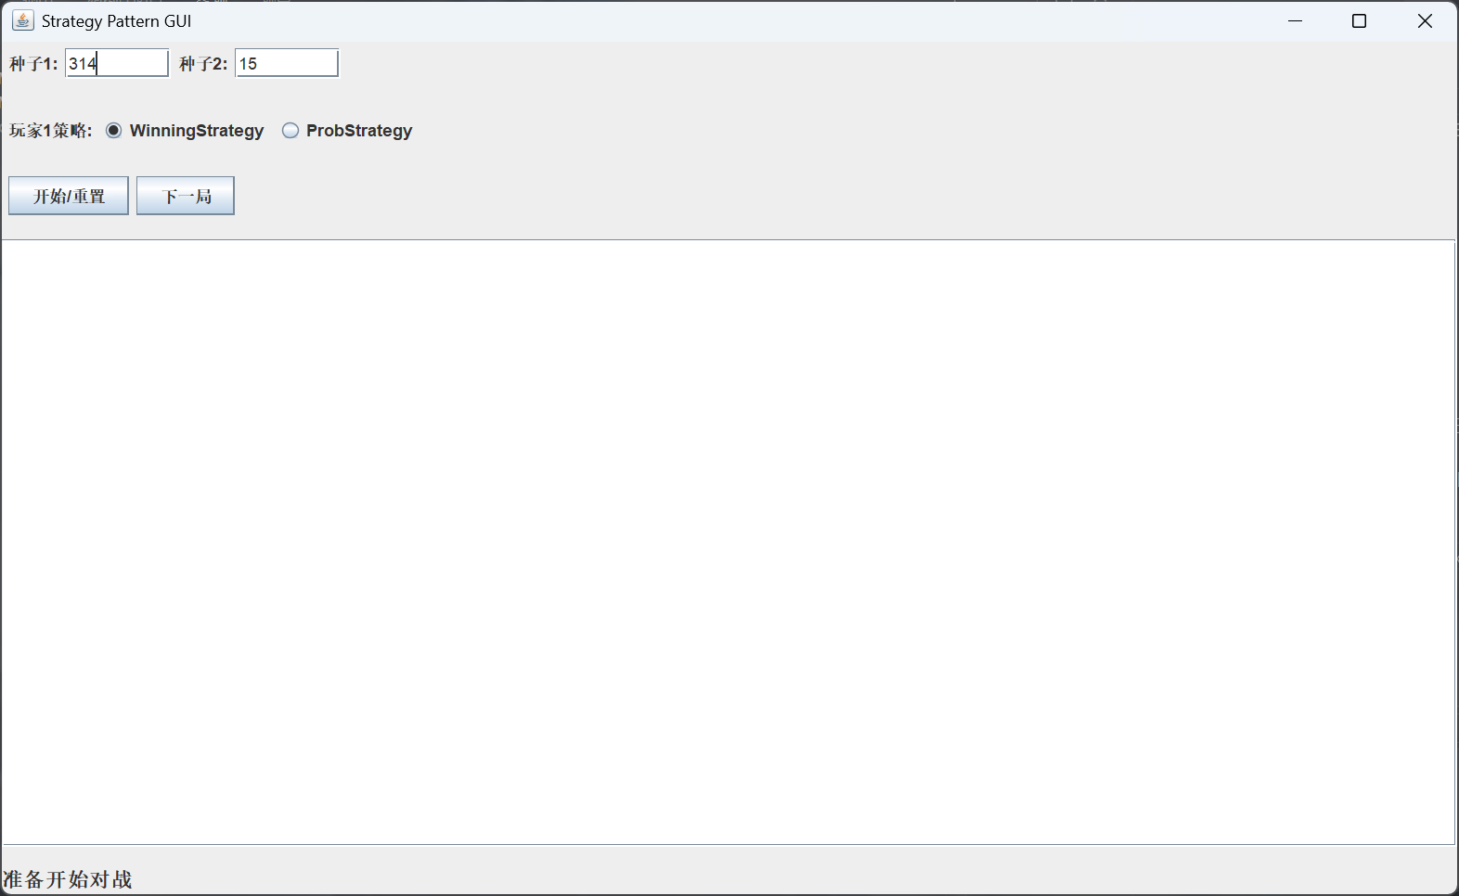

5. 运行结果
部分 | 说明
Strategy 接口 | 定义 nextHand() 和 study(boolean win)
ConcreteStrategy | WinningStrategy 和 ProbStrategy 提供不同算法
Context | Player 持有 Strategy 并在 GUI 中参与对战
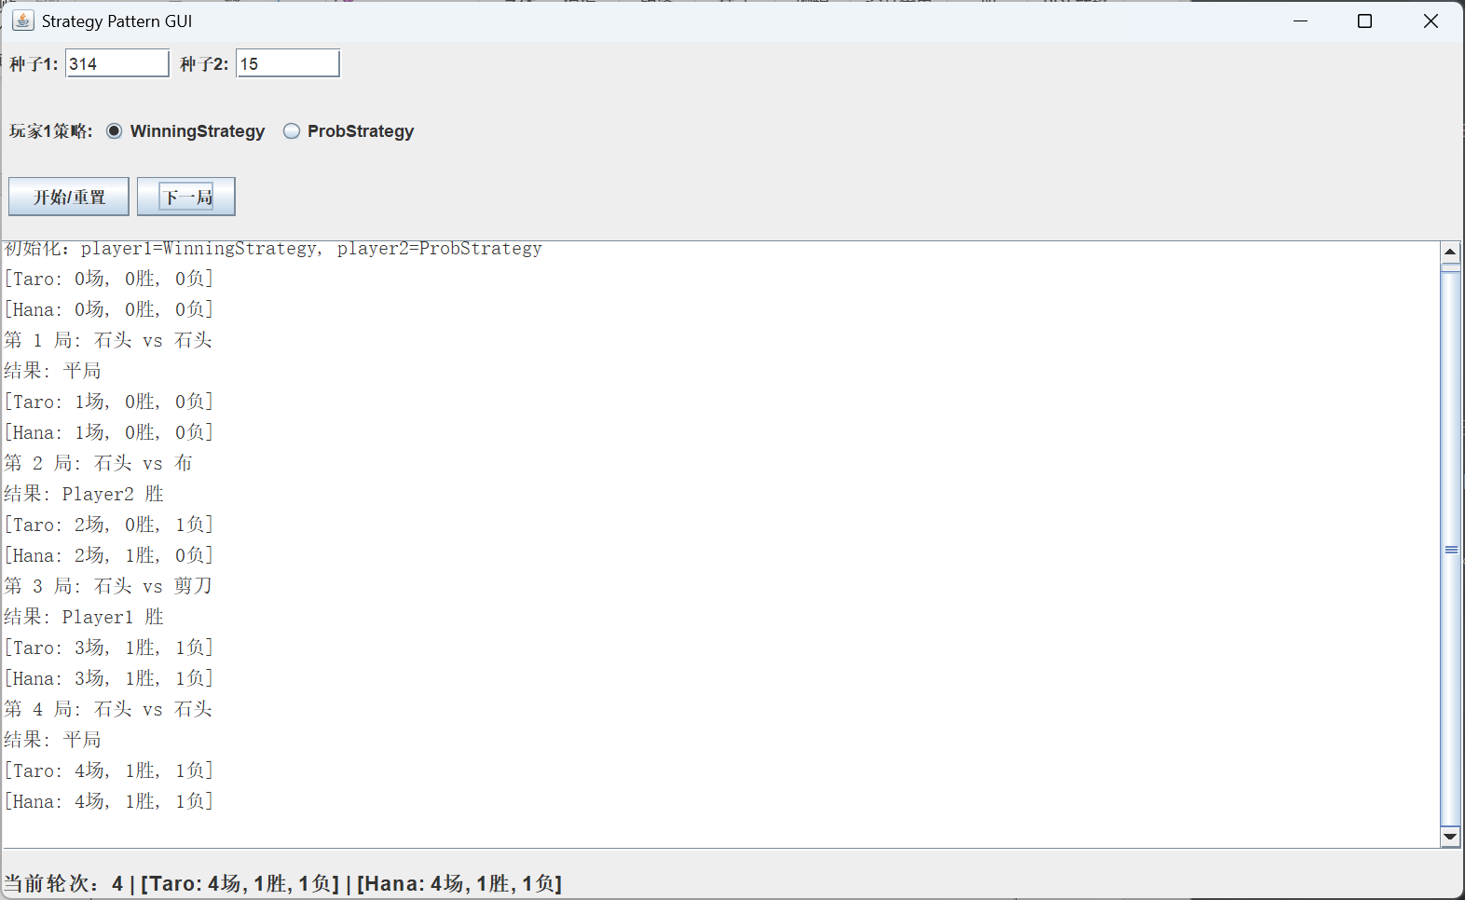
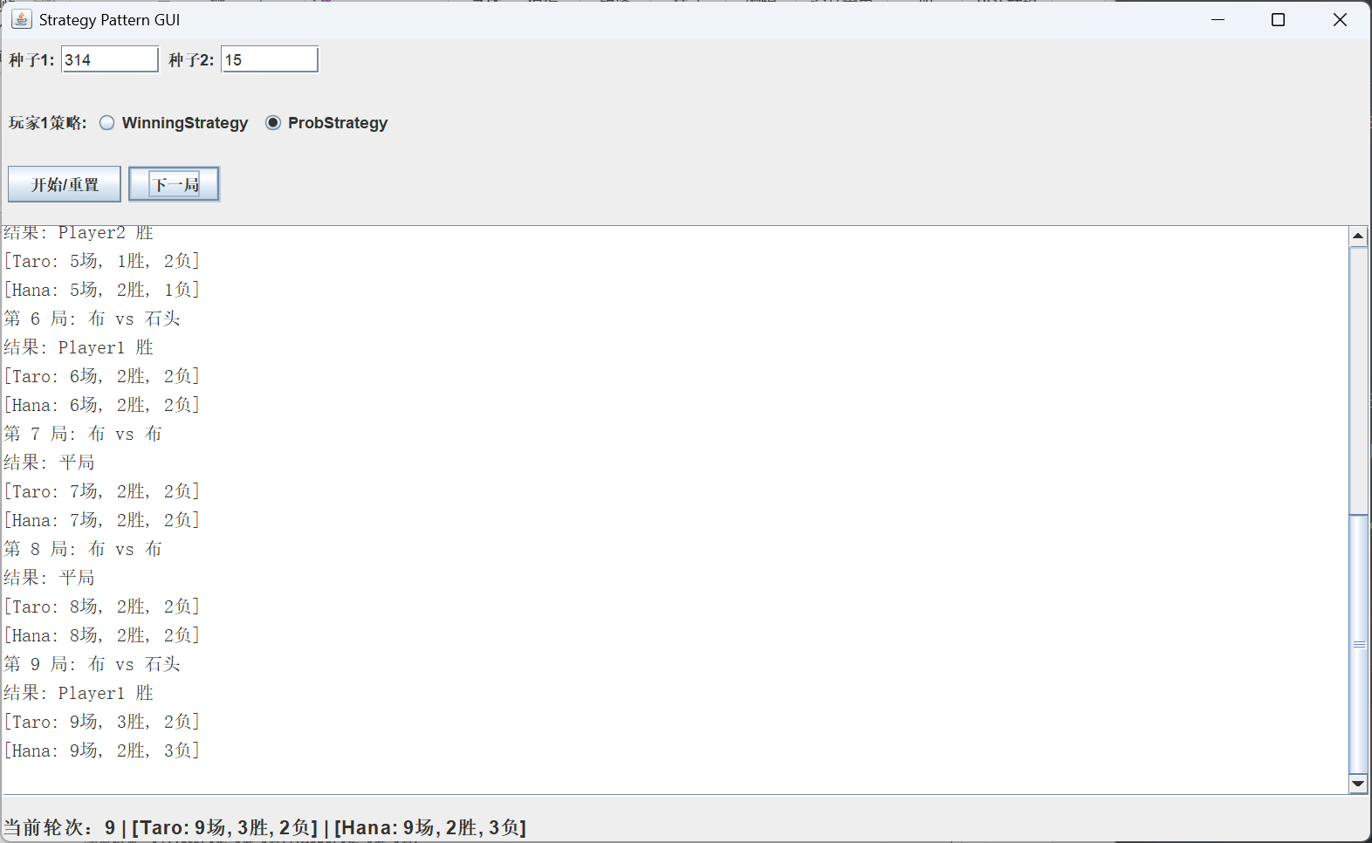
结论：这次改写把策略模式从控制台示例变成了可交互 GUI 示例，能够更直观地展示“算法可替换”的效果。

