1. 题意与改写思路
本例用组合模式将文件和目录统一抽象为 Component，目录是 Composite，文件是 Leaf。GUI 直接读取并展示工作区中的一个子目录。
用户点击“加载目录”后，程序会递归构建组合树，把目录和文件按树形结构显示出来。这样既体现了组合模式的“透明操作”特点，也满足“访问你的计算机某个子目录”的要求。

2. GUI 设计
界面包含路径输入框、加载/刷新按钮、左侧树形结构和右侧明细区域。树形结构展示目录层级，右侧文本显示 printList 的结果和总大小。

3. 源码
===== Component.java =====
public abstract class Component {
protected final String name;
protected Component(String name) {
this.name = name;
}
public String getName() {
return name;
}
public void add(Component component) {
throw new UnsupportedOperationException();
}
public void remove(Component component) {
throw new UnsupportedOperationException();
}
public Component getChild(int index) {
throw new UnsupportedOperationException();
}
public abstract long getSize();
public abstract String printList(String prefix);
@Override
public String toString() {
return name;
}
}
===== FileEntry.java =====
public class FileEntry extends Component {
private final long size;
public FileEntry(String name, long size) {
super(name);
this.size = size;
}
@Override
public long getSize() {
return size;
}
@Override
public String printList(String prefix) {
return prefix + "/" + this + " (" + size + " bytes)\n";
}
}
===== DirectoryEntry.java =====
import java.util.ArrayList;
import java.util.List;
public class DirectoryEntry extends Component {
private final List<Component> children = new ArrayList<>();
public DirectoryEntry(String name) {
super(name);
}
@Override
public void add(Component component) {
children.add(component);
}
@Override
public void remove(Component component) {
children.remove(component);
}
@Override
public Component getChild(int index) {
return children.get(index);
}
@Override
public long getSize() {
long size = 0;
for (Component child : children) {
size += child.getSize();
}
return size;
}
@Override
public String printList(String prefix) {
StringBuilder builder = new StringBuilder();
builder.append(prefix).append("/").append(this).append(" (dir, ").append(getSize()).append(" bytes)\n");
for (Component child : children) {
builder.append(child.printList(prefix + "/" + name));
}
return builder.toString();
}
public List<Component> getChildren() {
return children;
}
}
===== CompositeBuilder.java =====
import java.io.IOException;
import java.nio.file.Files;
import java.nio.file.Path;
public class CompositeBuilder {
public static DirectoryEntry build(Path path) throws IOException {
DirectoryEntry root = new DirectoryEntry(path.getFileName() == null ? path.toString() : path.getFileName().toString());
if (!Files.isDirectory(path)) {
return root;
}
try (var stream = Files.list(path)) {
stream.sorted().forEach(child -> {
try {
if (Files.isDirectory(child)) {
root.add(build(child));
} else {
root.add(new FileEntry(child.getFileName().toString(), Files.size(child)));
}
} catch (IOException exception) {
root.add(new FileEntry(child.getFileName().toString() + " (error)", 0));
}
});
}
return root;
}
}
===== CompositeBrowserFrame.java =====
import javax.swing.*;
import javax.swing.tree.DefaultMutableTreeNode;
import javax.swing.tree.DefaultTreeModel;
import java.awt.*;
import java.io.IOException;
import java.nio.file.Files;
import java.nio.file.Path;
public class CompositeBrowserFrame extends JFrame {
private final JTextField pathField = new JTextField(48);
private final JTextArea detailArea = new JTextArea(22, 52);
private final JLabel summaryLabel = new JLabel("请选择一个子目录并加载");
private final DefaultMutableTreeNode rootNode = new DefaultMutableTreeNode("未加载");
private final JTree tree = new JTree(rootNode);
public CompositeBrowserFrame() {
super("Composite Pattern GUI - Directory Browser");
setDefaultCloseOperation(WindowConstants.EXIT_ON_CLOSE);
setLayout(new BorderLayout(10, 10));
pathField.setText("D:\\XMU-SE\\XMU-SE\\大三下\\软件体系结构\\作业\\strategydemo");
detailArea.setEditable(false);
detailArea.setFont(new Font(Font.MONOSPACED, Font.PLAIN, 13));
tree.setFont(new Font(Font.SANS_SERIF, Font.PLAIN, 13));
add(buildTopPanel(), BorderLayout.NORTH);
add(new JScrollPane(tree), BorderLayout.WEST);
add(new JScrollPane(detailArea), BorderLayout.CENTER);
add(summaryLabel, BorderLayout.SOUTH);
setSize(1200, 680);
setLocationRelativeTo(null);
}
private JPanel buildTopPanel() {
JPanel panel = new JPanel(new FlowLayout(FlowLayout.LEFT));
panel.add(new JLabel("子目录路径:"));
panel.add(pathField);
JButton loadButton = new JButton("加载目录");
JButton refreshButton = new JButton("刷新");
loadButton.addActionListener(e -> loadDirectory());
refreshButton.addActionListener(e -> loadDirectory());
panel.add(loadButton);
panel.add(refreshButton);
return panel;
}
private void loadDirectory() {
Path path = Path.of(pathField.getText().trim());
if (!Files.exists(path) || !Files.isDirectory(path)) {
JOptionPane.showMessageDialog(this, "请输入有效的目录路径", "路径错误", JOptionPane.ERROR_MESSAGE);
return;
}
try {
DirectoryEntry root = CompositeBuilder.build(path);
rootNode.removeAllChildren();
rootNode.setUserObject(root.getName() + " (" + root.getSize() + " bytes)");
fillTree(rootNode, root);
((DefaultTreeModel) tree.getModel()).reload();
detailArea.setText(root.printList(""));
summaryLabel.setText("已加载: " + path + " | 总大小: " + root.getSize() + " bytes");
expandAll();
} catch (IOException exception) {
JOptionPane.showMessageDialog(this, exception.getMessage(), "读取失败", JOptionPane.ERROR_MESSAGE);
}
}
private void fillTree(DefaultMutableTreeNode treeNode, Component component) {
if (component instanceof DirectoryEntry directoryEntry) {
for (Component child : directoryEntry.getChildren()) {
DefaultMutableTreeNode childNode = new DefaultMutableTreeNode(child.getName());
treeNode.add(childNode);
fillTree(childNode, child);
}
}
}
private void expandAll() {
for (int i = 0; i < tree.getRowCount(); i++) {
tree.expandRow(i);
}
}
public static void main(String[] args) {
SwingUtilities.invokeLater(() -> new CompositeBrowserFrame().setVisible(true));
}
}

4. 系统运行截图
下图为程序运行时访问本机子目录的界面截图。
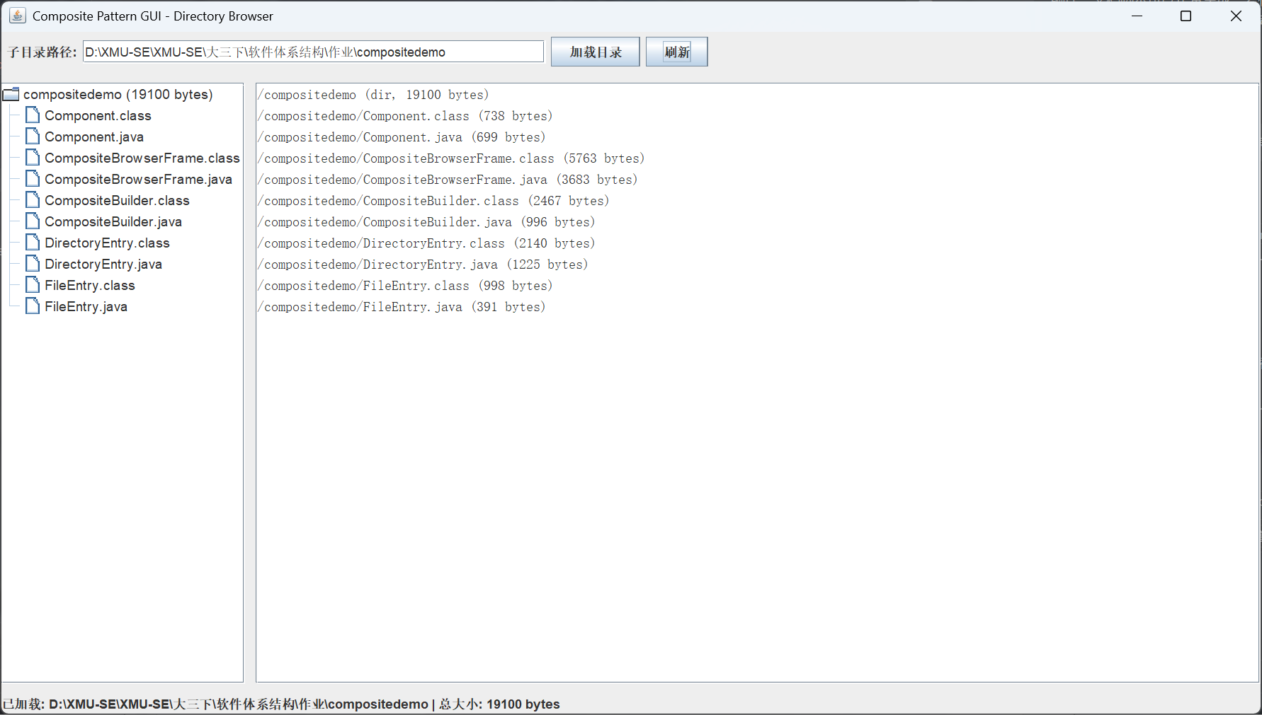

5. 运行结果
角色 | 说明
Component | 统一定义目录和文件的公共操作
Leaf | 表示文件，不能再包含子节点
Composite | 表示目录，可递归包含文件和子目录
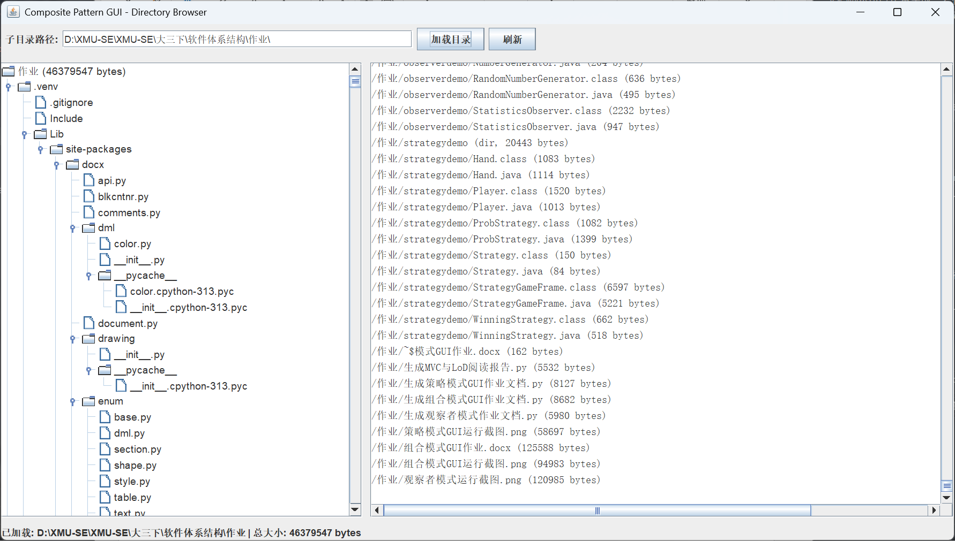
结论：GUI 改写后，程序可以直接浏览本机目录层次，组合模式的容器与内容统一处理特征更加直观。

