题目一：具有双向加锁功能的单例模式
代码说明
本题包含两个类：
DclSingleton：单例类，负责实例创建和对象访问。
DclSingletonDemo：测试类，用多线程方式验证该单例在并发环境下只会创建一个实例。

DclSingleton 中使用如下逻辑：
第一次判断 instance 是否为空，如果不为空直接返回。
如果为空，则进入 synchronized 同步代码块。
在同步块内部再次判断 instance 是否为空，若仍为空则创建对象。
返回同一个实例对象。
源码如下：
package com.xmuse.homework.singleton;

public final class DclSingleton {
private static volatile DclSingleton instance;

private final long createdAt;

private DclSingleton() {
this.createdAt = System.currentTimeMillis();
}

public static DclSingleton getInstance() {
if (instance == null) {
synchronized (DclSingleton.class) {
if (instance == null) {
instance = new DclSingleton();
}
}
}
return instance;
}

public long getCreatedAt() {
return createdAt;
}

public String describe() {
return "DclSingleton{" +
"identity=" + System.identityHashCode(this) +
", createdAt=" + createdAt +
'}';
}
}

测试代码如下：
package com.xmuse.homework.singleton;

import java.util.ArrayList;
import java.util.List;
import java.util.concurrent.CountDownLatch;

public class DclSingletonDemo {
public static void main(String[] args) throws InterruptedException {
int threadCount = 8;
CountDownLatch ready = new CountDownLatch(threadCount);
CountDownLatch start = new CountDownLatch(1);
CountDownLatch done = new CountDownLatch(threadCount);
List<DclSingleton> results = new ArrayList<>();

for (int i = 0; i < threadCount; i++) {
Thread worker = new Thread(() -> {
ready.countDown();
try {
start.await();
DclSingleton singleton = DclSingleton.getInstance();
synchronized (results) {
results.add(singleton);
}
System.out.println(Thread.currentThread().getName() + " -> " + singleton.describe());
} catch (InterruptedException exception) {
Thread.currentThread().interrupt();
} finally {
done.countDown();
}
}, "worker-" + (i + 1));
worker.start();
}

ready.await();
start.countDown();
done.await();

long distinctCount = results.stream()
.map(System::identityHashCode)
.distinct()
.count();

System.out.println("distinct instance count = " + distinctCount);
}
}
运行结果：
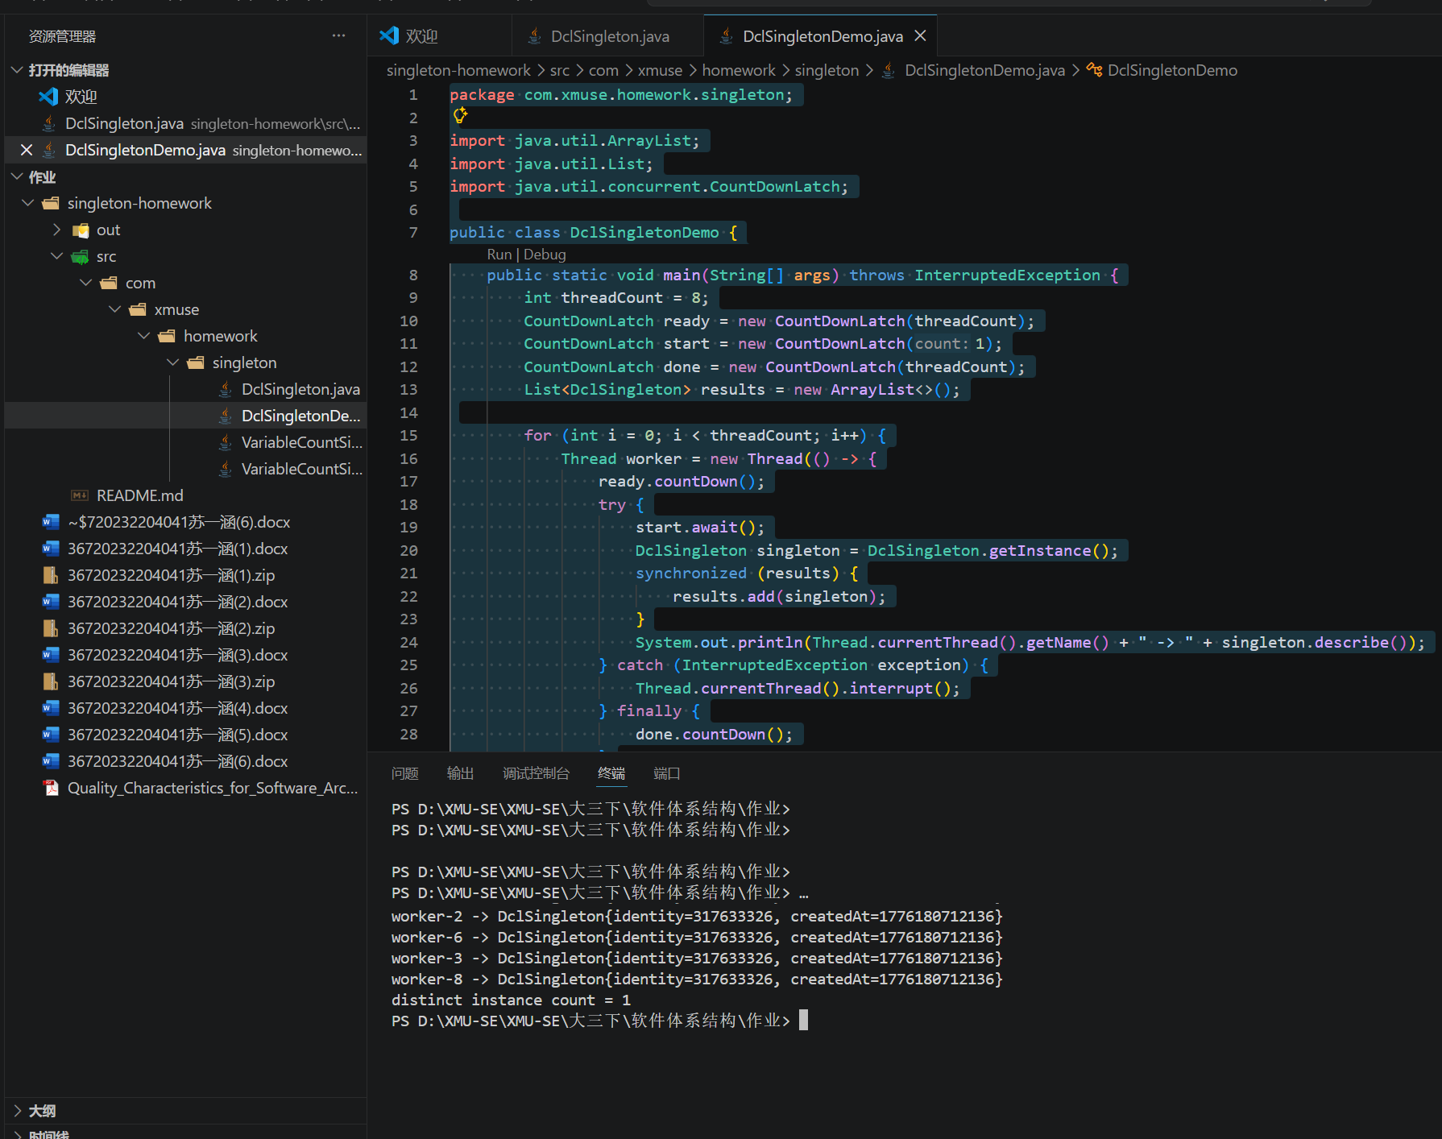
运行测试程序后，多个线程输出的实例标识一致，说明无论多少线程并发访问，系统中始终只存在一个实例。
题目二：具有可变用例数目的单例模式
代码说明
本题包含两个类：
VariableCountSingleton：可变实例数目的单例类，支持在初始化前设置实例数量。
VariableCountSingletonDemo：测试类，演示如何获取多个固定实例并验证同一索引返回的是同一个对象。

核心实现VariableCountSingleton.java
该类在首次使用前通过 configureInstanceCount(int) 设置实例数量。
首次调用 getInstance(int) 时，系统一次性创建指定数量的实例并保存到集合中。
之后根据索引返回对应实例，保证每个索引对应的对象始终不变。
实例集合初始化完成后不再允许修改数量，从而确保行为稳定。
源码如下：
package com.xmuse.homework.singleton;

import java.util.ArrayList;
import java.util.Collections;
import java.util.List;

public final class VariableCountSingleton {
private static volatile List<VariableCountSingleton> instances;
private static volatile int instanceCount = 1;

private final int index;

private VariableCountSingleton(int index) {
this.index = index;
}

public static void configureInstanceCount(int count) {
if (count <= 0) {
throw new IllegalArgumentException("instance count must be positive");
}
synchronized (VariableCountSingleton.class) {
if (instances != null) {
throw new IllegalStateException("instances already initialized");
}
instanceCount = count;
}
}

public static VariableCountSingleton getInstance(int index) {
List<VariableCountSingleton> localInstances = instances;
if (localInstances == null) {
synchronized (VariableCountSingleton.class) {
if (instances == null) {
instances = createInstances(instanceCount);
}
localInstances = instances;
}
}

if (index < 0 || index >= localInstances.size()) {
throw new IndexOutOfBoundsException("index must be between 0 and " + (localInstances.size() - 1));
}

return localInstances.get(index);
}

public static int size() {
List<VariableCountSingleton> localInstances = instances;
if (localInstances == null) {
synchronized (VariableCountSingleton.class) {
if (instances == null) {
instances = createInstances(instanceCount);
}
localInstances = instances;
}
}
return localInstances.size();
}

private static List<VariableCountSingleton> createInstances(int count) {
List<VariableCountSingleton> list = new ArrayList<>(count);
for (int i = 0; i < count; i++) {
list.add(new VariableCountSingleton(i));
}
return Collections.unmodifiableList(list);
}

public int getIndex() {
return index;
}

public String describe() {
return "VariableCountSingleton{" +
"identity=" + System.identityHashCode(this) +
", index=" + index +
'}';
}
}

测试代码如下：
package com.xmuse.homework.singleton;

public class VariableCountSingletonDemo {
public static void main(String[] args) {
VariableCountSingleton.configureInstanceCount(3);

for (int i = 0; i < VariableCountSingleton.size(); i++) {
VariableCountSingleton singleton = VariableCountSingleton.getInstance(i);
System.out.println("slot " + i + " -> " + singleton.describe());
}

VariableCountSingleton first = VariableCountSingleton.getInstance(0);
VariableCountSingleton again = VariableCountSingleton.getInstance(0);
System.out.println("same reference at index 0 = " + (first == again));
}
}

运行结果
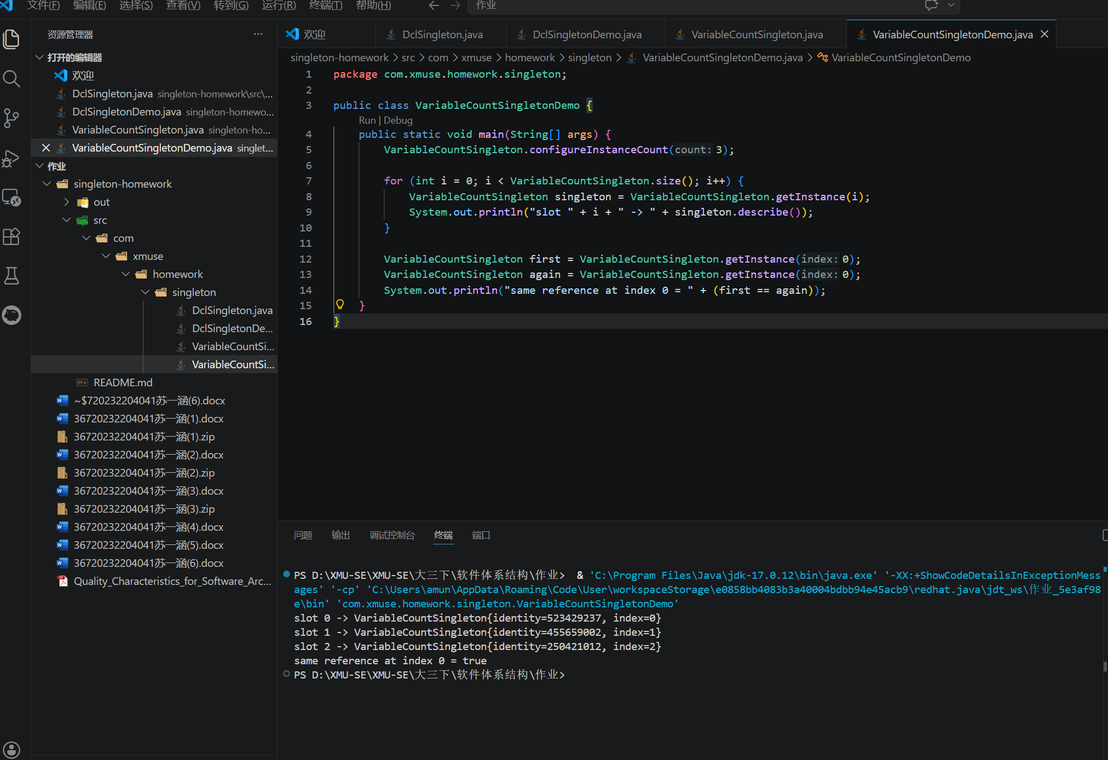
运行测试程序后，可以看到程序成功输出多个不同索引对应的实例信息，并且同一索引重复获取时返回的是同一个对象。

