1. 概念说明
IoC（Inversion of Control，控制反转）指的是对象创建和依赖装配的控制权，从业务代码转移给容器或框架。业务对象不再自己 new 依赖，而是由外部统一创建和注入。
DIP（Dependency Inversion Principle，依赖倒置原则）要求高层模块不依赖低层模块，二者都应该依赖抽象；抽象不应该依赖细节，细节应该依赖抽象。
Dependency Injection（依赖注入）是实现 IoC 的一种常见方式，通过构造器注入、Setter 注入或字段注入，把依赖从外部传入对象。

2. 实现思路
本示例以消息通知系统为例。NotificationService 只依赖 MessageSender 接口，而不是直接依赖 EmailSender 或 SmsSender。这样既满足 DIP，也便于替换实现。
ApplicationContainer 充当简单 IoC 容器，负责创建具体发送器并把它注入 NotificationService。NotificationService 只负责业务通知，不负责对象创建。

3. 源码
interface MessageSender {
void send(String recipient, String message);
}
class EmailSender implements MessageSender {
@Override
public void send(String recipient, String message) {
System.out.println("[Email] To: " + recipient + " | Message: " + message);
}
}
class SmsSender implements MessageSender {
@Override
public void send(String recipient, String message) {
System.out.println("[SMS] To: " + recipient + " | Message: " + message);
}
}
class NotificationService {
private final MessageSender messageSender;
public NotificationService(MessageSender messageSender) {
this.messageSender = messageSender;
}
public void notifyUser(String recipient, String message) {
messageSender.send(recipient, message);
}
}
class ApplicationContainer {
public NotificationService createEmailNotificationService() {
return new NotificationService(new EmailSender());
}
public NotificationService createSmsNotificationService() {
return new NotificationService(new SmsSender());
}
}
public class IoCDemo {
public static void main(String[] args) {
ApplicationContainer container = new ApplicationContainer();
NotificationService emailService = container.createEmailNotificationService();
NotificationService smsService = container.createSmsNotificationService();
System.out.println("=== IoC / DIP / DI Demo ===");
emailService.notifyUser("student@example.com", "Your assignment is due tomorrow.");
smsService.notifyUser("13800138000", "Your class starts in 30 minutes.");
}
}

4. 系统运行截图
运行示例后，容器分别装配 Email 和 SMS 发送器，输出如下：
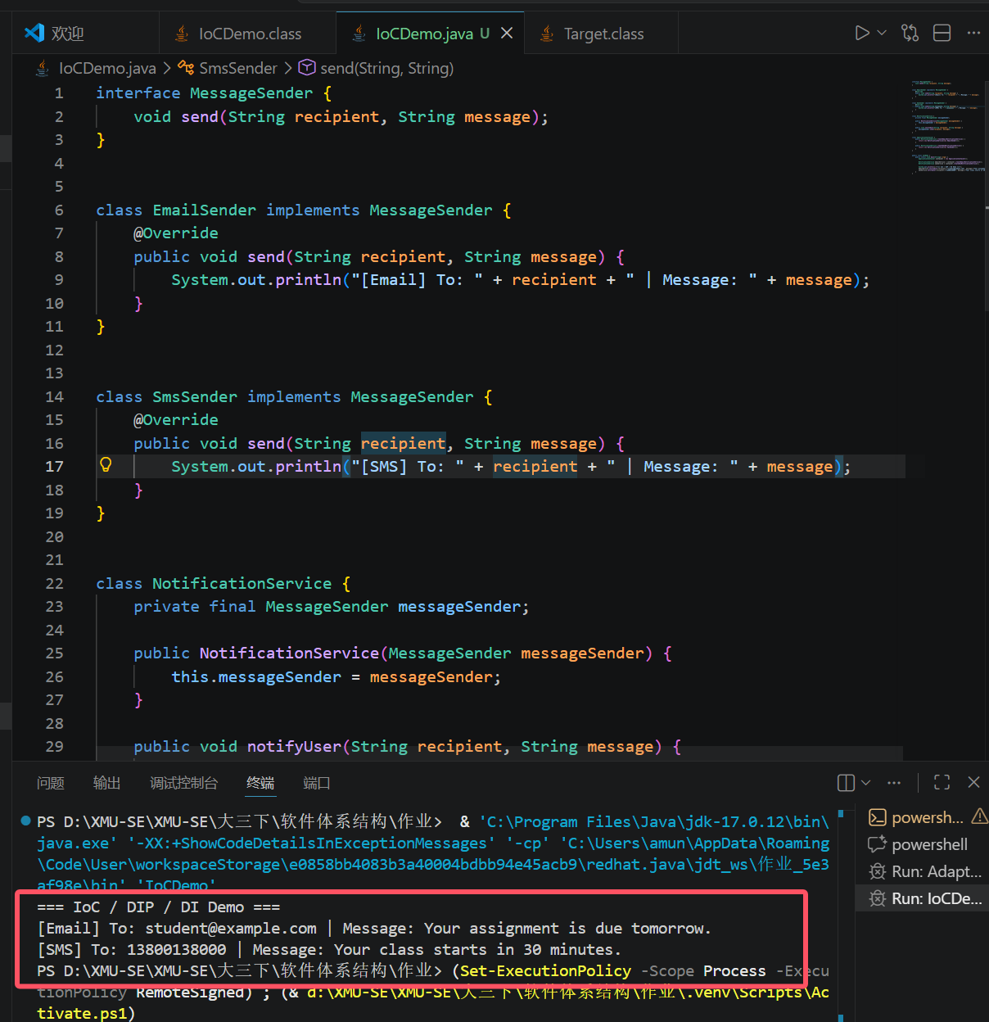

5. 运行结果
场景 | 结果
IoC | ApplicationContainer 负责创建并组装依赖
DIP | NotificationService 依赖 MessageSender 抽象
DI | 通过构造器把 EmailSender / SmsSender 注入 NotificationService
结论：IoC 解决对象由谁创建的问题，DIP 解决模块之间依赖谁的问题，DI 则是把依赖从外部注入对象的具体实现方式。

