

1. 概念说明
Iterator 模式用于顺序访问聚合对象中的元素，而不暴露其内部表示。客户端只需要依赖 Iterator 接口，就可以遍历集合中的元素。

2. 实现思路
本示例中 BookShelf 不再使用数组，而是使用 ArrayList 保存 Book。普通 BookShelfIterator 负责完整遍历；SpecifiedBookShelfIterator 则按关键字过滤书名，只返回匹配项。
这样既演示了 Collection 替换，又演示了自定义的指定迭代器。

3. 源码
import java.util.ArrayList;
import java.util.Iterator;
import java.util.List;
class Book {
private final String name;
public Book(String name) {
this.name = name;
}
public String getName() {
return name;
}
}
interface Aggregate {
Iterator<Book> iterator();
}
class BookShelf implements Aggregate {
private final List<Book> books = new ArrayList<>();
public void appendBook(Book book) {
books.add(book);
}
public Book getBookAt(int index) {
return books.get(index);
}
public int getLength() {
return books.size();
}
@Override
public Iterator<Book> iterator() {
return new BookShelfIterator(this);
}
public Iterator<Book> specifiedIterator(String keyword) {
return new SpecifiedBookShelfIterator(this, keyword);
}
}
class BookShelfIterator implements Iterator<Book> {
private final BookShelf bookShelf;
private int index;
public BookShelfIterator(BookShelf bookShelf) {
this.bookShelf = bookShelf;
this.index = 0;
}
@Override
public boolean hasNext() {
return index < bookShelf.getLength();
}
@Override
public Book next() {
return bookShelf.getBookAt(index++);
}
}
class SpecifiedBookShelfIterator implements Iterator<Book> {
private final BookShelf bookShelf;
private final String keyword;
private int index;
private Book nextMatch;
public SpecifiedBookShelfIterator(BookShelf bookShelf, String keyword) {
this.bookShelf = bookShelf;
this.keyword = keyword.toLowerCase();
this.index = 0;
this.nextMatch = null;
}
@Override
public boolean hasNext() {
if (nextMatch != null) {
return true;
}
while (index < bookShelf.getLength()) {
Book candidate = bookShelf.getBookAt(index++);
if (candidate.getName().toLowerCase().contains(keyword)) {
nextMatch = candidate;
return true;
}
}
return false;
}
@Override
public Book next() {
if (!hasNext()) {
throw new java.util.NoSuchElementException();
}
Book result = nextMatch;
nextMatch = null;
return result;
}
}
public class IteratorDemo {
public static void main(String[] args) {
BookShelf bookShelf = new BookShelf();
bookShelf.appendBook(new Book("Around the World in 80 Days"));
bookShelf.appendBook(new Book("Bible"));
bookShelf.appendBook(new Book("Forrest Gump"));
bookShelf.appendBook(new Book("Design Patterns"));
bookShelf.appendBook(new Book("The Pragmatic Programmer"));
System.out.println("=== 1. 使用 List 替代数组的 Iterator ===");
Iterator<Book> iterator = bookShelf.iterator();
while (iterator.hasNext()) {
Book book = iterator.next();
System.out.println(book.getName());
}
System.out.println();
System.out.println("=== 2. Specified Iterator（仅输出包含 'the' 的书名）===");
Iterator<Book> specifiedIterator = bookShelf.specifiedIterator("the");
while (specifiedIterator.hasNext()) {
Book book = specifiedIterator.next();
System.out.println(book.getName());
}
}
}

4. 系统运行截图
运行结果分为两部分：完整遍历和指定条件遍历。
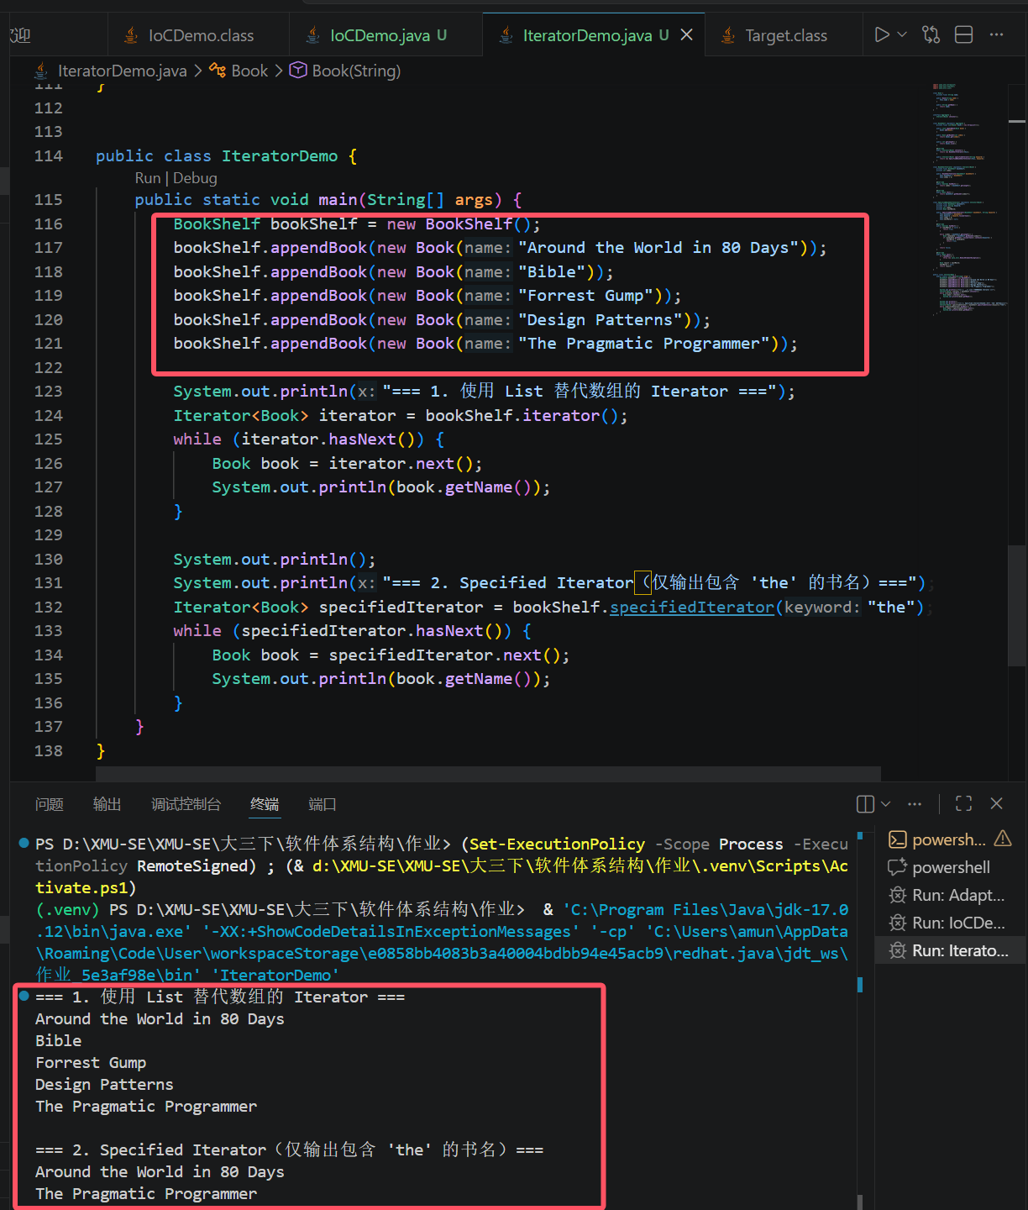

5. 运行结果
场景 | 结果
Collection 替换 | BookShelf 使用 ArrayList 存储 Book
普通 Iterator | 按插入顺序输出全部书名
Specified Iterator | 仅输出书名中包含关键字 the 的书
结论：使用 Collection 替代数组后，聚合对象更灵活；通过 Specified Iterator，可以在不修改客户端遍历代码的前提下实现定制遍历。

