PARKING SLOP IDENTIFIER

DIGITAL LOGIC DESIGN

INSTRUCTOR: ENGR. ASIF ALI



COMPUTER SYSTEMS ENGINEERING

SUBMITTED BY:

SOYAM KAPOOR [133-22-0041]

SYED HASHIR ALI [133-22-0037]

**CERTIFICATE**

It is certified that **SOYAM KAPOOR & SYED HASHIR ALI**  students of **BE-CSE-3** has carried out the necessary work of **DIGITAL LOGIC DESIGN** as per course of studies prevailed at the Computer System Engineering Department, Sukkur Institute of Business Administration for **Fall-2023.**

**Date: __\__\___ Instructor’s Signature: _______**

# ACKNOWLEDGMENTS

We would like to say thanks to **“SIR ENGR. ASIF ALI”** who suggested the idea of this project during the course of Digital Logic Design (DLD) and also thanks to those people who helped us through social websites and Internet but Specially We are indeed indebted to**" SIR ENGR. ASIF ALI"** for his support, advice and inputs in the course of this project. We would also like to thank various faculty members of the Computer Systems Engineering Department for their valuable suggestions and inputs.

# PROJECT IDEA

* Develop a cost-effective and efficient parking management system utilizing IR sensors and LEDs to indicate parking slot availability.
* To inform the students and other viewers about the working of parking slots.
* Mostly available in malls parking, hotels parking, hospitals parking.
* This project is not the exact same one but it is giving idea similar to those technologies.
* Enhances convenience for residents and visitors, making urban areas more attractive and user-friendly.

# ABSTRACT

This report is the summary of the work which I, SOYAM KAPOOR & SYED HASHIR ALI have done while working on the digital logic design for developing our project

**“PARKING SLOT IDENTIFIER”.**

The "Parking Slot Identifier" project introduces an intelligent parking detection system using IR sensors, LEDs, NOT gate IC, a 9V battery, and a breadboard.

The system aims to quickly determine parking slot occupancy in real-time. An IR sensor detects object presence, triggering the circuit through a NOT gate IC.

This process activates LEDs: red for occupied slots and green for available ones.

The system, compactly integrated on a breadboard, efficiently processes IR sensor data to drive the LEDs. Powered by a 9V battery, it's a portable solution. Cost-effective and user-friendly, this innovation optimizes parking resources, enhances efficiency, and simplifies parking management in various settings.

# TABLE OF CONTENTS

|  |  |
| --- | --- |
|  | **PAGE NO:** |
| **COVER PAGE** | **00** |
| **CERTIFICATE** | **01** |
| **ACKNOWLEDGEMENTS** | **02** |
| **PROJECT IDEA** | **03** |
| **ABSTRACT** | **04** |
| **TABLE OF CONTENTS** | **05** |
| **INTRODUCTION** | **06** |
| **COMPONENT LIST** | **07** |
| **WORKING OR METHODOLOGY** | **11** |
| **RESULTS** | **12** |
| **APPLICATIONS** | **16** |
| **CONCLUSION** | **17** |
| **REFERENCES** | **18** |

**INTRODUCTION**

Our Project aims to simulate the modern parking system which uses sensors to display whether a parking space has been taken or not. We tackled this challenge by using Infrared sensors to sense whether a parking space or parking slot had been taken and then used LED lights to confirm to any user of the circuit that the space has been occupied. Using a combination of advanced components such as Infrared (IR) sensors, Light Emitting Diodes (LEDs), a NOT gate integrated circuit (IC), a 9V battery, and a breadboard, our system detects the occupancy status of parking slots in real-time. When an object is detected by the IR sensor, the system swiftly processes this information through the circuit, activating a red LED to indicate an occupied slot or a green LED for an available slot.

This user-friendly and portable solution is meticulously designed to optimize parking space utilization while simplifying the parking process for users across diverse environments. Its core objective is to enhance convenience and efficiency, offering a practical tool for individuals seeking parking availability in various settings.

Top of Form

**COMPONENTS LIST**

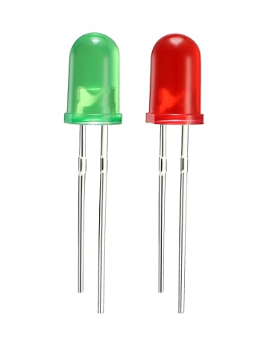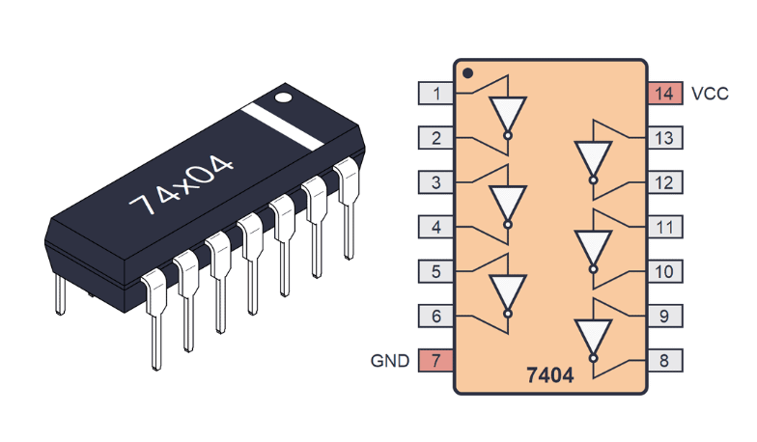NOT IC 74LS04: Inverts incoming signal.  
LED x 4: Lights up when given a signal.

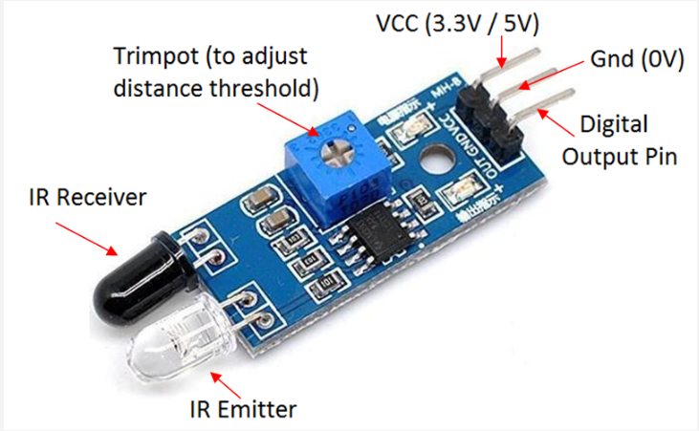IR SENSOR x 5: Detects object using infrared light and phototransistor then returns a low signal.

RESISTOR (100-ohm, 1000 ohm): Reduces incoming voltage.

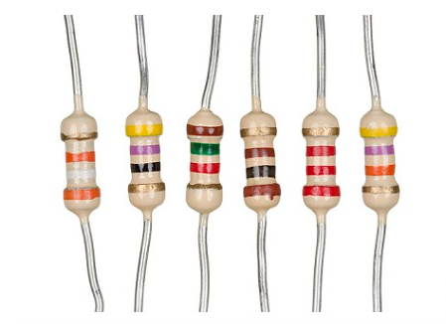

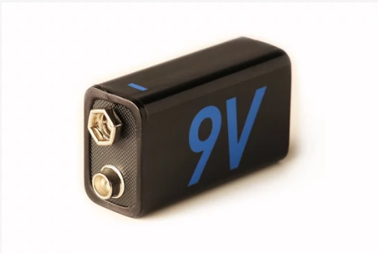BATTERY 9V: Produces a 9-volt charge.

WIRES: Connects Components and transfers Current.

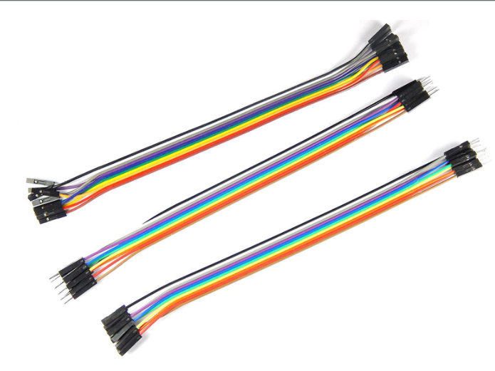

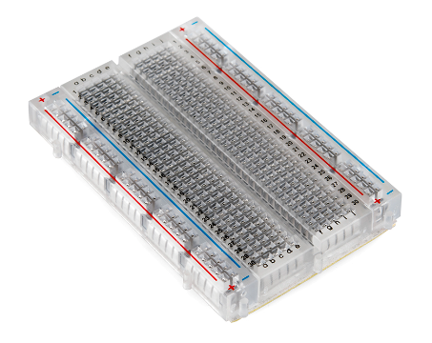BREAD BOARD: On which whole circuit will be designed.

# WORKING

1. **Vehicle Detection:** Our system uses special sensors (IR sensors) placed in parking slots to detect when a vehicle enters or leaves a slot.
2. **Signal Processing:** When a vehicle is detected, the sensor sends a signal to a smart control component (NOT Gate IC). This control unit processes the signal's information.
3. **LED Indication:** Based on this information, the control unit activates LEDs. If a vehicle is present, a red LED lights up, indicating the parking slot is occupied. If no vehicle is detected, a green LED illuminates, signaling the slot is available.
4. **User Interface:** People searching for parking can easily spot available slots by looking for the green LED. The red LED signals that the slot is currently occupied.
5. **Continuous Monitoring:** Our system keeps track of the parking slots at all times, immediately updating the LED status when a vehicle arrives or leaves.
6. **Enhanced Convenience:** This real-time display helps drivers quickly find available parking spaces, making parking more convenient and hassle-free.

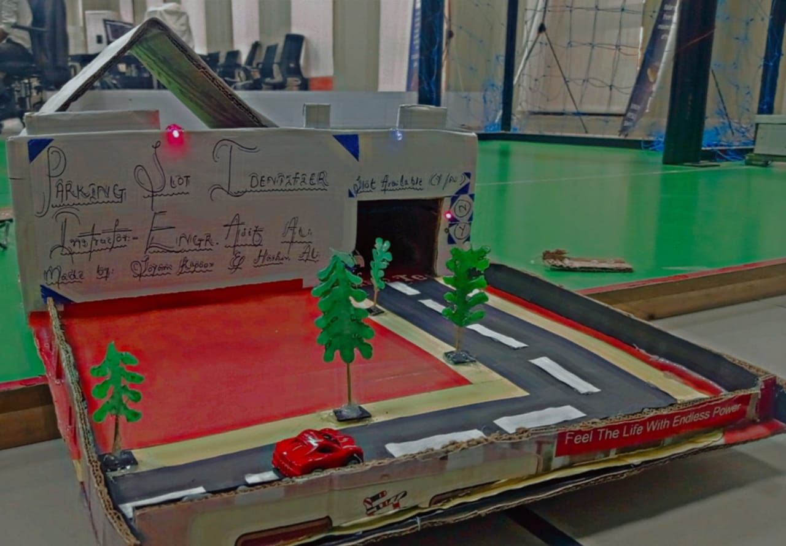**RESULTS**

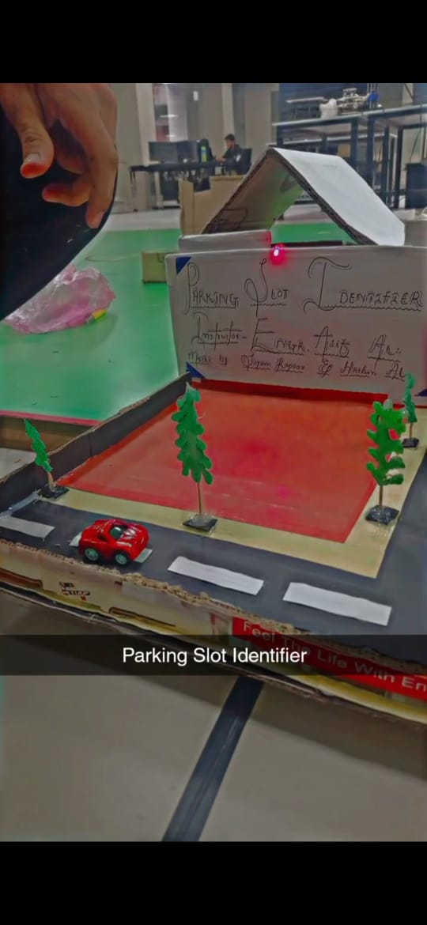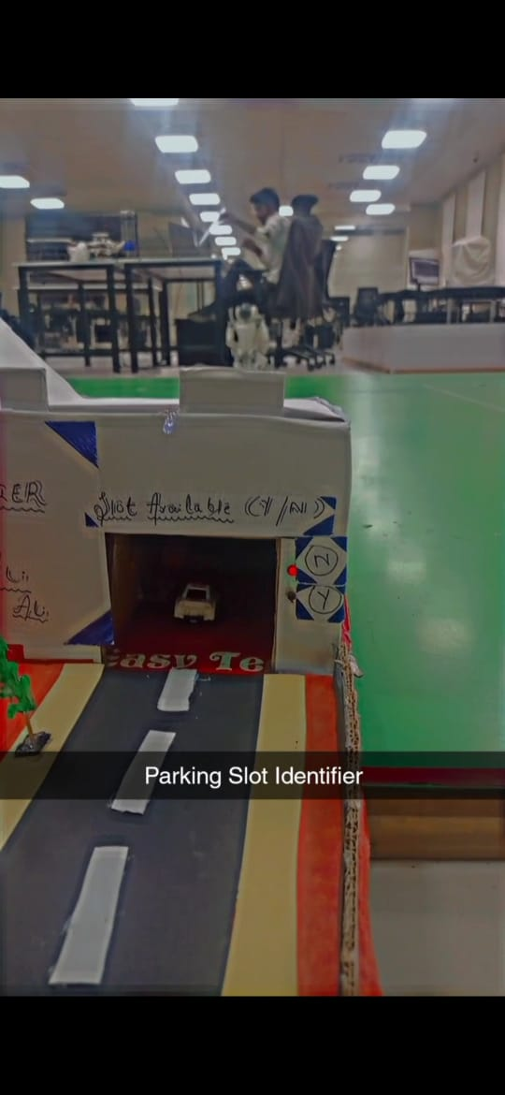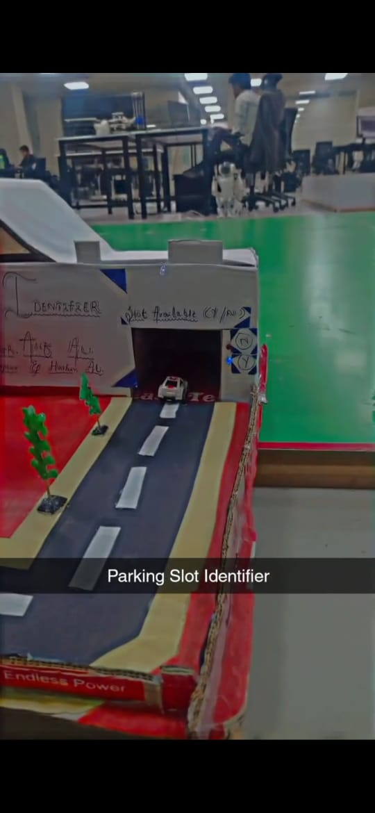

# APPLICATIONS

1. **Shopping Malls:** In busy shopping malls, this system can help shoppers quickly find available parking spaces, reducing stress and making their visit more enjoyable.
2. **Office Buildings:** For office complexes, the project can manage employee and visitor parking efficiently, ensuring that the parking area is used optimally.
3. **Airports:** At airports, where parking can be a challenge, this system can guide travellers to open parking spaces, making their journey more convenient.
4. **Hospitals:** In hospital parking lots, it can assist patients and visitors in locating empty spots, ensuring they can access medical care without parking hassles.

# CONCLUSION

The Parking Slot Identifier revolutionizes parking management by employing IR sensors, a NOT Gate IC, and LEDs to swiftly detect and indicate parking slot occupancy. When a vehicle enters, IR sensors trigger the NOT Gate IC, activating red LEDs for occupied slots and green LEDs for available ones.

This system streamlines the often tedious process of finding parking spaces by providing real-time status updates. Users benefit from clear, color-coded indicators that swiftly guide them to available spots, reducing search times and frustration.

By continuously monitoring parking slots, the system ensures optimal space utilization, minimizing congestion and enhancing overall parking efficiency. The Parking Slot Identifier emerges as a user-friendly, efficient solution, simplifying parking for individuals and contributing to more organized and resource-efficient parking facilities.

# REFRENCES

1. <https://www.youtube.com/watch?v=OnznDk4h_rQ>
2. Google & Chatgpt