**User Instruction**

When you start the game, it will show you as the image below. The game will start soon when the server starts the game.

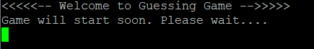

Before you start the game, you need to register yourself to the game with your name. Then it is ready to start the game.

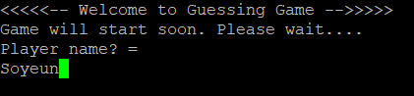

When the game is started, follow the server instruction. When you put wrong input, which is smaller than 0 or bigger than 12, the server will tell you the input is wrong. If your guess is wrong, it will also give you a hint whether the answer is smaller or bigger than your guess.

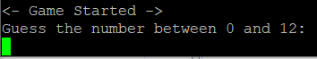

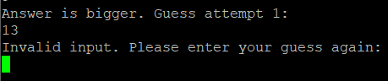

If you do not enter the response for a certain time period, it will remind you to enter your response.

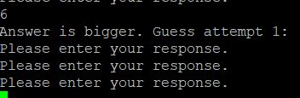

After the game, when all the player finishes, the server will have the ranking for the players. 

When you finish your round, you can either choose play again or quit the game. If you choose to play another round, it will bring you the first stage of the game to start again.

