Homework 5
Cloud SQL Request Logging
Jiaqiang Zhu (U38560530)
Repository: https://github.com/SoymilkWinsAgain/EC528
AI usage disclosure: I used ChatGPT for assistance, primarily for generating Windows bash scripts (which was permitted by the assignment requirements). Also, for code suggestions, SQL advice, and report formatting. In the past, manual formatting of my reports often yielded poor results.

1. System and deployment overview
This homework extends the first application from Homework. The second application is copied without source changes. Two concurrent clients issue 50,000 requests each. SQL queries are then used to analyze the 100,000 requests.
Resource | Configuration
Project | cs528-project-0-508215 (hardcoded in the scripts)
Application VM | hw5-server; e2-small; Debian 12; us-east1-b; HTTP port 8080
Cloud SQL | hw5-db; PostgreSQL 16; db-g1-small; us-east1; 10 GB SSD
Database and user | hw5 / postgres
Existing content | gs://ec528hw2/pages/; 12,000 HTML files; bucket in us-central1
Pub/Sub | hw5-forbidden-requests / hw5-forbidden-requests-sub
Runtime identity | hw5-app@cs528-project-0-508215.iam.gserviceaccount.com

Request flow
Client -> application 1 -> header extraction and country check -> Cloud Storage or the in-memory file cache -> PostgreSQL transaction -> HTTP response. Requests from banned countries additionally produce a Cloud Logging event and a Pub/Sub message. Application 2 receives, prints and acknowledges the Pub/Sub message.
The server uses ThreadingHTTPServer and a shared two-connection SQLAlchemy pool. All formal-client requests are logged to SQL, including cache hits and rejected requests.

Infrastructure and startup scripts
setup.sh enables APIs, creates the service account and permissions, provisions Pub/Sub, the hourly stopper, Cloud SQL and the VM, and passes source/configuration through VM metadata. startup.sh installs dependencies once using /var/log/startup_already_done, refreshes application files from metadata and runs both applications as systemd services.
The project roles are roles/cloudsql.client, roles/cloudsql.admin, roles/logging.logWriter, roles/pubsub.publisher and roles/pubsub.subscriber. The service account also receives roles/storage.objectViewer on the content bucket and authenticated invocation access to the function.

2. Database schema and request processing
schema.sql defines two tables. The generated request_id is the primary key of request_log and is reused as the primary/foreign key of request_errors. The error table therefore links to the full request without duplicating demographic columns.
request_log column | PostgreSQL type | Meaning / source
request_id | BIGINT IDENTITY, PK | Automatically generated request identifier
country | TEXT | X-country
client_ip | INET | Validated X-client-IP; simulated client metadata
gender | TEXT | X-gender
age_group | TEXT | X-age; preserve the supplied group label
income_group | TEXT | X-income; preserve the supplied group label
is_banned | BOOLEAN NOT NULL | Case-insensitive match against the country denylist
client_time | TIMESTAMP WITHOUT TIME ZONE | X-time parsed as YYYY-MM-DD HH:MM:SS
received_at | TIMESTAMP WITH TIME ZONE | Server receipt time in UTC
requested_file | TEXT NOT NULL | Decoded path / requested object name
status_code | SMALLINT NOT NULL | HTTP code, constrained to 100-599
run_id | TEXT NOT NULL; default 'manual' | Separates curl, health, trial and formal test records

request_errors column | Type / constraint
request_id | BIGINT PRIMARY KEY REFERENCES request_log(request_id)
received_at | TIMESTAMP WITH TIME ZONE NOT NULL
requested_file | TEXT NOT NULL
error_code | SMALLINT NOT NULL; 100-599 and not 200

The application strips header values, validates the supplied IP address, parses the client timestamp, and preserves age/income as categories. Invalid IP/time values and absent optional headers are recorded as NULL.

3. Configuration, execution and curl validation
Prerequisites: authenticated Google Cloud CLI with permissions in the hardcoded project, Python 3, and Bash (Git Bash on Windows). The existing ec528hw2 bucket supplies the pages. Run from the repository root:
gcloud auth login
# Windows PowerShell with Git Bash
& 'C:\Program Files\Git\bin\bash.exe' hw5/setup.sh
The setup script creates missing resources, starts an existing SQL instance and applies the idempotent schema without dropping existing rows. It generates app.env, including a random postgres password. The local file is ignored by Git and is passed privately as VM metadata. Wait for startup completion before making requests.
$serverIp = gcloud compute instances describe hw5-server `
--zone=us-east1-b --project=cs528-project-0-508215 `
--format='value(networkInterfaces[0].accessConfigs[0].natIP)'
The VM uses an ephemeral address, retrieved dynamically. Addresses visible in screenshots are the historical test addresses. In Cloud SQL Studio, select database hw5 and user postgres, using DB_PASSWORD from local app.env. The application already receives its database configuration through startup metadata.

Three curl requests (assignment part 4)
All three requests carry X-Run-ID: curl-demo. Query request_log with WHERE run_id = 'curl-demo'; query request_errors by joining request_log on request_id and applying the same filter.
Test | Country / file | Status / ID | Subset counts before -> after
Success | Canada / pages/0.html | 200 / 7 | main: 0 -> 1; errors: 0 -> 0
Missing file | Canada / pages/not-found-hw5.html | 404 / 8 | main: 1 -> 2; errors: 0 -> 1
Banned country | Iran / pages/0.html | 400 / 9 | main: 2 -> 3; errors: 1 -> 2

P.S. Appendix A includes the actual curl commands/responses and before/after table panels.

Load test and analysis commands
Start the following command in each of two terminals, using the same seed and starting the second client without waiting for the first:
.\hw5\http-client.exe -d $serverIp -p 8080 -b none -w pages `
-n 50000 -i 11999 -r 528 -t 30
Pause hw5-stop-sql-hourly while SQL is in use. After both clients finish, retain the IDs of the formal requests and export the systemd journal before deleting the VM.
gcloud compute ssh hw5-server --zone=us-east1-b `
--project=cs528-project-0-508215 `
--command="sudo journalctl -u hw5-service1.service -o cat --no-pager"
.\.venv\Scripts\python.exe .\hw5\analyze_timing.py

4. Concurrent load test and timing results (parts 5-6)
The formal run started October 27, 2026 at 22:57:42 and completed verification October 28 at 01:04:37, America/New_York (UTC-04:00). Both clients used the updated hw5/http-client.exe with n=50000, index=11999, seed=528 and timeout=30 seconds. The server address for this run was 35.237.121.161.
Run item | Verified result
Client 1 | 50,000 requested; exit code 0; 7,562.023 s
Client 2 | 50,000 requested; exit code 0; 7,612.136 s
Total elapsed including verification | 7,614.903 s (2 h 6 min 54.9 s)
Database verification | 100,000 records; 100,000 unique request IDs
Timing-log verification | 100,000 matching events; no missing IDs
Database / response failures in timing logs | 0 / 0

perf_counter_ns is used by the measure context manager. Header extraction, file reading, response writing and database insertion are separate functions. The analyzer matches journal events to stress-request-ids.csv so that trials and unrelated requests do not enter the averages.
Instrumented operation | Samples | Mean (ms)
Application request/header extraction | 100,000 | 0.129
Actual Cloud Storage download | 11,959 | 160.318
Server response write and flush | 100,000 | 32.286
Database insertion / transaction | 100,000 | 9.153

There were 83,499 successful cache hits. These requests skip the cloud read and have storage_ns=NULL; banned requests also skip storage. Only actual downloads enter the storage average. A small health/check run preceded the formal test. Each cache hit still generates its own SQL row.
Response timing measures the server write/flush operation. Pub/Sub, Cloud Logging and other overhead are outside these four measurements.
Figure 1. Output of analyze_timing.py (06-time.png).
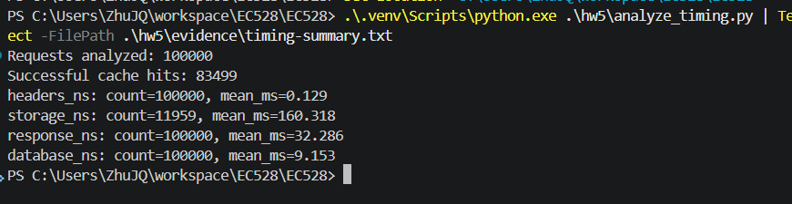

5. SQL request statistics (part 7)
All statistics use the same fixed formal-run cohort.
FROM request_log
WHERE run_id = 'stress-01'
AND request_id BETWEEN 2146 AND 102159
AND country IS NOT NULL
Question | Answer
Total requests | 100,000
Successful (HTTP 200) | 95,458
Unsuccessful (HTTP other than 200) | 4,542; all returned HTTP 400
Requests from banned countries | 4,542
Male vs Female | Male: 50,232; Female: 49,768
Most frequent age group | 76+; 12,689 requests
Most frequent income group | 250k+; 12,625 requests

Top five countries
Rank | Country | Requests
1 | Zambia | 562
2 | Colombia | 561
3 | Saint Vincent and the Grenadines | 559
4 | North Korea | 557
5 | Lithuania | 556

Appendix B reproduces the relevant SQL result panels.

6. Hourly stopping, cleanup and cost statement

Hourly database stopper (part 8)
sql_stopper/main.py is deployed as a private second-generation HTTP Cloud Function, hw5-stop-sql, with entry point stop_database and Python 3.12. Cloud Scheduler invokes it with an OIDC token. The schedule is 0 * * * * in Etc/UTC, once per hour.
The function reads the SQL state and activation policy. When the instance is RUNNABLE with policy ALWAYS, it requests a patch to settings.activationPolicy=NEVER; otherwise it reports that no action is needed. Its runtime service account has roles/cloudsql.admin, and the Scheduler identity has invoker access.

Cleanup and submission checks
cleanup.sh was executed and verified. It deletes the HW5 VM and boot disk, firewall rule, Pub/Sub subscription/topic, Scheduler job, function and service account, and removes the corresponding IAM bindings. The SQL instance and its data are retained with activationPolicy=NEVER, as required. The existing content bucket and earlier-homework resources are preserved.
Windows compatibility is handled by removing carriage returns from gcloud role output before the IAM-removal loop. Already-removed bucket permissions are skipped. setup.sh, startup.sh and cleanup.sh are recorded as mode 100755, and .gitattributes fixes Bash files to LF line endings. cleanup.sh also attempts ADC revocation.
Figure 2. Successful final cleanup (08-cleanup.png).
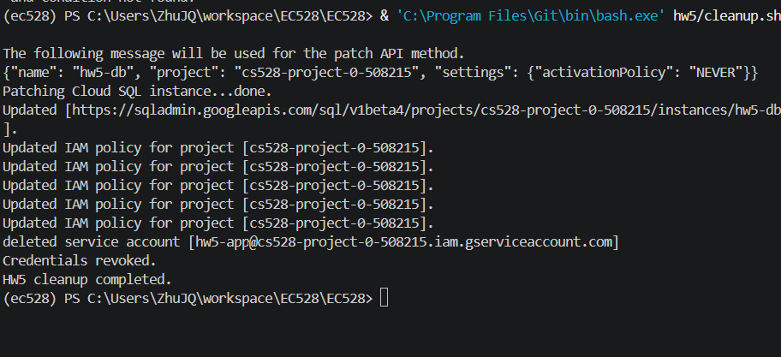

Cloud spending - pending verification
Not everything has been updated yet.
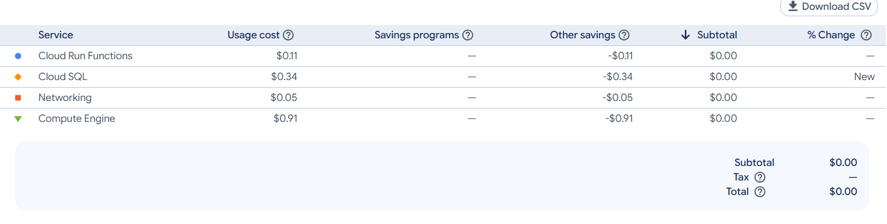

Appendix A1. HTTP 200: before and after
Panels are cropped to relevant results for readability. Original PNGs are preserved in hw5/evidence and embedded in this Word document. The queries select the curl-demo subset.
Before 200: request_log empty (01-before-main.png)  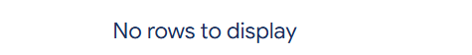 | Before 200: request_errors empty (01-before-errors.png)  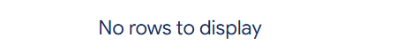
curl response: HTTP 200 (01-curl-200.png).
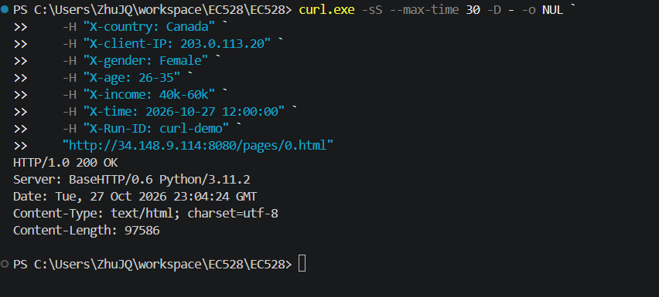
After 200: request_log contains ID 7 (01-after-main.png).
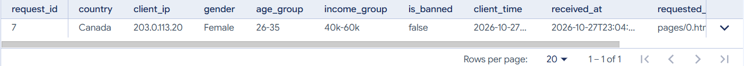
After 200: request_errors remains empty (01-after-errors.png).
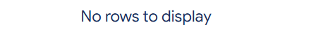

Appendix A2. HTTP 404: before and after
Before this request, the tables are exactly the after-200 state in Appendix A1: one main row and zero error rows. The missing file adds ID 8 to both tables.
curl response: HTTP 404 (03-curl-404.png).
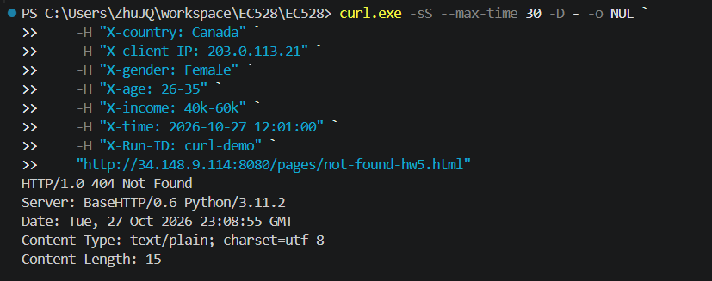
After 404: request_log contains IDs 7 and 8 (03-main-404.png).
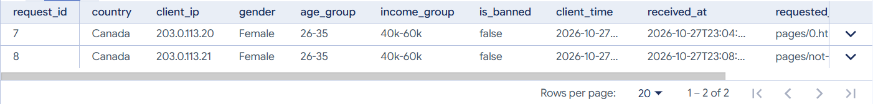
After 404: request_errors contains ID 8 / error 404 (03-errors-404.png).
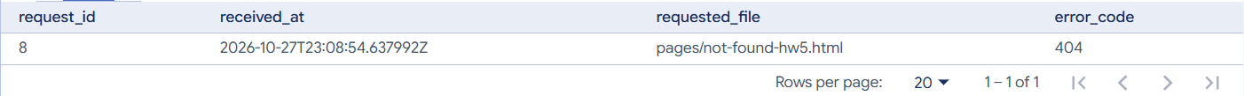

Appendix A3. HTTP 400: before and after
Before this request, the tables are the after-404 state in Appendix A2: two main rows and one error row. The Iran request adds ID 9 with is_banned=true and status 400.F
curl response: HTTP 400 (03-curl-400.png).
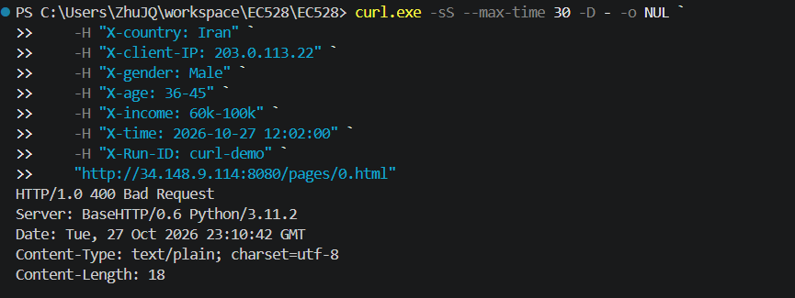
After 400: all three main rows, with status codes 200, 404 and 400 (03-main-400.png).
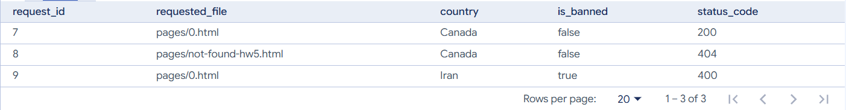
After 400: only the two failures appear in request_errors (03-errors-400.png).
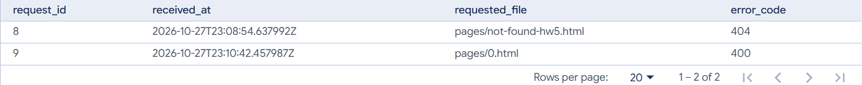

Appendix B. SQL statistics evidence
These are the recorded result panels from the same cohort selector shown in Section 5. Complete queries and result views are retained in the original screenshots.
Totals, successful, unsuccessful and banned requests (07-query.png).
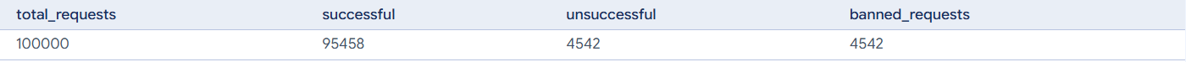
Male / Female counts (07-gender.png).
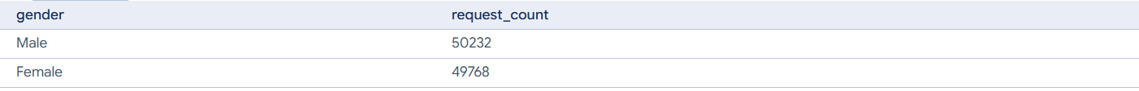
Top five countries (07-top-countries.png).
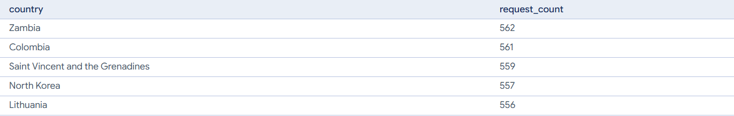
Most frequent age group: 76+ (first result row; 07-ages.png).
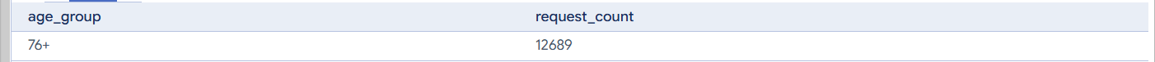
Most frequent income group: 250k+ (first result row; 07-income.png).


