Componente ale proiectului preluate din alte surse :

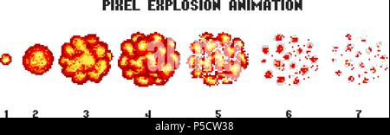https://www.alamy.com/pixel-art-explosions-game-icons-set-comic-boom-flame-effects-for-emotion-8-bit-vector-bang-burst-explode-flash-nuclear-bubble-dynamite-with-smoke-animation-frame-process-steps-video-fire-image209880812.html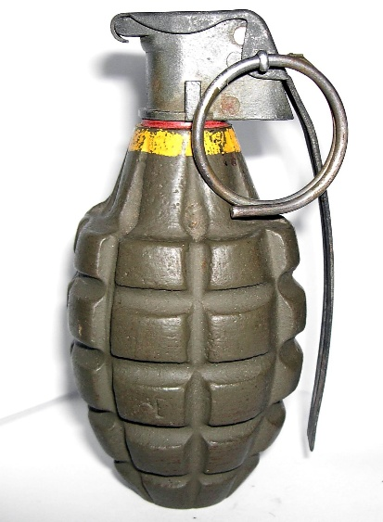

<https://en.wikipedia.org/wiki/Mk_2_grenade>

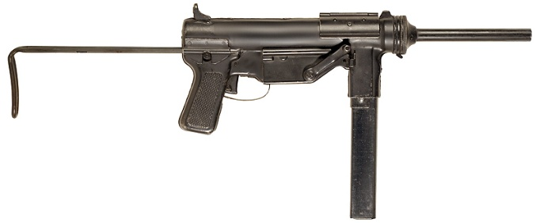

<https://wikiofbrothers.fandom.com/wiki/M3A1_%22Grease_Gun%22>



<https://www.shutterstock.com/image-illustration/pixel-art-first-aid-kit-item-1592154952?consentChanged=true>

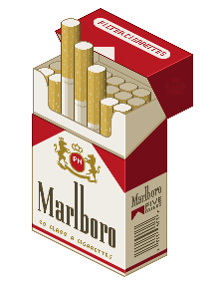

https://pixeljoint.com/pixelart/6545.htm