For the most up to date documentation, with video demonstrations, please use the online documentation. https://enigma23.gitbook.io/arcadetraincontroller/

Welcome
About ATC and what's included in the package
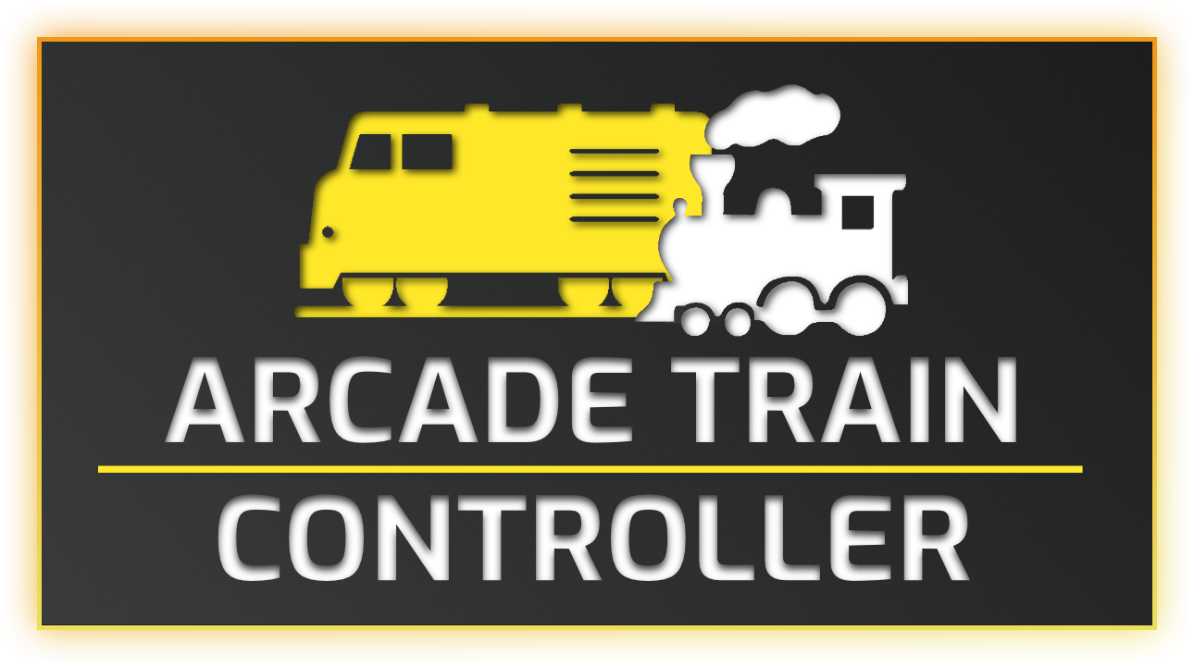

About
Arcade Train Controller (ATC) is a simple controller asset allowing you to quickly and easily create any type of track vehicle – for example: a train, rollercoaster, monorail, or tram. The customizable arcade-y feel to the movement gives a fun, satisfying, player experience to your game.
Included is a Train Prefab Builder editor window, which allows you to setup a new train in seconds! Just link the required objects and fill in the details, press a button and you’ve got your new vehicle!
Included Demo Vehicles
Steam train
Diesel train
Carriages
Monorail train with moving doors
The values for a train (throttle, acceleration, deceleration, etc.) are saved in a ScriptableObject, meaning you can re-use the same values for hundreds of different vehicles, and only have to tweak them in 1 place.

What’s Included
Arcade Train Controller (ATC) imports as a package. This means that after importing you'll see it as a package in the Package Manger, and the contents will be under Packages/ not Assets/
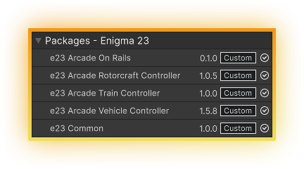
/Demo/ - In this folder is extra items that are used purely for the demo scene. Once you no longer require the demo scene, you may delete this folder without any issues.
/Examples/Input/ - Assets for use with the new input system are stored in here.
/Examples/Settings/ - ScriptableObjects holding the data for TrainBehaviour, StationSettings, BoostSettings.
/Scripts/ - Parent folder for all scripts required for ATC
/Scripts/Audio/ - Scripts realted to ATC's audio solution.
/Scripts/Editor/ - Editor scripts, which give a custom inspector for TrackPathManager.cs, and the train builder editor window scripts. In here there is also a ScriptableObject to save your builder window data.
/Scripts/Examples/ - Example scripts for both the new and old input systems, showing one way of making a train move.
/Scripts/Track/ - All the scripts that relate to track controll.
/Common/ - Scripts that are common across all Enigma 23 Arcade Controller assets. This is imported as a separate package, 'e23 Common'
Unity Packages
Unity Splines package is a requirement for ATC and should be imported along with the asset, if it isn't please import it manually.
The demo scenes require some of Unity's packages to work. When importing AVC a prompt will be displayed asking for you to confirm the import for the following packages:
TextMesh Pro
Cinemachine

Demo Scene
The demo scenes are located in /Assets/e23/ArcadeTrainController/Demo/DemoScene/
Load the scene and press play. The controls are: - W and D to move forwards/ backwards - SPACE to come to a complete stop
Use the buttons along the bottom of the screen to swap between cameras.
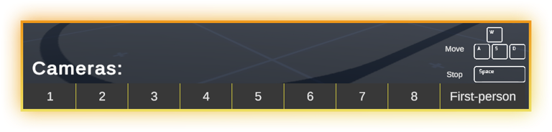

Adding ATC Features to a Scene
Arcade Train Controller uses the Unity Splines package as the solution for tracks. When importing ATC you hopefully selected to import the required packages, if not you'll need to import Splines manually. Instructions on how to do that can be found in the official Unity documentation here.

Create
You can add a spline by following the instructions in Unity's documentation linked above, however ATC also has some options to quickly create a Spline along with the various ATC components, available in the Hierarchy right mouse click menu.
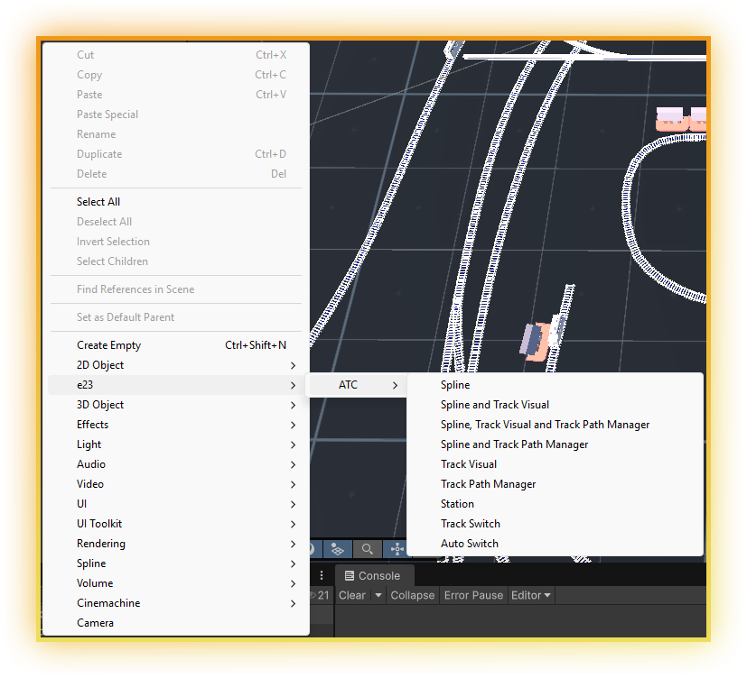

Spline
This adds an additional option for adding a Spline to the scene. Clicking this creates a new game object with the name 'TrackSpline' and a SplineContainer component on it. You can then use the spline tools to add knots and lay the path in the shape you want.

Spline and Track Visual
Same as above, with the addition of a child object named 'TrackVisual'. The SplineMeshRepeater component will be added to the child with the SplineContainer automatically assigned.

Spline, Track Visual and Track Path Manager
The Track Path Manager is a required component which calculates the path and comunicates with the train for movement around the path. Selecting this option will create an empty parent object and add all three componets on child game objects, as well as assign the Spline Container to the required fields.

Spline and Track Path Manager
Use this option if you do not require the SplineMeshRepeater.

Track Visual
If you already have a spline created and want to add the SplineMeshRepeater later, use this option.

Track Path Manager
Create a new game object containing the Track Path Manager component, no fields will be automatically assigned.

Station
Create a new game object called 'Station' with the Station component.

Track Switch
This component is used to create the different paths on tracks with multiple routes.

Auto Switch
Create a new empty game object called 'Auto Switch' with the AutoSwitch component, as well as the required box collider and rigidbody.

Creating a Track [Online Docs]
There are only two components that are required for a working track. A SplineContainer and a TrackPathManager.
It's best to first create an empty game object per track. Helps to keep everything tidy and reposition easier.
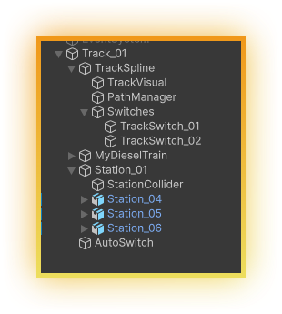

SplineContainer
The SplineContainer is the component needed to create, draw and manipulate splines. Follow the insctructions in the Unity documentation on how to draw and edit a spline - link.
First create a SplineContainer and then add some knots to create a spline path.

Track Visual
Once your spline is created and lay out how you want, at least for now, it's a good idea to be able to see the track! Use the right mouse create menu to add a 'Track Visual' as a child of the 'TrackSpline' game object.
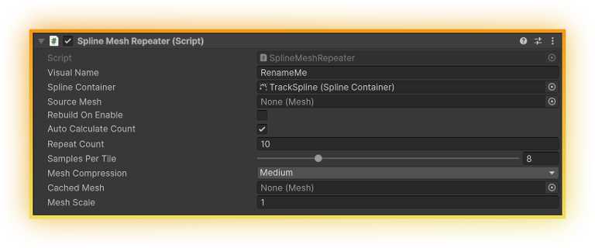
Change the field 'Visual Name' to something descriptive. Note: if you leave it at RenameMe and then generate any other meshes the the default values, the mesh will be overwritten each time.
The Spline Container should have automatically been assigned, if it hasn't been assign the container you wish to generate a mesh for.
Assign a source mesh. This should be a piece of modular (repeatable) track, a simple one is included with ATC.
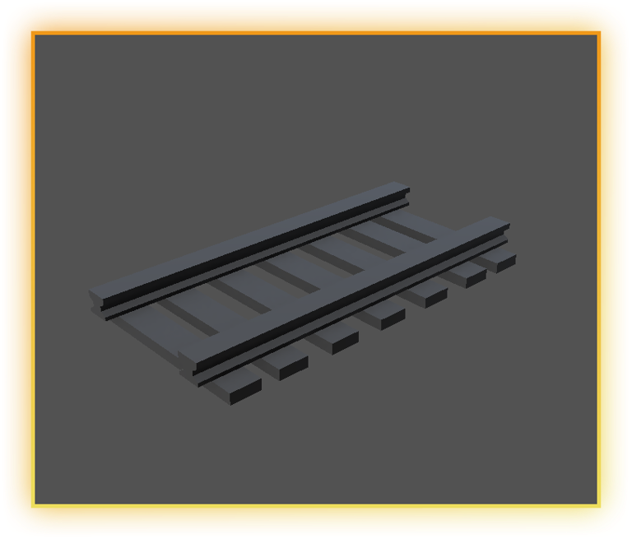
Everything else will most often be left at the default values, though you may wish to tweak the 'Samples Per Tile' value.
Now it's time to build the visual. Right mouse click on the component title -> Rebuild. After the mesh is generated you'll want to assign a material to the Mesh Renderer.
Generated meshes are saved in the project window in a new folder next to the active scene. EG: Packages/e23 Arcade Train Controller/Samples/DemoScene/e23.GeneratedMeshes/

Adding Paths to a Track [Online Docs]
The TrackPathManager is the component that deals with everything related to turning the Spline into an active path, visualise the currently active path, and communicate with the TrainBehaviour so it knows the route to take.
Each train requires its own TrackPathManager. One SplineContainer can be used by mulitple TrackPathManagers.
Now that we have a spline and track from the previous step, it's time to add a TrackPathManager, do that now and add it as a child of the TrackSpline.
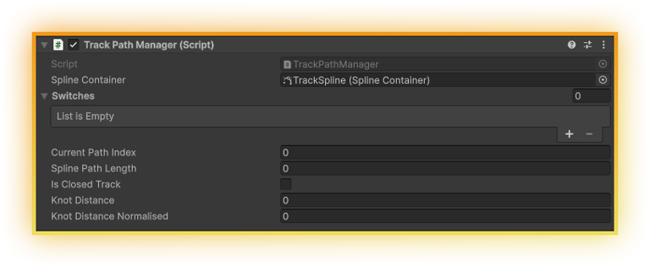
The SplineContainer field should have automatically been assigned, if it hasn't, assign this now.
With the TackPathManager displayed in the inspector you'll notice that now in the scene view the current path is displayed.
The displayed path is not complete, not a loop, but the track is. In cases where a single track loops you'll want to tick the 'Is Closed Track' bool. Without this bool ticked the train will jump from the end to the start, skipping that section of the track.
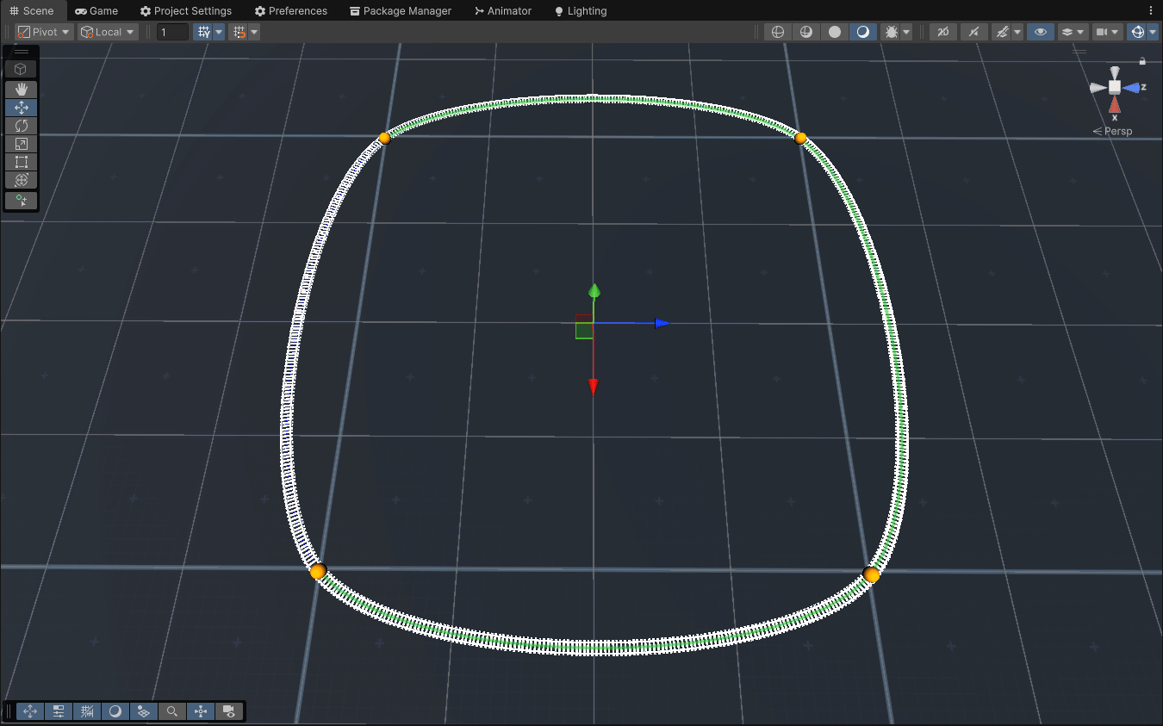

Adding Additional Paths
Unity's Spline package allows you edit a spline after creation, adding more knots, joints with new paths, positions, rotations etc. Select the TrackSpline game object, and enter the Spline edit mode, now add a few extra knots.
It's easier if you disable the game object with the SplineMeshRepeated comopnent, so that you can see what you're doing. Once you're happy with your new additions, re-enable the visual game object and you'll want to rebuild the track to add the new path.
We now have a new path, but the TrackPathManager doesn't know about it. The scene gizmo will still be showing the default path, and you're unable to change to the new one.
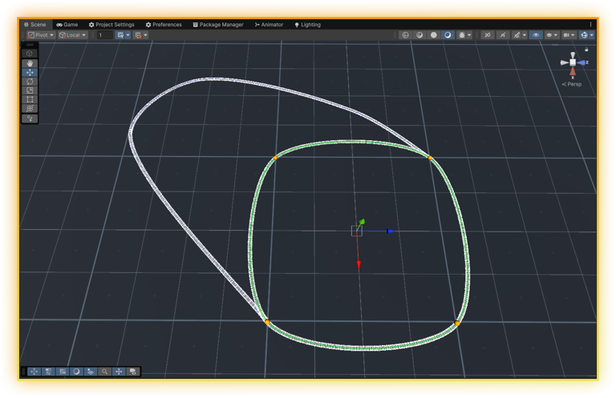

Switches
Create a new empty transform under as a child of the TrackSpline. Add two Track Switches, right mouse click -> e23 -> ATC -> Track Switch.
Whilst editing the fields on the switches, it's a good idea to have two inspectors open. The first should be locked displaying the TrackPathManager in use, and the second unlocked for use with the selected TrackSwitch - this means as you update the fields you can see the changes of the path in real time.
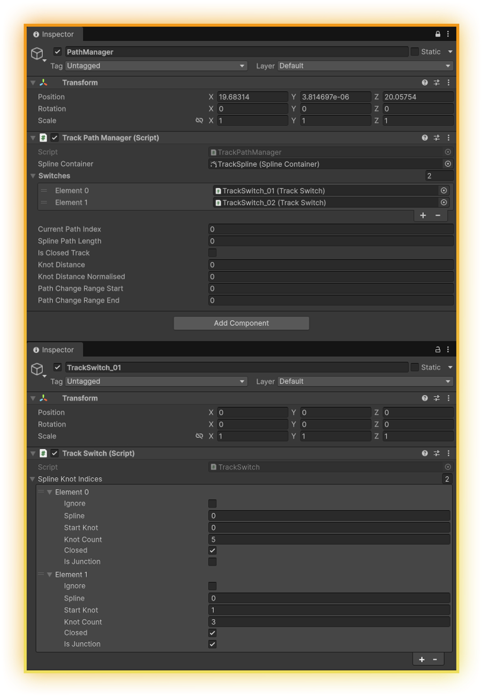
Assign the two newly created Track Switches to the 'Switches' list on the TrackPathManager, and make sure the 'Current Path Index' is still set to 0.
At this point there should be no gizmo path displayed in the scene.
Before we can add the information requried to create the path, we need to get some details from the SplineContainer to know what to add.
We need:
Spline index
Start Knot index
Knot Count
Note if the knot is a junction (link between two splines)
The scene view gizmo's don't make this information readable all the time, and displays inconsistently. In the screenshot below there are three values highlighted.
[1]
[(0,1), (1,4)]
[2]
If we take the longest one first, we have two pairs: (0,1) and (1,4). These numbers mean (splineIndex, knotIndex). So (0,1) is Spline 0 and Knot 1, the other is Spline 1, knot 4.
The other two values are lacking which spline index they belong to, because the knot is not part of a joint. You need to trace the path back to the knot on a joint to work it out. [1] is on Spline 1. [2] is on Spline 0.
Clicking the knot indices in the SplineContainer lists will select the knot, giving you another way of confirming the values.
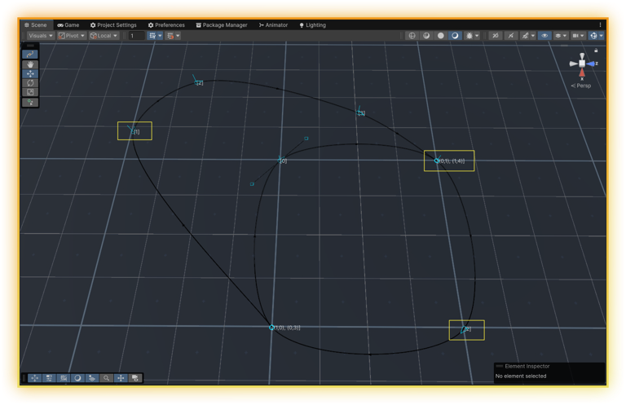
We are going to have two paths, so our list of indices needs two elements. Add two elements to the 'Spline Knot Indices' on each TrackSwitch.
For the first path, we can see we want Spline 0, the start knot is 0, and there are 4 knots. However, the knot count is 5, as we need to add the first knot again for the closed loop: 0 -> 1 -> 2 -> 3 -> 0. The 'Closed' bool will also require ticking.
On the second TrackSwitch the first element should have the 'Ignore' bool ticked, as we can achieve the first path with just the one set of information.
If we added a train now, it would have a track to travelling along, but it would only be able to follow the inner circle. For the next path we need to include two splines, 0 and 1.
In most cases, it's best to set the paths out in spline order (0, 1, 2, etc), see the Monorail setup in the included demo scene for a case where the spline order is reversed.
Let's start the new path at 0,1 with a count of 3, and because at this knot we want to change splines, mark it as IsJunction. Then on the second TrackSwitch continue from 1,0 for a count of 5. Also mark this as Closed.
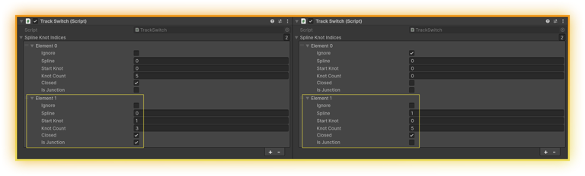
Changing the value of 'Current Path Index' on the TrackPathManager will swap between the two paths.
You now have a multipath track ready for trains to travel around.

Incorrect Paths
By now you should be familiar with what a correct path looks like; a green line that follows the path of the spline. If the path looks wrong (eg: like in the screenshot below), the values in one or more of the TrackSwitches has been entered incorrectly, go back, recheck and update the values.
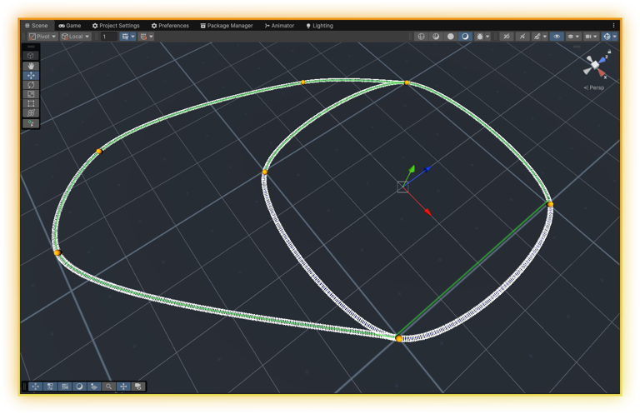

Changing Paths [Online Docs]
The control of your paths lies with the TrackPathManager. The TrackPathManager has three public methods available for swapping paths.
TrackPathManager.NextIndex() - Proceed to the next index by one. This will loop back round to 0 after reaching the last index.
TrackPathManager.PreviousIndex() - Decrease the currentIndex value by 1.
TrackPathManager.GoTo(int) - Swap directly to any path index. Be aware this may cause an issue where the train cannot reach the new path, so will never pass along a safe bit of track to change to it.

Manual
ATC comes with two functional ways of changing the path. Using the AutoSwitch component, or one of the UI components.
TrackSwitchUIButton - This is the base class and can be ignored. Adding this to a UI button will result in no functional changes. Use a combination of the other three componets.
TrackSwitchNext - Progress to the next path index using a UGUI button.
TrackSwitchPrevious - Progress to the previous path index using a UGUI button.
TrackSwitchGoTo - Change the index directly to the stated int.

Automatic
The other way to switch paths is to use the AutoSwitch component. When a train passes through the trigger it will call the NextIndex() or PreviousIndex() method on the assigned TrackPathManagers.
You can add an auto switch to the scene via the right mouse menu. e23 -> ATC -> Auto Switch. This will create a new game object with a correctly setup rigidbody, a box collider (set as a trigger), and AutoSwitch component. Resize and position this game object as needed.
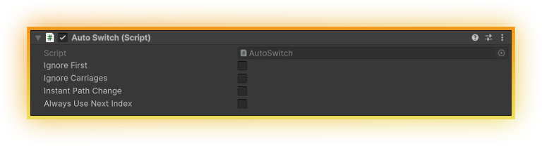
The only setup required, after creation, are these bools.
Ignore First - If the train starts off within the bounds of an AutoSwitch tick this to stop the track changing on scene load.
Ignore Carriages - This is the same as the Station component, only on this one you will probably wish to leave this true in almost all cases.
Instant Path Change - Enable this if the AutoSwitch is located at the end of a path (see Monorail example in demo scene).
Always Use Next Index - Force the AutoSwitch to call TrackPathManager.NextIndex() regardless of the direction the train is travelling (for a scenario where this is needed, see Monorail example in demo scene).
The AutoSwitch checks to see which direction the train is moving (forward/ reverse) and then calls TrackPathManager.NextIndex() or TrackPathManager.PreviousIndex() assigned to the train.

Station [Online Docs]
The station component can be used to have a train automatically stop at a location. It also offers the option to reverse the trains direction (eg: because it's end of the line), and open/ close doors while it's stopped.
Use the station settings scriptable object to manage how trains and stations interact with each other.
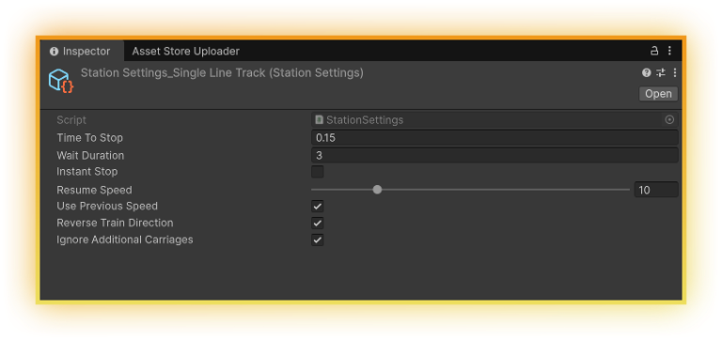
Time To Stop - Tweak this value (in seconds), along with the position of the station collider, to get the train to stop in the correct location at any station using this scriptable object.
Wait Duration - How long the train will wait at this station, in seconds, before continuing.
Instant Stop - Ignores the Time To Stop value and instantly stops the train.
Resume Speed - Sets the speed the train should staart moving at when leaving the station, unless 'Use Previous Speed' is ticked.
Use Previous Speed - Caches the speed the train enters the station at, and tells it to resume at that speed when leaving.
Reverse Train Direction - Set the train moving in the opposite direction from where it came.
Ignore Additional Carriages - If your carriages have colliders, use this to stop events triggering with every carriage. Set this to false for instances where you'd want your train to stop at a location for the train egine and each carriage.

Creating a Station
You can use the create menu to add a station to your station model: right mouse click -> e23 -> ATC -> Station
This will create a new game object (called 'Station') with the Station component, rigidbody (setup correctly) and box collider. Position and resize the game object as required.
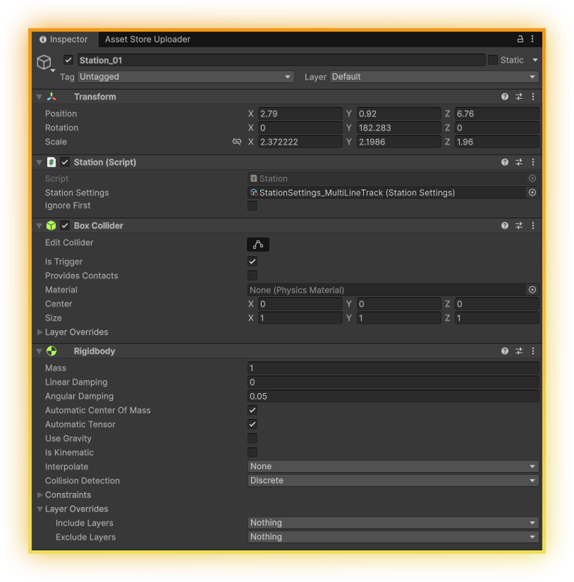
Assign the settings you wish this station to use and you're good to go.
'Ignore First' is present in case your train starts off within the station collider, tick this to stop this interaction (example used in the included demo scene, see the Monorail stations).
With 'Ignore Additional Carriages' set to false, each object that hits the station trigger will stop the train. This could be useful, for example, with a cargo train stopping to fill/ empty each bucket being pulled.

Track Signals [Online Docs]
A track signal points in the direction of the active path at a junction.
Assign the 'TrackSwitchVisual' component to your model.
In the 'TrackAngles' list add the amount of elements required for paths present. Assign the TrackPathManager to subscribe to for path changes, and fill in the details.

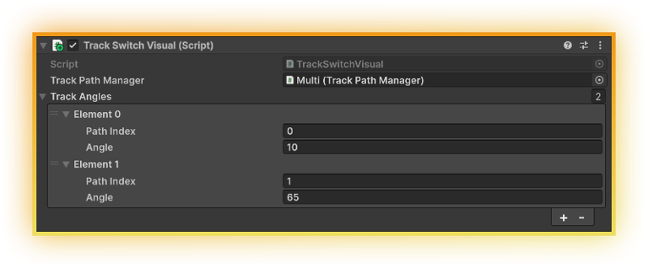

Train Settings
Train settings store the data for a train’s movement. These settings can be used on multiple trains at the same time, making it easy to tweak values. You can have 50 trains and 1 settings object, or 50 trains each with their own settings.
To create a new settings object, in the Project Window navigate to the folder you wish to store it in: right mouse click -> Create -> e23 -> ATC -> Vehicle Behaviour Settings
The below image is an example of the settings that come included with ATC. Most of the values are self-explanatory.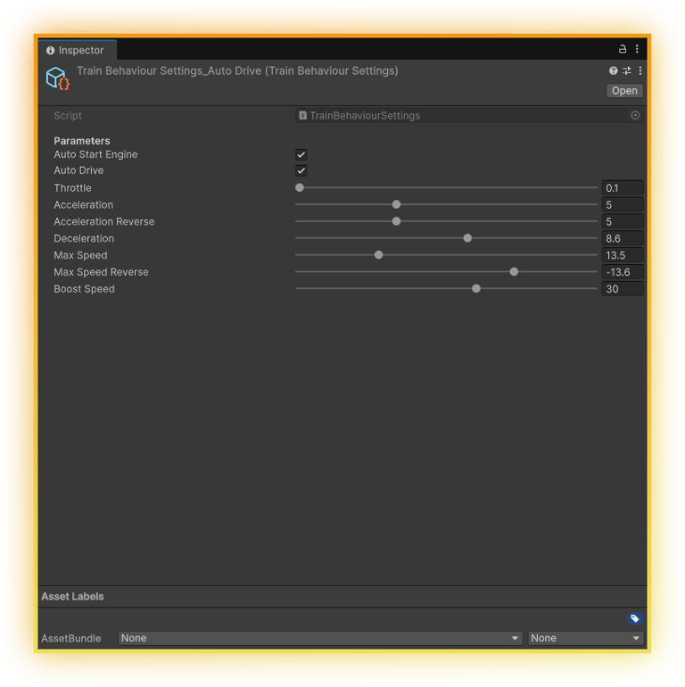
Auto Start Engine – Have the engine already running when the game starts, or require the engine to be started by the player.
Auto Drive – Enabling this will set the train to self-drive.
Throttle – Changes the train speed by increasing and decreasing the target speed.
Acceleration – How fast the train speed increases to reach the target speed.
Acceleration Reverse – How fast the train will speed up in reverse.
Deceleration – Controls how quickly a train slows down. Tweak this value when using the Station omponent to control trains stopping in the correct location.
Max Speed – How fast the train can drive.
Max Speed Reverse – How fast the vehicle can drive in reverse.
Boost Speed – A set value the train will boost at when calling Boost(). This value is the speed the train will reach, and should be set to a value higher than Max Speed. Other boost methods are also available for custom boosting functionality.

Preparing Your Train
ATC has a few small requirements for how your model is setup. Your model must be:
- Facing Z forward
- Y up
- (Optional) If you wish the wheels to rotate their pivot must be in the center
The included model has the pivot location set incorrectly on the wheels. There are two ways to solve this, the best way is to import the model into modelling software (eg: Blender) and re-export with the pivot location corrected. The second way is to correct in Unity by placing the wheels under empty parent transforms, with their local location centered.
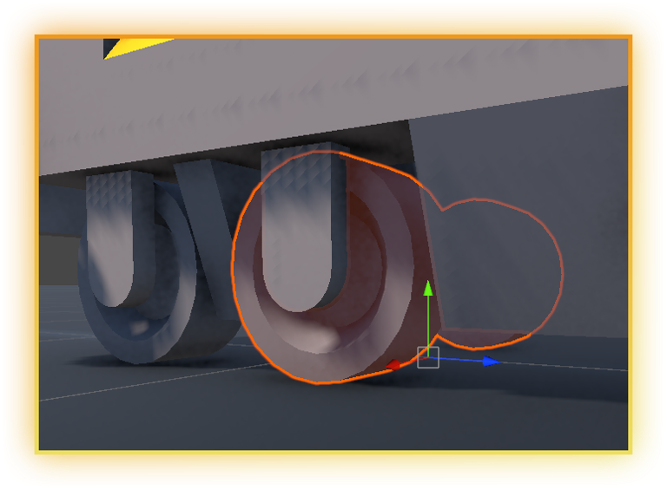
The left image is before, with the incorrect pivot location. The right image corrects the issue by placing the wheels under an empty parent.
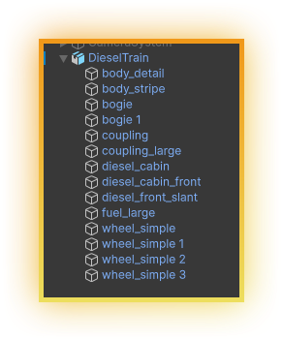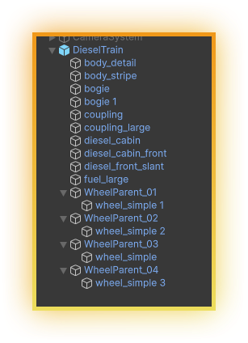
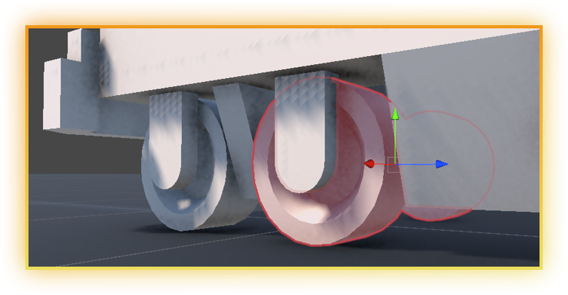

Building Your Train
Now that your train model is ready, you can open the train builder and make your working train. From the menu bar -> Tools/e23/ATC/Train Prefab Builder.
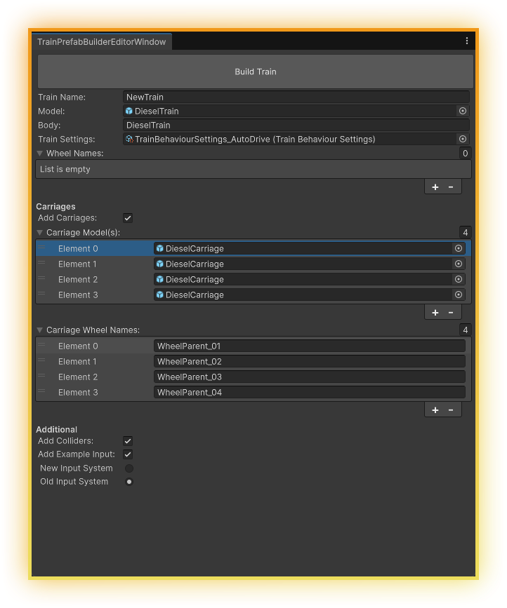
Train Name – the name you want your new train to be called.
Train Model – the model that you have just prepared to be used in the previous section.
Body – the name of the body in the model. This will usually be the name of the root parent.
Train Settings – the settings you wish to use for the train being created. This field can be left empty, but you will need to add Train Settings to the created train at a later time, this is a required object and trains will not work without settings assigned.
Wheel Names – the names of the wheels in the model. This is the name of the model GameObject for the wheel set at 0,0,0.

Carriages
Add Carriages – enable this option if you wish your train to have carriages.
Carriage Model(s) – add the amount of carriages you wish to add behind the train and assign the models. If you wish to only have multiple carriages using the same model, it is easiest to add 1 element, assign the model and then change the list count to the amount of carriages you wish to add.
Carriage Wheel Names – the names of the wheels in the model. This is the name of the model GameObject for the wheel set at 0,0,0.

Additional
Add Collider - enable this option if you wish the train to have collisions
Example Input – enable to add an example input component, and select which input system to use.

Linking Your Train to the Track [Online Docs]
After you click 'Build Train' on the prefab builder window your train will appear in the scene, at position 0,0,0. If you added carriages they'll also be at 0,0,0 - don't worry about that yet.
The train will have almost everything it needs, either a TrainBehaviour or MultiTrainBehaviour component, assigned fields. All that's missing is the TrackPathManager. When you assign the TrackPathManager the train will jump into position on the track.
You can then use the 'Carraige Distance' slider to move the carraiges out from the train and be positioned at equal distances from each other.
Use the 'Start Off Set' slider to change the start position of the train on the path.

Making Your Train Move
Now that you have your train in the scene and attached to a track, it needs to be able to move at runtime! There are two ways to move your train, manually and automatically.

Manually
Included with ATC are two example input components. One using the New Input System, one for the legacy input system. You can choose to add one of these with the prefab builder. If you want to add one of these components after already creating your train, just add either ExampleInputNew or ExampleInputOld to the parent game object - the same game object as the TrainBehaviour.
The InputActions asset for the New Input System can be found at: Packages/e23 Arcade Train Controller/Runtime/Examples/Input/

Automatically
In the case where you want the train to be moving on its own then all you need to do is tick the 'Auto Drive' bool on the assigned TrainBehaviourSettings scriptable object, you'll also want the 'Auto Start Engine' bool enabled.
With these two bools set to true, any train with these settings assigned will move automatically at runtime.
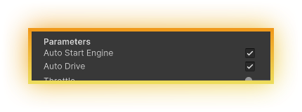
You can use Stations to add additional automatic controls to a train. See the Station page for more information.

Custom
ATC has been designed to be open for customisation, you should be able access any required method with a custom class, or extend any ATC class you need to, every method is virtual ready for extension or to be overridden.

