UOK Next

Foundational System Design

STATUS  Approved baseline; Gate 3 active |  | OWNER  UOK Next product and architecture |  | LAST UPDATED  August 25, 2026

Authors | UOK Next engineering
Reviewers | Product, architecture, security, module, and operations owners
Related docs | Product Charter; Architecture; Modular Monolith Contract; Roadmap
Scope | UOK Next foundation, authority, contracts, controls, and evidence-gated delivery.

1. Abstract
UOK Next is an evidence-first operating platform for multi-party commodity work. It uses one Elixir/OTP application release, one PostgreSQL 19 transactional data platform, and one React/TypeScript delivery workspace. A product-neutral kernel provides tenant, policy, command, idempotency, audit, outbox, evidence, human-task, integration-receipt, and operational primitives. Business modules retain exclusive record authority and communicate only through declared public contracts.
The design supports attributable human decisions, recoverable side effects, constrained-network users, operational reporting, and future advisory AI without granting probabilistic output command authority. It deliberately defers microservices, arbitrary runtime plugins, autonomous consequential action, production identity, specialist execution, and production availability claims until their evidence gates pass.

2. Goals and Non-Goals
Goals | Non-goals
Deliver the proving operation from governed masters through operational reporting with attributable evidence and human decisions. | Do not start with a distributed service network, arbitrary runtime plugins, or independently deployed modules without measured need.
Preserve one declared authority per record, tenant isolation, exact source versions, and auditable command outcomes. | Do not allow AI, the browser, integrations, communications, or evidence anchoring to become a second command or permission system.
Remain responsive and recoverable through bounded work, durable intent, idempotent delivery, receipts, and tested failover and restore paths. | Do not claim autonomous settlement, regulated approval, shipment execution, payment, or inventory effects before separate authority and recovery gates.
Add countries, commodities, organizations, modules, and specialist bindings through governed contracts without product forks. | Do not rebuild every back-office, document-intelligence, analytics, communications, or collaborative capability inside the kernel.

3. Background and Problem Statement
Earlier application work proved useful business concepts across several runtimes, but foundational concerns were duplicated and authority boundaries were inconsistent. UOK Next replaces line-by-line preservation with one governed foundation. The first proving operation now reaches party onboarding, sourcing, deterministic quote comparison, an internal commitment proposal, and shipment-readiness GO/HOLD; governed operational reporting is the active remaining Gate 3 vertical.
The application release owns synchronous commands, policy, workflows, read models, audit, evidence metadata, and outbox intent. The transactional database owns durable operational truth; object storage owns evidence bytes only; specialist systems retain their own content or execution records. The guiding invariant is simple: one record type has one declared authority, and no consequential mutation occurs without current tenant, actor, permission, version, evidence, reason, idempotency, and audit context.

4. Proposed Architecture

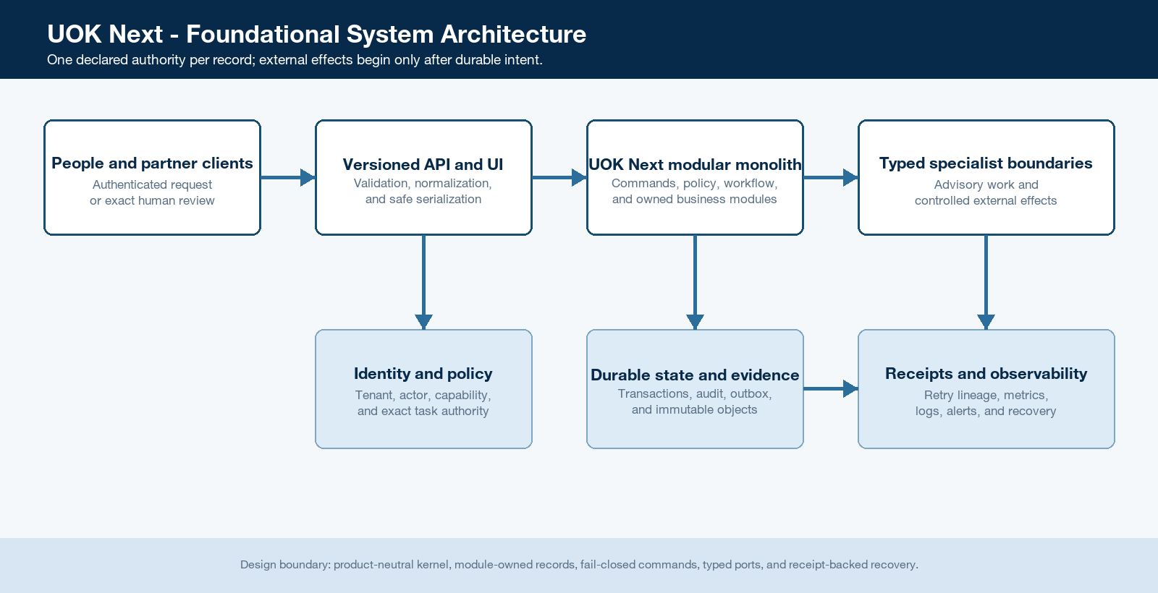
Figure 1. UOK Next system context, authority, durable state, and side-effect boundary.

Core components

Component | Responsibility | Primary storage | Failure behavior
API and UI delivery | Serve versioned APIs and module surfaces; validate, authenticate, serialize, and expose user intent without owning policy. | No business state; compiled assets and API contracts | Reject unsafe input before mutation; dependency failure returns bounded errors and readiness may fail.
Product-neutral kernel | Provide tenant, command, idempotency, audit, outbox, health, release, evidence, and correlation primitives. | Kernel-owned transactional tables | Fail closed; a failed required primitive rolls back the command and creates no side effect.
Platform governance modules | Own identity context, policy, human tasks, evidence metadata, integration receipts, module governance, and advisory agent plans. | Module-owned transactional tables and evidence metadata | Unavailable authority blocks the transition or produces HOLD; it never grants fallback permission.
Business authority modules | Own parties, products, locations, sourcing, proposals, readiness cases, and later quality, compliance, finance, BI, and publishing records. | Exactly one module-owned table set per record type | Invariant failure rejects or rolls back; cross-module work uses public contracts and exact versions.
Durable data and specialist ports | Persist operational truth and evidence bytes; deliver typed external work only after durable intent and retain receipts, health, and reconciliation. | Transactional database, object storage, and role-owned external systems | Database or evidence failure blocks readiness; external failure retries within budgets and becomes reviewable terminal state.

5. Request Lifecycle
- A request enters through the same-origin versioned API or a durable worker trigger with a bounded payload, correlation identity, and idempotency key.
- The delivery boundary authenticates the session or service identity, derives the tenant and actor server-side, validates shape and size, and authorizes the named operation.
- The application loads the validated module descriptor, command policy, current subject version, evidence state, and exact human task when the operation is consequential.
- The owning module applies a pure domain decision and rejects invalid, stale, cross-tenant, unauthorised, or unsupported transitions before mutation.
- One database transaction commits business state, command receipt, policy and audit evidence, domain events, and outbox intent together; any required write failure rolls back all of them.
- Only after commit may durable jobs call typed specialist adapters. Attempts use deadlines, bounded retries, immutable delivery identities, digests, receipts, reconciliation, and dead-letter review.
- The API returns the stored result or stable error, emits privacy-aware metrics and traces, and preserves enough lineage for replay, incident review, and recovery without logging protected payloads.

6. API and Data Contracts

Primary data contract

Field | Type | Required | Description
tenant_id | Opaque UUID | Yes | Server-derived tenant scope; mandatory on every tenant-owned command and persisted relationship.
actor_context | Object | Yes | Authenticated actor or service identity, session lineage, and effective capability; never accepted as browser authority.
command_name | Versioned identifier | Yes | Stable intent owned by one module; validated against the enabled module and public command catalog.
subject_ref | UUID plus version | Yes | Owned aggregate identity and expected version used for tenant checks, locks, task binding, and stale-state rejection.
idempotency | Key plus digest | Yes | Bounded key and canonical payload digest define exact replay; mismatch returns conflict.
reason_and_trace | Object | Yes | Attributable reason, correlation, causation, and request time; privacy-aware and size-bounded.
evidence_and_policy | Array or object | Conditional | Verified evidence references, policy decision, and exact human task required by the named consequential command.

Contract guarantees

- Authentication and tenant binding occur before tenant-owned subject resolution; every mutation is an allowlisted named command.
- The same tenant, idempotency key, command name, and canonical payload digest return the stored completed result; a mismatched replay is a conflict.
- Business state, command receipt, audit event, domain events, and outbox entries commit atomically and retain actor, subject version, correlation, causation, and evidence lineage.
- The command envelope proves intent and execution context. It never becomes a second source of truth for records owned by a business module or specialist system.
Versioned machine contracts and ownership declarations are published at
priv/api/openapi-v1.json and config/module_catalog.json; both advance through reviewed releases.

7. Consistency, Idempotency, and Replay

Commands are serialised at the owning aggregate where needed, use optimistic concurrency, and are exactly replayable after completion. External delivery is at-least-once with idempotent receivers or delivery keys, never inside the business transaction. Duplicate advisory work may be acceptable when its receipts and budgets are bounded; duplicate business mutation or hidden side effects are not.
Scenario | Expected behavior | Reasoning
Exact duplicate or completed replay | Return the stored completed response without a second mutation or side effect. | The receipt binds tenant, key, command, and canonical payload digest.
Required transactional write fails | Roll back business state, receipt, audit, events, and outbox; return a bounded retryable or terminal error. | No partial durable truth is exposed and downstream work cannot start.
External timeout or partial delivery | Keep durable intent and attempt receipt, apply bounded retry or reconciliation, then route terminal failure to review. | The business transaction stays committed while delivery remains attributable and recoverable.
Policy, module, or source version changes | The command uses the validated version and rejects stale state; a new attempt must reauthorize current state. | Plans, UI state, caches, or earlier approvals cannot become reusable bearer authority.

8. Security and Privacy Considerations

- Central authentication establishes a server-owned tenant and actor; command-specific authorization, forced row-level security, and composite tenant keys fail closed against substitution.
- Collect only bounded fields needed by the owning contract. Keep private content out of general logs and events; store evidence bytes separately from governed metadata, hashes, policy, and review state.
- Production credentials, signing keys, database trust roots, and certificates come from managed secret references, rotate independently of images, and never enter source, URLs, browser state, receipts, or error payloads.
- Migration, replay, break-glass, debugging, and maintenance paths use separate least-authority identities, explicit time limits, immutable evidence, and fail-closed defaults; they cannot silently bypass tenant or audit controls.
- Each owner declares classification, retention, deletion, residency, export, and legal-hold behavior. Integrity hashes and optional anchoring never replace access control, privacy, or lawful deletion.

9. Operational Readiness
Signal | SLO or alert | Owner | Launch gate
API availability | Provisional 99.9% monthly; paging thresholds require selected-platform validation. | Platform operations | Required
Command latency and saturation | Capture p50, p95, p99, lock wait, queue time, throughput, and resource headroom; numeric launch budgets require representative load evidence. | Platform and module owners | Required
Outbox, job, and connector health | Production remains blocked until delivery exists with age, retry, dead-letter, reconciliation, and alert thresholds. | Platform operations | Required
Release and database drift | Any revision, image, migration, role, grant, policy, prerelease, or compatibility mismatch blocks readiness or promotion. | Release and database owners | Required
Recovery and integrity | Monthly isolated restore and quarterly RPO/RTO exercise; provisional RPO 15 minutes and RTO 60 minutes until proven. | Operations and security | Required
Rollout constraint: protected checks, immutable exact-revision build, migration and policy verification, two-replica identity and failover, end-to-end workflow evidence, desktop/mobile accessibility, security review, backup/restore, monitored canary, and tested rollback must pass before production expansion.

10. Alternatives Considered

Alternative | Why it was considered | Why it was not selected
Microservices from the foundation | Independent scaling and fault boundaries may become valuable later. | Current domains share transactions, identity, policy, audit, release cadence, and a small team; the distributed-system cost is not yet justified.
Rust or C++ for the whole kernel | Maximum native throughput, memory control, and strong low-level performance. | Policy-heavy workflows, human decisions, and real-time coordination need safer delivery speed and fault semantics; native runtimes remain bounded specialists.
Direct Erlang kernel | Keeps BEAM supervision, concurrency, and fault containment. | It gives up material language and web-framework productivity without improving the selected business boundary.
Back-office suite as the kernel | Provides mature standard administrative breadth and localization. | It would constrain the differentiated evidence, command, workflow, module, and advisory-AI authority model; integration remains role-bounded instead.

11. Open Questions
- Which standards-based production identity, session-revocation, trusted-ingress, and delegated service-identity design will be selected and qualified?
- Which production platform will prove PostgreSQL 19 GA, fencing, TLS, WAL archival, immutable backup, PITR, monitoring, capacity, failover, and disaster recovery?
- When will module manifests, tenant enablement, registry-derived surfaces, source-to-catalog checks, kernel-only boot, and disabled-module boot be implemented?
- Which governed operational-reporting projection, metric definitions, freshness budget, reconciliation rules, and degraded behavior will complete Gate 3?

12. Decision and Next Steps
Retain the accepted Elixir/OTP modular monolith and continue one evidence-backed vertical at a time. The immediate milestone is governed operational reporting, followed by exact merged-revision qualification and Gate 3 closure. Specialist execution and broader production rollout remain blocked until identity, platform, recovery, observability, capacity, security, and rollback evidence are attached to the candidate release.
Milestone | Deliverable | Exit criteria
M1 | Define governed operational reporting through an ADR, metric catalog, product-neutral workflow benchmark, and explicit projection ownership. | Authorization, grain, lineage, freshness, reconciliation, failure behavior, accessibility, and no-mutation boundary are accepted.
M2 | Implement the report projection, versioned API, module-owned UI, reconciliation checks, and operational telemetry. | Success plus tenant, permission, stale, source, replay, reconciliation, and degraded-mode tests pass with no second system of record.
M3 | Close Gate 3 through protected delivery and exact merged-revision qualification. | Real database, object storage, UI, two-replica failover, recovery path, desktop/mobile proof, security review, and rollback evidence pass.
M4 | Open specialist integration and production qualification only through new evidence-backed verticals. | Production identity, trusted TLS ingress, PostgreSQL 19 GA, HA, PITR, monitoring, capacity, security, disaster recovery, and rollback gates pass.

Use footnotes for definitions, assumptions, or terms that need precision without interrupting the main narrative.

