ENGINEERING STRATEGY

SozoGraph Portable Memory Passport Engineering Plan
  - Architecture Mathematics Benchmarks and Delivery Plan
5 September 2026

Decision We will build the passport as a governed source of truth. We will compile it into fast retrieval sidecars. This structure preserves portability and gives us room to beat systems that bind memory to one model or database.

The target is a local first memory system with deterministic state, strong evidence, temporal truth, secure sharing, and measured answer quality. Every advanced component remains optional. A valid passport stays readable without a server, vector database, or language model.
This plan covers the product shape, mathematical model, optimization sequence, benchmark program, security controls, interoperability contract, and sixteen week delivery path.

Contents
Section | Subject | Page
1 | Executive decision | 3
2 | Current SozoGraph baseline | 4
3 | Frontier systems and lessons | 5
4 | Target architecture | 6
5 | Passport 3 data model | 7
6 | Mathematical design | 9
7 | Optimization strategy | 15
8 | Benchmark and release gates | 16
9 | Delivery plan | 18
10 | Risks and decisions | 20
11 | References | 21
Appendix | Implementation status September 2026 | 22

Reading guide
The first five sections define the system. Section six gives the mathematical model. Section seven turns the mathematics into an optimization sequence. Sections eight and nine define proof and delivery.

1 Executive decision
Product claim A SozoGraph passport is a portable memory authority. It carries facts, preferences, events, procedures, relations, policy, evidence, history, and deletion state. It can be compiled into any retrieval engine.

What winning means
- Answer quality reaches or exceeds the strongest published memory systems on LoCoMo, LongMemEval, and BEAM.
- Evidence recall stays above 97 percent before answer generation.
- The canonical file round trips and merges deterministically.
- Deletion reaches every derived index and cache.
- Imported text cannot raise its own authority.
- A basic reader works with one file and no network service.

Strategic rule
The canonical layer owns truth, identity, provenance, policy, and history. Sidecars own speed and learned ranking. Sidecars can be rebuilt. The passport remains stable.

Why this can win
Current leaders optimize memory extraction, graph retrieval, temporal reasoning, and token cost. Portability efforts optimize interchange and deletion. SozoGraph can combine both lines. The combination is still rare in public systems.
The strongest engineering advantage is measurable separation. We can locate a failure in writing, projection, retrieval, context selection, reasoning, or evaluation. Each layer receives its own metric and release gate.

2 Current SozoGraph baseline
SozoGraph already has a useful base. Version 0.2.1 stores facts, preferences, observations, entities, sources, and metadata. It can render compact context and retrieve with lexical ranking. The test suite passes under the module runner with 181 passing tests and 4 skipped live provider tests.

Strengths
Area | Present capability | Value
Portability | Single readable JSON passport | Simple inspection and transfer
Retrieval | BM25 style lexical ranking and entity expansion | Strong local baseline
Rendering | Budgeted plain text context | Low integration cost
Schema | Typed facts preferences observations entities and sources | Clear initial model
Prompts | Extraction and update prompts | Working ingestion path

Limits that block state of the art
Gap | Current effect | Required change
Stable identity | Facts and preferences lack durable record identifiers | Add immutable IDs and event history
Time | Observations carry one date | Add valid time and transaction time intervals
Evidence | Source links are coarse | Add exact evidence spans and derivation links
Lifecycle | No supersession expiry or tombstones | Add explicit state transitions and deletion propagation
Relations | Entities lack a typed relation graph | Add relation records and graph projections
Memory classes | No procedures episodes outcomes or policy records | Expand the type system
Security | No authority or sensitivity gate | Bind authority to origin and filter before ranking
Portability | Unknown fields move under metadata | Preserve unknown fields and unknown kinds exactly

Baseline decision
Keep the compact JSON profile as a friendly view. Add an append only event form as the canonical state. Generate the compact profile from that log. Existing users retain a simple file. Advanced users gain audit, merge, deletion, and temporal reconstruction.

3 Frontier systems and lessons
The literature points to six useful mechanisms. Each solves a distinct failure mode. We should combine them through clear interfaces.
Approach | Core mechanism | Lesson for SozoGraph
Mem0 | LLM extracts candidate memories and selects add update delete or no operation | Use explicit write actions and a verifier. Keep the policy pluggable. [1] [2]
LightMem | Token compression topic segmentation and deferred consolidation | Separate online capture from offline maintenance. Measure calls and tokens. [3]
A MEM | Atomic notes gain tags embeddings links and evolving context | Create small records and enrich them through background projections. [4]
AtomMem | A learned CRUD policy receives task outcome reward | Learn write policy after deterministic telemetry is strong. [5]
HippoRAG 2 | Knowledge graph retrieval uses query seeding and Personalized PageRank | Add graph propagation for associative and multi hop questions. [6]
Graphiti | A bitemporal graph tracks changing facts and provenance | Represent valid time and ingestion time on every claim. [7] [8]
LangMem | Semantic episodic and procedural memories have separate roles | Use distinct record classes and retrieval plans. [9]

Published frontier
Mem0 reports 92.5 on LoCoMo, 94.4 on LongMemEval, 64.1 on BEAM at one million tokens, and 48.6 on BEAM at ten million tokens for its managed April 2026 system. The same report gives a median latency range of 0.88 to 1.05 seconds and a context size near 7,000 tokens. These numbers are our public reference line. They come from a proprietary managed implementation. [1]
Graphiti reports 94.8 on its deep memory retrieval measure and up to 18.5 percent improvement on LongMemEval, with large latency reductions in its reported setup. [7] HippoRAG 2 reports a seven point gain in associative memory against its strongest embedding baseline. [6]

Portability projects
Project | Useful contract | Adoption plan
Portable Memory | Canonical JSONL bundle checksums evidence bitemporal fields tombstones signatures and conformance levels | Implement levels zero through two as an import and export profile. Preserve unknown fields. [15]
OAMP | JSON Schema Protobuf provenance privacy export and deletion | Map the core schema and publish adapters. [16]
OMIR | Interchange record concepts for agent memory | Track field mappings and conformance tests. [17]
PAM | Portable personal memory concepts | Use as a compatibility signal. [18]

4 Target architecture
The architecture has one canonical stream and several disposable projections.
Stage | Purpose | Persistent output
1 Origin bound ingestion | Capture text events files and tool results with issuer and trust context | Raw evidence and import receipt
2 Immutable event ledger | Record create amend supersede retract expire and delete events | Canonical passport stream
3 Typed projections | Build claims episodes procedures relations policies and resource references | Materialized portable views
4 Retrieval sidecars | Build lexical dense graph temporal and entity indexes | Rebuildable local indexes
5 Query planning | Select intent specific retrievers and evidence windows | Candidate set with trace
6 Policy and context | Apply access rules deduplicate diversify and fit the token budget | Evidence packet for the model

Canonical boundary
The ledger is the authority. Every projection records its source event IDs and build version. A damaged index can be removed and rebuilt. A disputed claim can be traced to exact evidence. A deletion event can enumerate every affected artifact.

Query plans
Intent | Primary route | Special rule
Current state | Valid claims plus latest transaction state | Exclude superseded and expired claims
Historical state | Bitemporal interval filter plus evidence | Answer from the requested valid time
Timeline | Event and episode retrieval | Order by valid time and preserve uncertainty
Associative | Dense seeds plus graph propagation | Return supporting paths
Multi hop | Entity and relation expansion plus reranking | Require evidence for each edge
Preference | Scoped preference records | Honor audience purpose and recency
Procedure | Procedure and outcome retrieval | Prefer verified successful variants
Unknown | Broad hybrid search | Abstain when evidence coverage is low

Deployment shape
- Core package reads validates merges and renders the passport.
- Local sidecar adds SQLite FTS dense vectors and graph adjacency.
- MCP surface exposes search inspect write correct delete export and audit.
- Cloud services can add stronger embedding reranking and policy learning.
- Every cloud feature has a local fallback and a declared capability flag.

5 Passport 3 data model
Every memory item carries identity, meaning, time, evidence, authority, policy, lifecycle, and integrity.
Field group | Required content
Identity | id type schema version namespace
Meaning | subject predicate object content tags entities
Time | created at observed at valid from valid to transaction interval
Evidence | source id exact span content digest extraction method
Authority | issuer origin actor authority class confidence basis
Policy | audience purpose sensitivity consent expiry
Lifecycle | active superseded retracted expired deleted and links to prior records
Integrity | canonical content hash signature and extension preservation

Memory types
Type | Meaning | Example use
Claim | A proposition with evidence and time | Current employer
Preference | A scoped choice with strength and conditions | Writing style
Correction | An explicit replacement or rejection | Name spelling
Episode | An event with participants and outcome | Meeting decision
Observation | A sensed or reported state | Device state
Goal | A desired state and open loop | Finish a migration
Procedure | A reusable sequence and success evidence | Release process
Relation | A typed edge between entities | Works at
Policy | A rule for use disclosure or retention | Private to one workspace
Resource | A durable reference to an external artifact | Document or repository

Normative record sketch
{ "id": "mem_01...", "type": "claim", "schema": "3.0",
"subject": "entity:user", "predicate": "prefers_style",
"object": "simple spare declarative prose",
"valid": {"from": "2026-09-05", "to": null},
"transaction": {"from": "2026-09-05T08:15:00Z", "to": null},
"evidence": [{"source": "src_01", "start": 41, "end": 91}],
"authority": {"origin": "user", "class": "self_asserted"},
"policy": {"audience": ["owner"], "sensitivity": "personal"},
"status": "active", "supersedes": [], "extensions": {} }

Determinism rules
- Canonical JSON uses RFC 8785 serialization. [19]
- Schema validation uses JSON Schema 2020 12. [20]
- IDs are stable and content hashes exclude mutable transport fields.
- Unknown fields and unknown kinds survive import export and merge.
- Merge order uses hybrid logical time actor ID and event ID.
- Tombstones win over stale replicas after the deletion authority check.

6 Mathematical design

6 1 Global objective
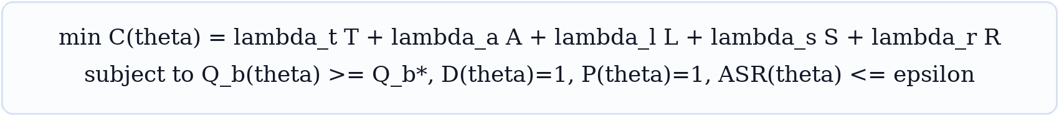
Equation 1 Constrained system objective
T is token cost. A is answer latency. L is learned model cost. S is storage cost. R is security and governance risk. Q is benchmark quality. D is deterministic conformance. P is deletion and policy conformance. The attack success rate stays below epsilon.
This objective forces every optimization to carry its full cost. A small quality gain can lose if it raises latency, operating cost, or risk beyond the release envelope.

6 2 Write pipeline
Equation 2 Capture extraction and projection
The source is segmented at granularity g. The extractor emits atomic candidates. The projector applies validated events to memory state. Raw evidence remains addressable through every step.
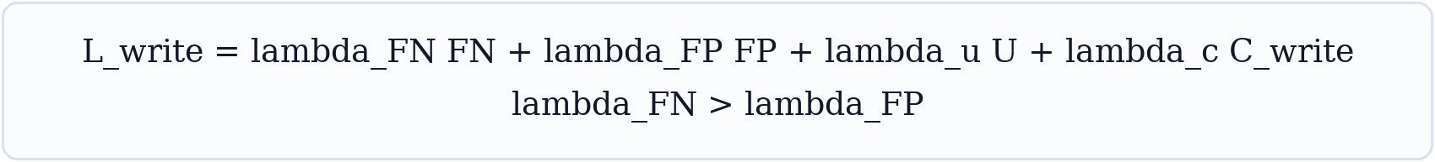
Equation 3 Write error cost
False negatives receive the larger early weight. Missing a durable fact removes it from every later stage. False positives still matter because they increase conflict, leakage, and retrieval noise. U measures unsupported content. Cwrite measures compute and latency.

6 3 Efficient consolidation
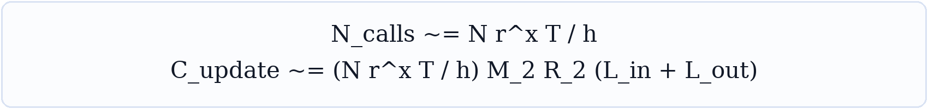
Equation 4 Approximate LightMem call and update cost
N is source volume. r is retained token rate. x captures repeated compression. T is transformation depth. h is effective batch size. M2 and R2 describe maintenance passes. This model shows why aggressive early compression and deferred maintenance can reduce cost. [3]

6 4 Evidence and confidence
Equation 5 Evidence grouped belief update
Each evidence group contributes a bounded log likelihood ratio. Grouping prevents copied sources from creating false certainty. The prior comes from record class and issuer authority. Confidence is derived and auditable.
We should store the confidence basis. We should avoid storing an unexplained scalar. Calibration is measured with the Brier score and reliability diagrams.

6 5 Bitemporal truth
Equation 6 Bitemporal claim
The tuple stores subject predicate object, valid time, transaction time, evidence, and status. Valid time answers when the claim held in the world. Transaction time answers when the passport knew it. [7] [15]
A current state query selects claims whose valid interval contains the requested date and whose transaction interval contains the chosen knowledge cutoff. A correction closes the prior transaction interval and creates a new record. History remains visible.

6 6 Deterministic merge
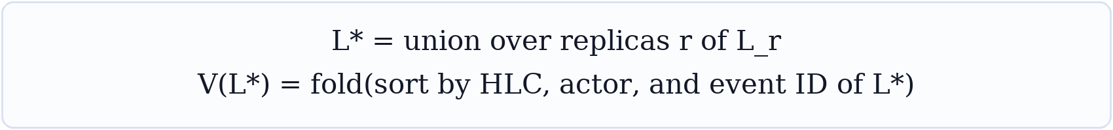
Equation 7 Ledger union and deterministic fold
Replica logs are unioned by event ID. The fold order uses hybrid logical clock, actor, and event ID. Event validation runs before state reduction. The same valid event set produces the same view.
Conflict policy is type specific. Independent claims coexist. Explicit correction can supersede a prior claim. Deletion applies only with sufficient authority. Policy fields use the more restrictive result when no explicit grant exists.

6 7 Hybrid retrieval
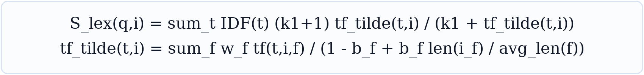
Equation 8 Field weighted lexical score
BM25F weights exact tokens across title, content, entities, tags, and source fields. Length normalization is field specific. This remains the default local retriever. [24]
Equation 9 Dense semantic score
Dense retrieval recovers paraphrase and concept similarity. Embeddings live in a sidecar. The passport stores the model identifier and projection provenance only when needed.
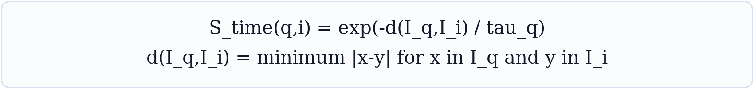
Equation 10 Temporal relevance
The time kernel uses interval distance and an intent specific scale. A recent status question uses a small scale. A biography query uses a larger scale.
Equation 11 Weighted reciprocal rank fusion
Rank fusion combines lexical dense entity graph and temporal lists without requiring calibrated raw scores. The weight for each retriever depends on query intent. [25]

6 8 Graph propagation
Equation 12 Personalized PageRank
The query seed vector starts on recognized entities, claims, and passages. Graph propagation finds related memories across typed edges. Alpha controls restart strength. Every returned path keeps its supporting evidence. [6] [26]
Graph expansion is capped by relation type, depth, evidence quality, and fan out. This keeps broad hubs from dominating. It also gives multi hop answers a visible proof path.

6 9 Policy gate
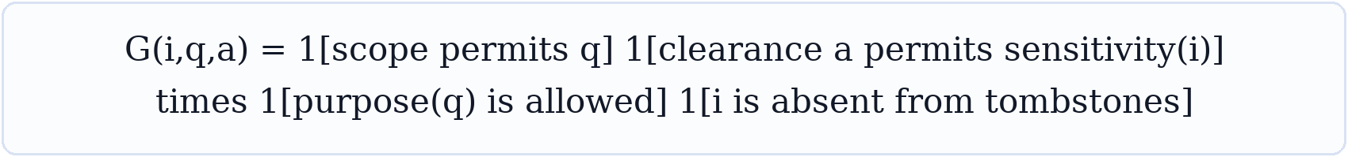
Equation 13 Pre retrieval policy gate
The gate checks scope, requester clearance, allowed purpose, and deletion state. Policy runs before ranking and again before context emission. Imported content cannot grant itself more authority. [28] [29] [30]
Equation 14 Final item score
The final score combines fused rank, temporal fit, confidence, authority, and utility. The policy gate makes any forbidden record score zero. Coefficients are tuned by intent class.

6 10 Context selection
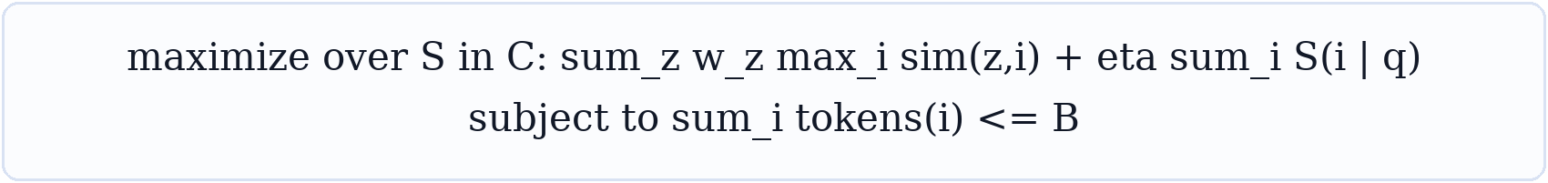
Equation 15 Budgeted evidence coverage
The selector maximizes coverage of query facets and item relevance under a token budget. This facility location form rewards diverse evidence. It reduces duplicated context and supports exact token limits.
A practical solver starts with the best marginal gain per token. It then performs pair swaps. The final packet includes claims, evidence snippets, graph paths, timestamps, and a short uncertainty note.

6 11 Consolidation
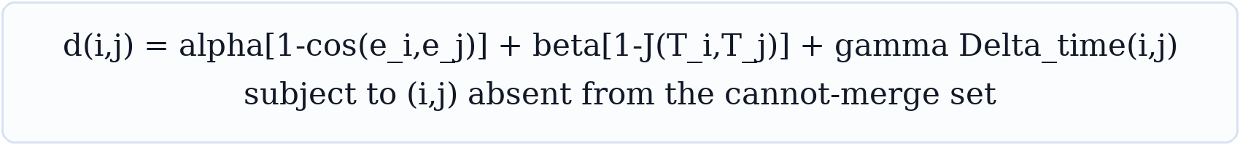
Equation 16 Constrained memory distance
The distance joins semantic difference, tag difference, and time separation. Cannot merge constraints protect distinct people, conflicting values, separate episodes, and records with incompatible policy.
Consolidation creates a derived summary. It does not erase source atoms. The summary lists every source item and can be rebuilt after a correction or deletion.

6 12 Retention
Equation 17 Retention utility
Relevance, access frequency, authority, verification, and open loop value raise utility. Sensitivity, staleness, and unresolved noise lower it. Retention policy maps utility and legal rules to keep, compress, archive, or delete actions.

6 13 Learned write policy
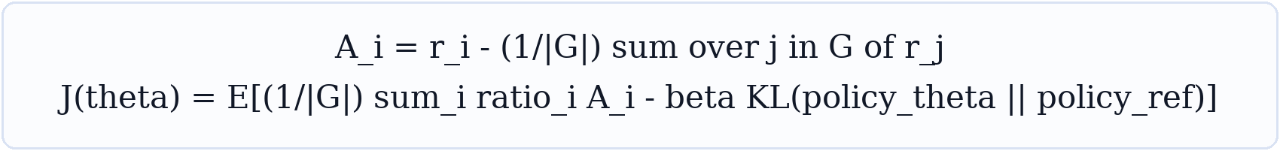
Equation 18 Group relative policy optimization
AtomMem trains memory actions from terminal task reward. The group advantage compares samples from the same prompt. The KL term limits policy drift. This is a useful later stage after deterministic actions and telemetry are stable. [5]
Equation 19 Proposed SozoGraph policy reward
Task quality receives positive reward. Tokens, latency, write volume, risk, and portability violations receive penalties. Portability cost includes events that cannot be represented by the core schema or exported without loss.

6 14 Measurement
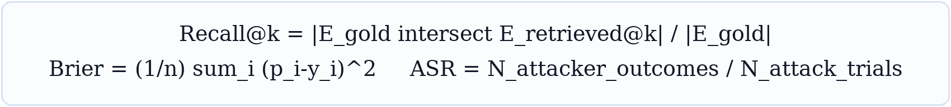
Equation 20 Retrieval calibration and attack metrics
Evidence recall measures whether gold support reaches the generator. Brier measures confidence calibration. Attack success rate measures whether adversarial memory controls a protected outcome.
We also measure answer exactness, temporal accuracy, multi hop path validity, source attribution, context tokens, p50 and p95 latency, cost per query, write precision, merge determinism, deletion propagation, and authority elevation.

7 Optimization strategy
Optimization order Improve evidence capture first. Improve candidate recall second. Improve ranking third. Improve context packing fourth. Learn write policy last.

Stage one Evidence capture
Optimize chunk boundaries, exact spans, record atomicity, entity resolution, dates, and correction detection. The gate is evidence recall. The target is at least 97 percent on benchmark support facts.

Stage two Deterministic projections
Add bitemporal claims, relations, episodes, procedures, lifecycle events, and provenance. Verify lossless rebuild, merge, and deletion before using learned consolidation.

Stage three Candidate generation
Run BM25F, dense, entity, temporal, and graph retrieval in parallel. Target high recall at 100 to 300 candidates. Tune query intent routing before reranker complexity.

Stage four Fusion and reranking
Start with weighted reciprocal rank fusion. Train a compact reranker on attributed benchmark errors. Add authority, temporal fit, contradiction, and evidence quality features.

Stage five Context packing
Use the budgeted coverage objective. Preserve exact evidence and temporal state. Remove duplicates. Add abstention when required facets lack support.

Stage six Maintenance policy
Schedule consolidation by measured retrieval pressure and staleness. Learn CRUD policy only after a deterministic policy reaches a strong baseline. Keep a safe rules engine for rollback.

Parameter search
Layer | Parameters | Search method | Primary metric
Write | segment size overlap extraction threshold verifier threshold | Bayesian optimization with recall constraint | Evidence recall and write precision
Lexical | field weights k1 field b | Coordinate search | Candidate recall
Fusion | retriever weights RRF k intent priors | Pairwise ranking optimization | NDCG and answer quality
Graph | restart depth fan out edge weights | Grid then Bayesian search | Multi hop accuracy and latency
Context | budget diversity weight facet weights | Discrete greedy tuning | Answer quality per token
Policy | reward weights KL coefficient action limits | Offline evaluation then guarded GRPO | Task reward under risk gates

Ablation rule
Every new mechanism ships with an ablation. We record quality, evidence recall, latency, tokens, storage, and attack surface. A feature stays enabled by default only when it improves the constrained objective.

8 Benchmark and release gates
We need one public scorecard and one private failure lab. The public set makes progress legible. The private set protects the product from benchmark specialization.
Suite | Capability | Use
LoCoMo | Long conversation memory and reasoning | Headline quality and citation tests [10]
LongMemEval | Five long term memory abilities | Diagnostic retrieval and answer tests [11]
LongMemEval V2 | Harder temporal and evidence conditions | Forward looking validation [12]
MemoryAgentBench | Accurate retrieval test time learning long range understanding and selective forgetting | Capability balance [13]
MemBench | Memory construction retrieval and downstream use | Pipeline diagnosis [14]
BEAM | Memory at one million and ten million tokens | Scale latency and token efficiency [1]
Security corpus | Poisoning authority escalation privacy and deletion | Adversarial release gate [27] [28] [29] [30]
Passport conformance | Round trip merge signatures tombstones and unknown fields | Portability release gate [15] [16]

Failure attribution
Every failed answer receives one primary cause: source absent, write miss, projection miss, retrieval miss, context cut miss, reasoning miss, policy error, or judge error. We optimize the largest validated bucket. This keeps model changes tied to evidence.

Provisional target line
Metric | Target | Release meaning
LoCoMo | 93 or higher | Above the current reported Mem0 line
LongMemEval | 95 or higher | Above the current reported Mem0 line
BEAM 1M | 65 or higher | Above the current reported Mem0 line
BEAM 10M | 50 or higher | Above the current reported Mem0 line
Gold evidence recall | 97 percent or higher | Generator receives support
Retrieved context | 7,000 tokens or fewer | Comparable token envelope
Round trip and merge | 100 percent deterministic | Portable authority
Deletion propagation | 100 percent | No stale derived copies
Authority elevation | Zero successful cases | Origin bound trust
Core dependencies | No model vector database or server | Portable read and render

9 Delivery plan

Weeks one and two Truth sprint
- Freeze the current test and benchmark baseline.
- Add raw chunk BM25 as a recall control.
- Create gold evidence annotations and failure attribution.
- Write the Passport 3 schema ADR and compatibility rules.
- Add deterministic IDs and exact evidence spans behind a feature flag.

Weeks three through five Passport 3
- Implement the append only event ledger and materialized profile view.
- Add bitemporal claims lifecycle state tombstones and extension preservation.
- Implement deterministic merge canonical hashing and conformance fixtures.
- Ship migration from the current passport format.

Weeks six through nine Accuracy engine
- Add BM25F dense entity temporal and graph candidate generators.
- Add intent planning weighted rank fusion and an attributed reranker.
- Add budgeted context selection and evidence packet rendering.
- Run ablations on LoCoMo LongMemEval MemoryAgentBench and BEAM.

Weeks ten through twelve Governance and interop
- Add origin bound authority purpose sensitivity and consent policy.
- Propagate deletion through projections indexes caches and exports.
- Add signatures with RFC 8785 canonical JSON and Ed25519.
- Ship Portable Memory and OAMP adapters with golden fixtures.

Weeks thirteen through sixteen State of the art push
- Tune by failure bucket and intent class.
- Add offline consolidation scheduling and outcome memory.
- Evaluate learned CRUD policy under fixed safety gates.
- Publish the scorecard conformance suite and reproducible benchmark harness.

First fourteen days
Day | Deliverable | Exit test
1 | Pin datasets prompts judges models and seeds | One command reproduces baseline
2 | Run current SozoGraph and raw chunk BM25 | Comparable score and latency table
3 | Label evidence on first failure slice | Gold spans pass review
4 | Add failure attribution schema | Every failed case has one cause
5 | Draft Passport 3 event model | Schema review complete
6 | Implement stable IDs and source spans | Round trip retains IDs and offsets
7 | Add valid and transaction time | Historical query fixtures pass
8 | Add lifecycle and tombstones | Delete fixtures pass
9 | Build deterministic fold | Replica order permutations agree
10 | Add unknown field preservation | Golden future field fixture passes
11 | Implement BM25F fields | Candidate recall beats baseline
12 | Add intent labels and temporal route | Temporal slice improves
13 | Build scorecard dashboard output | One report shows all gates
14 | Review evidence and choose next bottleneck | Next sprint is tied to largest error bucket

Team shape
One owner controls schema and determinism. One owner controls retrieval and evaluation. One owner controls ingestion and evidence. Security and privacy review every lifecycle feature. A research lane runs ablations without changing the canonical contract.

Definition of done
A feature is done when its schema is versioned, tests cover migrations and deletion, benchmark impact is recorded, telemetry identifies its failures, and the portable fallback still works.

10 Risks and decisions
Risk | Control | Decision trigger
Extraction loss | Raw evidence retention coverage verifier and write recall gate | Recall below 97 percent blocks ranking work
Graph noise | Typed edges evidence thresholds depth caps and hub penalties | Disable graph route when ablation loses quality
Temporal contradiction | Bitemporal records explicit supersession and query cutoff | Conflicting current answers block release
Memory poisoning | Origin authority quarantine policy gate and adversarial suite | Any authority elevation blocks release
Privacy residue | Tombstone fan out manifest and index rebuild proofs | Any undeleted derivative blocks release
Learned policy drift | KL bound action limits offline replay and rules fallback | Risk gate failure reverts the policy
Benchmark overfit | Private scenarios rotating prompts and hidden judges | Public gain with private loss is rejected
Format sprawl | Small canonical core extension registry and lossless passthrough | New field requires a portability test

Decisions to lock now
- The event ledger becomes canonical in Passport 3.
- The compact profile remains a generated first class view.
- Evidence spans and origin authority are required for durable claims.
- Policy executes before retrieval and before emission.
- Indexes and learned artifacts stay disposable.
- Portable Memory levels zero through two and OAMP become target adapters.
- Learned write policy waits for deterministic telemetry and safety gates.

Expected outcome
This plan gives SozoGraph a credible path beyond current benchmark leaders. It also creates a stronger product claim. The memory stays inspectable, portable, correctable, and governable across agents and runtimes.

11 References
[1] Mem0 official repository and April 2026 benchmark table. https://github.com/mem0ai/mem0/blob/main/README.md
[2] Mem0 Building Production Ready AI Agents with Scalable Long Term Memory. https://arxiv.org/abs/2504.19413
[3] LightMem Lightweight and Efficient Memory Augmented Generation. https://arxiv.org/abs/2510.18866
[4] A MEM Agentic Memory for LLM Agents. https://arxiv.org/abs/2502.12110
[5] AtomMem Learning Atomic Memory Operations for Long Term Agentic Tasks. https://arxiv.org/abs/2601.08323
[6] HippoRAG 2 From RAG to Memory. https://arxiv.org/abs/2502.14802
[7] Zep A Temporal Knowledge Graph Architecture for Agent Memory. https://arxiv.org/abs/2501.13956
[8] Graphiti official repository. https://github.com/getzep/graphiti
[9] LangMem conceptual guide. https://langchain-ai.github.io/langmem/concepts/conceptual_guide/
[10] LoCoMo Evaluating Very Long Term Conversational Memory of LLM Agents. https://arxiv.org/abs/2402.17753
[11] LongMemEval Benchmarking Chat Assistants on Long Term Interactive Memory. https://arxiv.org/abs/2410.10813
[12] LongMemEval V2. https://arxiv.org/abs/2605.12493
[13] MemoryAgentBench Evaluating Memory in LLM Agents. https://arxiv.org/abs/2507.05257
[14] MemBench Towards More Comprehensive Evaluation on the Memory of LLM Based Agents. https://arxiv.org/abs/2506.21605
[15] Portable Memory specification. https://github.com/MacPaw/portable-memory/blob/main/Spec/portable-memory-spec.md
[16] Open Agent Memory Protocol. https://github.com/deep-thinking-lab/open-agent-memory-protocol
[17] Open Memory Interchange Record specification. https://omir.io/spec/R1/overview.html
[18] Portable AI Memory specification. https://www.portable-ai-memory.org/spec/v1.0/
[19] RFC 8785 JSON Canonicalization Scheme. https://www.rfc-editor.org/rfc/rfc8785.html
[20] JSON Schema Draft 2020 12. https://json-schema.org/draft/2020-12
[21] W3C Verifiable Credentials Data Model 2.0. https://www.w3.org/TR/vc-data-model/
[22] W3C DID Core. https://www.w3.org/TR/did-core/
[23] W3C PROV Overview. https://www.w3.org/TR/prov-overview/
[24] The Probabilistic Relevance Framework BM25 and Beyond. https://doi.org/10.1561/1500000019
[25] Reciprocal Rank Fusion Outperforms Condorcet and Individual Rank Learning Methods. https://research.google/pubs/reciprocal-rank-fusion-outperforms-condorcet-and-individual-rank-learning-methods/
[26] Topic Sensitive PageRank. https://doi.org/10.1145/511446.511513
[27] Sleeper Memory Poisoning Long Term Memory Backdoors in LLM Agents. https://arxiv.org/abs/2605.15338
[28] Origin Bound Authority for Persistent Agent Memory. https://arxiv.org/abs/2606.24322
[29] Memory Poisoning in Large Language Model Agents. https://arxiv.org/abs/2606.04329
[30] OWASP Agent Memory Guard. https://owasp.org/www-project-agent-memory-guard/
[31] Maximal Marginal Relevance. https://aclanthology.org/X98-1025/

Prepared for SozoGraph engineering and research planning

Implementation Status September 2026
The foundation and direct-ingestion tranches are complete in code. Passport 3 runs beside Passport 2.1. SozoGraph.ingest_v3 writes validated extraction output straight into the event ledger.

Completed in this session
Status | Capability | Result
[x] | Record model | Nine memory kinds with lifecycle, authority, sensitivity, scope, confidence, and metadata.
[x] | Stable identity | Canonical JSON, SHA-256 logical IDs, and independent revision hashes.
[x] | Evidence | Character offsets, UTF-8 byte offsets, exact quotes, source hashes, locators, and verification.
[x] | Time | Half-open valid-time intervals and transaction-time as-of materialization.
[x] | Event ledger | Append-only upsert, retract, and delete events with Lamport clocks and causal parents.
[x] | Replica merge | Deterministic event union, event deduplication, and convergent materialized state.
[x] | Deletion | Monotonic tombstones block stale replica resurrection.
[x] | Policy gate | Sensitivity, scope, authority, and lifecycle filtering runs before ranking and rendering.
[x] | Retrieval | Field-aware BM25F weights keys, values, text, evidence, and metadata.
[x] | Prompt boundary | Rendered memory is labeled as claim data. Embedded instructions are denied authority.
[x] | Integrity | HMAC-SHA-256 signatures cover canonical passport content and detect tampering.
[x] | Persistence | Passport 3 saves and loads atomically as readable JSON.
[x] | Migration | Passport 1 and Passport 2 snapshots upgrade offline and retain their source snapshot.
[x] | Forward compatibility | Unknown fields survive at their original level in Passport 2 and Passport 3.
[x] | Public API | Passport 3 primitives are exported from the sozograph package root.
[x] | Direct ingestion | SozoGraph.ingest_v3 projects validated extraction output into immutable Passport 3 events.
[x] | Evidence anchoring | The extractor requests verbatim support quotes. Verified quotes become exact character and UTF-8 byte spans.
[x] | Replay safety | Semantic hashes ignore transaction timestamps and lineage fields, so deterministic replays append no events.
[x] | Revision history | Stable logical IDs and valid-time selection preserve current and historical values.
[x] | Source identity | Content-derived source IDs prevent collisions and source registries union during replica merge.
[x] | Failure isolation | A failed source is recorded for audit while the remaining ingestion continues.

Verified
- 188 tests passed.
- 4 live provider tests were skipped because they require provider credentials.
- New and changed production code passes Ruff.
- Existing Passport 2 behavior remains green.
- Twenty-seven Passport 3 tests cover exact evidence, Unicode coordinates, replay, bitemporal revisions, replica convergence, stale deletion, policy filtering, failure isolation, file round trips, and tamper detection.

Mathematics now represented in code
The identity equations map to canonical JSON and SHA-256. Semantic replay identity excludes transaction time and supersession lineage. The convergence equation maps to event-set union and a deterministic fold. Event order maps to Lamport clock, event time, replica ID, and event ID. Valid-time selection chooses the latest applicable revision. Retrieval maps to BM25F with per-field weights and per-field length normalization.

Remaining work
- Extract relations, procedures, and outcomes from provider output.
- Add calibrated contradiction and supersession policy.
- Add asymmetric signatures, envelope encryption, consent receipts, purpose binding, and retention jobs.
- Add disposable graph and dense retrieval sidecars, temporal query parsing, learned reranking, and diversity selection.
- Run LoCoMo, LongMemEval, conflict-heavy portability tests, property tests, fuzz tests, and long-running replica convergence tests.
- Publish the Passport 3 JSON Schema and migration guide.

Current integration point
Use SozoGraph.ingest_v3 for direct event-ledger ingestion. Pass the returned MemoryPassport back into the method for incremental updates. Use Passport.to_v3 for an offline snapshot upgrade. SozoGraph.ingest remains the stable Passport 2.1 path.

