**Green SP-27 Spotify Mobile App**

**CS 4850-01, Section 01, Fall 2024**

**Sept 1, 2024**

|  |  |
| --- | --- |
| Marc Gagnon  Developer | Muhammad Saad  Documentation |
| Brian Okonji  Developer | Jace Windbigler  Team Lead |

**Team Members:**

|  |  |  |
| --- | --- | --- |
| Name | Role | Cell Phone / Alt Email |
| Muhammad Saad | Documentation | 678-629-6373  [Muhdsaad2003@gmail.com](mailto:Muhdsaad2003@gmail.com) |
| Marc Gagnon | Developer | 678-316-0327  [Chewie83@gmail.com](mailto:Chewie83@gmail.com) |
| Jace Windbigler | Tester | 912-227-8887  [Jacewindbigler@gmail.com](mailto:Jacewindbigler@gmail.com) |
| Brian Okonji | Developer | 404-518-7861  [Brianokonji9@gmail.com](mailto:Brianokonji9@gmail.com) |
| Sharon Perry | Project Owner or Advisor | 770.329.3895  [Sperry46@kennesaw.edu](mailto:Sperry46@kennesaw.edu) |

## 1.0 Project Overview / Abstract

The project’s purpose is to develop a custom mobile application using the Spotify API that enhances the features of Spotify’s native application. The app will be developed in React Native framework with full compatibility for iOS and Android devices. The key functionality we will focus on is to generate, edit, and control in several ways the use of playlists, recommended songs list, and queues through sorting songs by the song’s tempo. The design process of the screen will include designing a prototype using Figma which will give us an interface that closely relates to what we want the final product to look like. At the end of the project, we aim to have a functional customized Spotify mobile application that will further enhance the user experience with features that were not offered before.

## 2.0 Project website

Will make website later

## Deliverables - Specific To Your Project

Final Report Package includes: Final Report, source code, website, and link to Github, Tutorials, Screen Mock-UPs, and link to the apps.

## Milestone Events

#1 Planning and Research - By September 29, 2024

#2 Prototype – By October 27, 2024

#3 Final Draft Review - By ___Date November 19, 2024

## Meeting Schedule Date/Time

Thursdays at 5 pm unless class is in session.

## Collaboration and Communication Plan

We will be using Discord and cellular messages to communicate.

## Project Schedule and Task Planning

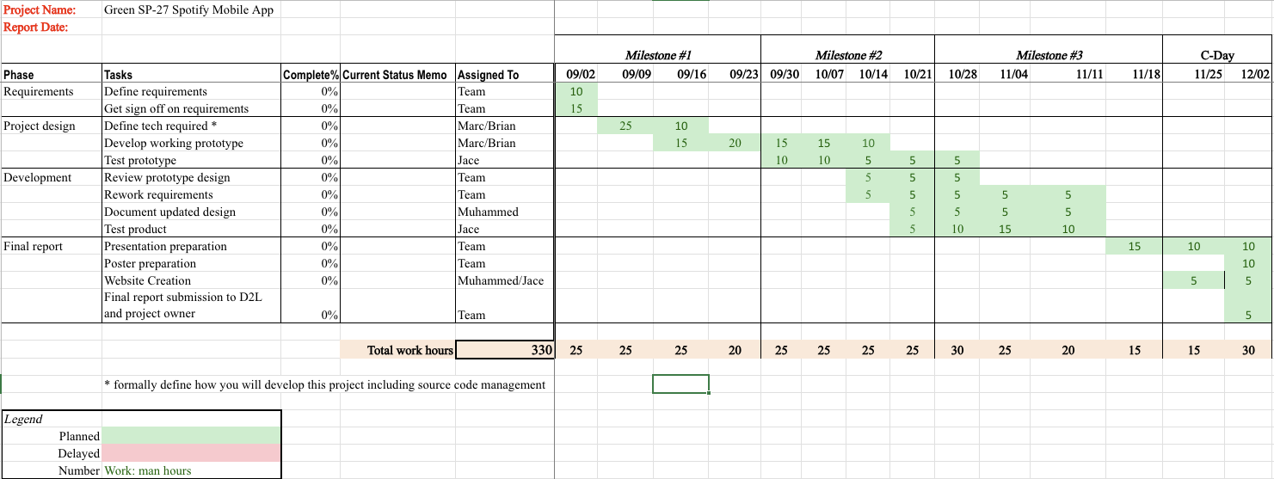

## Version Control Plan

Git: This allows for every team member to work independently and push their code, and others can pull the changes. Constant communication is needed so that members know when to pull or not make changes to the code.