[Report title to be finalized]
DSA4266 Group 3
Author names and affiliations to be added
Abstract

Index Terms— network intrusion detection, representation learning, temporal classification, data augmentation

1 Introduction
An individual flow describes one exchange but may omit the surrounding evolution of a host’s behaviour. Ordered behavioural intervals can retain traffic intensity, service usage, destination diversity and inactivity. The challenge is to determine whether these representations support reliable detection under severe imbalance, rather than merely reflecting host or capture-specific regularities.
Our study asks how frozen bucket embeddings and training-only vector superimposition support temporal intrusion classification. The downstream work compares CNN, LSTM, CNN–LSTM and XGBoost models. A proposed generalization experiment excludes selected attack subtypes while retaining related subtypes within broad classes such as DoS and DDoS. This differs from excluding an entire broad attack class.
Pending team contribution: Finalize research questions and contribution statements after auditing completed experiments. Do not claim gains or zero-day generalization before results are available.

2 Background and Related Techniques
An autoencoder learns a compact representation through reconstruction. Here it transforms individual traffic buckets, rather than acting as the final anomaly detector. Supervised models subsequently classify sequences of frozen bucket representations. CNNs learn local patterns across time, LSTMs propagate recurrent state, and the hybrid combines both. A positional XGBoost baseline provides a tree-based comparison.
Pending team contribution: Add primary literature on flow-based intrusion detection, learned representations and vector-space augmentation. Distinguish positional trees from an order-invariant baseline.

3 Data and Temporal Preprocessing

3.1 Source Data and Targets
NF-CICIDS2018-v3 [1] contains 20,115,529 flows and 14 attack types. Attack flows constitute 12.93% of records, but only 0.744% of the 1,466,665 original nonempty 100-second source windows contain attacks. Flow volume, sequence support and source diversity differ substantially (Figure EDA-1): HOIC contributes 1,032,311 attack flows across 340 windows and ten sources, whereas Brute_Force_-Web contributes 1,618 attack flows across 1,295 windows and 561 sources. These differences motivate subtype-level evaluation and type/source-aware donor sampling.
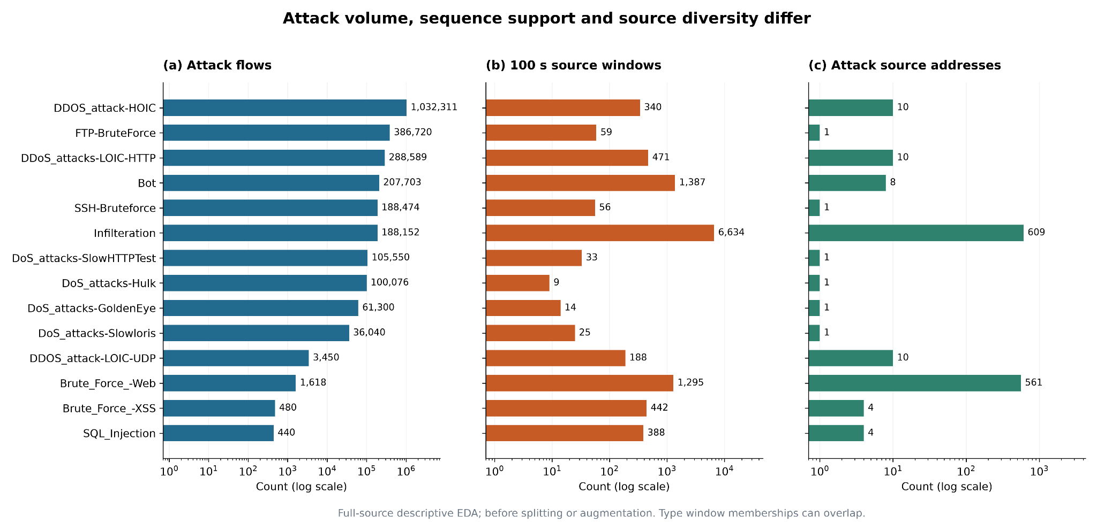
Figure EDA-1. Attack flows, 100-second source windows and attack-source counts by type. Count axes are logarithmic; type window memberships may overlap.
Comparing observation perspectives, the ten most attack-active sources account for 62.93% of attack flows, versus 98.63% for destinations (Figure EDA-2). Source grouping therefore offers a less concentrated observation unit suited to local behavior modeling. Source identities remain grouping metadata outside detector inputs.
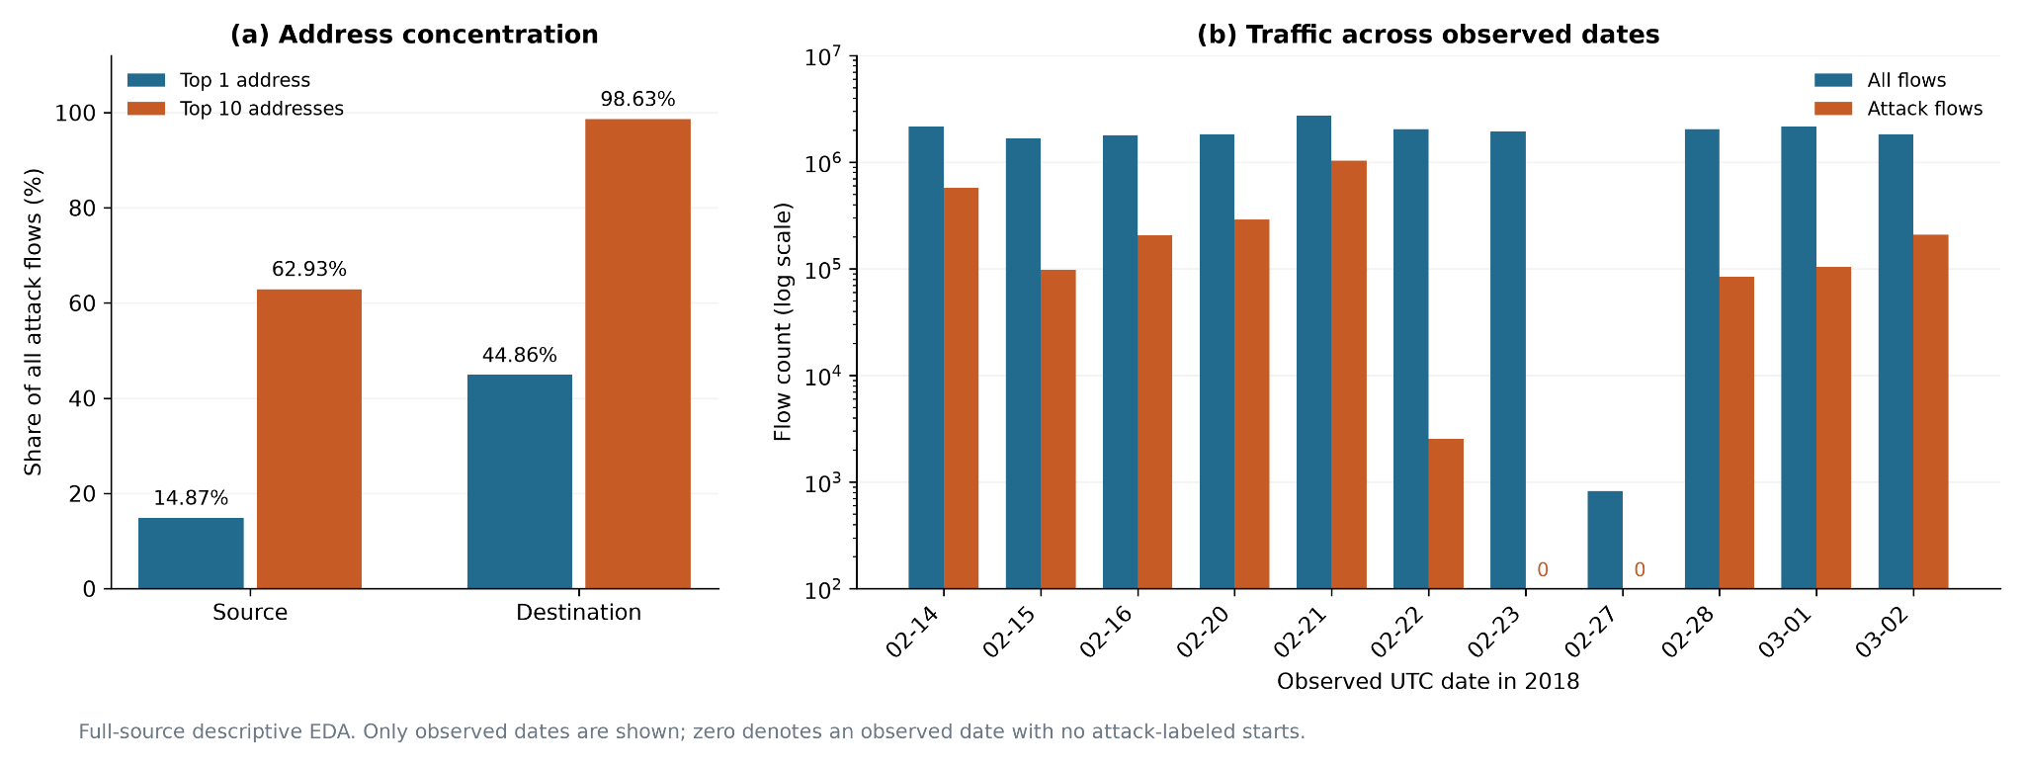
Figure EDA-2. Attack-flow concentration by source/destination and traffic counts across observed UTC dates.
Across 50–1,000-second windows with 10-second buckets, the median active-bucket count remains one. Longer windows increase mean active buckets from 1.87 to 5.62 while reducing mean occupancy from 37.31% to 5.62% (Figure EDA-3). At 100 seconds, 51.95% of windows contain only one active bucket. We therefore retain sparse examples and explicit activity masks, using 100 seconds as the baseline for subsequent temporal-scale experiments.
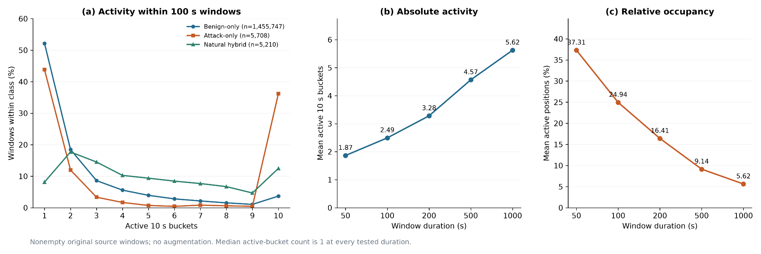
Figure EDA-3. Class-normalized active-bucket distributions at 100 seconds, and mean activity/occupancy across durations. Activity denotes recorded flow starts.
Natural hybrid windows contain both benign and attack flows. At 100 seconds, they comprise 47.72% of attack-bearing windows but contain only 7.36% of all attack flows; 87.56% of hybrid windows contain Infilteration. Observed DoS/DDoS and FTP/SSH brute-force windows are attack-only at every tested duration. Longer windows increase hybrid prevalence and dilute within-hybrid attack fractions (Figure EDA-4). This type-dependent background structure motivates benign-plus-attack augmentation, with benign-plus-benign mixtures applying the same composition process to benign traffic.
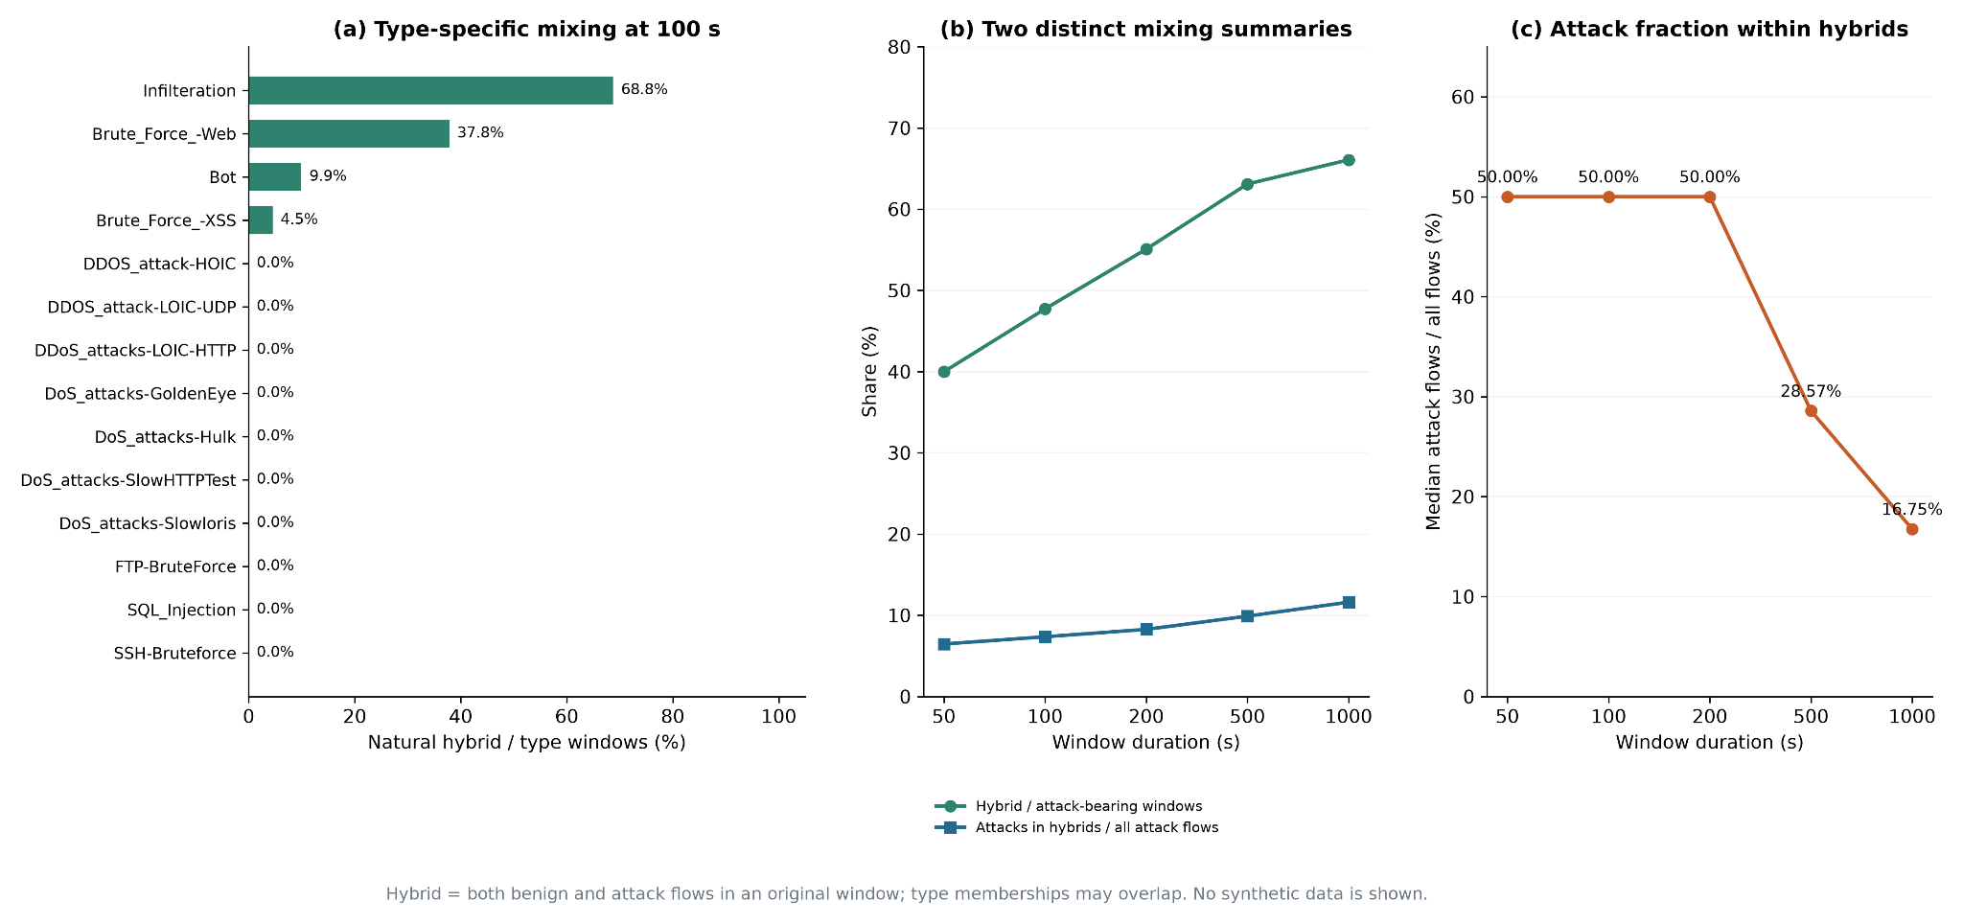
Figure EDA-4. Natural hybrid prevalence by attack type and duration, and attack-flow fractions within hybrids. All figures describe original data before splitting or augmentation.
The feature audit found that the legacy L7 vocabulary collapses 39.64% of flows into its residual category, motivating dataset-specific categorical representations. An eight-candidate split audit identified a tradeoff between temporal separation and attack coverage, informing the adopted coverage-constrained global 15-minute split. These full-source descriptive analyses precede splitting and augmentation; vocabularies and scalers are fitted only on real training data.
Together, these findings motivate a source-level temporal representation that preserves sparse activity and supports the study of attack–background composition. We adopt 100-second windows as the baseline, with internal empty positions retained through an explicit activity mask.
Flows are grouped by source IPv4 address into fixed, nonoverlapping 100-second windows. Window boundaries use a common clock grid rather than starting at each host's first flow. Each window is divided into ten 10-second buckets. To assign a flow, we first round its start timestamp down to the beginning of its 100-second window. For flow start time $s_{i}$ in milliseconds, the origin is
$w_{i}=100000⌊s_{i}/100000⌋, \left(1\right)$
Its zero-based bucket index is
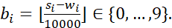 (2)
Subtracting converts an absolute timestamp to elapsed time within the window. All ten positions are retained even when some contain no flows. A mask records whether each position is observed: for a nonempty bucket and otherwise; entirely empty source-window combinations are not enumerated.
A bucket is malicious if any assigned flow is malicious, and a sequence is malicious if any bucket is malicious. Addresses, attack names and time identifiers remain audit metadata. Primary attack annotations record the most frequent malicious type; they do not describe all attack memberships.
Input checks require the expected columns, nonnegative integer fields, binary labels, nonmissing identifiers, and end times no earlier than starts. Flow counts are reconciled between source and staging. These checks establish construction consistency, not original-label correctness. Full-flow summaries belong to their start bucket even if they end later; this is offline detection rather than an early-warning latency benchmark.

3.2 Behavioural Bucket Statistics
Each observed bucket receives 82 numerical statistics describing volumes, durations, protocol/application diversity, port reuse and concentration, destination diversity, TCP flags, ICMP/DNS activity, packet lengths, retransmissions, packet-size proportions, TCP windows and within-bucket start-time gaps. Destination addresses are used only for equality and diversity calculations.
Separate histograms summarize protocol, L7 application and destination-service proportions. Services group destination ports into DNS, web, SSH, FTP, mail, RDP, SMB and other. The representation therefore retains service information while avoiding exact endpoint identities.

3.3 Temporal Split and Training-Only Fitting
The baseline allocates complete global 15-minute blocks to approximately 60%, 20% and 20% training, validation and test, balancing retained original-sequence counts. A 100-second boundary embargo and actual-flow-end envelope exclusions protect boundaries. Attack metadata reserves training coverage for every type and feasible held-out coverage. This is label-informed blocked allocation, not a chronological future-time split.
Only retained real training active buckets determine category vocabularies and numerical transforms. Non-ratio/non-entropy statistics receive $log\left(1+x\right)$; all 82 dimensions are then standardized using training means and scales. Empty buckets are reset to zero. Unknown categories receive a dedicated slot distinct from a known category with code zero. Hosts and campaigns can recur in separated blocks, so the baseline measures same-environment held-out-time-block classification.

3.4 Recorded Baseline Population
Table I summarizes the verified baseline dataset. Synthetic examples are restricted to training; validation and test contain only real sequences. Subtype-holdout and temporal-resolution variants are reported separately.
Table I: Recorded baseline sequence population
Group | Train | Validation | Test
Real benign | 757,559 | 250,229 | 262,274
Real malicious | 8,093 | 917 | 851
Synthetic benign | 8,093 | 0 | 0
Synthetic malicious | 8,093 | 0 | 0
Flow and retained sequence prevalence have different denominators. Validation/test malicious-sequence shares are approximately 0.365%/0.323%; aggregation and exclusions must accompany these figures.
Temporal exclusions remove 186,742 original windows. The retained training, validation and test sets contain 14, 13 and 12 attack types, respectively, counting all type memberships.

4 Bucket Representation and Augmentation

4.1 Learning a Bucket Representation
We compared Scheme 1, which combines recomputed numerical statistics with field-level categorical representations (137 channels), its bucketwise L2 variant, and Scheme 2, which learns a unit bucket embedding with a separate intensity channel (65 channels). Normalization diagnostics and the paired representation comparison motivated adopting Scheme 2 for subsequent experiments (Section 5.1). Figure R1 summarizes the resulting pipeline.
Let $x_{t}∈R^{82}$ denote standardized numeric statistics and $p_{tf}$ the categorical distribution for field $f∈\{protocol,L7,service\}$. A numerical branch maps $x_{t}$ to 32 values. Each field has a learned category table $E_{f}$ with 16 columns; $p_{tf}E_{f}$ is its frequency-weighted representation. Concatenation gives 80 values, encoded through widths $80→128→64$ and L2-normalized:
$z_{t}={normalize}_{2}\left(g_{θ}\left(\left[h\left(x_{t}\right),p_{t1}E_{1},p_{t2}E_{2},p_{t3}E_{3}\right]\right)\right). \left(2\right)$
A decoder reconstructs numeric statistics and categorical distributions. The objective is
$L_{bucket}=\frac{∥x_{t}−{\hat{x}}_{t}∥_{2}^{2}}{82}+\frac{1}{3}\sum_{f}{}CE\left(p_{tf},{\hat{p}}_{tf}\right). \left(3\right)$
Default fitting uses Adam, learning rate 0.001, batch 512 and 5,000 updates. Validation is evaluated every 200 updates on a fixed subset of at most 4,096 active buckets; lowest reconstruction loss selects the checkpoint. Real active training buckets from both classes fit the encoder without attack labels in the reconstruction objective.
The encoder is frozen before encoding originals and generating mixtures. It learns individual bucket content; temporal transitions are learned downstream. Reconstruction improvement alone does not establish temporal learning or detection utility.

4.2 Training-Only Vector Superimposition
Let $P$ be the real malicious training-sequence count. The baseline adds $P$ benign–malicious and $P$ benign–benign mixtures. Donors are real training originals from different source IPs. Background sampling balances occupancy bands, hosts and sequences; malicious sampling balances type, host and sequence. Donors may repeat.
With masks $m_{t}^{a},m_{t}^{b}$, the zero-shift baseline combines corresponding positions:
$z_{t}^{mix}={normalize}_{2}\left(m_{t}^{a}z_{t}^{a}+m_{t}^{b}z_{t}^{b}\right). \left(4\right)$
Masks and bucket labels use logical OR; flow counts add. The final channel retains standardized log total-flow count,
$c_{t}=\left(log\left(1+n_{t}\right)−μ_{train}\right)/σ_{train}, \left(5\right)$
with empty positions zeroed. Each input is $10×65$: 64 embedding coordinates and one intensity coordinate, plus a separate mask.
These are learned-space mixtures, not observed combined flows. Nonlinear encoding need not commute with raw-flow addition. Their utility requires evaluation, and donor reuse does not create independent new attacks. Validation/test remain real only.
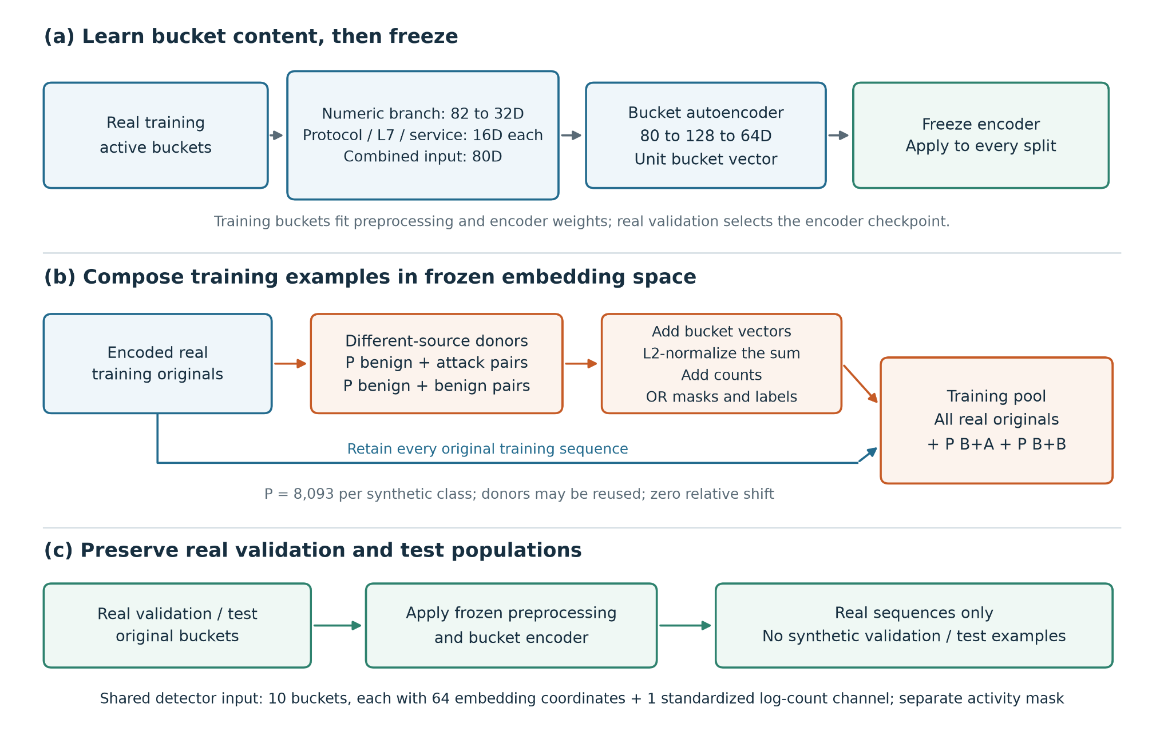
Figure R1. Scheme 2 pipeline. A bucket encoder fitted on real training data is frozen before encoding and augmentation. Different-source training donors generate benign-plus-attack and benign-plus-benign mixtures; all originals are retained. Each bucket contains 64 embedding coordinates and a separate intensity channel. Validation and test remain real only.

4.3 Representation Diagnostics
Scheme 1 diagnostics identified rare standardized ICMP ratios as dominant contributors to extreme reconstruction errors. The highest-error 0.1% of real validation sequences accounted for 41.66% of total error, compared with 0.80% after bucketwise L2 normalization (Figure R2). This supports per-bucket amplitude control; Scheme 2 retains unit bucket vectors and represents intensity separately.
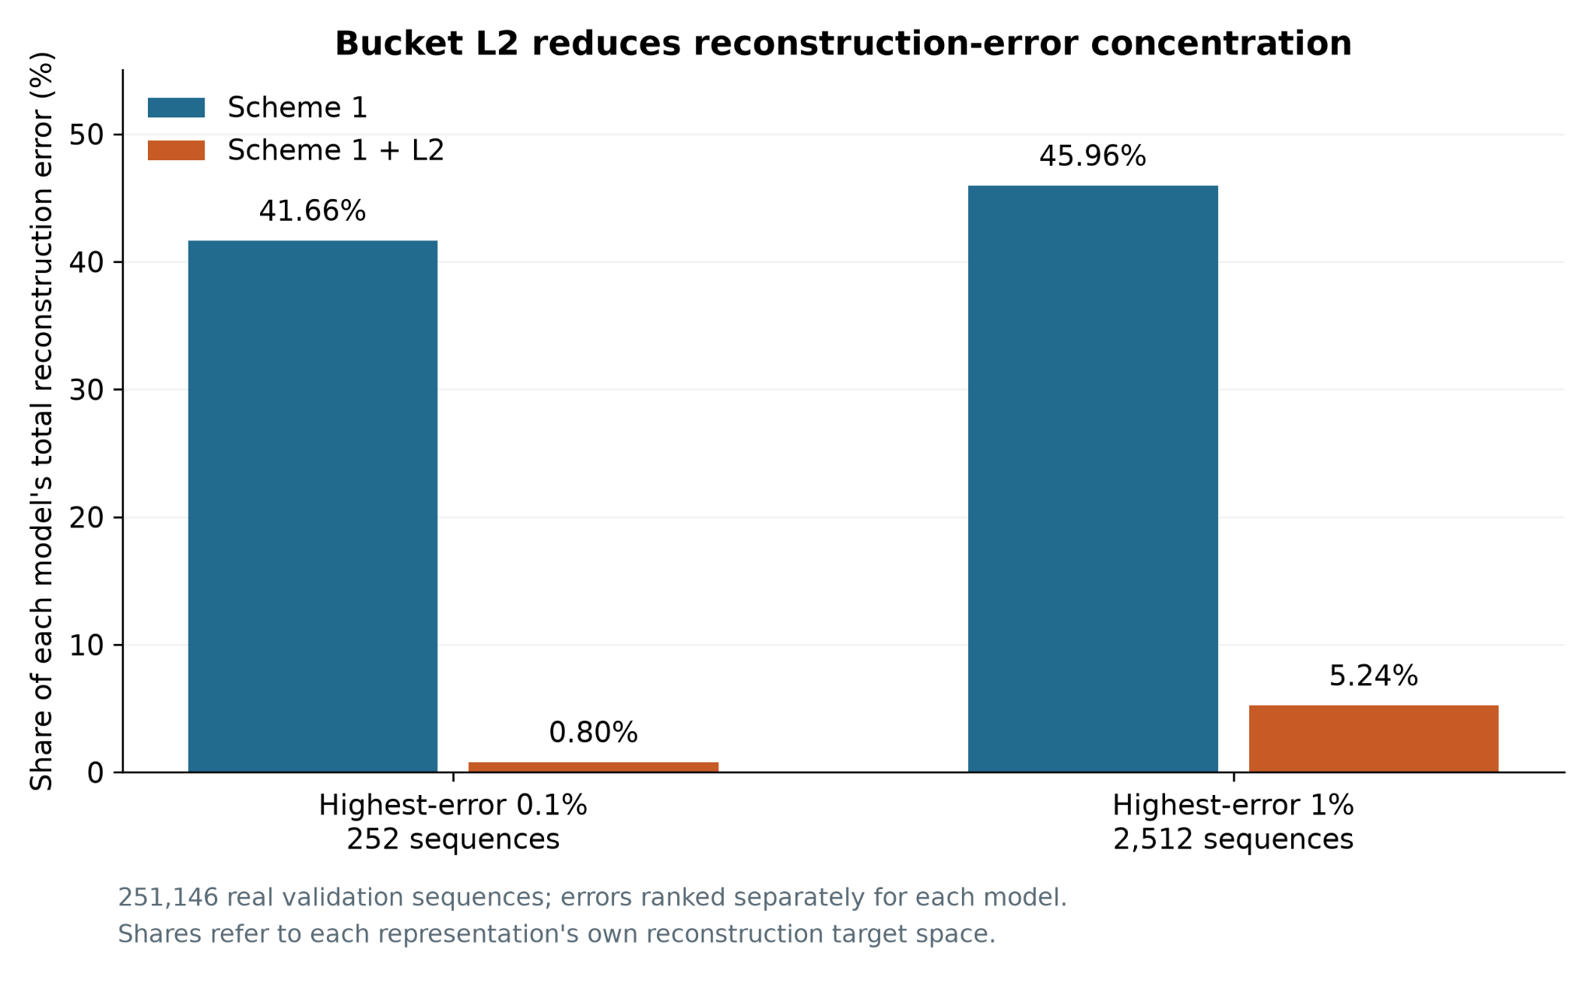
Figure R2. Reconstruction-error concentration before and after bucket L2. Validation sequences are ranked separately for each model; bars show the fraction of each model’s own total error. Reconstruction target spaces differ. The population contains 251,146 real validation sequences.

5 Establishing the Detection Baseline
We first compare representation pipelines, then select a supervised detector and examine what its high scores represent. This establishes both the working baseline and the reasons for concentrating the later analyses on Web and Infilteration.
Checkpoints are selected by validation average precision (AP). Recall uses global validation false-positive-rate (FPR) budgets of 1% and 0.1%; these thresholds are frozen before test scoring where reported. Validation comparisons are exploratory, and the historical test population has been inspected in earlier project work. Training-derived probes and oracle interventions are identified separately from detection evaluation.

5.1 Representation Choice
The Scheme 1, Scheme 1 plus bucket L2, and Scheme 2 pipelines were compared using a temporal autoencoder and a linear readout fitted on real training latents at seed 4266. Original sequence IDs, splits and donor plans were paired. Table R1 shows that bucket L2 improves Scheme 1 validation AP from 3.44% to 10.40%; Scheme 2 reaches 19.65% and achieves higher historical test AP and recall. These results support the normalized bucket representation and separate intensity channel described in Section 4.
Table R1. Representation comparison. Test recall and actual FPR use the frozen validation 1% threshold; a dash denotes an unevaluated entry.
Representation | Validation AP | Test AP | Test recall | Actual test FPR
Scheme 1 | 3.44% | - | - | -
Scheme 1 + L2 | 10.40% | 7.27% | 31.02% | 1.03%
Scheme 2 | 19.65% | 14.93% | 40.54% | 0.99%
This comparison evaluates complete representation pipelines with an autoencoder/readout. The supervised detector comparison below uses a different learning objective and should be interpreted on its own scale.

5.2 Detector Comparison and Temporal Sensitivity
XGBoost, CNN, LSTM and CNN-LSTM were fitted to the same frozen Scheme 2 inputs across seeds 4266-4270, with equal total objective weights for the four training groups. Their real validation cohort contains 251,146 sequences, including 917 positives. Neural AP means are close, while LSTM has particularly low seed variation in recall at the stricter FPR budget (Table M1).
Table M1. Detector validation results, mean +/- sample SD across five seeds on a fixed cohort. Recall uses each fit's global validation threshold.
Model | AP (%) | Recall at 1% FPR (%) | Recall at 0.1% FPR (%)
XGBoost | 50.70 +/- 0.39 | 69.31 +/- 0.37 | 37.58 +/- 0.73
CNN | 61.43 +/- 0.54 | 73.50 +/- 1.02 | 52.17 +/- 2.22
LSTM | 61.25 +/- 0.59 | 74.68 +/- 1.31 | 50.73 +/- 0.40
CNN-LSTM | 60.97 +/- 0.74 | 73.98 +/- 1.00 | 50.40 +/- 2.30
Each family was also refitted after a five-bucket circular rotation, moving all channels and masks together in training and validation. Mean overall AP changes were small, but LSTM Web recall at the 1% budget fell in all five seed pairs, by 5.75 percentage points on average. Rotation preserves most local adjacency, so the experiment measures adaptation to a rotated grid. Considering both comparisons, we retain the original-order LSTM as the working baseline and use the other families to investigate complementary detection behavior.

5.3 Attack Differences and Host Information
Detection difficulty varies substantially by attack type. In the baseline Projector views, Web and Infilteration occupy broader, locally mixed regions than the compact DDoS groups (Figure D1). Their mean benign shares among ten neighbors in unit-normalized native 64D space are 20.72% and 24.81%, versus 0% for each DDoS type; equal-size resampling preserves the dispersion contrast. The plot describes learned representations on an attack-enriched sample.
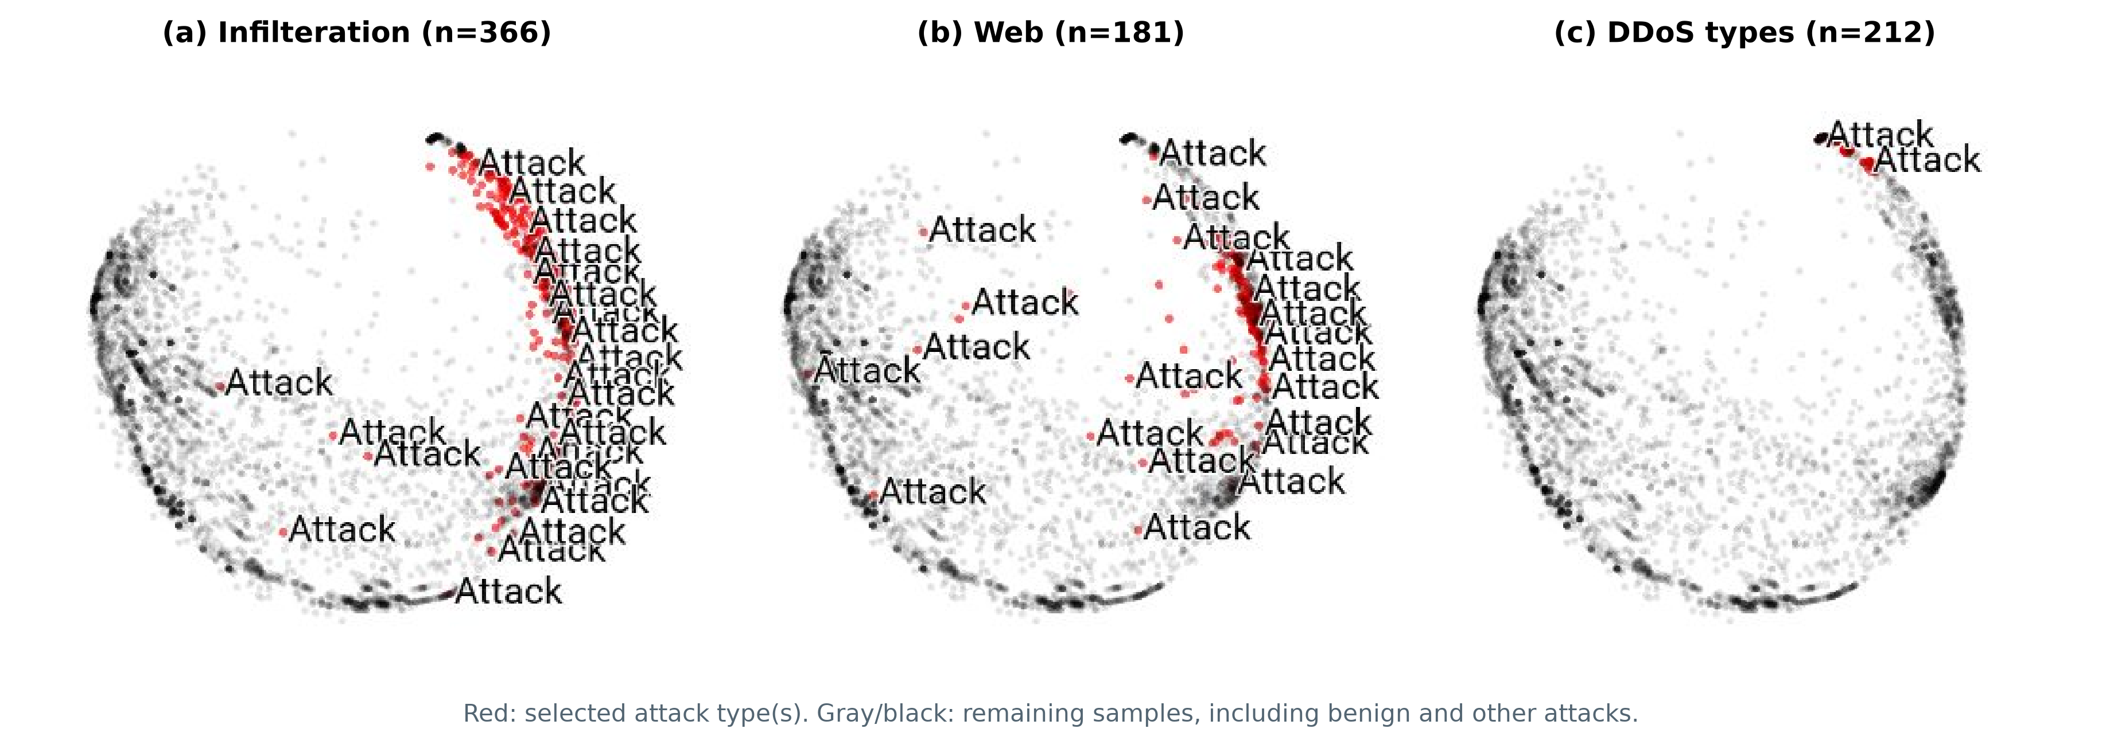
Figure D1. Baseline LSTM Projector views of Infilteration, Web and DDoS. The same 4,917 validation samples and PCA settings are used in each panel; red marks the selected type. Sphereization is enabled.
Source concentration provides a further reason to examine these differences: most attack types involve at most ten sources, compared with 609 for Infilteration and 561 for Web in the full-source EDA. We therefore trained class-conditional host-adversarial LSTMs at strengths 0, 0.01 and 0.1, using fixed baseline inputs and seed 4266. Source hosts are auxiliary training targets, not detector inputs; synthetic examples retain detection supervision. Independent probes evaluate frozen representations on matched, purged time partitions of detector-training records.
Within-type baseline probes recover hosts well above chance for Bot, Web and Infilteration (Figure S1a), establishing substantial host information after identifier exclusion. Weak adversarial training preserves AP but leaves aggregate attack-host probe balanced accuracy at 47.08%, versus 46.31% initially. Moderate training reduces it to 36.56%, with validation AP falling from 61.53% to 59.89%. Suppression varies by subtype, and several low-support DoS types lack eligible host supervision.
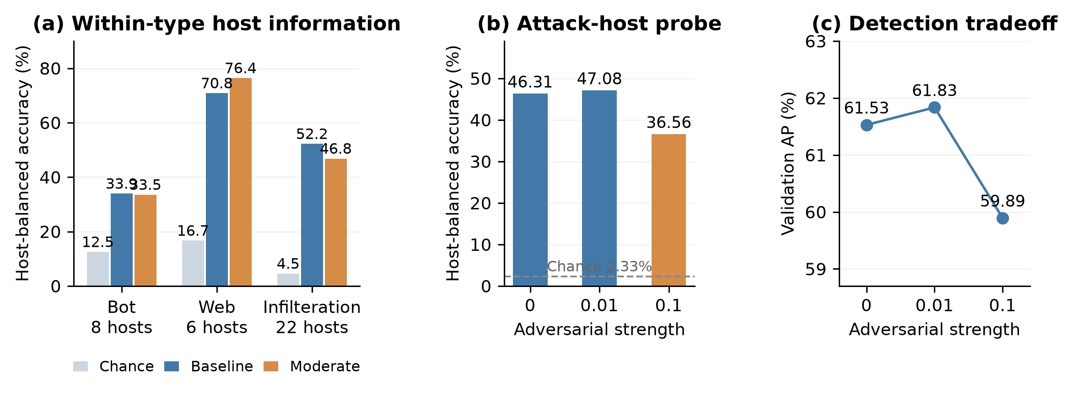
Figure S1. Host information and suppression tradeoffs. Panels (a-b) reuse detector-training records for independent host probes; panel (b) covers 43 hosts and 640 evaluation records. Panel (c) uses real validation sequences. One detector seed; supervision coverage varies by subtype.
The intervention identifies a practical tradeoff between host suppression and detection under the available source support. We retain the baseline and focus the following analyses on Web and Infilteration, whose broader source coverage and persistent detection difficulties support closer examination of local evidence, temporal context and background mixing.

6 Focused Analyses and Transfer
Web offers sparse local evidence, while Infilteration includes both input ambiguity and sensitivity to traffic mixtures. We connect these observations to temporal context, targeted changes to the original LSTM and detection after training-label exclusions.

6.1 Sparse Web Evidence and Temporal Context
Web positives often supply isolated local evidence: 171/181 validation sequences contain attack flows in one bucket, and 96/181 have only one active traffic bucket. Using the original masks and five original-order seeds, XGBoost achieves 64.79% mean recall on the single-active-bucket group at its global 1% FPR budget, compared with 38.75% for LSTM. LSTM is stronger in the two-bucket and three-or-more-bucket groups. Figure W1 shows how these observational groups reveal complementary local and contextual detection profiles.
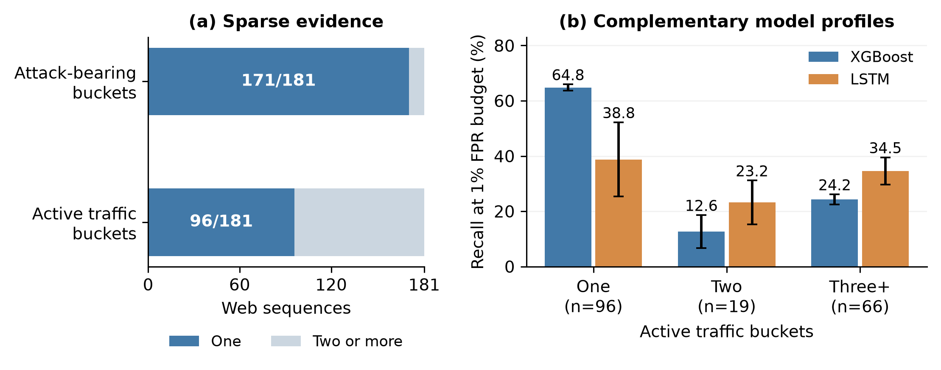
Figure W1. Sparse Web evidence and occupancy-conditioned recall on the same validation cohort. Error bars are sample SD across five original-order seeds; each fit uses its global 1% FPR-budget threshold.
To check whether longer history supplies the missing context, a common-anchor raw-flow diagnostic extends eligible past windows from 100 to 400 seconds at fixed 10-second resolution. Median active buckets rise from one to three for Web and from three to eight for Infilteration. Yet 47/143 eligible Web anchors remain single-bucket; among stable XGBoost-detected/LSTM-missed cases, 14/17 remain single-bucket. Longer history adds activity for some samples while a distinct sparse subgroup persists.
Separate LSTM pipelines were fitted at 200/10, 200/20, 400/10 and 400/40 sequence/bucket seconds, with refitted preprocessing and encoders (Figure T1b-c). The 400/40 setting gives 58.12% Web and 73.33% Infilteration recall at the 1% budget, but only 8.89% Infilteration recall at 0.1%. Its cohort contains 117 Web and 45 Infilteration sequences, versus 181 and 366 in the historical 100/10 reference. AP across the new geometries is 52.78-55.49%. These are single-seed comparisons on rebuilt cohorts; the historical reference uses a different runtime. Temporal scale changes coverage and operating-point behavior, supporting more targeted changes to the baseline.
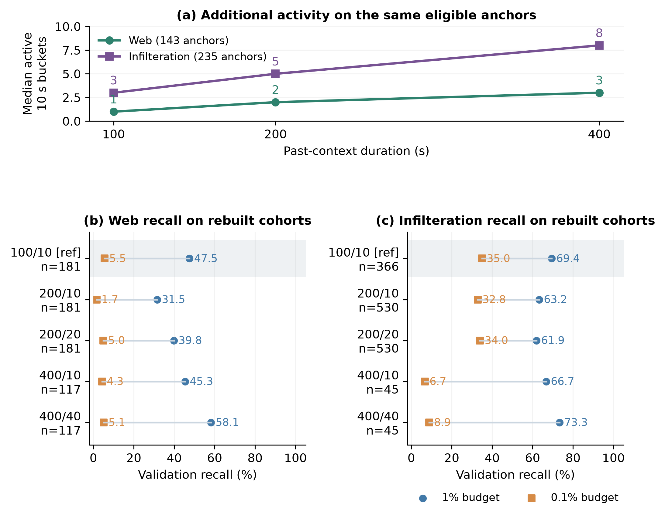
Figure T1. Matched-anchor activity (a) and separately rebuilt detector cohorts (b-c). Duration labels are sequence/bucket seconds; n is subtype support. The shaded row is the historical reference from a different runtime. New geometries use seed 4266.

6.2 Infilteration Input Ambiguity
Among 138 pure Infilteration validation sequences, whose constituent flows are all attack-labeled, the historical LSTM misses 34 at its frozen 1% FPR-budget threshold. Reconstructing their raw bucket statistics and searching all 250,229 benign validation sequences identifies exact benign counterparts for ten misses. Ten of the 104 pure detections also have exact benign counterparts. Equality already holds in unscaled numeric aggregates and category counts, before neural encoding. Identical detector inputs produce identical deterministic scores, creating a direct recall versus false-alarm tradeoff for these pairs.
The misses are predominantly sparse: 30/34 have one active bucket and 29/34 contain at most two flows, compared with 48/104 and 46/104 among pure detections. Source and staged labels agree for all 734 flows in the audited pure sequences. At least one other detector recovers 17 of the 34 LSTM misses. The findings therefore identify both a concrete subset with input ambiguity and remaining architecture-dependent recovery, motivating experiments on representation information and learning objectives.

6.3 Targeted Learning and Representation Changes
We tested three changes against the same-runtime seed-4266 LSTM: learned attention in place of uniform mean pooling, fifteen added distribution statistics with a refitted bucket encoder, and auxiliary bucket supervision with fixed loss weight 0.5. Original sample IDs, splits and donor assignments were retained. Each model selects its own checkpoint by sequence validation AP and its own global thresholds. Table V1 presents the comparisons together so that overall ranking and attack-specific sensitivity can be read jointly.
Table V1. Single-seed targeted comparisons on the same real validation cohort. Recall pairs are percentages at global 1% / 0.1% FPR budgets; Infilteration n=366 and Web n=181. The distribution extension includes encoder refitting.
Variant | AP (%) | Infilteration recall (%) | Web recall (%)
Same-runtime reference | 61.53 | 72.95 / 36.61 | 25.97 / 3.87
Attention pooling | 61.87 | 70.49 / 35.79 | 29.28 / 2.21
Distribution statistics | 61.50 | 70.77 / 31.69 | 36.46 / 6.08
Bucket supervision | 61.64 | 74.04 / 36.07 | 26.52 / 3.87
Frozen context diagnostics motivate selective weighting: removing pure-benign buckets changes mean detection rates across five LSTMs by -7.29 percentage points for Web and -2.30 for Infilteration at unchanged 1% thresholds. Learned attention subsequently increases median weight on attack-bearing buckets from 25.00% to 85.55% in context-bearing Web cases. Its Web gain at 1% is concentrated in single-active-bucket cases, however, where attention weight already equals one; multi-bucket detections fall from 24 to 18. Selective weighting and sequence discrimination are distinct outcomes of joint retraining.
Training-only ExtraTrees probes screened candidate feature families using time-block and source-host development partitions. Distribution/joint statistics add about 0.0027 mean AUC under both partitions across three forest seeds, motivating the compact fifteen-feature extension. The resulting pipeline improves Web recall at both budgets while reducing Infilteration recall despite similar overall AP. At 0.1%, it loses 23 previously detected Infilteration sequences and recovers five, a net loss of 18.
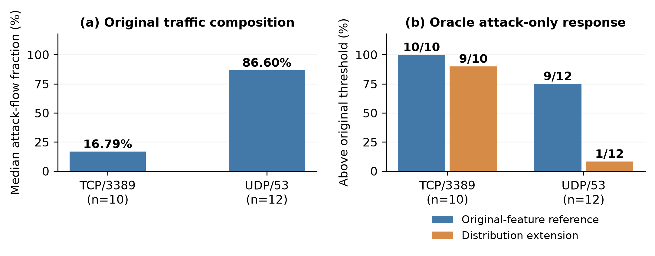
Figure I2. The two largest groups among 23 strict-threshold Infilteration losses after the distribution extension. Attack-only inputs remove all benign-labeled flows; each pipeline retains its original threshold. Intervention FPR is uncalibrated.
A flow audit of these changed cases distinguishes two responses. Removing pure-benign buckets moves 3/23 losses above the extended model's original threshold, versus 11/23 after removing every benign-labeled flow. Figure I2 contrasts mixture-sensitive TCP/3389 cases with attack-heavy UDP/53 cases that largely remain below threshold after benign-flow removal. The original-feature reference gives much higher attack-only responses in the latter group, showing that similar overall AP can conceal different responses to attack evidence. Label-based deletions alter inputs at fixed thresholds and are oracle diagnostics, not calibrated detection improvements.
Finally, bucket supervision tests whether the existing finer labels support localization without changing the inputs or frozen encoder. Any-attack bucket BCE is averaged over active positions per sequence, combined with sequence BCE and the original group weights; labels are targets only. Active-bucket validation AP is 82.88%. In 135 Infilteration sequences containing both attack-bearing and pure-benign active buckets, the highest-scoring bucket hits an attack position in 116 cases (85.9%), compared with 54.4% expected under uniform selection. Localization is learnable even though low-FPR sequence gains remain modest. These one-seed interventions characterize useful signals and tradeoffs rather than replacing the working baseline.

6.4 Transfer After Training Exclusions
Two fixed training-holdout sets test different transfer questions. Set A jointly removes XSS, SlowHTTPTest and HOIC while retaining related types; set B removes all seven DoS/DDoS primary labels. Preprocessing and the bucket encoder are refitted per arm, with unchanged validation/test IDs. Exclusion uses sequence primary labels, with secondary memberships audited separately. Four detector families use seeds 4266-4268; withheld types remain in validation for model/threshold selection, and test scoring uses the saved thresholds.
Table H1. Frozen-test pooled recall, mean +/- sample SD across three seeds. Deltas are paired holdout minus control, in percentage points; set A n=134 and set B n=202. The FPR budget is 1% on validation, not a guarantee of 1% test FPR. Values reproduce the completed team three-seed report.
Model | Set A recall (%) | Delta A (pp) | Set B recall (%) | Delta B (pp)
CNN | 99.00 +/- 0.43 | -0.75 +/- 0.75 | 68.32 +/- 0.00 | -31.68 +/- 0.00
CNN-LSTM | 98.76 +/- 1.14 | -1.00 +/- 0.86 | 68.32 +/- 0.00 | -31.68 +/- 0.00
LSTM | 98.76 +/- 1.14 | -0.50 +/- 1.14 | 72.94 +/- 4.00 | -26.57 +/- 3.14
XGBoost | 99.00 +/- 0.43 | +2.74 +/- 0.43 | 68.65 +/- 0.29 | -27.72 +/- 0.50
With related types retained, set-A pooled recall remains 98.76-99.00%. The matched Projector views in Figure H2 describe an earlier one-seed LSTM comparison on 4,917 validation IDs. Native 64D benign-neighbor fractions for retained Web and Infilteration change little, alongside changes in attack-to-attack neighborhoods. These independently fitted pipelines differ in preprocessing and historical runtime; the views explain within-model composition rather than literal point movement.
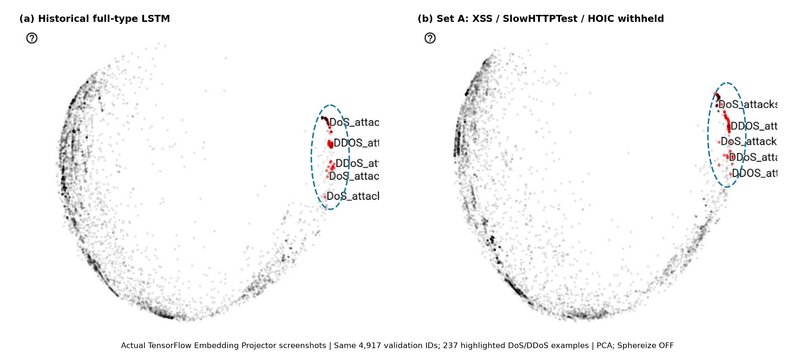
Figure H2. Historical and set-A LSTM Projector views of matched validation samples. The highlighted points are the same 237 DoS/DDoS sequences. Ellipses guide inspection; PCA axes are independent and sphereization is disabled.
Set B reduces pooled recall to 68.32-72.94%, with paired losses of 26.57-31.68 percentage points and lower recall in every seed for every model. Transfer therefore depends on the scope of exclusion. A separate one-seed LSTM illustrates the subtype differences: it detects 142/202 flooding test sequences at an actual full-test FPR of 1.0619%, including all HOIC, GoldenEye and SlowHTTPTest examples, 60/110 LOIC-HTTP and 4/14 LOIC-UDP examples. Hulk and Slowloris have no test support.
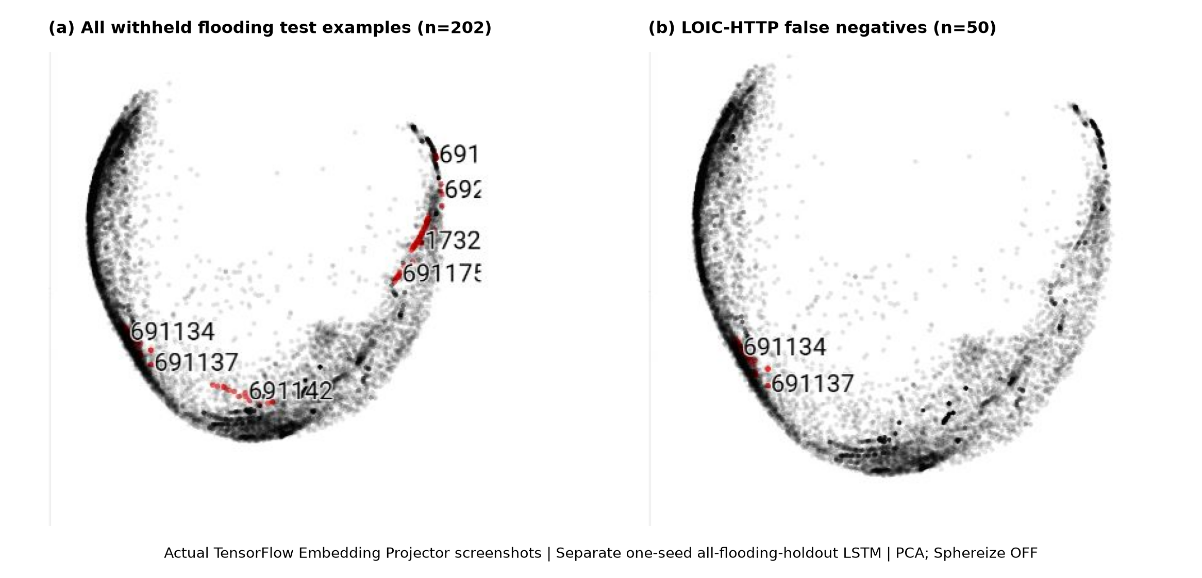
Figure H3. Projector views from the separate all-flooding-holdout LSTM: all 202 flooding test examples (left) and 50 LOIC-HTTP misses (right). Both use PCA without sphereization.
Full-training 64D neighborhoods further separate the missed subtypes. The 50 LOIC-HTTP misses average 98.5% benign neighbors among their twenty nearest training rows; the ten LOIC-UDP misses average 22.5% and have median score 0.9245 against threshold 0.9503. The reference contains all 780,899 training rows, including synthetic rows, whereas the displayed plot is a smaller attack-enriched sample. This post-fit reuse of training references describes geometry and remains separate from the team's three-seed test comparison. Together, the results establish high related-type transfer and pattern-dependent detection after broad-family removal.

7 Discussion and Limitations
The results in Sections 5 and 6 suggest that detection depends on the evidence retained in each source window and its relationship to the training population. Scheme 2 provides a useful common representation, but the focused analyses show why similar overall performance can coexist with different errors across attack types and false-alarm budgets.

7.1 Representation and Background Composition
The normalization diagnostics in Section 4.3 and the representation comparison in Section 5.1 support controlling bucket amplitude while retaining intensity separately. This design reduces the influence of extreme reconstruction errors and supplies compact inputs for downstream detection. The comparison nevertheless evaluates complete pipelines: it does not isolate the benefit of embedding addition or establish an augmentation gain over training on originals alone. As Section 4.2 explains, adding normalized embeddings also need not reproduce the encoding of physically merged traffic.
The EDA in Section 3.1 makes background composition relevant to this distinction. Natural benign-attack mixtures are concentrated in Infilteration, while several flooding and brute-force types occur only in attack-only windows at the examined scales. Superimposition therefore introduces background variants whose resemblance to observed traffic varies by type. The mixing diagnostics in Section 6.3 reinforce the need to examine these responses separately. Reusing recorded training donors expands background combinations without supplying independent attack events.

7.2 Temporal Context and Sparse Evidence
The close neural AP means in Section 5.2 support retaining LSTM as a working baseline without establishing a consistently superior architecture. The Web analysis in Section 6.1 offers a more informative distinction: XGBoost recovers more single-active-bucket examples, whereas LSTM is stronger in the observed multi-bucket groups. This agrees with the sparse occupancy found in Section 3.1 and suggests that the value of context depends on how much activity a window contains. A detector combining local and contextual evidence is a reasonable next hypothesis, but the present comparisons do not test that combination.
Neither rotation nor longer windows resolve this issue alone. Circular rotation preserves most local adjacency, and the temporal-scale experiments rebuild cohorts with different subtype support. The context-deletion results show that surrounding benign activity can contribute to scores, while the attention experiment shows that greater weight on attack buckets need not improve multi-bucket detection. Context can carry useful behavioral relationships as well as host-related regularities. The host probes and partial suppression tradeoff in Section 5.3 confirm that excluding identifiers does not eliminate host information, but they do not establish how much detection depends on it.

7.3 Information Limits and Learning Tradeoffs
The exact benign counterparts in Section 6.2 identify a specific limit of the current inputs. Because equality already occurs before neural encoding, changing the classifier cannot distinguish those pairs without additional information. Collisions among both missed and detected Infilteration examples also show why this finding explains only part of the difficulty. Recovery of other LSTM misses by alternative detectors leaves room for improvements in how the available evidence is learned.
The targeted interventions in Section 6.3 distinguish this learning opportunity from demonstrated sequence-level improvement. Added distribution statistics improve Web recall while reducing Infilteration recall, despite nearly unchanged AP. Auxiliary bucket supervision localizes attack-bearing positions in 116 of 135 eligible Infilteration sequences, yet yields only modest sequence gains. Localization, overall ranking and recall under a strict false-alarm budget therefore require separate assessment. The TCP/3389 and UDP/53 audits further show that Infilteration contains different failure mechanisms; label-based flow removal helps diagnose these mechanisms, but its unchanged thresholds and uncalibrated intervention FPR prevent interpreting it as a deployable detection improvement.

7.4 Scope of Transfer
Section 6.4 connects detection to the coverage of related training patterns. High recall after selected subtype exclusions indicates substantial transfer when related attacks remain available. The consistent losses after removing all DoS/DDoS primary labels reveal a narrower boundary. The separate flooding diagnostic further distinguishes LOIC-HTTP misses with predominantly benign training neighborhoods from LOIC-UDP misses whose scores often lie nearer the threshold. These observations suggest different transfer difficulties, although neighborhood composition alone does not prove their cause. Since withheld types remain in validation for checkpoint and threshold selection, the experiment measures transfer after training exclusions under that selection policy; it does not establish fully unseen-attack or zero-day generalization.

7.5 Limitations
The study uses one dataset with imported labels and recurring hosts and campaigns across time blocks; external-network and future-time generalization remain untested. Several targeted interventions use one detector seed, model capacities differ, and synthetic donors are dependent. Host probes and stress diagnostics reuse training records. Repeated validation analysis and historical test inspection limit independent performance claims. A fresh holdout, matched order controls and an explicit augmentation ablation would strengthen evaluation. Full-flow summaries assigned by start time also leave online detection latency unmeasured.

8 Conclusion
Pending team contribution: Complete after evidence is available: answer the research questions and delimit contributions and generalization claims.

References
[1] M. Portmann et al., “Machine Learning-Based NIDS Datasets,” University of Queensland. [Online]. Available: https://staff.itee.uq.edu.au/marius/NIDS_datasets/. Accessed: Oct. 25, 2026.
[2] TensorFlow, “Visualizing Data using the Embedding Projector in TensorBoard.” [Online]. Available: https://www.tensorflow.org/tensorboard/tensorboard_projector_plugin. Accessed: Oct. 25, 2026.

Appendix A: Reproducibility Artifacts
Pending team contribution: Add full features, exact label mappings, fold manifests, exclusions, donor plans, configs, versions, seeds, hashes and projection settings. Keep the submitted main section within eight pages; relocate supporting material as needed.

