
COMSATS University Islamabad
object oriented programming
Semester Project
Documentation
NAME : IMARA ASIM , Shafia Shafique
REGSTRATION NUM : SP25-BCS-034, 093
SUBMITTED TO : MAM SAJIDA
Student Management System - Complete Semester Project Documentation
1. Project Overview
The Student Management System (SMS) is a Java desktop application built using Swing GUI. The project is divided into two main parts:
The Student Management System (SMS) is a Java application consisting of two parts:
- Console-based application – implements all core functionality including student/course management, transcript/results management, GPA calculations, and file storage using menus in the console.
- GUI-based application – implemented using Swing (MainGUI.java), providing a user-friendly interface for managing students, courses, results, transcripts, and system statistics.
Key Objectives:
- Demonstrate object-oriented programming (OOP) concepts: inheritance, polymorphism, abstraction, composition.
- Use Java Swing to create GUI menus, forms, and event-driven programming.
- Handle file input/output for persistent storage.
- Implement student/course management, transcript management, and system reports.
2. Functional Features
2.1 Student Management
- Add students with type-specific information (Science, Arts, Engineering)
- View a list of all students
- Search for a student by ID
- Remove a student by ID
2.2 Course Management
- Add courses with:
  - Course Code
  - Course Title
  - Credit Hours
  - Instructor Details
- View all courses
- Search courses by Course Code
- Remove courses
2.3 Result / Transcript Management
- Add course results for students
- View full transcripts (courses + marks)
- Search transcripts by student ID
- Remove transcript entries
- Calculate:
  - GPA
  - Total Marks
  - Grades
2.4 File Operations
- Save / Load students, courses, and transcripts using serialization (DataStore<T>).
- Save / Load courses
2.5 System Reports
- Total number of students
- Total number of courses
- Display global pass marks

3. Class-Level Description
3.1 Core Classes
(this table only contain some important point for complete picture look at the uml below )
Class | Purpose | Key Attributes | Key Methods
MainGUI | Main manue | JFrame, MenuItems, Buttons | initComponents(), addListeners(), showWindow()
Student (abstract) | Base for all student types | id, name, program, Transcript transcript | calculateGPA(), getTranscript()
ScienceStudent / ArtsStudent / EngineeringStudent | Derived student types | Inherits Student | No extra attributes, but differentiates by type
Course | Represents a course | courseCode, courseName, creditHours, instructor | getCourseDetails(), toString()
CourseInstructor | Holds instructor info | name, qualification | toString()
Transcript | Holds student results | ArrayList<ResultEntry> results | addResult(), calculateGPA(), getTotalMarks()
ResultEntry | Represents a student’s result in a course | Course course, double marks | getGrade(), toString()
RecordList<T> | Generic list of records | ArrayList<T> list | add(), remove(), search()
DataStore<T> | Generic file I/O | filename | saveList(), loadList()

3.2 Event Listener Classes
Listener | Purpose
StudentMenuListener | Opens student menu from MainGUI
AddStudentListener | Handles adding students
RemoveStudentListener | Handles removing students
SearchStudentListener | Handles searching students
CourseMenuListener | Opens course menu from MainGUI
AddCourseListener | Handles adding courses
RemoveCourseListener | Handles removing courses
SearchCourseListener | Handles searching courses
ResultMenuListener | Opens result menu from MainGUI
TranscriptAddListener | Adds a course result for a student
TranscriptRemoveListener | Removes a result from transcript
TranscriptSearchListener | Searches a student transcript
TranscriptViewListener | Displays transcript window
TranscriptCalculatorListener | Calculates GPA, total marks, and grades
FileOperationListener | Handles save/load operations for students, courses, transcripts
SystemListener | Handles system statistics (total students, courses, etc.)

4. Code Relationships & Design Patterns
4.1 Inheritance
Student (abstract)
├─ ScienceStudent
├─ ArtsStudent
└─ EngineeringStudent
4.2 Composition
Student ──has──> Transcript ──has──> ResultEntry ──has──> Course ──has──> CourseInstructor
4.3 Associations
- GUI (MainGUI) associates with all Listeners
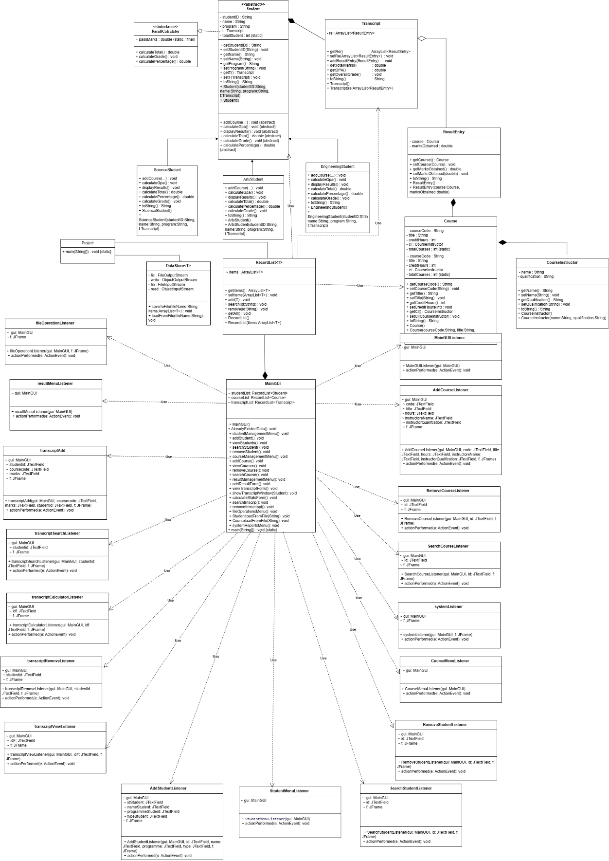
5. Method-Level Details
- 5.1 Student
- calculateGPA() → Iterates through Transcript results and calculates GPA based on marks and credits.
- getTranscript() → Returns student’s transcript object.
- 5.2 Course
- getCourseDetails() → Returns formatted string with course code, title, credits, instructor.
- 5.3 Transcript
- addResult(ResultEntry r) → Adds course result to transcript.
- calculateGPA() → Uses standard GPA formula (weighted by credit hours).
- getTotalMarks() → Sum of all course marks.
- getGrade(double marks) → Returns grade A/B/C/D/F.
- 5.4 DataStore<T>
- saveList(ArrayList<T> list) → Saves objects to a .dat file using serialization.
- loadList() → Loads objects from a .dat file.

3. GUI Documentation
3.1 Main GUI Overview
Class: MainGUI
Purpose: Entry point for all GUI operations. Handles menu bar, buttons, and opens forms for student, course, and transcript management.
3.1.1 Components
- Menu Bar
  - File → Save / Load
  - Student → Add, View, Search, Remove
  - Course → Add, View, Search, Remove
  - Result → Add, View, Search, Remove, Calculate GPA
  - System → Show statistics
- Main Panel
  - Buttons for quick access: Add Student, Add Course, Add Result etc
3.1.2 Layout
- BorderLayout for main frame
- FlowLayout for forms and input panels
- Panels grouped logically for separation of concerns
3.1.3 Event Listeners
Listener | Purpose
StudentMenuListener | Opens student menu
AddStudentListener | Handles adding a new student
RemoveStudentListener | Removes student by ID
SearchStudentListener | Searches student by ID
CourseMenuListener | Opens course menu
AddCourseListener | Adds a new course
RemoveCourseListener | Removes course by code
SearchCourseListener | Searches course by code
ResultMenuListener | Opens transcript/result menu
TranscriptAddListener | Adds a course result to a student
TranscriptRemoveListener | Removes a course result
TranscriptSearchListener | Searches a student transcript
TranscriptViewListener | Displays transcript for a student
TranscriptCalculatorListener | Calculates GPA, grades, total marks
FileOperationListener | Saves or loads data for students, courses, transcripts
SystemListener | Displays system statistics

3.2 GUI Forms
- Add Student Form
  - Fields: ID, Name, Program (Science, Arts, Engineering)
  - Submit Button → triggers AddStudentListener
- Add Course Form
  - Fields: Course Code, Name, Credit Hours, Instructor
  - Submit Button → triggers AddCourseListener
- Add Result / Transcript Form
  - Fields: Student ID, Course Code, Marks
  - Submit Button → triggers TranscriptAddListener
- View / Search Forms
  - List students/courses or search by ID/code
  - Display results in JTextArea or JTable
- Statistics / GPA
  - Calculate GPA, total marks, and grades
  - Display in dialog box or panel

3.3 GUI Flow
MainGUI
├─ Student Menu → Add / View / Search / Remove Student
├─ Course Menu → Add / View / Search / Remove Course
├─ Result Menu → Add / View / Search / Remove Result / Calculate GPA
├─ System Menu → Statistics
└─ File Menu → Save / Load

4. Integration: GUI + Backend
- MainGUI communicates with RecordList<Student>, RecordList<Course>, and RecordList<Transcript>.
- Each GUI action triggers a listener,
- File operations ensure persistent storage of all records.

5. File Handling
Loading data from .dat files populates backend records (RecordList), which may later be reflected in GUI when fully integrated.
GUI PART OF PROJECT :
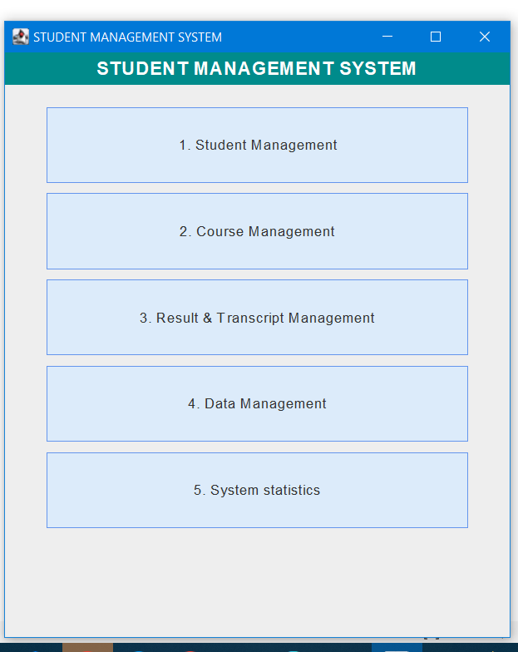
1: student management :
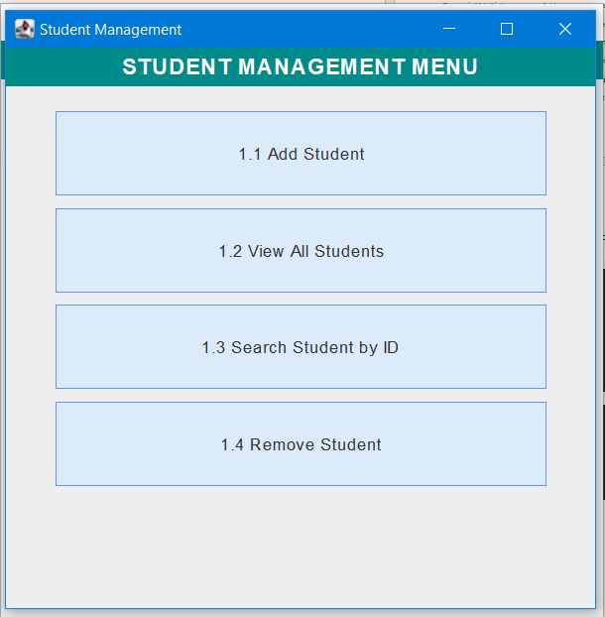
1.1 Add student
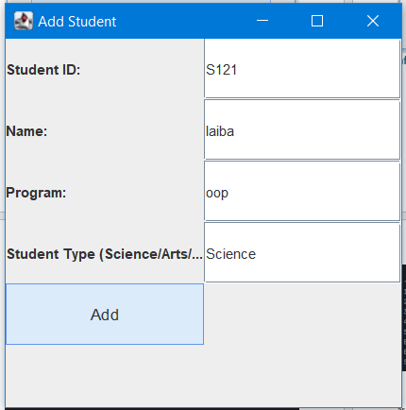
after pressing add :
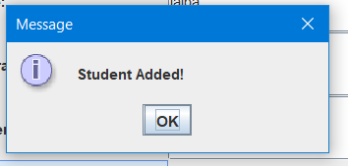
1.2 : view students :

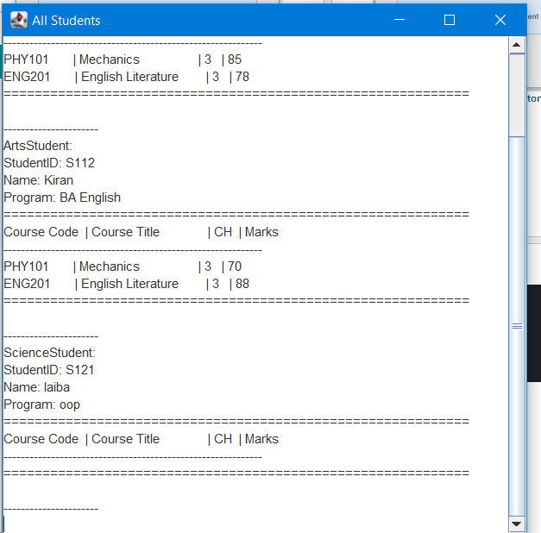
1.3 search by id :

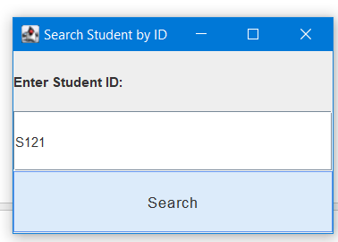
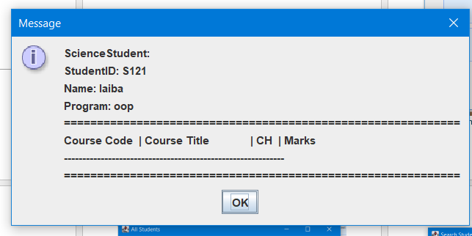
1.4 remove student :

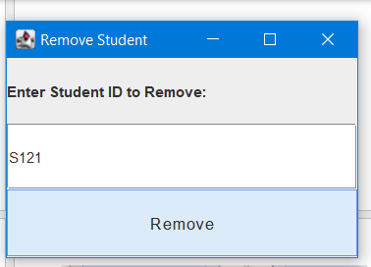
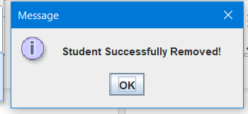
2 : course management :

2.1 : add course 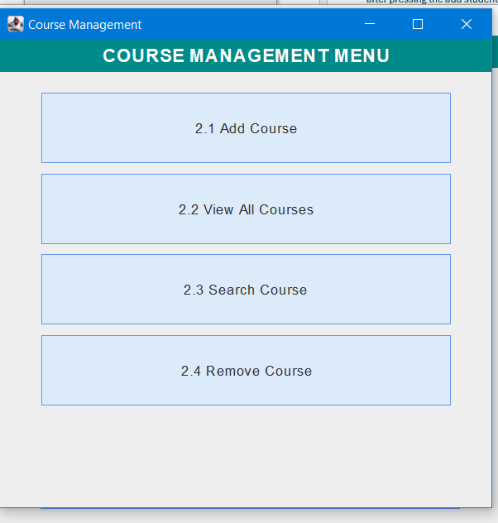: 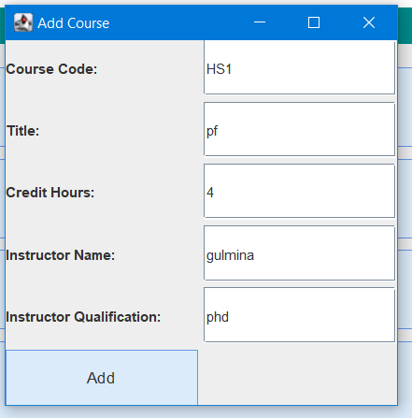
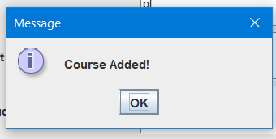
2.2 : view all course :

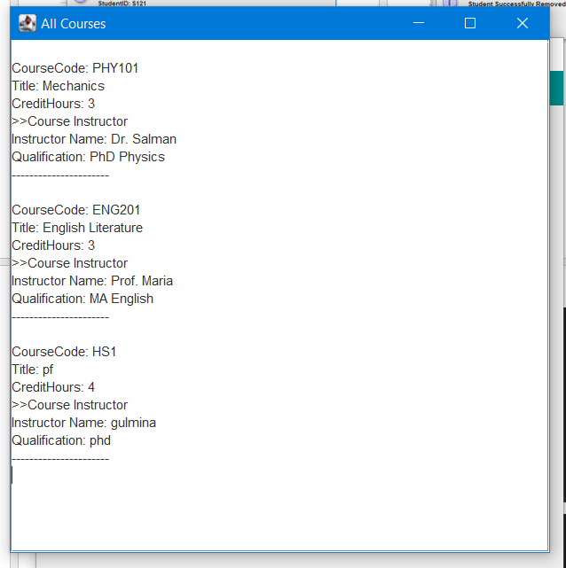
2.3 Course Search
: 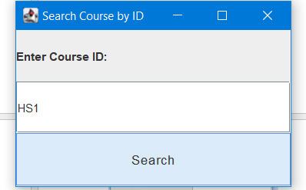
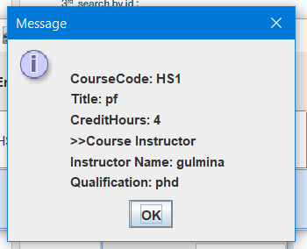
2.4 :Remove Course :

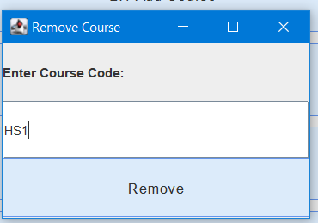 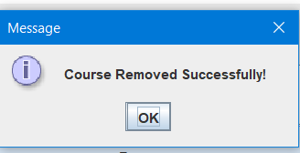
3 : RESULT & TRANSCRIPT MANAGEMENT :
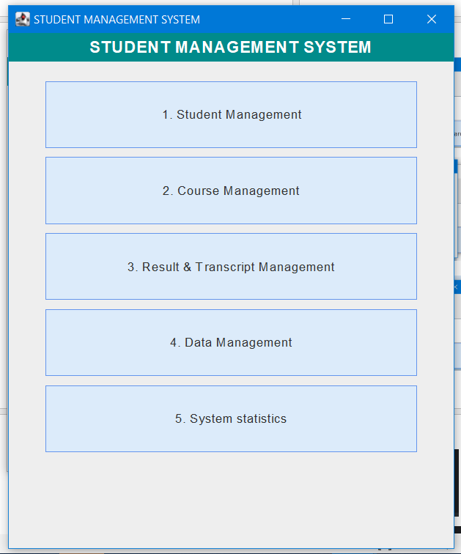
3.1 Add transcript :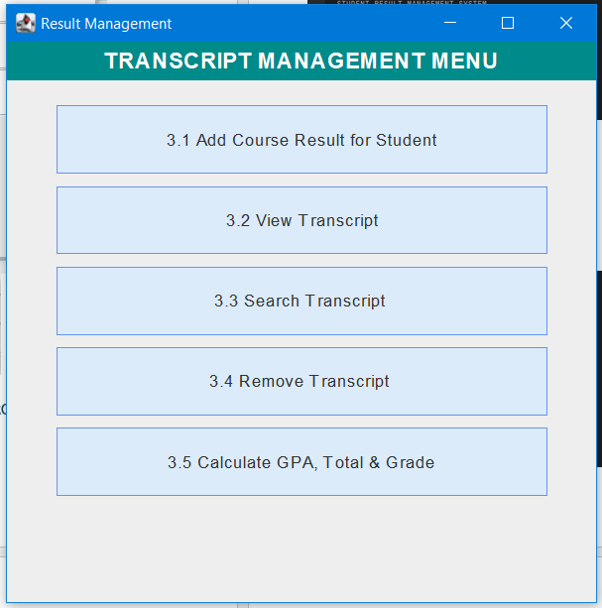
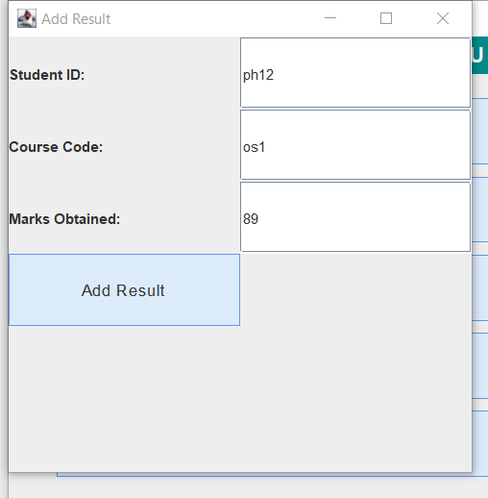
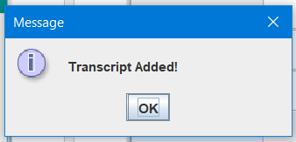
3.2 : view transcript :

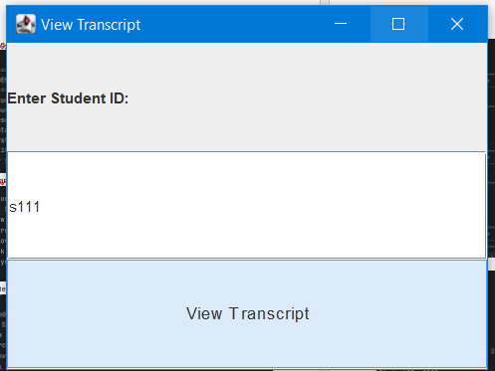
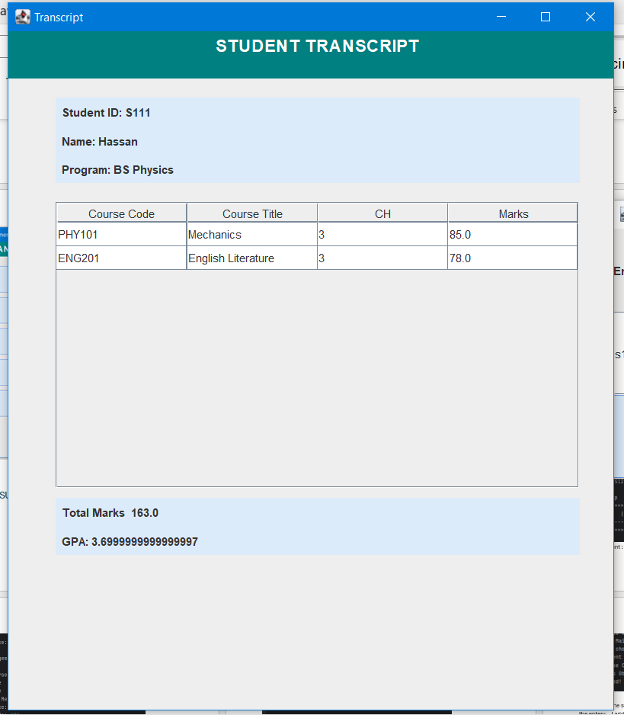
3.3 :search transcript :

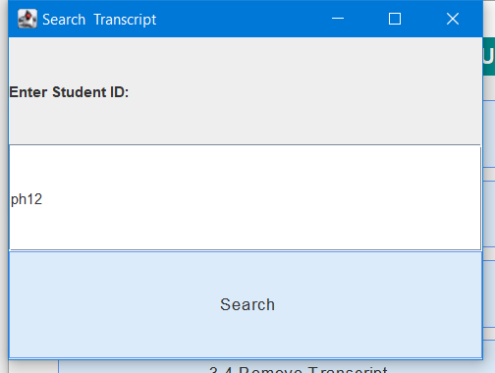
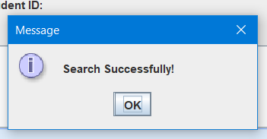
then we can view too :
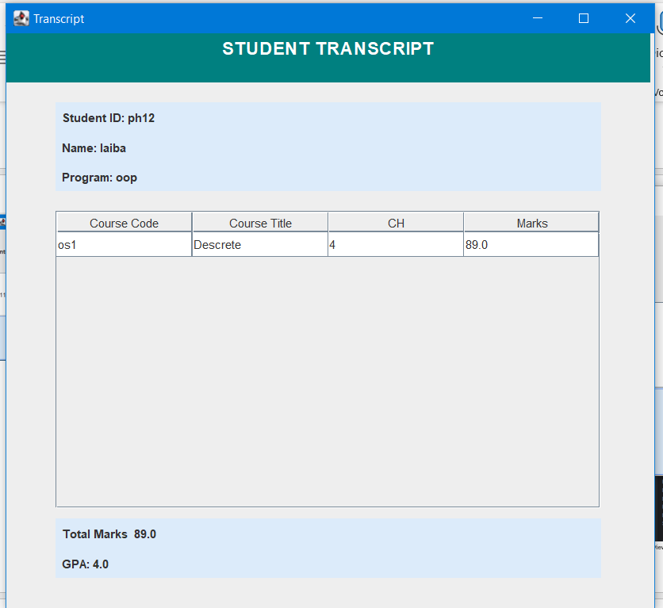
3.4 Remove transcript ||
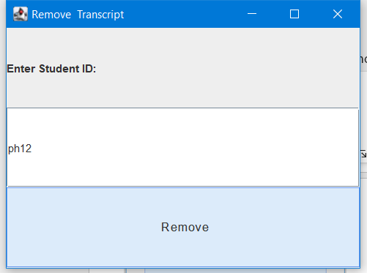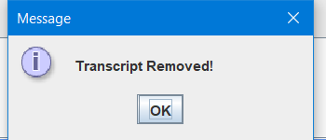
3.5 Calculate GPA , Total Marks & Grades
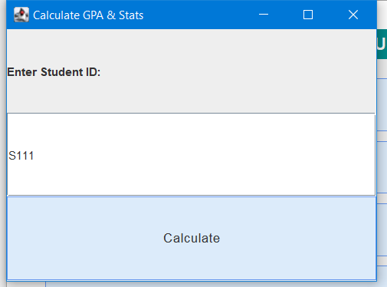
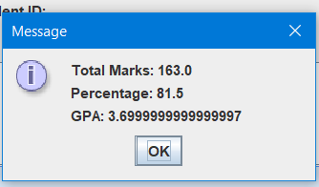
4 DATA MANAGEMENT :
4.1 : SAVE STUDENT :
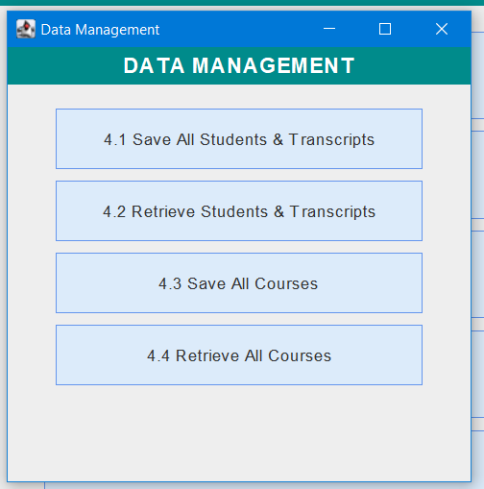
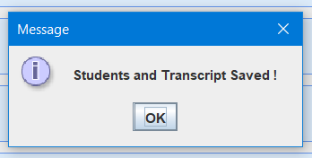
4.2 : RETRIEVE STUDENT

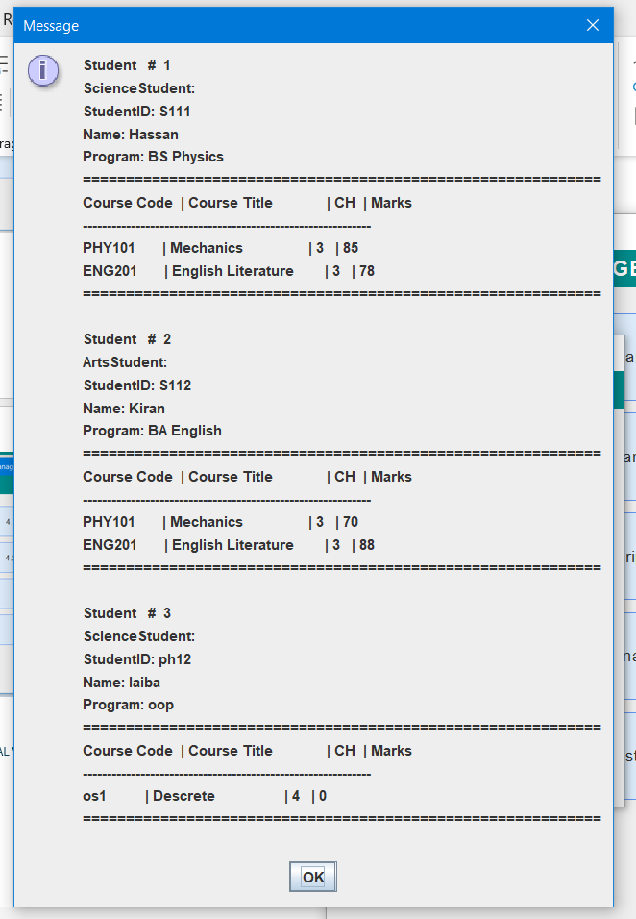
4.3 :SAVE ALL COURSES

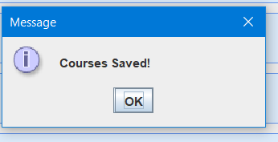
4.4 : COURSES RETREIVE :

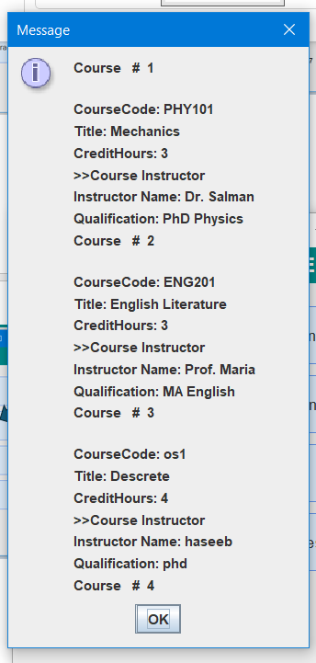
5: SYSTEM STATISTIS : 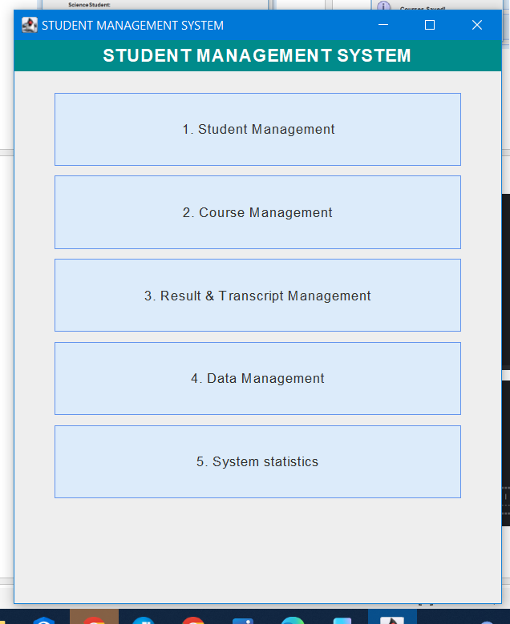
5.1 : Total Student :
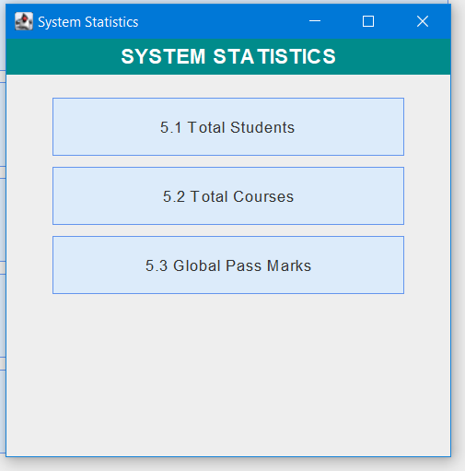
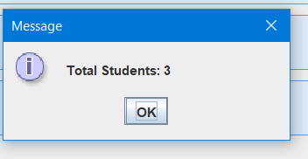
5.2 : Total Courses

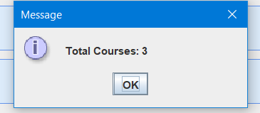
5.53 : Global Pass Marks

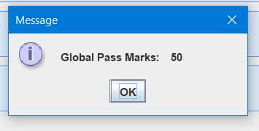
TERMINAL VISUAL PART OF PROJECT
Main manue :
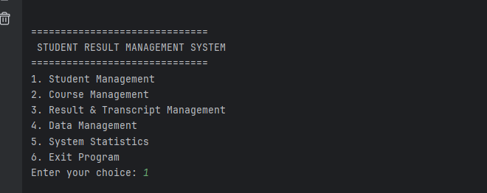
Student manue :
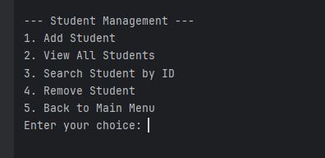
1. Add Student
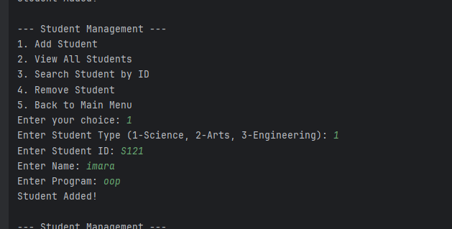
View All student :
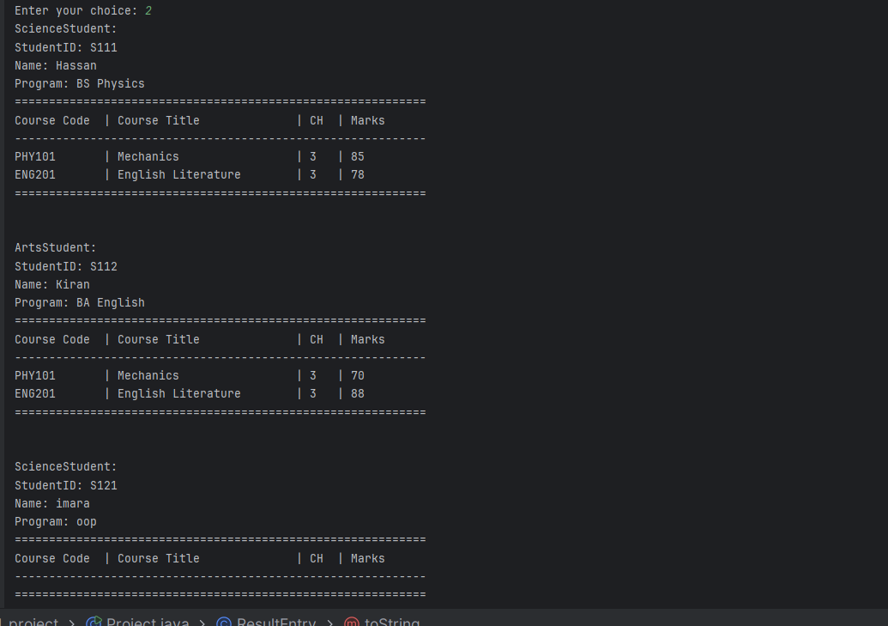
search student :
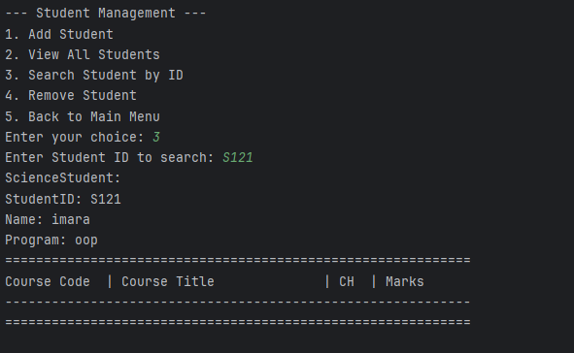
remove student :
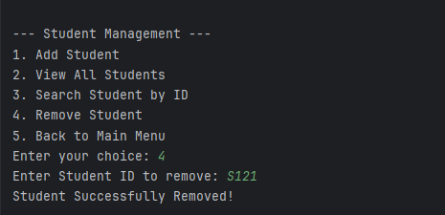
as for the course too
course manue :
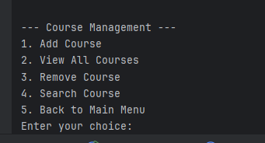
course add :
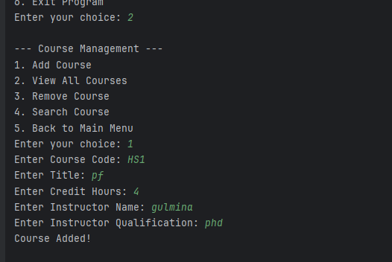
course view :
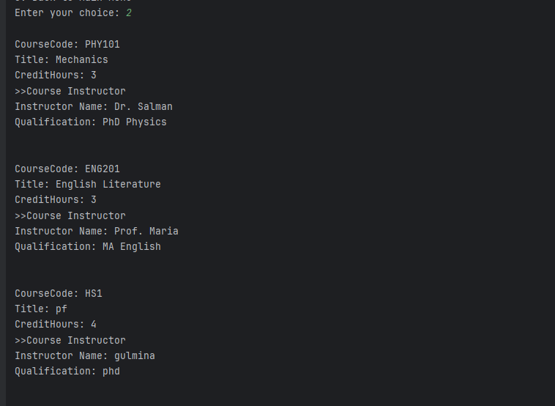
search course :
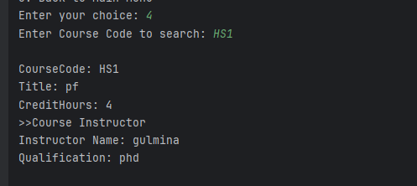
remove course :
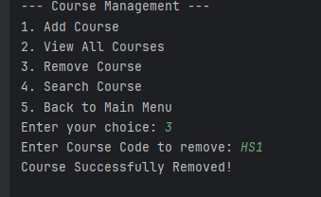
result transcript manue :
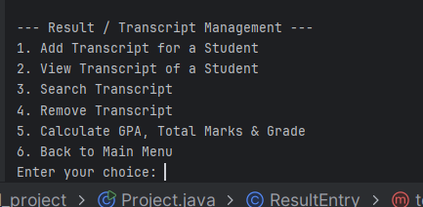
add transcript :
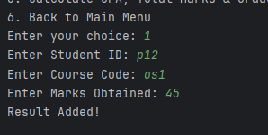
it will check the student I the student present then check the course if I present then enter the entery .. I added the student as well as the course before enter this
view transcript of p12 :
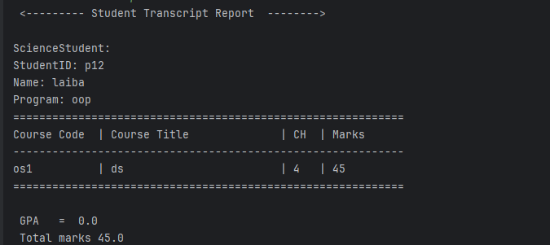
calculate gpa :
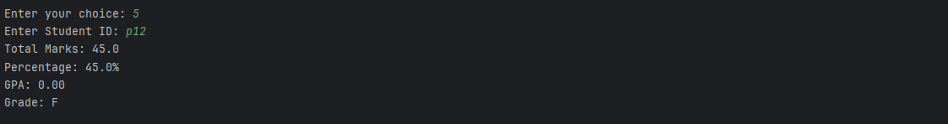
remove transcript :
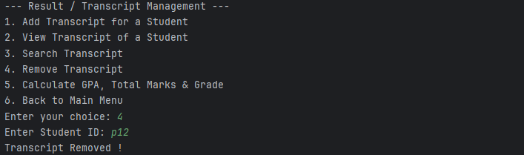
data mangemnet :
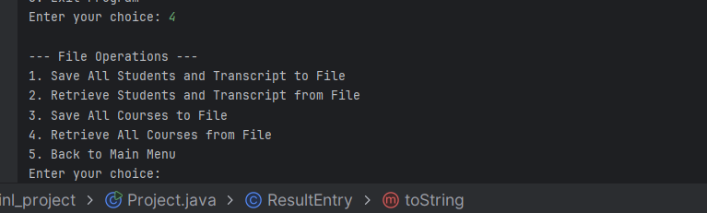
save student record in file :
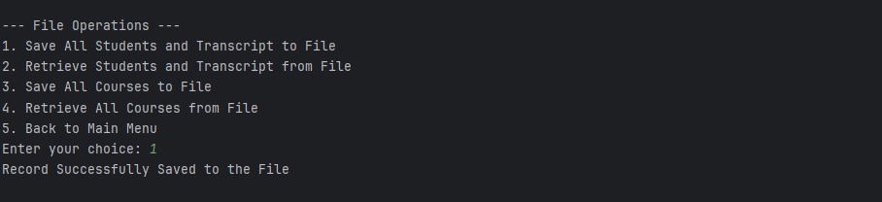
retrieve the student file :
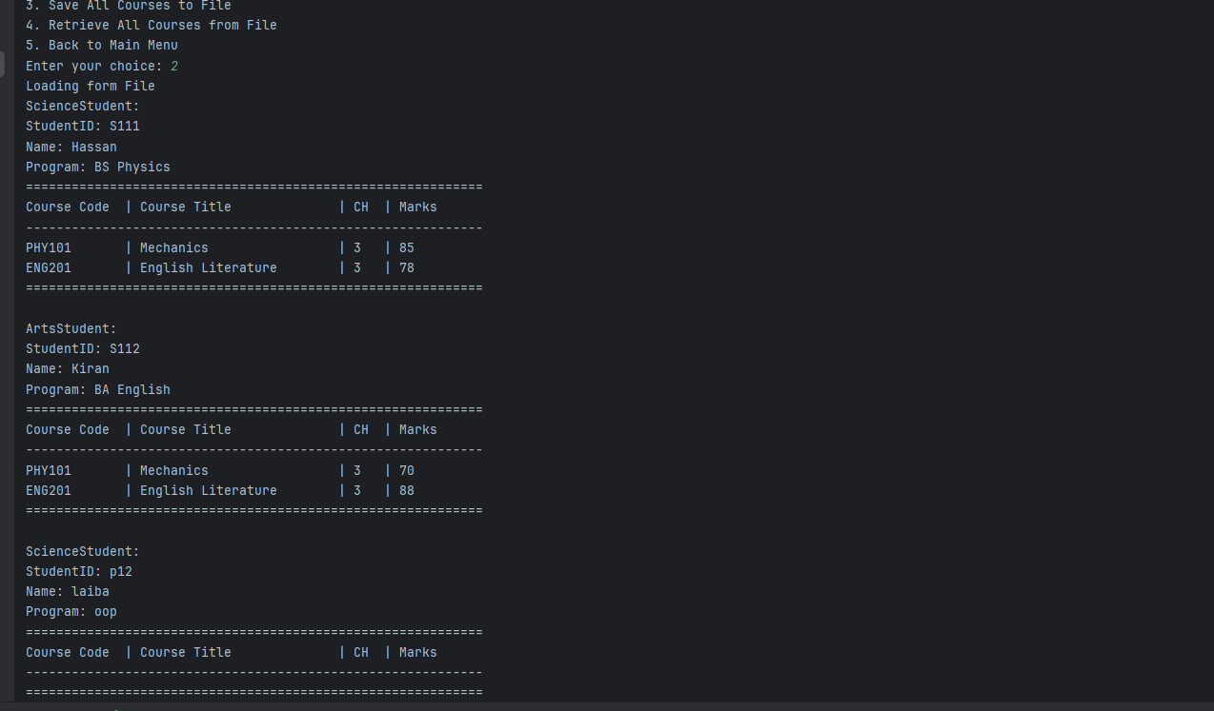
save he course
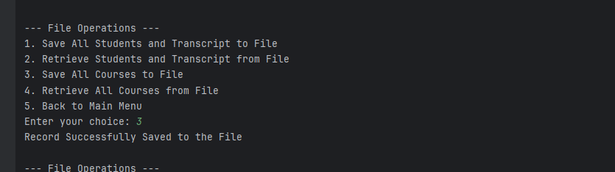
retrieve the courses
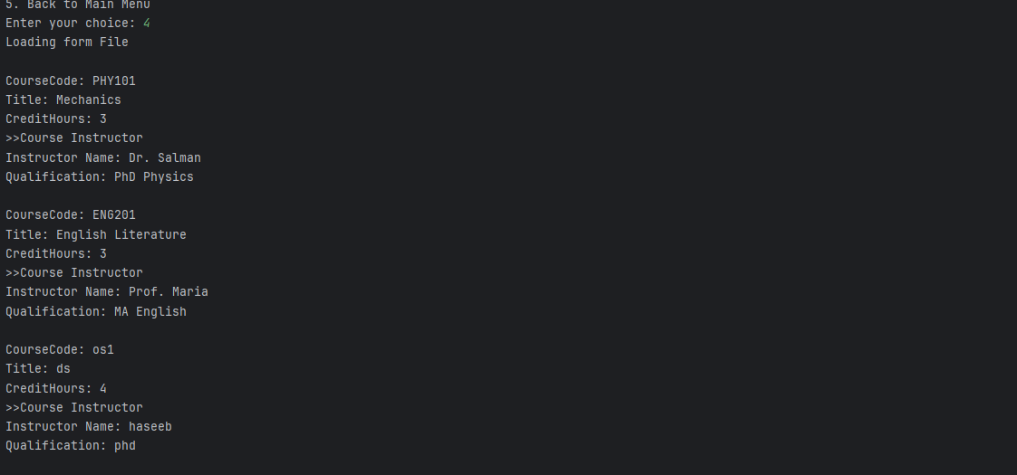
system statistics :
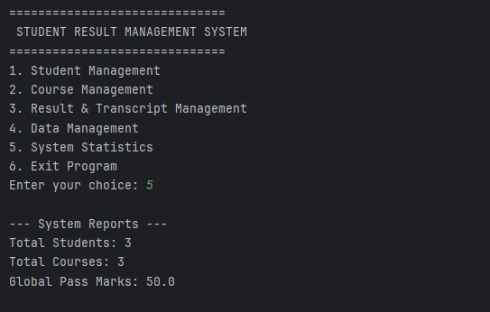
exiting the program :
