**STUDY OF MIMO SYSTEMS IN WIRELESS COMMUNICATION**

A THESIS SUBMITTED IN PARTIAL FULFILLMENT OF

THE REQUIREMENTS FOR THE DEGREE OF

BACHELOR OF TECHNOLOGY

By:

SITAL PRAKASH

ROLL NO: 113EC0381



**DEPARTMENT OF ELECTRONICS AND COMMUNICATION ENGINEERING**

**NATIONAL INSTITUTE OF TECHNOLOGY**

**ROURKELA**

**2016-2017**



**NATIONAL INSTITUTE OF TECHNOLOGY ROURKELA**

**Certificate**

This is to certify that the thesis entitled, “Study of MIMO Systems in Wireless Communication” submitted by Sital Prakash, for the fulfilment of the requirements for the award of Bachelor of Technology Degree in Electronics and Communication Engineering, at National Institute of Technology, Rourkela is an authentic work carried out by her under my supervision and guidance.

To the best of my knowledge, the matter embodied in the thesis has not been submitted to any other university / institute for the award of any Degree or Diploma.

Date: Dr. Siddarth Deshmukh

Dept. of Electronics and communication Engineering

National Institute of Technology

Rourkela-769008

**Acknowledgement**

I wish to express my heartfelt thanks and gratitude to Dr. Siddharth Deshmukh, Department of Electronics and Communication Engineering, and NIT Rourkela for introducing me to the current topic present research topic and for his invaluable guidance, valuable suggestions and constructive criticism in this research work.

SITAL PRAKASH

Date: Roll No: -113EC0381

B.Tech, Dept. of Electronics and Communication Engineering

NIT Rourkela

**ABSTRACT**

***The past few decades have witnessed rigorous research and evolution in the field of adaptive antenna technology which has led to the use of multiple antennas at both the end of wireless links. Constant research have showed that MIMO technology can show an impressive improvement in overall system performance, resulting in less cost and higher successful data transmissions. MIMO technology has all the possible traits that can be termed as the requirement to be the next frontier of wireless communication. It has been a constant topic for research to improve the current technologies in wireless communications. The main trait that enables MIMO to be an evolving technology in the field of wireless communication is the gradual increase in the channel capacity and increase the data rate even in the case of high interference. In Layman’s term, the use of multiple antennas at the transmitter and receiver allows to improve reliability of the system and increase the data rate by allowing several streams of data to be transmitted simultaneously.***

***MIMO in combination with orthogonal frequency division multiplexing (OFDM) can result in further improvement of the communication system. This thesis is a compilation of the latest works in the field of MIMO technology to constantly improve for desirable performances as well as the basics of MIMO-OFDM technology and tries to explain all the possible notions regarding it.***

|  |
| --- |
| CONTENTS  Acknowledgement  Abstract  **Chapter 1: Introduction 8** |
| 1.1MIMO Basics  1.2MIMO SISO  1.3 MIMO SIMO  1.4 MIMO MISO  1.4MIMO  1.5 Benefits of MIMO  **Chapter 2: Theory of MIMO Systems 14** |
| * 1. Rayleigh Fading   2.2 Shannon Capacity Formula  2**.**3Extended Capacity Formula for MIMO Channels  2.4General Capacity Formula  2.5No CSI at the transmitter  2.6CSI at the transmitter  2.7Capacity of SIMO-MISO Channels  2.8 Capacity of a MIMO channel using the singular Values of the Channel Matrix H  2.9 Signal Transmission in a Slow Fading Frequency Nonselective MIMO Channel  2.10 Detection of data symbols in a MIMO system  **Chapter 3: OFDM 22** |
| 3.1Introduction to OFDM  3.1.1 Advantages of OFDM  3.1.2 Disadvantages of OFDM  3.1.3 Types of OFDM  3.2 OFDM Transmission Scheme  3.3 OFDM Modulation and Demodulation  **Chapter 4: MIMO-OFDM 29** |
| 4.1Introduction  4.2 Performance Gains IN MIMO Systems.  4.3 Spatial multiplexing in MIMO OFDM systems  4.4 Non coherent MIMO-OFDM systems.  4.5 Space frequency coding in MIMO-OFDM Systems |
| Chapter 5: Results and Discussions 33 |
| Chapter 6: Conclusion 39 |
| Chapter 7: References 41 |

CHAPTER 1

Introduction

**1.1 MIMO-Basics**

Use of multiple antennas has resulted in an improvement in the capacity of a given channel. Due to increase in number of receiving and transmitting antennas, it has become possible to increase the throughput of the channel with each pair of antennas being added to the system. These improvements make MIMO wireless technology as the constant research areas in the recent years. Spectral bandwidth being a valuable commodity requires use of available bandwidth more efficiently.



**Figure 1.1 MIMO Technology uses multiple antennas to transfer more data simultaneously**

**1.2. MIMO-SISO**

The simplest of the MIMO technology is SISO- Single Input Single Output. This standard radio channel comprises of a single transmitter with one antenna and the receiver with one antenna. No diversity and no additional processing is required.

The advantage of a SISO is the simplicity. It requires no processing in terms of the various forms of diversity which can be used. However the SISO channel has got its limitation in performance as interference and fading may impact the system more than a MIMO system having some form of diversity. The throughput depends upon the channel bandwidth and the SNR. 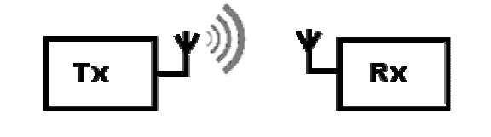

**Figure 1.2 SISO systems**

**1.3. MIMO-SIMO**

The SIMO or Single Input Multiple Output comprises of a transmitter having a single antenna and the receiver having multiple ones, known as receive diversity. It is often used to enable a receiver system that receives signals from a number of independent sources to combat the effects of fading. It has been in constant use with short wave listening/receiving stations to combat the effects of ionospheric fading and interference.

SIMO has got an ease of implementation with some limitations due to required processing in the receiver. The use can be acceptable in many applications, but where the receiver is located in a mobile device such as a cellphone handset, the levels of processing may be limited by size, cost and battery drain.

Two forms of SIMO have been in constant applications:

* ***Switched diversity SIMO:*** This form of SIMO looks for the strongest signal and switches to that antenna.
* ***Maximum ratio combining SIMO***: This form of SIMO sums up both the signals to give the combination. As resultant the signals from both the antennas contribute to the overall signal.

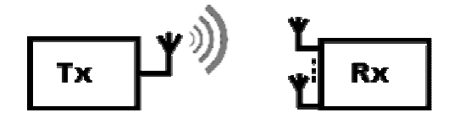

**Figure 1.3 SIMO system**

**1.4 MIMO-MISO**

Multiple input single Output (MISO) can also be termed as transmit diversity, quite opposite to MIMO-SISO being a receiver transmit. In this case, date is transmitted redundantly from the two transmitter antennas. The receiver is able to receive the optimum signal which it can then use to receive extract the required data.

MISO broads its advantage by the application of multiple antennas and the redundancy coding / processing is moved from the receiver to the transmitter. In instances such as cellphones UEs, there can be a significant advantage in terms of space for the antennas and the reducing the level of processing required in the receiver for the redundancy coding. This results into a positive impact on size, cost and battery life as the lower level of processing requiring less battery consumption.

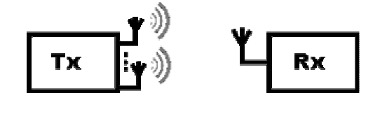

**Figure 1.4 MISO Systems**

**1.5 MIMO**

MIMO is an effective radio antenna technology that uses multiple antennas at the transmitter and the receiver to enable multiple signal paths to be used. One of the leading ideas behind MIMO wireless systems is space-time signal processing in which time is being implemented with the spatial dimension inherent in the use of multiple spatially distributed antennas that have been used for many years to improve wireless.

The signal takes various paths between a transmitter and a receiver. This can be observed from moving the antennas even a small distance .The variety of paths available occurs as a result of the number of objects that appear to the side or even in the direct path between the transmitter and the receiver. These multiple paths led to the introduction of interference. By the use of MIMO, these additional paths can be used to advantage. They can be used for additional of robustness to the radio link by improving the SNR, or by increasing the link data capacity.

The two main formats for MIMO:

***Spatial diversity:*** It is often referred to transmit and receive diversity. These provide improvement in the SNR and are characterized by an improvement in the reliability of the system with respect to various forms of fading.

***Spatial Multiplexing:*** It provides an additional data capacity by utilizing the different paths to carry additional traffic i.e. increases in data throughput capability.

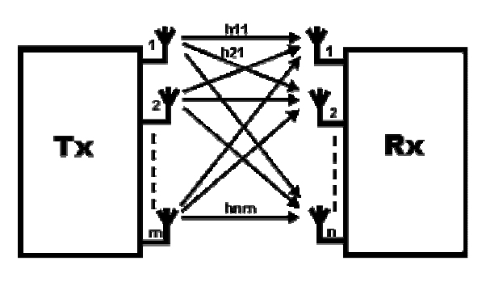

**Figure 1.5 MIMO system**

**1.6 Benefits of MIMO**

* ***Multiple antenna configurations overcome the detrimental effects of multi-path and fading in order to achieve high data throughput in limited-bandwidth channels.***

MIMO antenna systems have constantly been in use in modern wireless communication standards. The technique supports enhanced data throughput under interference, multi path and fading. Higher data rates over longer distances motivated the development of MIMO-OFDM communication systems.

* ***Superior Data Rates, Range and Reliability***

Systems’ having multiple antennas at the transmitter and receiver offers superior data dates, range and reliability without any additional bandwidth or transmit power. MIMO create multiple independent channels for sending multiple data streams, by using several antennas at both the transmitter and receiver.

4X4 MIMO system supports up to four independent data streams. These streams are combined though dynamic digital beamforming and MIMO receiver processing resulting in increased reliability and range.

The number of independent channels and associated data streams that can be supported over a MIMO channel is equivalent to the minimum number of antennas at the transmitter or receiver.

CHAPTER 2

Theory of MIMO SYSTEM

**2.1 RAYLEIGH FADING**

Rayleigh fading is a statistical model that describe the effect that propagation environment has on the radio signal. It is assumed that the fading of the signal that has passed through such a medium will be according to the Rayleigh distribution. This model is most applicable in cases where there is no dominant propagation along a LOS between transmitter and receiver. The model describes a situation in which there are many objects in the environment that scatter the radio signal before it arrives at the receiver. According to the Central Limit Theorem that holds here, if there is enough scattering the channel impulse response will be a well modeled Gaussian process irrespective of the distribution of the individual components. In the case when there is no dominant component to the scatter process will have zero [mean](https://en.wikipedia.org/wiki/Arithmetic_mean) and phase [evenly distributed](https://en.wikipedia.org/wiki/Uniform_distribution_(continuous)) between 0 and 2π [radians](https://en.wikipedia.org/wiki/Radian). In such a case the envelope of the channel response will be Rayleigh distributed.

If R represents a random variable then the probability distribution function is

, r≥0

Where =E(R2).

In Rayleigh fading, it is assumed that the real and imaginary responses are modelled by independent identity distributed zero-mean Gaussian processes. Hence the amplitude of the response is the sum of two such processes.

* 1. **SHANNON CAPACITY FORMULA**

Shannon’s capacity formula provides theoretically the maximum achievable transmission rate for a given channel with bandwidth B, transmitted signal power P and single side noise spectrum No ,based on the assumption that the channel is white Gaussian (fading and interference effects are not considered explicitly).

In general practice, this is considered to be a SISO scenario and it gives an upper limit for the achieved error-free SISO transmission rate. If the transmission rate obtained is less than C bits/sec(bps), then an appropriate coding scheme is there that could lead to reliable and error-free transmission. On the other hand, if the transmission rate is less than C bps, it will involve bit errors.

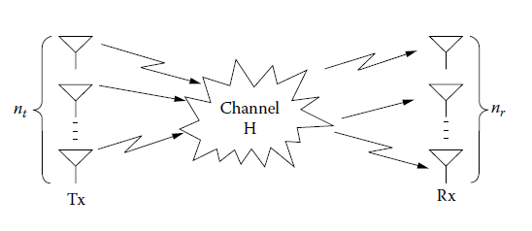

**Figure 2.1 : The MIMO Channel**

* 1. **Extended Capacity Formula for MIMO Channels**

For multiple antennas at both the receiver and the transmitter ends, the channel exhibits multiple inputs and multiple outputs or simply MIMO, its capacity can be estimated by the extended Shannon’s capacity formula.

* 1. **General Capacity Formula**

Considering an antenna array with *nt* elements at the transmitter and an antenna array with *n*r elements at the receiver. The impulse response of the channel between the *j*th transmitter element and the *i*th receiver element is denoted as *hi,j()*. The MIMO channel can then be described by the *nr x nt* H() matrix:

H()=

The matrix elements are complex numbers that correspond to the attenuation and phase shift that the wireless channel introduces to the signal reaching the receiver with delay. The input-output notation of the MIMO system can now be expressed by the following equation:

*y(t)=* H() s(*t*) + u(*t*)

where denotes convolution, s(*t*) is a *n*t X 1 vector corresponding to the *nt* transmitted signals, y(*t*) is a *n*t X 1 vector corresponding to the *nr* received signals and u(*t*) is the additive white noise.

If it is assumed that the transmitted signal bandwidth is narrow enough that the channel response can be treated as flat across frequency, and then the discrete-time description corresponding to above equation is

The capacity of a MIMO channel can be estimated by the following equation:

Where H is the *nr x nt* channel matrix, Rss is the covariance matrix of the transmitted vector s, HHis the transpose conjugative of the Hmatrix and *p* is the maximum normalized transmit power. The above equation is resulted of extended theoretical calculations, and its practical use is not obvious.

* 1. **No CSI at the Transmitter**

The achieved capacity depends on the algorithm used for allocating power to each sub-channel. The theoretical analysis assumes the channel state is known at the receiver. This assumption is correct since the tracking methods are usually performed by the receiver in order to obtain CSI, however same consideration does not stand for the transmitter.

When the channel is unknown to the transmitter, the transmitting signal **s** is chosen to be statistically non-preferential, which implies that the *nt* components of the transmitted signal are independent and equi-powered at the transmit antennas. Hence, the power allocated to each of the *nt* subchannels is pk=p/*nt* . which gives :

Or

**2.6 CSI at the Transmitter**

The CSI is mostly unavailable at the transmitter. In order for the transmitter to obtain the CSI, two methods are used:

1. Feedback
2. Reciprocity principle

In the first one, forward channel is calculated by the receiver and information is sent back to the transmitter through the reverse channel. If the channel is changing fast then it does not function properly. In order for the transmitter to get the right CSI, more frequent estimation and feedback are needed. As a result the overhead for the reverse channel becomes prohibitive.

In the second one, the forward and reverse channels are identical when the time, frequency and antenna locations are the same. Based on this principle the transmitter may use the CSI obtained by the reverse link for the forward link. But it has got its limitation when frequency duplex schemes are employed.

* 1. **Capacity of SIMO-MISO Channels**

For a SIMO channel *nt* =1 ,so *n=min(nr ,nt)* =1; hence , the CSI at the transmitter does not affect the SIMO channel capacity:

If we consider|*hi*|2=1 and then =*nr. Hence the equation is*

For a MISO channel and *n=min(nr ,nt)* =1. With no CSI at the transmitter, the capacity formula can be expressed as:

If we consider|*hi*|2=1 and then =*nr. Hence the equation is*

Comparing above two equations we can have *CSIMO > CMISO* . This is because the transmitter , as opposed to the receiver cannot exploit the antenna array gain since it has no CSI and , as a result, cannot retrieve the receiver’s direction.

* 1. **Capacity of a MIMO channel using the singular Values of the Channel Matrix H**

Can be converted into

as follows:

According to singular value decomposition

H=UDVH

**D** is a diagonal matrix with elements the singular values of **H.** The singular values of a complex matrix are always non-negative and equal to the square root of the eigenvalues of the positive semi-hermitian matrix **HH**H. Let be the *k*th singular value of **H**, hence , will be the *k*th eigenvalue of **HHH**. the above equation can be transformed into:

HHH = UDVH.( UDVH)H=UD2UH

We replaceAbove equation in the first one we have

**2.8 Signal Transmission in a Slow Fading Frequency Nonselective MIMO Channel**

Assuming that there are NT transmitting and NR receiving antennas, a block of the NT

Symbols undergo serial to parallel conversion and each symbol is fed to one of the NT identical modulators, where each modulator is connected to a spatially separate antenna. Hence, the NT symbols are parallel transmitted and received on NR spatially separated receiving antennas. It is assumed that each antenna undergoes frequency nonselective Rayleigh fading and that the NT transmitting antennas and NR receiving antennas are synchronous. Therefore, the received signals at the receiving antennas in a signaling interval can be represented as:

Where gT(t)is the pulse shape of the modulation filters, hmn is the complex-valued zero-mean Gaussian channel gain between the *n*th transmitting antenna and the *m*th receiving antenna, sn ­is the symbol transmitted on the *n*th antenna , and zm(t) is a sample function of an AWGN noise process. The channel gains hmn are modeled as identically distributed and statistically independent from channel to channel. The Gaussian sample functions Zm(t) are assumed to be identically distributed and mutually statistically independent, each having zero mean and two sided power spectral density No/2. The information symbols sn are drawn from either a binary or M-ary PSK or QAM signal constellation.

The output for the demodulator is sampled at the end of the each symbol interval and at each of the Nr receiving antennas there is a matched filter gT(t). The output of the demodulator corresponding to the mth receiving antenna can be represented as,

, where the energy of the signal pulse gT(t) is normalized to unity and m is the additive

Gaussian noise component. The N R soft outputs from the demodulators are passed to

the signal detector. The above equation can be expressed in matrix form as

*y=Hs+*

wherey = [y1,y2 . .,. yNR]t , s = [s1,S2, . .,. SNy]t, = [ 1, 2 ,… , NR]t and H is

the NR x NT matrix of channel gains. The below figure illustrates the process:

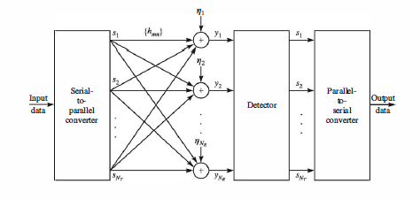

**Figure 2.2 Discrete-time model of the communication system with multiple transmit**

**and receive antennas in frequency nonselective slow fading channel**

**2.9 DETECTION OF DATA SYMBOLS IN A MIMO SYSTEM**

Based on the frequency nonselective MIMO channel two different detectors for recovering the transmitted data signals are considered and their performance is evaluated for Rayleigh fading and additive white Gaussian noise. It is assumed that the elements of the channel matrix H are known to the receiver. The detection schemes are:

1. ***Maximum-likelihood Detector (MLD); and***
2. ***Minimum Mean Square Error Detector***

***Maximum-likelihood Detector (MLD):***  The MLD work by minimizing the probability of error. The additive noise term at NR receiving antennas are statistically independent and identically distributed (i.i.d.), zero-mean Gaussian, the joint conditional PDF p (yls) is Gaussian. Hence the MLD selects the symbol vector ŝ that minimizes the Euclidean distance metric

***Minimum Mean Square Error Detector (MMSE):*** The received signals {*ym ,1≤m≤NR*} are linearly combined by the MMSE detector to for an estimate of the transmitted symbols. This is expressed in matrix form as

Ŝ=WHy

where W is an NR x NT weighting matrix, which is selected to minimize the mean square error

*J(W)* is minimized to obtain the solution for optimum weight vectors w1,w2,…,wNT as

where Ryy = E[yyH] = HRssHH +Nol is the (NR x NR) autocorrelation matrix of the received signal vector y, Rss = E[ssH], = E[] and E[] = Nol. If the signal vector has uncorrelated, zero-mean components, Rss is a diagonal matrix. Each of the components of the estimate Ŝ is quantized to the closest transmitted symbol value.

CHAPTER 3

Orthogonal Frequency Division Multiplexing

3. **OFDM**

**3.1 Introduction to OFDM**

OFDM is a popular modulation technique. It is becoming more and more popular in the telecommunication world. It is a multicarrier modulation technique. In other words, it uses multiple narrow band subcarriers to carry information. A single high data stream is broken down into low data streams and is modulated using subcarriers. Which are orthogonal to one another. The carriers are made orthogonal by choosing the spacing between them with care. The spacing between the carriers is the reciprocal of the symbol period.

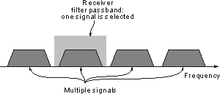

**Figure 3.1 Traditional view of receiving signals carrying modulation**

**3.1.1 ADVANTAGES OF OFDM**

The reason OFDM had become so popular is that it has many advantages over other schemes. Some of the advantages of using OFDM are:

* *Immunity to selective fading*: The major advantage of OFDM is that compared to single carrier systems, it is more resistant to frequency selective fading. This is because it the overall channel is divided into multiple narrowband signals that are affected individually as flat fading sub-channels.
* *More immune to interference*: Interference that will appear on the channel will not affect all sub-carriers as it is bandwidth limited. Hence, not all the data will be lost.
* Spectrum efficiency: As OFDM uses multiple sub-carriers; it makes efficient use of the bandwidth.
* Resilient to ISI: The low data rate of OFDM makes it fairy resistant to inter-symbol and interference.
* Simpler channel equalization: As OFDM uses multiple sub-carriers; the channel equalization becomes much simpler.

**3.1.2 DISADVANTAGE OF OFDM**

Despite its many advantage, OFDM also has some disadvantages. Such as:

* High peak to average power ratio: An OFDM signal has a relatively high peak to average power ratio and noise like amplitude variation This affects the RF amplifier efficiency as the amplifiers need to be linear and accommodate the large amplitude variations and these factors mean the amplifier cannot operate with a high efficiency level.
* Sensitive to carrier offset and drift: Another disadvantage of OFDM is that is sensitive to carrier frequency offset and drift. Single carrier systems are less sensitive to such things.

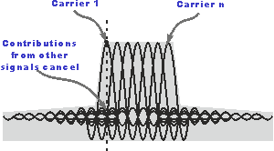

**Figure 3.2 OFDM Spectrum**

**3.1.3 Types of OFDM**

**COFDM:** Coded orthogonal frequency division multiplexing includes error correction coding being incorporated into the signal.

**Flash OFDM:** It uses multiple tones and fast hopping to spread signals over a given spectrum band.

**OFDMA:** Orthogonal frequency division multiple access provides multiple access capability for applications i.e. cellular telecommunications when using OFDM technologies.

**VOFDM:** Vector OFDM uses the MIMO technology.

**WOFDM:**  Wideband OFDM uses a degree of spacing between the channels that is large enough that any frequency errors between transmitter and receiver do not affect the performance.

**3.2 OFDM Transmission Scheme**

Orthogonal frequency division multiplexing (OFDM) transmission is another kind of a multichannel framework, which is like the FMT transmission, as in, it utilizes various subcarriers. It doesn't utilize individual bandlimited channels and oscillators for each subchannel and moreover, the spectra of subcarriers made to overlap for bandwidth efficiency, as opposed to the FMT scheme, where the wideband is completely partitioned into N orthogonal narrowband subchannels. By generalizing the single-carrier Nyquist criterion, the various orthogonal subcarrier signals, which are overlapped in spectrum, can be created. DFT and IDFT processes are useful for the implementation of the orthogonal signals. DFT and IDFT can be implemented easily by FFT and IFFT, respectively. When it comes to OFDM transmission system, N-point IFFT is taken or the transmitted symbols, so as to generate, the samples for the sum of N orthogonal subcarrier signals.

Being time limited, each subcarrier signal for each symbol, an OFDM signal may incur out-of-band radiation, which causes non-negligible adjacent channel interference (ACI). Hence, OFDM scheme inserts a guard band at outer subcarriers, called virtual carriers (VC), around the frequency band to reduce the out-of-band radiation. OFDM also inserts a guard interval in the time domain, called cyclic prefix (CP), which reduces the inter-symbol interference (ISI) between OFDM symbols.

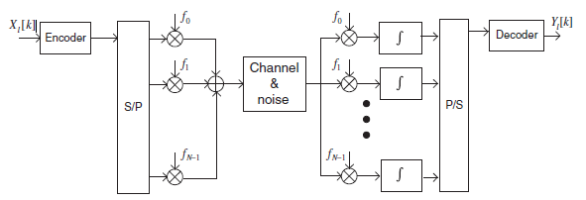

**Figure 3.3 (a) Outline of OFDM transmission scheme**

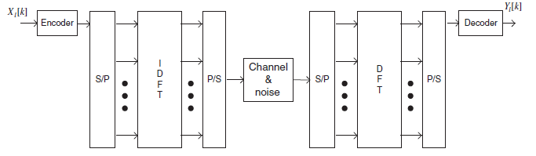

**Figure 3.3 (b)** **OFDM transmission scheme implemented using IDFT/DFT**

**3.3 OFDM MODULATION AND DEMODULATION**

With the help of OFDM transmitter ,the message bits are mapped into a sequence of PSK or QAM symbols which will then be converted into N –parallel streams. Each of N symbols from serial-to-parallel (S/P) conversion is carried out by the different subcarrier. Let (k) represent the lth transmit symbol at the kth subcarrier, l = 0, 1, 2 …∞, k = 0,1,2..., N-1. This S/P conversion extends the duration of transmission time for N symbols to NTs , which forms a single OFDM symbol with a length of Tsym (i.e., Tsym =NTs). Let Ψl,k (t) denote the *l*th OFDM signal at the *k*th subcarrier, which is given as

Ψl,k (t)=

Then the passband and baseband OFDM signals in the continuous-time domain can be expressed as

And

If we sample the continuous time baseband OFDM signal in above equation at t=*lTsym + nTs, with Ts =Tsym/N and fk = k/Tsym,* to yield the corresponding discrete-time OFDM symbol as



The above equation turns out to be the N-point IDFT of PSK or QAM data symbols and can be efficiently computed by IFFT algorithm.

The received baseband OFDM symbol , lTsym<t≤lTsym + nTs, from which the transmitted symbol *Xl[k]* can be constructed by the orthogonality among the subcarriers as follows:

=

=(k)

Where the effects of channel and noise are not considered. Let be sampled values of the received OFDM symbol at t= l+nTs.Then, the integration in the modulation process of the above equation can be represented in the discrete time as follows.

=

== [k]

The above equation is actually in the N-point {} and can be computed using FFT algorithm.

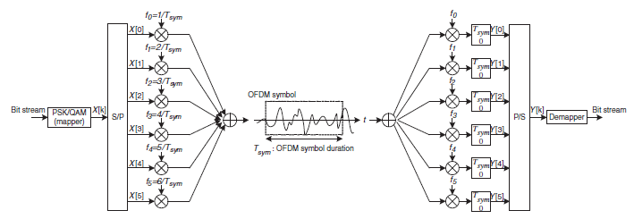

**Figure 3.4 (a) OFDM modulation/demodulation**

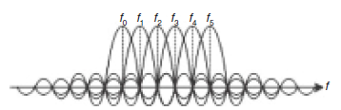

**Figure 3.4(b) Realization of subcarrier orthogonality**

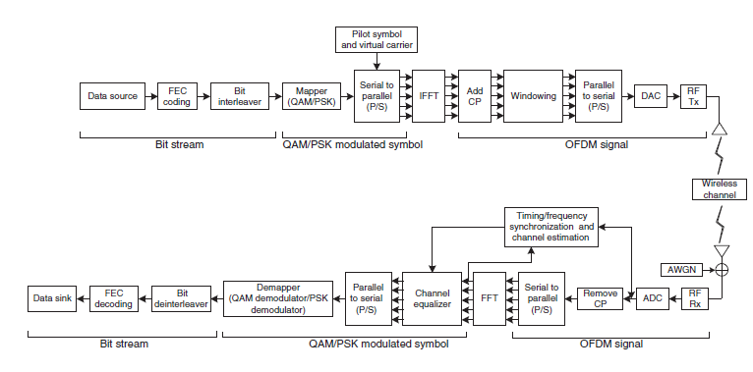

**Figure 3.4 (c) Block diagram of transmitter and receiver in an OFDM system.**

CHAPTER 4

MIMO-OFDM

* 1. **Introduction**

Multiple-input multiple-output orthogonal frequency-division multiplexing (MIMO OFDM) is a combination of MIMO technology, which increase the capacity by transmission over multiple antennas, and orthogonal frequency division multiplexing, which divides the radio channel into large number of narrow-band closely spaced subcarriers, which provides more reliable communication at high speeds. MIMO can also be combined with popular air-interfaces such as time division multiple access (TDMA) or code division multiple access (CDMA). However, MIMO-OFDM is better for higher data rates.

As MIMO-OFDM achieves great spectral efficiency, delivering the high data capacity and throughput, it is considered as the foundation for the most advanced wireless local area network ( wireless LAN) and mobile broadband network standard.

MIMO exploits multipath propagation by having several versions of the same signal reach the receiver, thereby, reducing the chances of error and fading as there are multiple copies of the same signal to choose from. MIMO also increases capacity by transmitting multiple signals over multiple, co-located antennas, and this is done without using additional power or bandwidth. With the help of space-time codes, it is ensured that the signals transmitted over different antennas are orthogonal to each other, which makes it easier for the receiver to distinguish them. With the use of OFDM one of the biggest hurdles of broadband communication-intersymbol interference (ISI), can be eliminated. When the overlap between consecutive symbols is large with respect to the duration, ISI occurs. Mostly, higher data rates require shorter duration of symbols, which in turn increases the risk of ISI. OFDM divides a higher data rate stream into several low-data streams. With the use of cyclic prefix (CP) to create a guard interval between symbols, ISI may be eliminates entirely.

**4.2 Performance Gains In MIMO Systems.**

The utilization of multiple antennas at both ends of the radio link leads to spatial multiplexing gain, which is responsible for the increase in spectral efficiency. Due to spatial multiplexing there is a linear capacity increase, without the use of any additional power or bandwidth. With the use of the difference in the spatial signature induced by the MIMO channel into the multiplexed data stream in the same frequency band, the receiver separates the different signals, and thereby, realizes the capacity gain.

The diversity available in MIMO channels leads to an improvement in link reliability by reducing the fading and increasing the robustness to co-channel interference. In order to get diversity gain, the data signal is transmitted over multiple independent fading dimensions in time, frequency and space. When compared to time or frequency diversity, spatial diversity is particularly attractive. This is because there is no extra expenditure of in transmission time or bandwidth. With the use of space-time coding spatial diversity gain can be realized without requiring extra knowledge at transmitter.

The array gain may be obtained at both the transmitter and receiver. Here, the channel knowledge for coherent combining is required, which leads to an increase in signal-to-noise ratio (SNR) and improved coverage. Also, multiple antennas at both ends of the link leads to reduction of co-channel interference, which in-turn results in an improvement of cellular capacity.

**4.3 Spatial multiplexing in MIMO OFDM systems**

In MIMO OFDM systems, spatial multiplexing is performed by transmitting independent data streams on a tone-by-tone basis and having the transmit power split uniformly across antennas and tones. The use of OFDM eliminates ISI, but the computational complexity of the receiver is high, as there are 48 to 1728 number of data-carrying tones and spatial separation has to be performed for each. The complexity can be reduced by using some algorithms that exploit the fact that the matrix-valued transfer function in a MIMO-OFDM system is “smooth” across tones as the delay spread in the channel is limited. This can be done by performing channel inversion in the case of a minimum mean-squared error (MMSE) receiver, or QR decomposition in a sphere decoder (or a successive cancellation receiver) on a subset of tones only and computing the remaining inverses or QR factors, respectively, through interpolation. A maximum of 50 per cent reduction in complexity can be obtained.

**4.4 Non coherent MIMO-OFDM systems.**

When CSI is available at the receiver but not at the transmitter, and a fixed amount of transmit power is available, the capacity increases with bandwidth until saturating and being given by the receive SNR. However, in non-coherent systems, where the CSI is unavailable at both the transmitter and the receiver, the capacity behavior as a function of bandwidth is different. When considering full-bad OFDM systems, beyond a critical bandwidth, the capacity goes to zero. This is called overspreading and it occurs because with the increase in bandwidth, a proportional increase in the number of independent frequency-diversity branches occurs. The receiver does not have the CSI so these diversity branches contribute to “channel uncertainty”, resulting in a capacity penalty. For large bandwidths which have small SNR per degree of freedom, this penalty eventually drives the capacity to zero. In MIMO systems, with an increase in the number of transmit and receive antennas, an increase in the total number of degrees of freedom for communication occurs. However, an increase in the channel uncertainty also occurs. Additionally, increasing the number of transmit antennas will results in a smaller SNR per degree of freedom, as the total available transmit power is split uniformly across transmit antennas, leading to the existence of a finite optimum (in the sense of capacity maximizing) number of transmit antennas. On the other hand, increasing the number of receive antennas leads to an increase in the receive SNR and is, therefore, always beneficial.

**4.5 SPACE FFREQUENCY CODING IN MIMO OFDM SYSTEMS**

The basic function of spatial multiplexing is to increase spectral efficiency by transmitting independent data streams, the space time coding aims to introduce redundancy across space and time to realize spatial diversity gain without CSI at transmitter.

Two sources of diversity can be observed in frequency selective fading MIMO channels:

1. Frequency diversity
2. Spatial diversity

By simple application of space –time code to code across space and frequency can be shown to yield spatial diversity gain only. Space frequency diversity can be realized by the combination of this approach and forward error correction coding and interleaving across tones; bit-interleaved coded modulation is observed to be employed by most practical systems. However the problem can be solved in a more systematic manner through space frequency codes that spread the data symbols across the space and frequency, i.e., coding being performed on one OFDM symbol and not across OFDM symbols. The resultant codes differ significantly from those for the flat fading, when presence of ISI is considered explicitly. In coherent cases low correlation between shifted versions of the transmitted signals is required, in addition to the properties required in the flat fading case, because of ISI, due to the receiver having perfect CSI. In the non-coherent case the receiver learns the channel because of a good code. As the opposed to the coherent case, non-coherent space frequency codes that are designed in order to achieve full spatial diversity in frequency flat fading channels can fail completely to exploit both frequency as well as spatial diversity, when used in frequency selective environment.

CHAPTER 5

Results & Discussions

1. **RESULTS AND DSCUSSION**

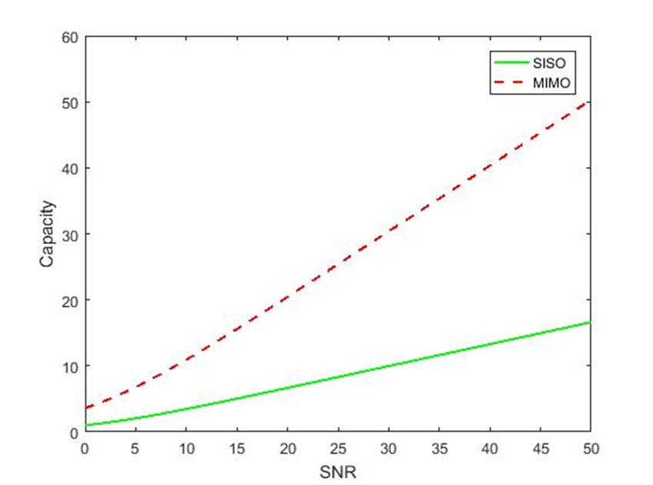

**Figure 5.1: Comparison of capacity of a MIMO and SISO channel by using Shannon’s equation**

The simulation is done using MATLAB R2016a

The channel capacity of 3x3 MIMO system is compared with a SISO system to demonstrate how an increase in the number of antenna significantly improves the throughput. The SVD is used here.

As we can see from the graph the capacity of a MIMO channel is much more than that of a SISO channel. This demonstrates the increase in spectral efficiency obtained by MIMO systems.

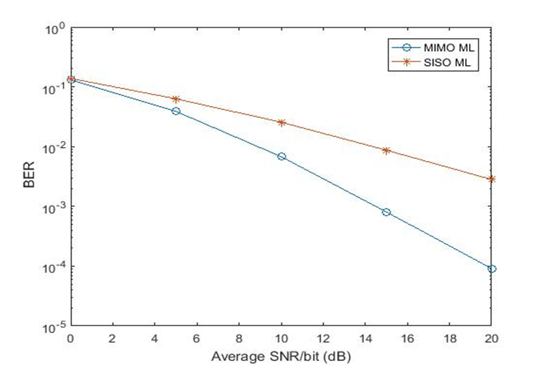

**Figure 5.2: BER comparison of a 2x2 MIMO system with SISO system by using MLD**

Monte Carlo simulation was performed to obtain the bit error rate of a 2x2 MIMO system and SISO system. The detection scheme used is maximum likelihood detection. BPSK modulation is used.

As it can be observed from the graph, the bit error rate performance is increased significantly for a MIMO system. As the SNR value increases, the MIMO system outperforms the SISO system even more. For low SNR values MIMO BER performance is better. The throughput for MIMO systems is also superior

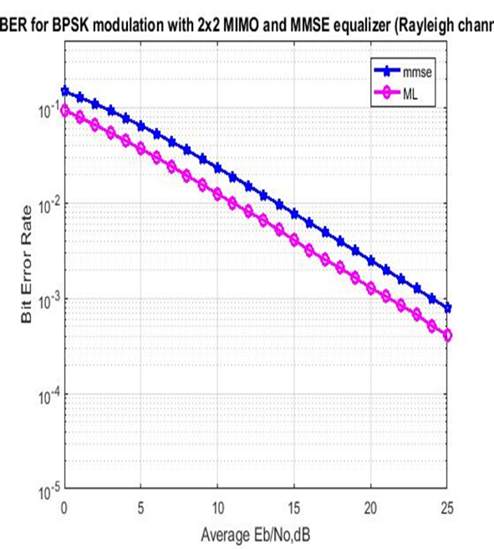

**Figure 5.3: comparison of BER rate when using MLD and MMSE**

The Rayleigh fading model is used. The modulation scheme is BPSK and the number of antennas at the transmitter and receiver is 2.

The graph compares the maximum likelihood detection scheme with the minimum mean square error detection scheme. As we can observe from the graph, the error rate decreases with the SNR. Also, the MIMO system simulated using ML detection has the lowest BER for the given SNR

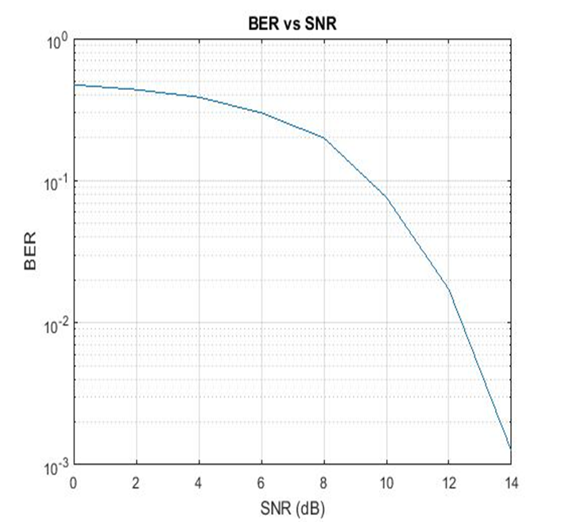

**Figure 5.4: BER performance for OFDM systems.**

The number of sub-carriers is 64 and the modulation scheme is QAM. As it can be observed from the graph, the BER value decreases as the SNR increases. The bit error rate performance for OFDM systems is quite good.

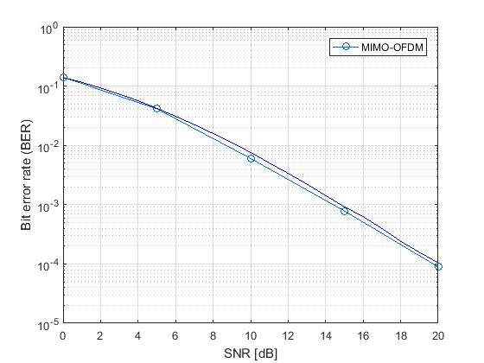

**Figure 5.5: comparison of MIMO OFDM with simple MIMO systems.**

The Rayleigh fading model is used. The modulation scheme is QPSK and the number of sub-carriers is 128. Also the number of transmitter antennas is 2 and receiver is 3. Monte carlo simulation is used.

As it can be seen from the graph, the BER performance of the MIMO_OFDM system is inversely proportional to the SNR. Also the MIMO-OFDM system slightly outperforms the MIMO system.

CHAPTER 6

Conclusion

1. **CONCLUSION**

MIMO systems increase the spectral efficiency of the signal as well as improve the reliability. As the number of antennas at the transmitter and receiver is increases the capacity of the channel and the throughput is also increased. The performance of the MIMO channel can be further improved by combining MIMO with OFDM. OFDM uses multiple sub-carriers and CP to create guard intervals and reduce inter-symbol interference.

Furthermore, more work can be done in the field of MIMO especially for cellular networks. This thesis mostly refers to single-user MIMO but a lot of work is currently being done on multi-user MIMO. For cellular technology, the form of MIMO being used is massive MIMO, which is essentially multi-user MIMO with several base station antennas.

CHAPTER 6

References

*[1] Yong Soo Cho, Jaekwon Kim, Won Young Yang, Chung-Gu Kang*

*MIMO OFDM Wireless Communication with matlab, IEEE Press, John Wiley & Sons (Asia) Pte Ltd, 2 Clementi Loop, # 02-01, Singapore 129809*

*[2] George Tsoulos, MIMO System Technology for Wireless Communication, Taylor and Francs group, London, CRC Press*

*[3] John G.Proakis, Masoud Salehi, Gerhard Bauch, Contemporary Communication Systems using Matlab, cenage learning, 3rd edition, 2011*

*[4] Helmut Bὃlcskei, Eth Zurich, “MIMO-OFDM Wireless Systems: Basics, Perspectives, and Challenges”, IEEE Wireless Communications , August 2006*