

Pagina-einde

Content

[What is zabbix2](bookmark://_Toc40728532" \t "_blank)

[Zabbix Implementation3](bookmark://_Toc40728533" \t "_blank)

[Zabbix Frontend6](bookmark://_Toc40728534" \t "_blank)

[Maak nog duidelijker wat u bedoelt door tekst op te maken10](bookmark://_Toc40728535" \t "_blank)

[Laat ons weten wat u vindt14](bookmark://_Toc40728536" \t "_blank)

Pagina-einde

Welcome to Zabbix

Instructions for implementing zabbix

In this document you will get more information about what zabbix is and how we work with it in our project. You can read about some basic configurations of Zabbix in this document, but it is not just for reading. It is also meant to apply when there is a problem, so you can learn by doing.

In several places in this document there is **bold printed** text, these are commands that have to be executed.

|  |  |
| --- | --- |
| C:\Users\Kenzo\AppData\Local\Microsoft\Windows\INetCache\Content.MSO\F2FBDA9B.tmp | **Time Saver:** Watch the following video if you don't have a lot of time and want to know how it works: [Welcome to Zabbix](https://www.youtube.com/watch?v=yYmkFf3AEBo&t=266s). |

What is zabbix

Zabbix is an open-source application for monitoring servers, applications and their components. Originally the application was intended for internal use at a bank, but in 2001 the software was released as an open source product.

Zabbix consists of a number of parts where the Zabbix Server is the spider in the web. Obtaining and processing the statuses and sending out notifications is all taken care of by the server. With the Zabbix web interface you can configure everything and get insight in the monitoring details on several pages.

The Zabbix Server can perform simple checks itself, such as pinging a host, checking if a certain port is open and checking if a web page contains a certain keyword.

However, if you want more insight you can install the Zabbix Agent (or a SNMP daemon) on the server you want to monitor. After installation and configuration, Zabbix will be able to read a lot of extra information such as information about active processes, bandwidth usage and processor details.

Zabbix Implementation

**It’s best practice to use the command ‘sudo su’ before starting implementation .**

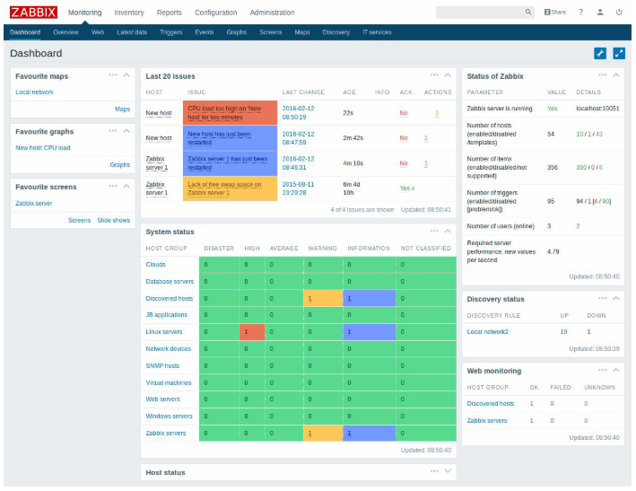

**Probeer het eens:** Selecteer **Bestand** > **Opslaan als**. Selecteer vervolgens OneDrive en geef dit document een naam.

Als u zich op een ander apparaat aanmeldt bij Office 365, staat dit document in uw lijst met recente bestanden. U kunt nu doorgaan waar u gebleven was… zelfs als u het document open hebt laten staan op de computer die u nu gebruikt.

Zabbix Server

Before installing Zabbix first configure Zabbix package repository in your system using following commands. Use commands as per your operating system.

**Install Zabbix repository:**

* **# wget**<https://repo.zabbix.com/zabbix/5.0/ubuntu/pool/main/z/zabbix-release/zabbix-release_5.0-1+focal_all.deb>
* **# dpkg -i zabbix-release\_5.0-1+focal\_all.deb**
* **# apt update**

After adding Zabbix apt repository in your system use following command to install Zabbix server. Here zabbix-server-mysql package includes Zabbix server with MySQL support. The zabbix-frontend-php package provides and web interface is written in PHP for the Zabbix server management.

**Install Zabbix server, frontend:**

* **# apt install zabbix-server-mysql zabbix-frontend-php zabbix-apache-conf zabbix-agent**

Now create a database schema for your Zabbix server. Login to your MySQL server using administrative privileges and use the following queries to create MySQL database and user for the Zabbix server. Also, load the Zabbix database schema to the database created above.

**Create initial database:**

* **# mysql -uroot -p**

password

mysql> create database zabbix character set utf8 collate utf8\_bin;

mysql> create user zabbix@localhost identified by 'password';

mysql> grant all privileges on zabbix.\* to zabbix@'%';

mysql> quit;

* **# zcat /usr/share/doc/zabbix-server-mysql\*/create.sql.gz | mysql -uzabbix -p zabbix**

Edit Zabbix server configuration file /etc/zabbix/zabbix\_server.conf in your favorite text editor and update the following database configurations. This will be used by Zabbix server to connect to the database.

**Configure the database for Zabbix server:**

* DBHost=192.168.117.15
* DBName=zabbix
* DBUser=zabbix
* DBPassword=password

**Configure PHP for Zabbix frontend:**

* **# php\_value date.timezone Europe/Brussels**

Zabbix creates its own apache configuration file /etc/zabbix/apache.conf and make a link to Apache configuration directory. Let’s use the following command to restart Apache service.

**Start Zabbix server and agent processes:**

* **# systemctl restart zabbix-server zabbix-agent apache2**
* **# systemctl enable zabbix-server zabbix-agent apache2**

Zabbix Frontend

Zabbix web installer can be accessed on /zabbix subdirectory URL on your servers IP or domain. For example, www.mydomain.com is pointed to my Zabbix server. Now access the Zabbix using the following URL. You must change FQDN as per your setup.

**Zabbix Setup Welcome Screen:**

* In your browser, open Zabbix URL: http://<server\_ip\_or\_name>/zabbix

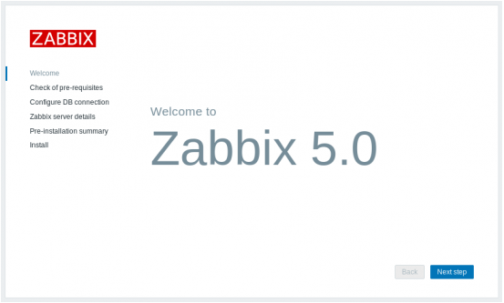

* Make sure that all software prerequisites are met.

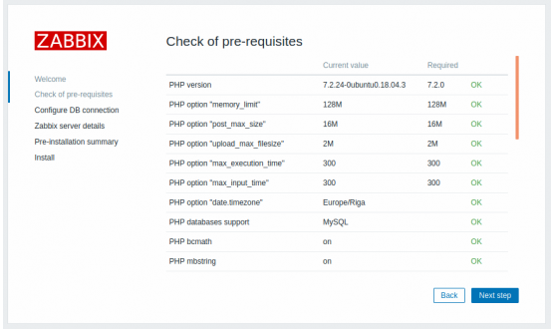

* Enter details for connecting to the database. Zabbix database must already be created.

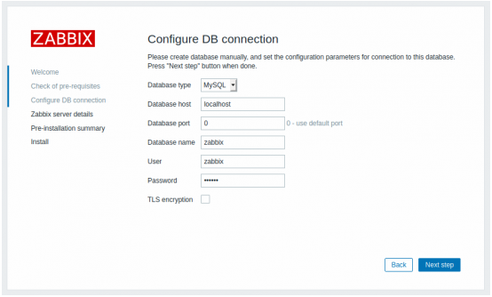

*If the TLS encryption option is checked, then five additional fields for configuring the TLS connection to the database appear in the form (MySQL or PostgreSQL only).*

* Enter Zabbix server details.

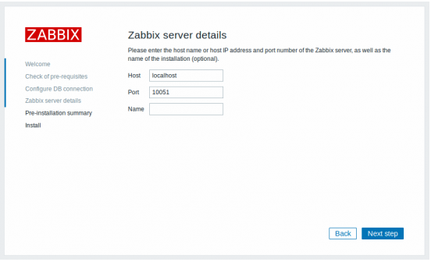

*Entering a name for Zabbix server is optional, however, if submitted, it will be displayed in the menu bar and page titles.*

* Review a summary of settings.

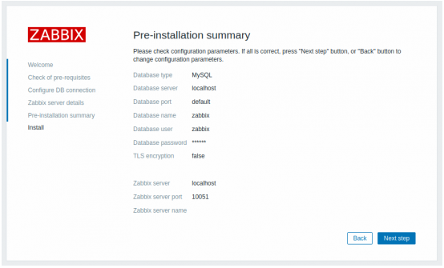

* Finish the installation.

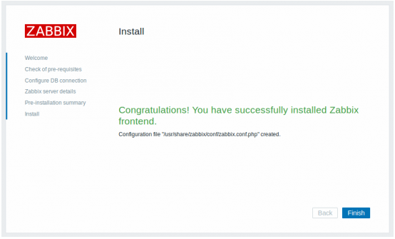

* Zabbix frontend is ready! The default user name is ***Admin***, password ***zabbix***.

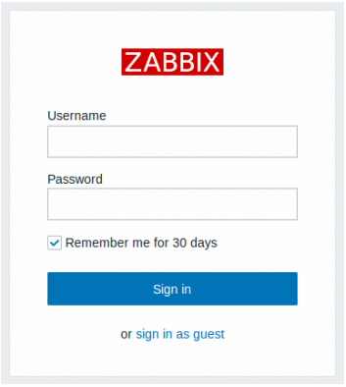

# Adding hosts to zabbix (backend) Linux

If we want tracking to work we need to find a way to add hosts to our Zabbix server. But first we need to give all our VM’s an agent Zabbix version so our server can connect with the agent.

After that we can use Templates so our hosts now what they need to monitor.

All these commando’s are executed in the root so before starting type

**sudo su**

Do know that release numbers may change we are now working with 5.0 the only thing you need to change our the release numbers.

First we need to get the Zabbix repo if you found those we can install our agent on the VM

**Install Zabbix repository:**

**# wget** [**http://repo.zabbix.com/zabbix/5.0/ubuntu/pool/main/z/zabbix-release/zabbix-release\_5.0-1+bionic\_all.deb**](http://repo.zabbix.com/zabbix/5.0/ubuntu/pool/main/z/zabbix-release/zabbix-release_5.0-1+bionic_all.deb)

**# sudo dpkg -i zabbix-release\_5.0-1+bionic\_all.deb**

**# sudo apt-get install Zabbix-agent**

Now go look inside the Zabbix agent config file and go to line 97 and 138 change those IP’s to the IP of the Zabbix server. This step is very important since these are the settings to connect with your server

**Configuring zabbix agent file :**

**# nano /etc/zabbix/zabbix\_agentd.conf**

**Server=172.27.66.127**

**ServerActive=172.27.66.127**

**Hostname=T02Ticketsystem (here you can choose whatever you want)**

We need to restart our agent so he can save the configuration file

**Restart the Zabbix agent:**

**# systemctl restart zabbix-agent**

**# systemctl status Zabbix-agent**

The Zabbix daemon uses port 10050 so we need to allow this port on the firewall

**Allow port 10050 tcp**

**# ufw allow 10050/tcp**

# Adding hosts to zabbix (backend) Windows

**Download the agent:**

[**https://www.zabbix.com/download\_agents/**](https://www.zabbix.com/download_agents/)

**Extract zip file**

Create a new directory on the c: disk to keep it easy make a folder Zabbix on the c: disk but you can also choose your own name

**Make a new directory**

**C:\zabbix\**

**Merge bin and conf file**

**Go to your zip file and copy the bin and conf file to your zabbix folder**

Open the config file from the agent and change the following parameters. This step is very important since these are the settings to connect with your server

**zabbix\_agentd\_win.conf file**

**Server=172.27.66.127 (change it to the IP of the Zabbix server)**

**ServerActive=172.27.66.127 (change it to the IP of the Zabbix server)**

**Hostname=T02Ticketsystem (here you can choose whatever you want)**

Register your agent into windows as a service. Run the following command in PowerShell

**Register the agent**

**C:\zabbix\zabbix\_agentd.exe -c c:\zabbix\zabbix\_agentd.win.conf -i**

Go to windows as a service and click on your Zabbix agent the installation should start .

**Start the installation of your Zabbix agent**

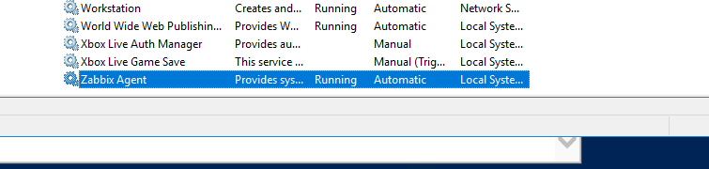

If you want to ping your agent type in the following command in PowerShell

**Enable ICMP**

**netsh advfirewall firewall add rule name=”ICMP Allow incoming V4 echo request” protocol=”icmpv4:8,any” dir=in action=allow**

Since our Zabbix daemon listens to port 10050 we need to open it in order to work

**Open port 10050**

**netsh advfirewall firewall add rule name=”Open Port 10050” dir=in action=allow protocol=TCP Localport=10050**

# Adding hosts to zabbix (frontend)

Now our agent VM’s is ready to go and now it’s time to add them to our host list.

Go to Configuration > Hosts

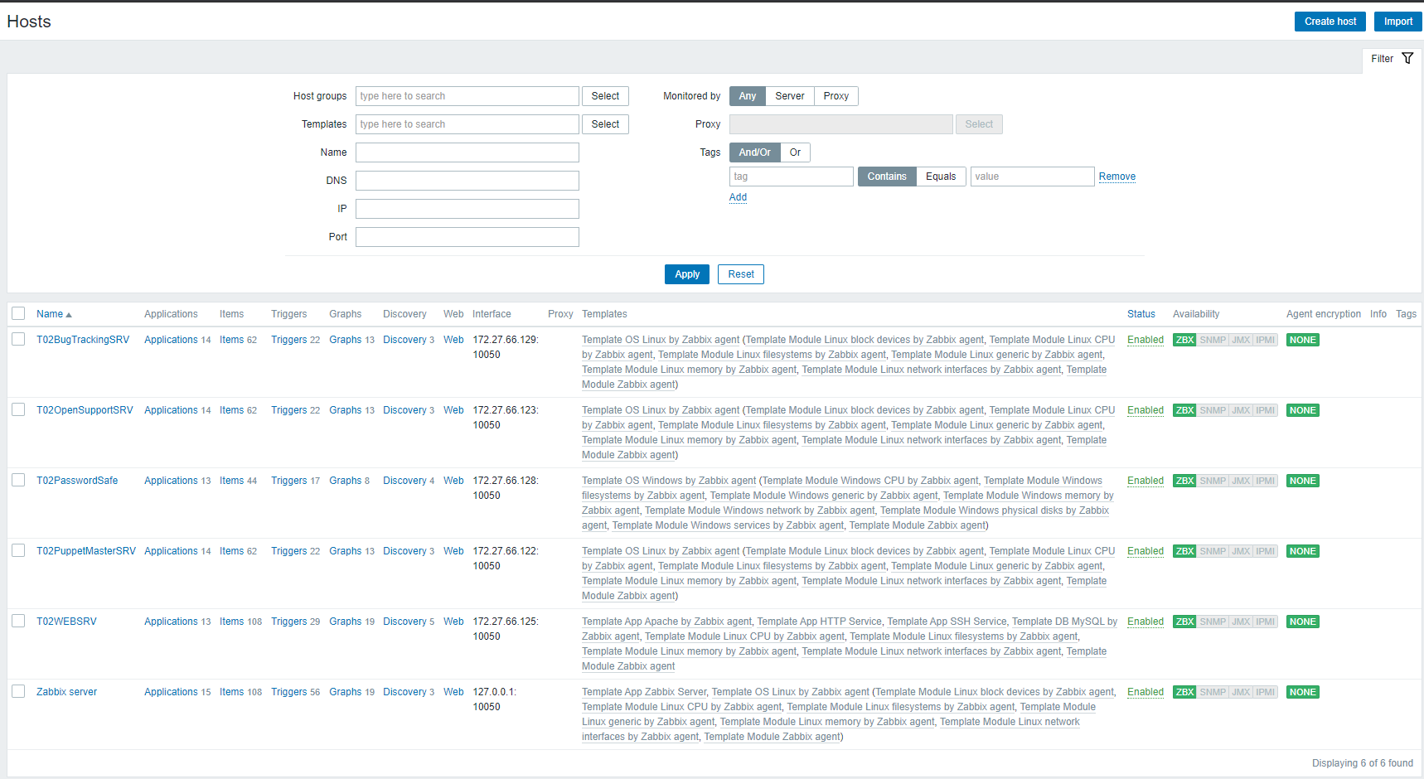

Here you can find all our hosts that we already have configured. If we want to add a new host click Create host in the top right corner.

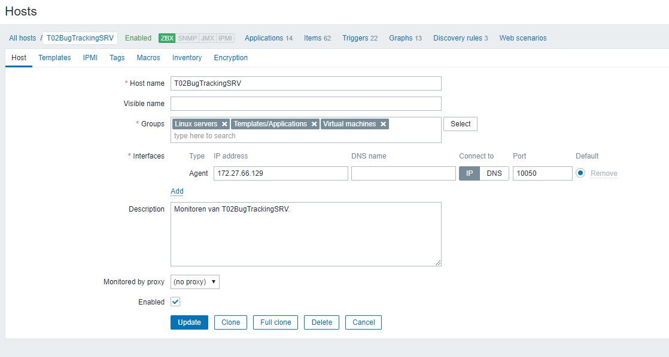

Host name need to be the same name as the host name in the config file of our zabbix agent.

Visible name you can choose a name you want

Groups are just tags so they are not that imortant but try to pick the most logical tags for your VM

Interface here you give the IP of the VM you want to host and port 10050 since the daemon works on port 10050.

You can add a description

Next go to Templates.

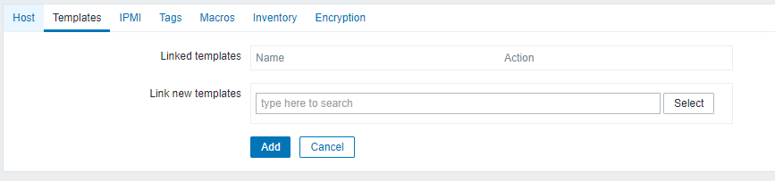

This templates tells our host go find the agent and try to monitor the data of that agent.

Click Select.

Add the Template OS Linux by zabbix agent if you work with Linux

Add the Template OS Windows by zabbix agent if you work with wWndows

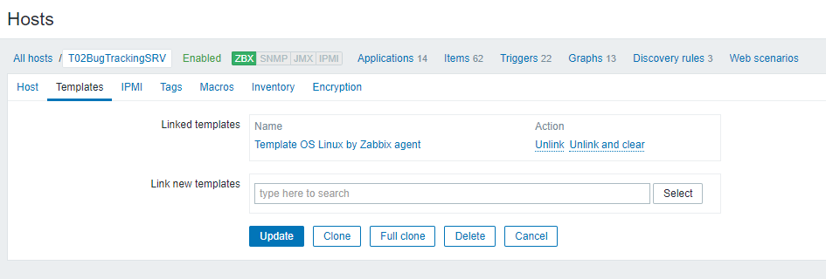

After that click Update and you should see the new host. You may need to wait 5 minutes before he starts monitoring (ZBX in green means he started)



# Monthly metrics

We need to have a way to ‘measure’ our company’s performance.  
This is where Monthly metrics or visualizing is useful. They show you how each VM is doing.  
Each Host has different type of graphs that may be important.

With these value our company can check if there is something going wrong. If there is something wrong they will get a message after 5 minutes, this way they can quickly solve the problem and move on.  
  
We can also use the data to make some improvements for our company. We can for example add more memory to a VM.

If you go to Monitoring > Hosts you will find the collection of all our host that we are currently monitoring.

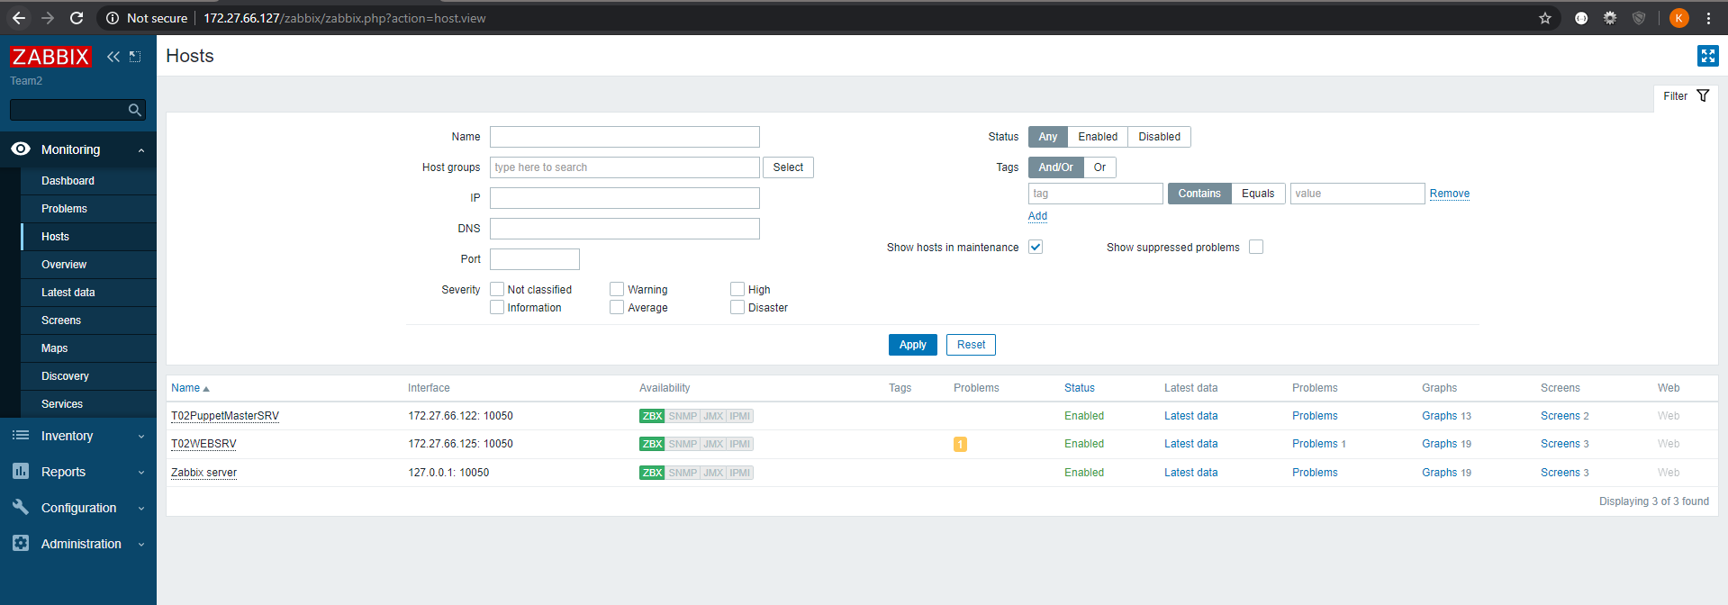

Each VM has the option Graphs. Here you can see all the available graphs for that VM. 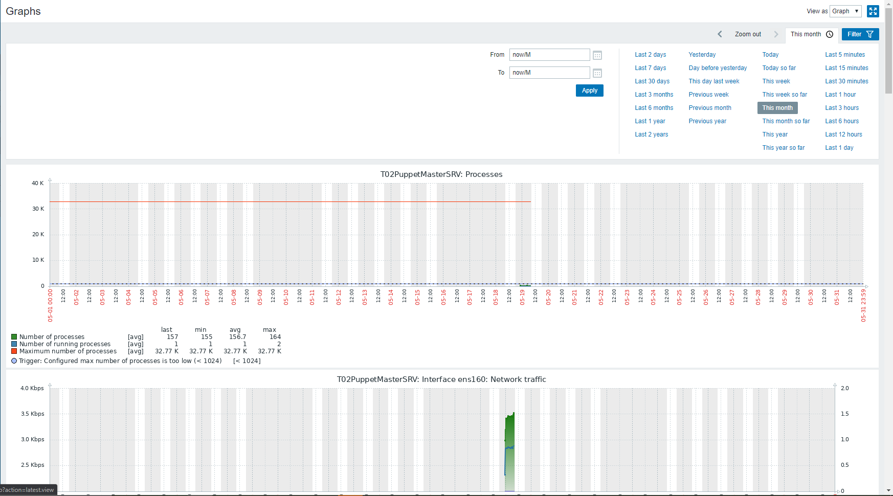

In the top right you can see that we can look at our data in different time frames. If you want to know the monthly metrics it’s best practice to put it on This month.

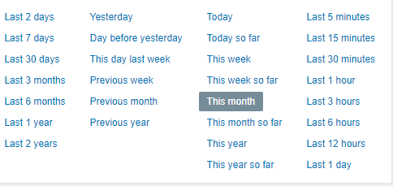

# Screens

We now already know how to look at all the graphs but what if we don’t want all the graphs and want a custom dashboard for our graphs. This is where screens are useful.

If you go to Monitoring > Screens. You will find all our screens.

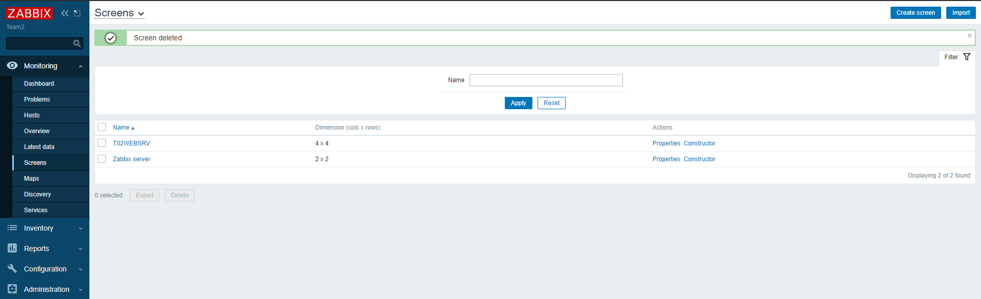

If you want to make your own screen click Create screen in the top right corner



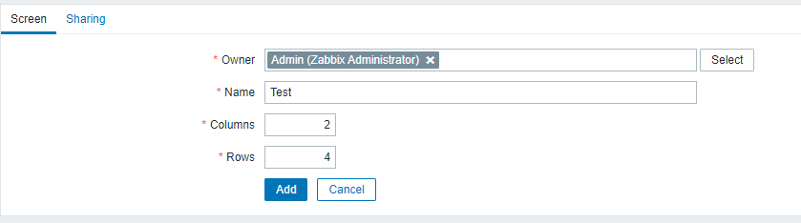

Here you can enter a custom name for your screen

How many columns you want

How many rows you want

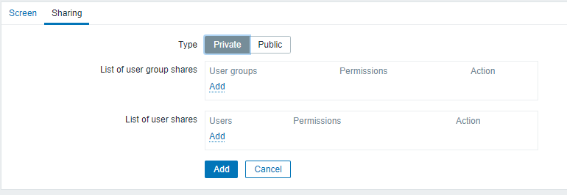

In the sharing tab you can choose the List of user group shares

Click add

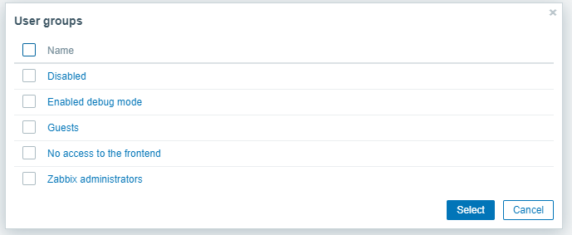

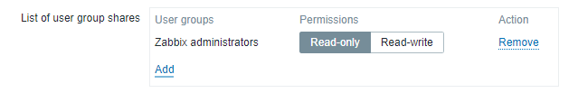

Once added you have the option to give them permissions Read only / Read write

Choose your List of user shares and if you’ve entered it all click Add

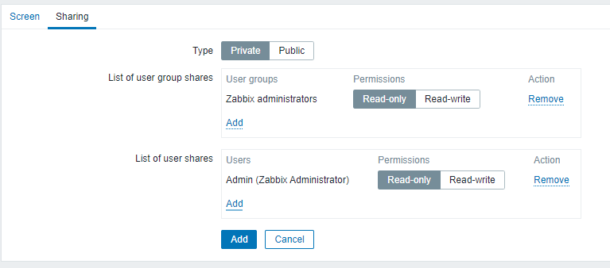

Now it’s time to construct our screen. Click construct on the screen you just made.



Here you can choose which column/row you want to edit first click Change

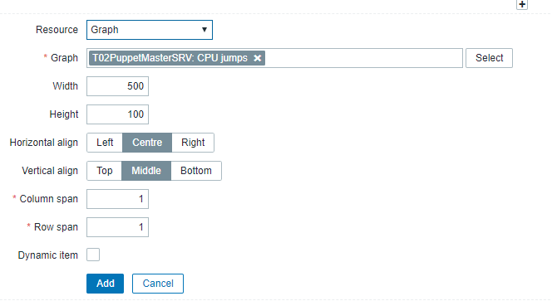

Here you will choose your graph that you want on your dashboard. Click select on the Graph field and select your VM with the graph you need. Fill in all the other option the way you like and click Add

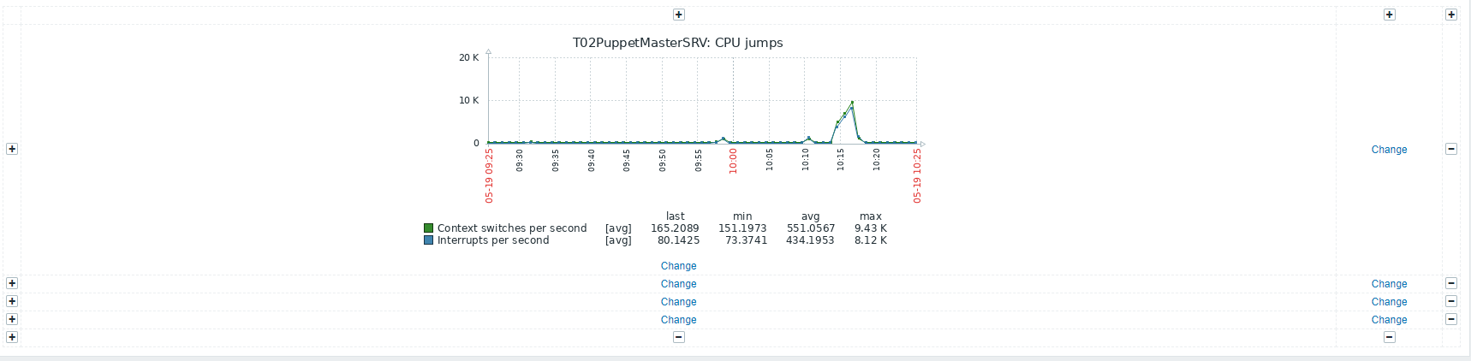

Once added you will find your graph in the screen

# Alerts

Zabbix comes with an alerting tool this means whenever something is going wrong Zabbix can send an alert to the administrators, guest or even a custom email for our team.  
Let’s first create an email where we will collect all our error or warning mails.

Go to Administration > Media types

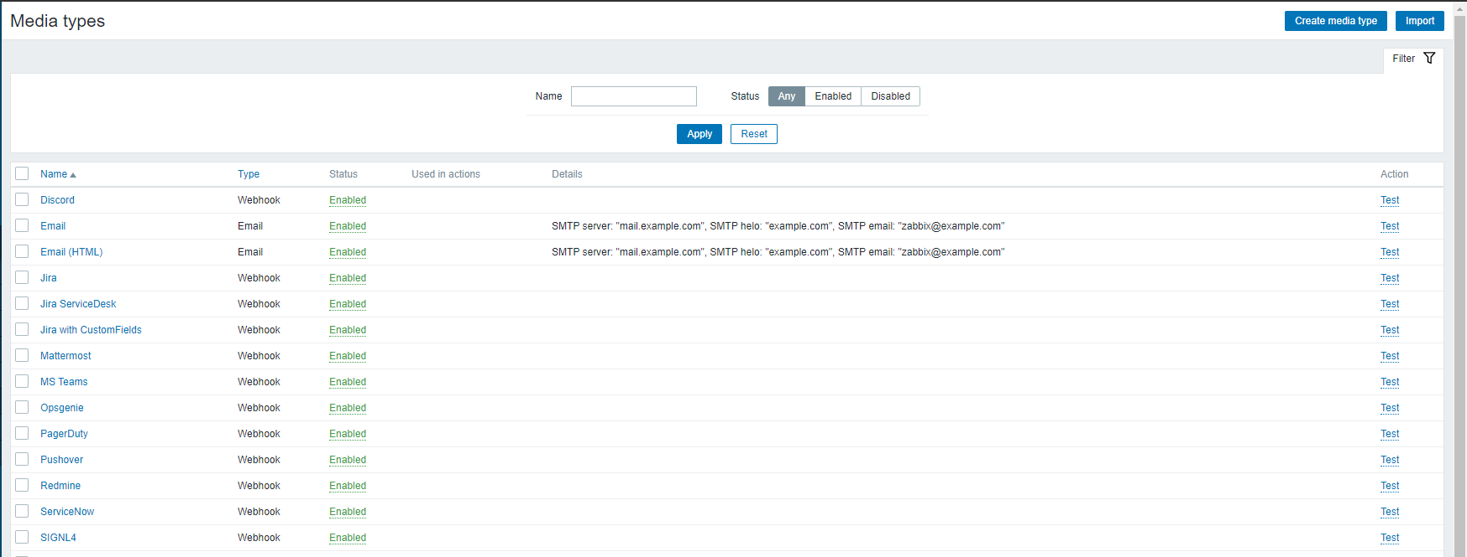

Here you can find all the default premade media types but since we want our mail we need to create a new media type. You can find this option in the top right corner of the screen.



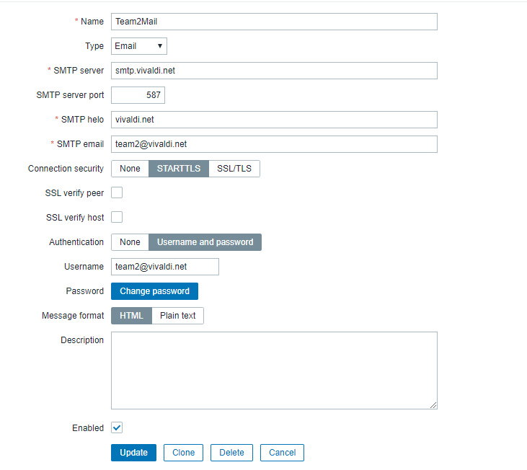

We as a team chose Vivaldi since you don’t need to deactivate different security settings.  
Give your media type a custom name this is up to you.  
The next settings: SMTP server, SMTP server port, SMTP helo are different if you use other mail clients. These are the values for Vivaldi.

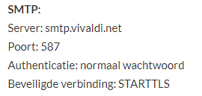

For Authentication choose Username and password and type in the username and password of your mail.

Next we need to add our media to the users. So go to Administration > Users.  
Here you can find all the users/media of our Zabbix server. Now we need to create a new one for our Media type we just made. Click Create user.

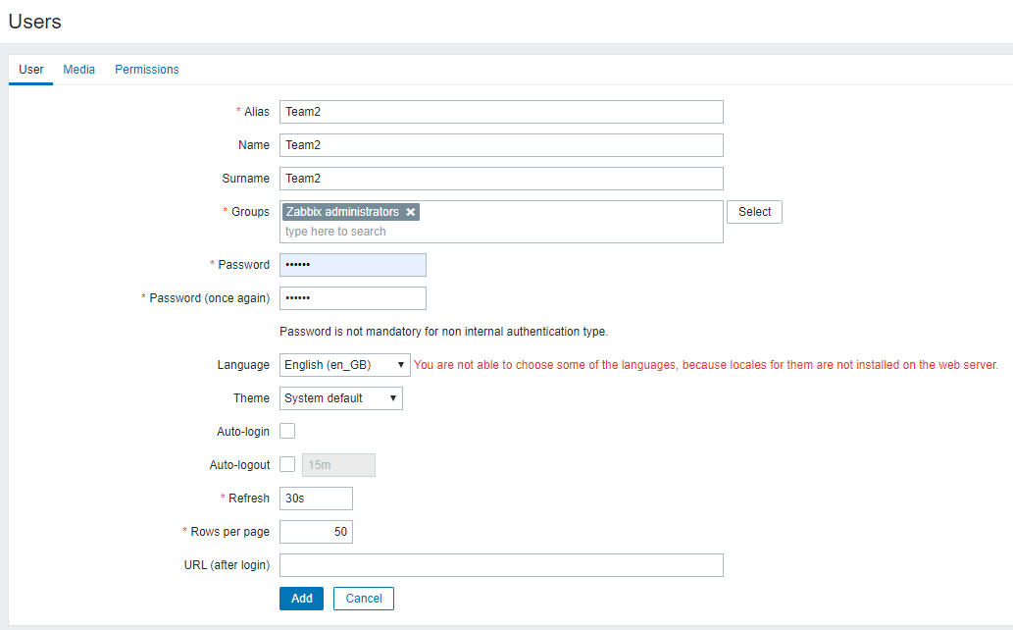

Here you enter your Alias, Name, Surname this is all up to you.  
For Groups Zabbix administrator of course since we want all the permissions as this user.

Choose your own password the following settings can stay the same but if you want to change anything go ahead.

Next step is the Media window

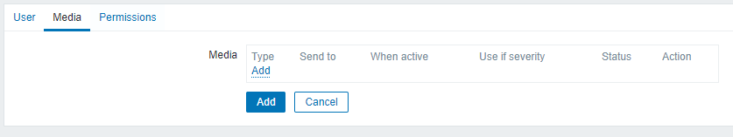

Click Add

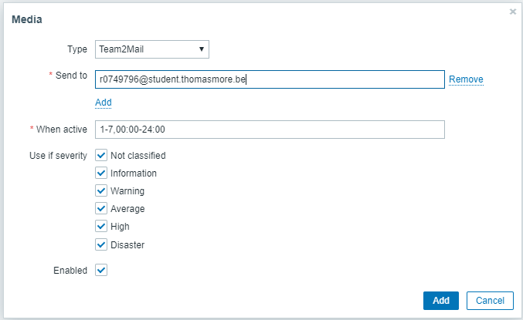

For type choose your mail that you’ve just created in media type. (in our example Team2Mail).

Send to here you can choose who will get the mail for this example I choose my own school mail.

You can keep all the other default settings and click Add.

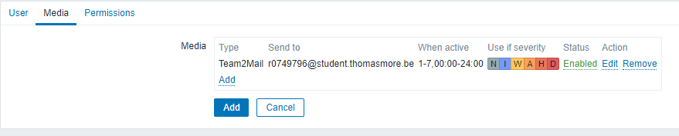

Click once more Add to add your user to the user list.

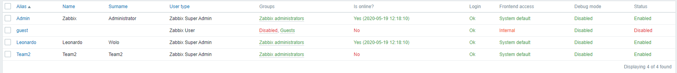

If everything went well you should see your user in the list.

The last step is Creating the alerts themselves.  
Go to Configuration > Actions

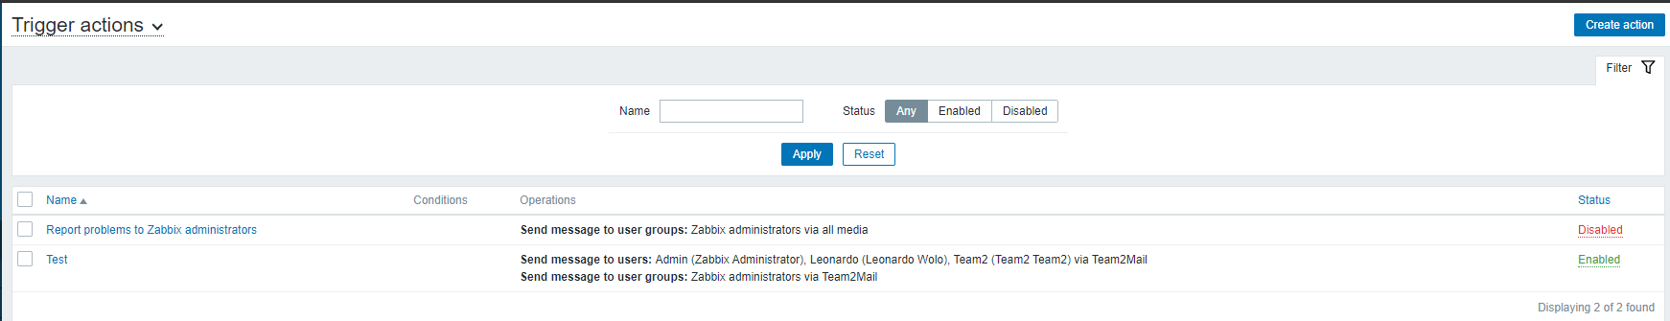

Here you can find all the actions. An action is some kind of mail/message you get if something is going wrong. We need a custom one so we click Create action

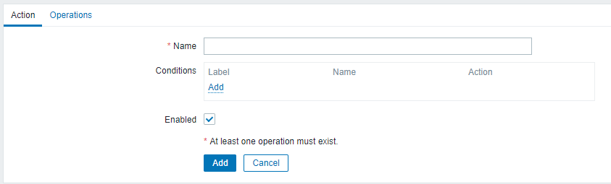

In this first window you only need to choose a custom name for your alert.  
If you want a condition you can add one but for our alert we don’t need one.  
Next window is Operations.  
This is where you create the mail.

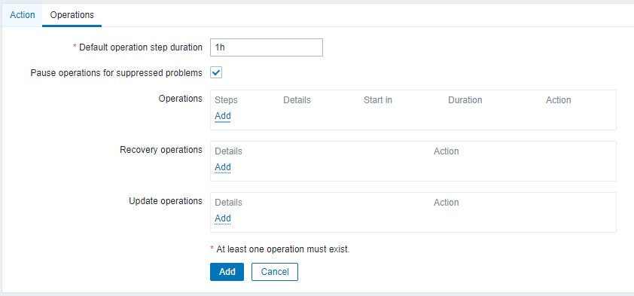

Operations if you click add you will see this window.

Here we can configure an email if a problem happens. Send to User group here you can choose which User group will get the mail.  
Send to Users here it’s very important that you add the created mail form media type. And the last field is the Custom message here you can create your own message with the use of macro’s.

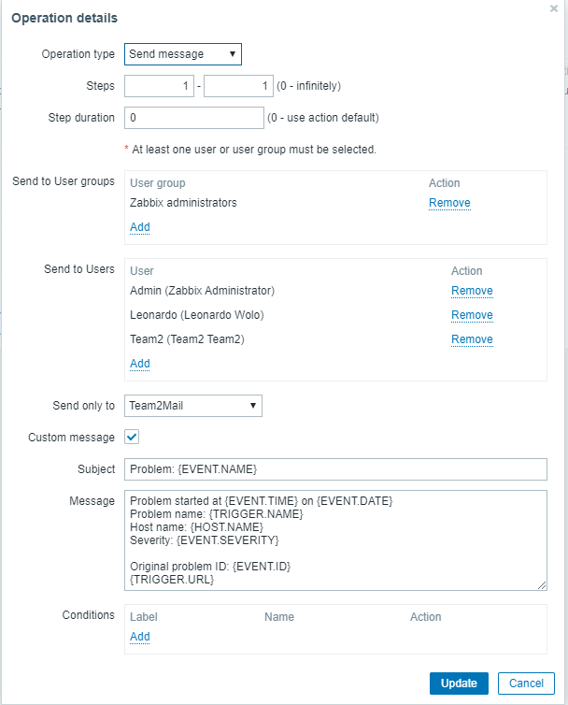

If you’re done click Update.

If you want you can also send a message whenever a problem is resolved. This can be created in Recovery operations.  
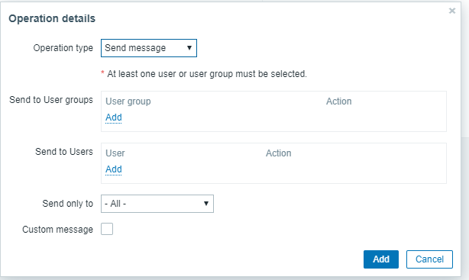

Finally click Add and the action should be in the list.

That’s all for alerts. Whenever a problem occurs you will get an email in your mailbox like this (these can appear in spam).



