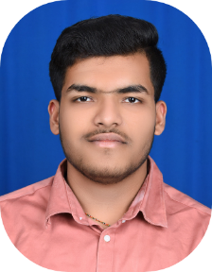**Sanket Patil**

[sanket.patil201@vit.edu](mailto:sanket.patil201@vit.edu) | (+91) 9359986374

Portfolio Website link: https://spthedevloper.github.io/myPortfolio.github.io/

EDUCATION

* Mechanical Engineering | Vishwakarma Institute of Technology, Pune. CGPA: 8.10 | 2023
* XII (HSC) | Shri. Balaji jr college, Ichalkaranji. 78.62% | 2019
* X (CBSE) | J. S. Shramik Vidyalaya, Banage. 92.20% | 2018

EXPERIENCE

* **Android Development Training Intern| Teachnook Growth Community, Pune.** (August ‘22 - September ‘22)

Worked with android development training intern team as an android developer on a building Industrial Application projects.

Technology Used - XML, JAVA, Firebase

* **Full Stack Web Development Training Intern| Teachnook Growth Community, Pune.**  (February ‘23 - Present)

Working with Web Development training team with a mentor as a web developer on building professional websites.

Technology Used - HTML/CSS, JavaScript, Bootstrap

SKILLS

* **Programming Skills:** Java, XML, HTML, CSS, Bootstrap
* **Tools Used:** Android Studio, VS Code, Intellij idea, Oracle 19c

ACADEMIC PROJECTS

* **Project Manager Application:** An android application, especially for teachers and mentors where they can create their profile and store their students group details and update their progress.
* **Quiz Application:** A general knowledge based quiz application with 10 questionswith marking.

*Technology used* - Java, XML, Firebase

* **Myntra Clone:** Develop a Website that is clone of Myntra shopping website

*Technology used* - HTML/CSS, Bootstrap, Python, Flask

* **Health Monitoring System using IOT:** A prototype of health monitoring device which can detect the heartbeat rate, pulse rate, temperature of the body

*Technology used* – Arduino UNO, ESPN8266