PROJECT BOOBIES

Key: **(Bold)** Player made choices  
***(Bold and Italics)*** Conditional situations  
(Subtitles) Directions and information  
*(Italics)* How information is conveyed to the player  
(Subscript1) Reference image

# Prototype – script

## The park scene

Park cinematic. Camera rests on K and Milos.   
*Milos is leaning down, looking at his phone.1 K is sitting beside him, with her legs crossed.2*

K: Hey, we should probably get off this bench soon.

Milos: Can you wait a second?

K: So, when I said soon, I kinda meant now.

Milos: Alriiight, alright. What do we gotta do right now?

K: **(Explore)** Let’s scout out the park, see what we can find.  
**(Interrogate)** Let’s go see what some of these people have to say about the government.

Milos: Sure, sounds good, I’ll be right behind you.

K and Milos both get off the bench. The player is now able to control K.

### Interactive items

If the player interacts with warning poster of killingsMilos: Woah, what’s this? I haven’t heard of anything like this for a really long time.

K: Yeah, neither have I really.

Milos: Should we be worried about this at all?

K: **(Be aware)** Well, I guess we need to stay on the lookout, but we’re already doing that anyways.  
**(Not really)** No, we have the government to worry about, I’m sure we’ll be fine.

Milos: **(Be aware)** Jeez, there’s so much stuff happening, hopefully we can pull through.  
**(Not really)** I sure hope so.

K *[thoughts]*: We might need to investigate this further. Could the government be involved in this at all?

If the player interacts with the yellow jacketMilos: Is that- are those the drugs that do some funky stuff to your chip implant?

K: Yeah, they’re used for altering your perspective to make it more positive, or… happier.

Milos: Well, I’m pretty happy just being able to explore the city with you.

K: Where’d that come from?

Milos: You know, K, I’m just a pretty sentimental guy.

If the player interacts with the two childrenMilos: Hey, look at those two!

K: **(Cute)** Aren’t they so adorable? And so naïve too. I wish I could be a kid again.  
**(Annoying)** Kids are kinda annoying. But they’re so naïve too. It’d be nice to be a kid again.

If the player interacts with the map before getting info on the abandoned barK [thoughts]: I don’t think I’ve ever realised just how big this city is.

If the player interacts with the map after getting info on the abandoned barK [thoughts]: So, I guess we need to walk down the road then.

If the player interacts with the billboard advertising health and technology classesK: I think I read somewhere that since 2020, we’ve had so much growth in health and technology.

Milos: Wow, school. I wagged so much-

K: Wagged?

Milos: You know, skipped class. Failed to attend. Excused myself from-

K: Yeah, alright, I got it.

## Conversation with citizens

The police officer  
*The police officer will be standing in front of a nearby tree, which has the warning poster of the killings stuck to it. She will be typing into a holographic tablet, being slightly frustrated with her brows furrowed.3 The player will have multiple dialogue options if they choose to talk with her.*   
*As you approach her*:  
Police officer: Hello, can I help you?

K: **(Poster, *reliant on if the player has interacted with the poster before)*** Do you know anything about the killings happening around town?  
Police officer: That shouldn’t be up there.   
*The police officer will then rip the poster of the tree, fold it up, and put it into her pocket.*Police officer: Those kinds of poster were classed as a felony years ago, in order to reduce vandalism and give the environment some peace.  
Milos: Are ya sure? Because I think-  
K: Oh, I see, I’ll make sure to let you know if I see anymore of those posters hanging around.

K: **(Government building)** Has there been any criminal activity surrounding the government building lately?  
Police officer: Not that I know of.  
Milos: Has anyone ever broken into the government building successfully?   
Police officer: No.

K: **(Tablet)** It’s pretty amazing that you guys now use these kinds of tablets to do your work in the field.   
Police officer: Yeah, I guess it is.

K: **(Say nothing)**Milos: We just wanted to ask, how you doing?  
Police officer: I’m well, thanks.

After the exchange with the police officer:  
K: ***(If discussed government building)*** Milos, you can’t be so obvious when talking to police officers!  
Milos: What do you mean ‘obvious’?  
K: You can’t go around asking them about government building break-ins! It needs to be somewhat subtler.  
Milos: Noted.  
K: *sighs*

K: ***(If discussed killings poster however did not interact with billboard)***Ripping that poster off the tree was a little strange. And what did she say about that law?  
Milos: I’m 99% certain that that isn’t a law.   
K: How would you know?  
Milos: Well, back in the day, I was studying to become a lawyer and I’m pretty sure-  
K: Wait you were studying to become a lawyer?  
Milos: Well, yeah.   
K: That’s amazing.   
Milos: Aw, shucks, I know I’m amazing.

K: ***(If discussed killings poster and interacted with billboard)*** Ripping that poster off the tree was a little strange. And what did she say about that law?  
Milos: I’m 99% certain that that isn’t a law.   
K: How would you know?  
Milos: Well, back in the day, I was studying to become a lawyer and I’m pretty sure-  
K: Wait you were studying to become a lawyer?  
Milos: Well, yeah.  
K: But I thought you said you skipped class all the time.  
Milos: You can skip class and still be smart, right?  
K: Riiiight.

K: ***(If discussed killings poster and government building)*** Milos, you can’t be so obvious when talking to police officers!  
Milos: What do you mean ‘obvious’?  
K: You can’t go around asking them about government building break-ins! It needs to be somewhat subtler.  
Milos: Noted.  
K: *sighs*  
Milos: But you know, that law she was talking about? I’m 99% certain that isn’t a law.   
***The following is reliant on whether the player interacted with the billboard.***  
K: How would you know?  
Milos: Well, back in the day, I was studying to become a lawyer and I’m pretty sure-  
K: Wait you were studying to become a lawyer?  
Milos: Well, yeah.   
K: That’s amazing.   
Milos: Aw, shucks, I know I’m amazing.

The father of two children   
*He will be sitting on a bench, watching over his children playing on the grass. He should look tired and stressed.4*

K: **(Children)** Hey, are those your children over there? They’re really cute.  
Father: I really appreciate that. I’m struggling quite a bit to provide for them right now, and its taken a toll on me.  
K: Wow, I’m sorry to hear that.  
Father: Well, I did sign up for the parental initiative the government is doing, for people… I guess, like me, but they haven’t sent me any support yet.  
Milos: That sounds really dodgy.   
Father: Yeah, well, what can you do?

K: **(Killings)** Have you heard of any killings around the city?  
Father: No… Are-are we safe?  
K: Um, yeah, don’t worry, it’s still a rumour at this stage.  
Father: Please let it be a rumour. I’d give anything for my children’s’ safety.

K: **(Government building)** Have you ever heard if the government building has been broken into?  
Father: I think there’ve been some security breaches in the past. But I don’t have all the details, sorry.  
K: ***(If already talked about children)*** No that’s fine, thanks for your help. All the best with your children.  
K:***(If haven’t talked about children)*** No that’s fine, thanks for your help.

The city planner  
*She should be standing near a tree, eating a sandwich.* *5*

K: Hi, how are you?

City planner: I’m a little confused. I’ve just finished looking at a bar that’s to be refurbished, and I was told it had been abandoned for a good 5 years, but it seems to be clean and relatively unscathed.

K: ***(If have not received information on abandoned bar from citizen)*** Do you have any more information on that?  
City planner: I’m not able to say anything more on this project currently.  
K: I understand. I was also looking to ask, have you ever heard of the government building being broken into before?

Milos: ***(If have received information on abandoned bar from citizen)*** That sounds really strange.  
K: I was also looking to ask, have you ever heard of the government building being broken into before?

City planner: No, I haven’t heard of a such a thing.

K: Alright, good luck on refurbishing that bar!

After the exchange with the city planner:  
Milos: I think it’d be better if the bar was made into a café.

K: How come?

Milos: Alcohol is pretty sucky. It does all sorts of damage and I just don’t like to not be in control, you know?

K: Didn’t think you’d be one to not like alcohol.

Milos: **(If discussed killings poster with police officer)** Well, you didn’t think I’d be one to study law either.  
K: I guess that’s true.

Milos: **(If didn’t discuss killings poster with police officer)** Well, I’m just an interesting character.  
K: I guess you could say that.

Random citizen at bus stop  
*He will be sitting at the bus stop well-dressed, staring off into the distance. Despite the fact that he is the head of a company, he should look relatively young, in his late 20s.6 Every so often, he will glance down to look at his watch.*

K: Hi sir, would you happen to know when the next bus is coming?

Citizen: Err, it should be here in 15 minutes. I really hope it doesn’t arrive though, so I don’t need to go to my incredibly delightful job.

K: What’s wrong with your job?

Citizen: Well, I work at the head of a food manufacturing company, but it’s boring like nothing else.

Milos: That sounds pretty cushy.

Citizen: I guess it is, but wouldn’t you rather do something that you love? Something that makes you excited to get out of bed every day?

K: **(Good point)** That’s a good point you got there.  
Citizen: I’m just really looking forward to that bar that’s opening downtown. I’ve heard its open to government and high-ranking officials, and I guess I count? That’s a pretty nice benefit of my job.

K: **(Are you serious)** Are you kidding me? There’s so many people that would like to have your job.  
Citizen: Well, I’m just really looking forward to that bar that’s opening downtown. I’ve heard its open to government and high-ranking officials, and I count. That’s a pretty nice benefit of my job.

K: A bar?

Milos: ***(If have received information on abandoned bar from city planner)*** That sounds really strange.

Citizen: Yeah, hopefully I can catch a drink over there soon.

K: Alright, it was nice to meet you.

Citizen: ***(If previously said ‘good point’)*** Same here.

Citizen: ***(If previously said ‘are you serious’)*** Yeah.

## Reference images

1. 
2. 
3. 
4. 
5. 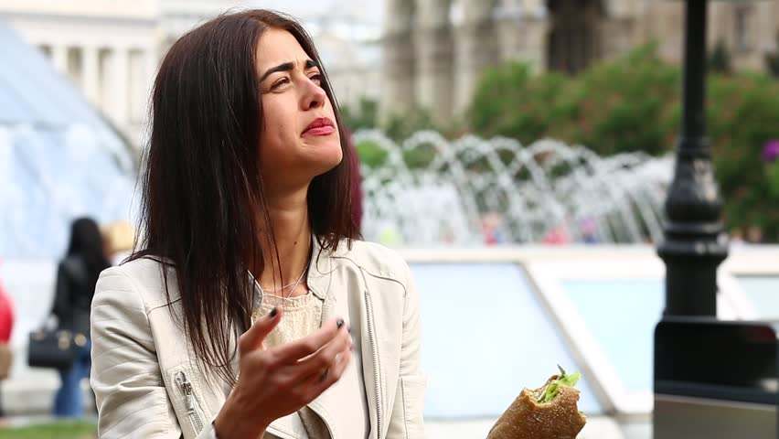
6. 