PROJECT BOOBIES

Key: **(Bold)** Player made choices  
***(Bold and Italics)*** Conditional situations  
(Subtitles) Directions and information  
*(Italics)* How information is conveyed to the player  
(Subscript1) Reference image

# Prototype – script

## The park scene

Park cinematic. Camera rests on K and Milos.   
*Milos is leaning down, looking at his phone.1 K is sitting beside him, with her legs crossed.2*

K: Hey, we should probably get off this bench soon.

Milos: Can you wait a second?

K: So, when I said soon, I kinda meant now.

Milos: Alriiight, alright. What do we gotta do right now?

K: **(Explore)** Let’s scout out the park, see what we can find.  
**(Interrogate)** Let’s go see what some of these people have to say about the government.

Milos: Whatever you say, lady.

K and Milos both get off the bench. The player is now able to control K.

### Interactive items

If the player interacts with warning poster of killingsMilos: Woah, what’s this - some killer’s on the loose? That definitely wasn’t here yesterday.

K: Huh, that’s strange.

Milos: Should we be worried about this at all?

~~K:~~ **~~(Be aware)~~** ~~I guess we need to stay on the lookout, but we’re already doing that anyways.~~**(Not really)** Calm down Milos, it’s probably a prank done by a kid or something. No need to get all antsy…

~~Milos:~~ **~~(Be aware)~~** ~~I suppose you’re right.~~

**(Not really)** I sure hope so.

~~K~~ *~~[thoughts]~~*~~: We might need to investigate this further. Could the government be involved in this at all?~~

K (faces away from Milos) *[thinks anxiously]*: Could it be…

Milos: You alright?

K *[bluffing]*: Um yeah…! I thought I saw someone I knew. Turns out it was just a lamp post. I really need to get my eyes checked.

Milos: Huh? Whatever you say K.

If the player interacts with the yellow jacketMilos: Omg K, look over there – what’s that guy doing?

K: I’m pretty sure that’s just Felinol.

Milos: Huh? But it looks like that man’s try’na stab himself in the head!

K: It was a breakthrough drug we’ve developed to help our patients overcome depression many years ago. Works by temporarily overclocking the user’s implant, giving them a temporary sense of euphoria. Long story short, the drug was blacklisted for it’s addictive nature; It now only exists in the form you see before you. Just stay from that guy would you?

Milos: Jesus that looks painful. I wouldn’t want to be stabbed in the head with that.

K: Are you even listening to what I’m saying?

Milos: Yeah yeah. Well, I’m already having a blast being able to explore the city with you. I’ve never felt so alive in ages!

K: Where’d that come from?

Milos: You know, K, I’m just a pretty sentimental guy.

If the player interacts with the two childrenMilos: Hey, look at those two!

K: Aren’t they so adorable? And so naïve too. I wish I could be a kid again.  
**~~(Annoying)~~** ~~Kids are kinda annoying. But they’re so naïve too. It’d be nice to be a kid again.~~

Milos: Yeah nah I don’t think you’re getting any younger. But babies could definitely grow up to be kids.

K: Whaaaat are you implying?

Milos: Nothing!

[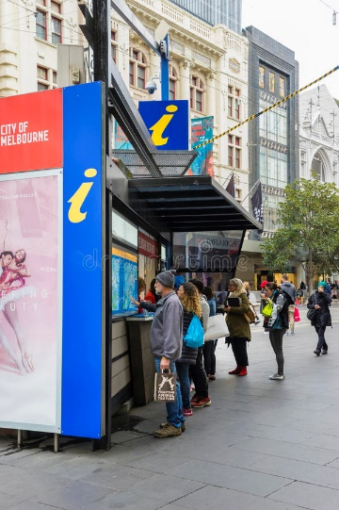](https://www.google.com.au/url?sa=i&rct=j&q=&esrc=s&source=images&cd=&cad=rja&uact=8&ved=0ahUKEwjSqJ72oK7ZAhXJKZQKHTiWApQQjRwIBw&url=https%3A%2F%2Fwww.dreamstime.com%2Feditorial-stock-image-tourists-looking-information-melbourne-visitor-booth-australia-august-bourke-street-image57901759&psig=AOvVaw3IUz8POwK5HPNAG72o_riN&ust=1519001767396791) This image is not really accurate

If the player interacts with Info Stall/MAP before getting info on the abandoned barK [thoughts]: Maps huh. I guess I’ll be a tourist for a day and take one of these. Pretty unfortunate this one only shows what’s around this area though.

If the player interacts with the INFO STALL/MAP after getting info on the abandoned barK: 124th Alberton Street...

Milos: Come on K we don’t have all day.

K: Not my fault if it’s not on the map.

Milos: But you’re holding the map upside down man!

[Snatches map away and reads it himself]

Milos: See it’s right there on the top right corner! It’s quite far from here by foot but I think I know a shortcut. We should be able to make it before sunset.

K: This map is poorly designed.

Milos: *Sigh* Alright let’s get going.

If the player interacts with the billboard advertising health and technology classesK: I’ve read somewhere that since 2020, we’ve had so much growth in health and technology. I really don’t get why they won’t let us share our discoveries and innovations with the world.

Milos: Wow, school. The good old days y’know? I wagged so much-

K: Wagged?

Milos: You know, skipped class. Failed to attend. Excused myself from-

K: Yeah, alright, I got it.

Milos: Say K, have you ever wagged?

K: I think I could remember one instance, when [something]. After learning the consequences – the hard way of course – I’ve never thought of doing that again.

Milos: Never imagined you’d do such a thing. Back where I came from you could never turn up to class and still ace the exams. No one even cares.

K: What a lucky boy.

## Conversation with citizens

### The police officer

*The police officer will be standing in front of a nearby tree, which has the warning poster of the killings stuck to it. She will be typing into a holographic tablet, being slightly frustrated with her brows furrowed.3 The player will have multiple dialogue options if they choose to talk with her.*   
*As you approach her*:  
Police officer: Hello madam, can I help you?

Milos: **(Poster, *reliant on if the player has interacted with the poster before)*** What’s up those posters hanging on the trees around here?

Police officer: Those…shouldn’t be up there.   
*The police officer will then rip the poster of the tree, fold it up, and put it into her pocket.*Police officer: Those kinds of poster were classed as a felony years ago, in order to reduce vandalism and give the environment some peace.  
Milos: Are ya sure? Because I think-  
K: Oh, I see, I’ll make sure to let you know if I see anymore of those posters hanging around.

K: **(Government building)** Anyways, we would to ask you a few questions as part of an assignment.

Police officer: Sure.

Milos: Huh what assi-

K [Whispering to milos]: Shut up.

K [To the police officer]: Has there been any news of criminal activity surrounding the government complex lately?  
Police officer: Not that I know of. Well I guess there were police employees sneaking snacks into our office, if that counts.

K: I’m more interested in breaches of security, as in, are there sufficient security measures put in place to secure the government complex?

Police officer: I would not informed if a security breach occurs. I do not see any reason for one to take such a risk in any case.

Milos: You wouldn’t know of any past – umm - Break-ins, or break-outs, would ya?

Police officer: You’re really getting on my nerves you know that? I have important work right now. It would a pleasure to see you guys leave.

K: **(Tablet)** It’s pretty amazing that you guys now use these kinds of tablets to do your work in the field.

Police officer: Yeah, I guess it is.

K: **(Say nothing)**Milos: We just wanted to ask, how you doing?  
Police officer: I’m well, thank you.

After the exchange with the police officer:  
K: ***(If discussed government building)*** Milos, you can’t be so obvious when talking to police officers!  
Milos: What do you mean ‘obvious’?  
K: You can’t go around asking them about government building break-ins! It needs to be somewhat subtler.  
Milos: Noted.  
K: *sighs*

K: ***(If discussed killings poster however did not interact with billboard)***Ripping that poster off the tree was a little strange. And what did she say about that law?  
Milos: I’m 99% certain that that isn’t a law.   
K: How would you know?  
Milos: Well, back in the day, I was studying to become a lawyer and I’m pretty sure-  
K: Wait you were studying to become a lawyer?  
Milos: Well, yeah. It wasn’t really my decision though. But I guess it was a decision nonetheless.  
K: That’s amazing.   
Milos: Aw, shucks, I know I’m amazing.

K: ***(If discussed killings poster and interacted with billboard)*** Ripping that poster off the tree was a little strange. And what did she say about that law?  
Milos: I’m 99% certain that that isn’t a law.   
K: How would you know?  
Milos: Well, back in the day, I was studying to become a lawyer and I’m pretty sure-  
K: Wait you were studying to become a lawyer?  
Milos: Well, yeah.  
K: But I thought you said you skipped class all the time.  
Milos: Simply put – I’m too cool for school.

K: Riiiight.

K: ***(If discussed killings poster and government building)*** Milos, you can’t be so obvious when talking to police officers!  
Milos: What do you mean ‘obvious’?  
K: You can’t go around asking them about government building break-ins! It needs to be somewhat subtler.  
Milos: Noted.  
K: *sighs*  
Milos: But you know, that law she was talking about? I’m 99% certain that isn’t a law.   
***The following is reliant on whether the player interacted with the billboard.***  
K: How would you know?  
Milos: Well, back in the day, I was studying to become a lawyer and I’m pretty sure-  
K: Wait you were studying to become a lawyer?  
Milos: Not anymore.   
K: Well, that’s pretty amazing.   
Milos: Aw, shucks, I know I’m amazing.

The father of two children   
*He will be sitting on a bench, watching over his children playing on the grass. He should look tired and stressed.4*

K: **(Children)** Hey, are those your children over there? They’re really cute.  
Father: I really appreciate that.

Milos: Hey, you doing alright old man? You look a bit tired.

Father : I’m fine… – Actually I’m struggling quite a bit to provide for them right now, and it’s taken a toll on me.  
K: I’m sorry to hear that.  
Father: Ever since their mother left the world, I’ve been struggling to make ends meet. No one wants to employ someone who also needs to care for two children full-time you know? We came to this great city with great ambitions. And now, the only motivation for me to keep fighting are these two young boys.   
Milos: Is that so?  
Father: Well, what can you do? Lovely to see the government not giving a damn about us.

K: **(Killings)** You’ve heard of the killings around the city?  
Father: Killings…? Are-are we safe?  
K: Um, yeah, don’t worry, it’s still a rumour at this stage.  
Father: You’d better be joking young lady. I’m already in pretty deep water here.

K: **(Government building)** Have you ever heard if the government building has been broken into?  
Father: Huh? Are you planning on breaking in?

Milos: Yeah we’re gonna break in like its nothin.

K: Milos shut up will ya.

Father: I’ve heard it’s almost impossible to get in without being an employee. My wife used to work closely with top-level personell. She’s always bothersome it is to get through all the security procedures to just to get into the foyer. I’m not really sure what exactly it takes to get in though. I really wouldn’t risk getting caught though.

K: ***(If already talked about children)*** No that’s fine, thanks for your help. All the best with your children.  
K:***(If haven’t talked about children)*** No that’s fine, thanks for your help.

Father: *Laughs* You two really remind me of the old times, when she and I were still together. Thank you for bringing some hope to my heart.

The city planner  
*She should be sitting near a tree, eating a sandwich.* *5*

K: Hi, how are you?

City planner: I’m alright. I’ve just finished looking at a bar that’s to be refurbished, and I was told it had been abandoned for a good 5 years.

K: ***(If have not received information on abandoned bar from citizen)*** An abandoned bar huh? Would you care to tell me more about it?

City planner: Sorry, I’m not able to say anything more on this project currently. But why don’t you go and check it out yourself? It’s at [address]. It’s pretty clean for a place abandoned for 5 years. It’s almost as if the place is still maintained by the ghosts of the past owners!

K: Thanks. I was also looking to ask, have you ever heard of the government building being broken into before?

Milos: ***(If have received information on abandoned bar from citizen)*** That sounds really strange.  
K: I was also looking to ask, have you ever heard of the government building being broken into before?

City planner: No, I haven’t heard of a such a thing. Why do you ask?

K: Just out of interest, good luck on refurbishing that bar!

After the exchange with the city planner:  
Milos: I think it’d be better if the bar was made into a café.

K: How come?

Milos: I’ve never liked alcohol. It does all sorts of damage and I just don’t like to not be in control, you know?

K: Didn’t think you’d be one to not like alcohol.

Milos: **(If discussed killings poster with police officer)** Well, you didn’t think I’d be one to study law either.  
K: I guess that’s true.

Milos: **(If didn’t discuss killings poster with police officer)** Well, I’m just an interesting character.  
K: I guess you could say that.

Random citizen at bus stop  
*He will be sitting at the bus stop well-dressed, staring off into the distance. Despite the fact that he is the head of a company, he should look relatively young, in his late 20s.6 Every so often, he will glance down to look at his watch.*

K: Hi sir, would you happen to know when the next bus is coming?

Citizen: Err, it should be here in 15 minutes. A part of me kind of wishes that it never arrives though, so I don’t need to go to my incredibly delightful job.

K: What’s wrong with your job?

Citizen: Well, I work at the head of a food manufacturing company, but it’s boring like nothing else.

Milos: That sounds pretty cushy.

Citizen: I guess it is, but wouldn’t you rather do something that you love? Something that makes you excited to get out of bed every day?

K: **(Good point)** That’s a good point you’ve got there.  
Citizen: I’m just really looking forward to that bar that’s opening downtown. I’ve heard its exclusive to government and high-ranking officials, and I guess I count? That’s a pretty nice benefit of my job.

K: **(Are you serious)** Are you kidding me? There’s so many people that would like to have your job.  
Citizen: Well, I’m just really looking forward to that bar that’s opening downtown. I’ve heard its exclusive to government and high-ranking officials, and I count. That’s a pretty nice benefit of my job.

K: A bar?

Milos: ***(If have received information on abandoned bar from city planner)*** You don’t mean – that bar?

Citizen: Yeah, hopefully I can catch a drink over there soon.

K: Alright, it was nice to meet you.

Citizen: ***(If previously said ‘good point’)*** Same here.

Citizen: ***(If previously said ‘are you serious’)*** Yeah.

## Reference images

1. 
2. 
3. 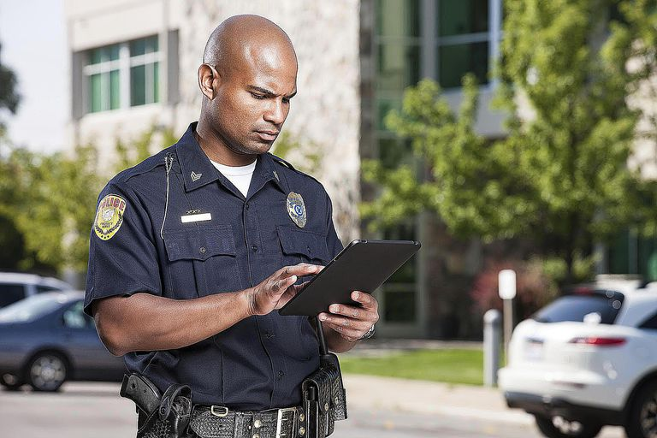
4. 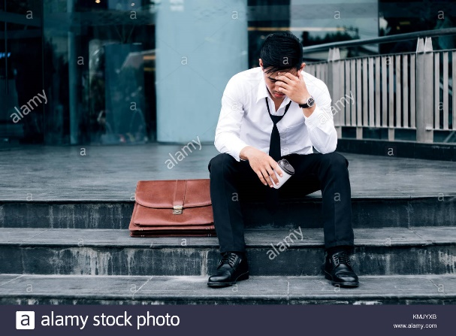
5. 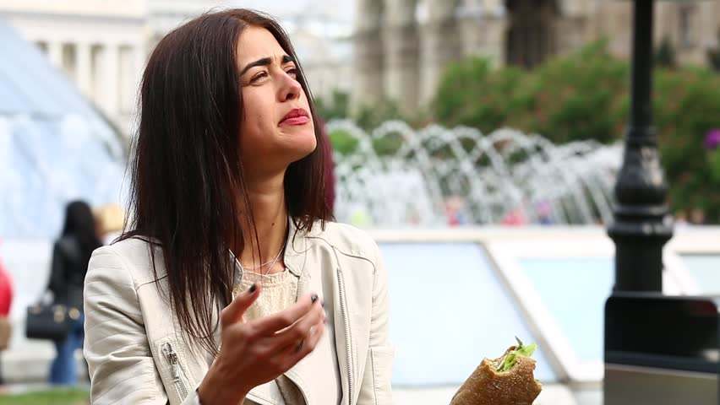
6. 