Silentnight
Barclays eFinance Module

Background
Silentnight want to introduce Barclays eFinance payment method within Magento to allow the customer to split the cost of their purchase over a defined time period.
Silentnight have opted for bFlex option which requires the use to select their preferred time period and the amounts are calculated.

Standard Process
Once the use has completed their basket and proceeds to checkout the user will be provided an option to pay for their items via finance.
The user will complete their checkout within Magento and the order is placed. The order will have a suitable status to reflect the stage of the order.
At this point the user is typically shown the “order success” page however there will be some logic placed to check if the order has been placed using the Barclays eFinance method. If this is true at this point we will redirect the user to the Barclays eFinance website to complete their finance application form.

Finance Options
Once the user has reviewed their order and they opted to pay via finance there is one of three possibilities that can take place:
- Magento requests from BPF the available finance options given the orders details (order value, etc). BPF respondes with suitable finance options for Magento to parse and present to the user.
- Magento presents the user with an already determined set of finance options.
- No finance options are presented to the user, this is take care of when the user is redirected through to the BPF website.
The client needs to decide which method they prefer. This can also be configurable but will extend the development time required.

Magento Integration
A single module will be developed to encompass all the functionality required to start a credit application to completion of an application.

SOAP Library
A library will also be developed that will act as the communication layer between Magento and BPF.
The library will expose all the functionality provided by the BPF web service. The library will be developed extensibility and maintainability in mind.

Payment Method
The module will expose a new payment method within Magento. This will be developed following standard Magento practises. It will appear amongst the list of selectable payment methods during the checkout process.

Status Observer
Once orders are placed in Magento using BPF payment method the order will not be further manipulated by Magento itself and is then the responsibility of the module to progress the order.
Initially the status of the order will be set to “Awaiting Customer”. The module will then listen to events from the BPF callback service and update/progress the order status.
The following image shows a list of possible statuses of the application. The module will act accordingly to each state and reflect the status on to the respective orders. Once complete, depending on the outcome, the order will either be “complete” or “closed” (cancelled).
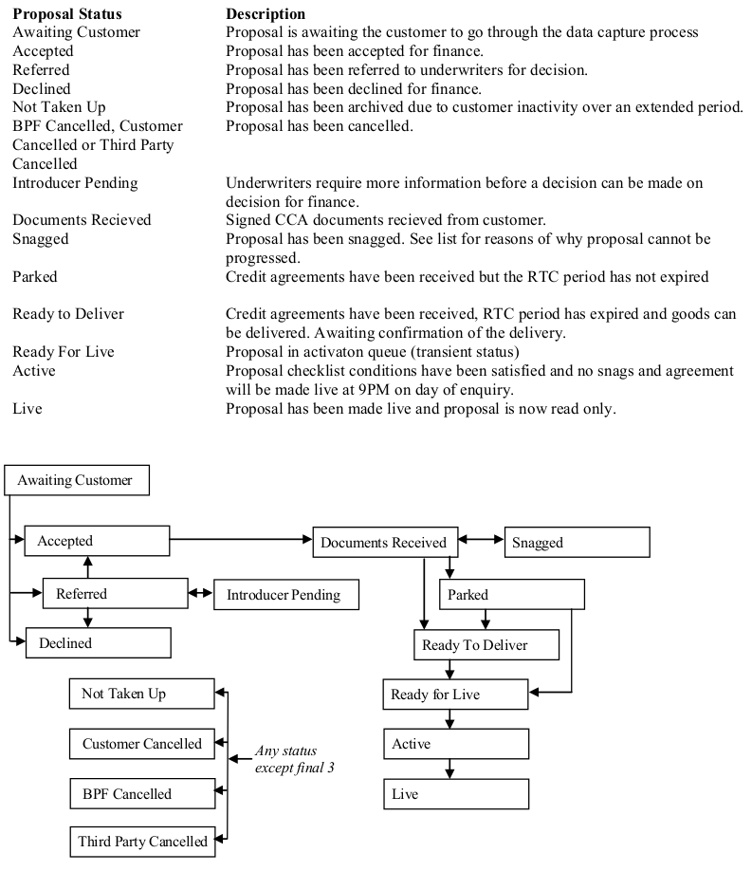

Admin User Notifications
The admin user will be notified via email at relevant stages of an application where a human process is required.
Admin user notifications will be triggered via the observer.

User Notifications
The user will be notified via email at relavant stages of an application to advise them of the status of their order.
User notifications will be triggered via the observer.

Order Statuses
The module will present a new state/status list item that will relate to the corresponding states of the finance application.

Order Dispatch Notifications
The module will also observe when orders, which are financed, are dispatched to allow it to notify the Barclays eFinance service of the status of the order which in turn should active the finance application.

Manual Order Progression
At relavent stages of the finance application where a human workflow has taken over the admin user is able to manually progress the order as long as it satisfies the requirements from BPF.

Application Manager
The module will include an admin screen whereby a list of applications can be seen. This will be a grid of all applications made including their status, their related order, the amount and other general information.
Clicking on an application will allow the admin user to drill down into the application to see more in-depth details of the application.
From here the admin can also perform the following actions:
- Respond to underwriter queries.
This is known as “Introducer Response”. This basically allows the client to respond to queries posed by the underwriters at BPF.
- Cancel an agreement/application.
This will cancel the application or agreement. In turn it will also “close” the order. This may also be invoked automatically when either creating a credit memo or processing an RMA.
Application information will also be visible within the core order management screen within Magento. This will show high level detail of the application as above.

