Project: Diamond Prices

# Step 1: Understanding the Model

*Answer the following questions:*

1. According to the model, if a diamond is 1 carat heavier than another with the same cut, how much more should I expect to pay? Why?

* The one additional carat would result in an additional $8413 in price. The formula created by the regression determined that the coefficient for a carat is 8413, so for every increase in the weight of carat the price will increase by the amount of the coefficient.

1. If you were interested in a 1.5 carat diamond with a **Very Good** cut (represented by a 3 in the model) and a **VS2** clarity rating (represented by a 5 in the model), how much would the model predict you should pay for it?

* The formula is Price = -5,269 + 8,413 x Carat + 158.1 x Cut + 454 x Clarity

Price = -5,269 + 8,413 x 1.5+ 158.1 x 3+ 454 x 5

Price = 10094.8

# Step 2: Visualize the Data

Make sure to plot and include the visualizations in this report. For example, you can create graphs in Excel and copy and paste the graphs into this Word document.

1. Plot 1 - Plot the data for the diamonds in the database, with carat on the x-axis and price on the y-axis.
2. Plot 2 - Plot the data for the diamonds for which you are predicting prices with carat on the x-axis and predicted price on the y-axis.
   * **Note**: You can also plot both sets of data on the same chart in different colors.
3. What strikes you about this comparison? After seeing this plot, do you feel confident in the model’s ability to predict prices?

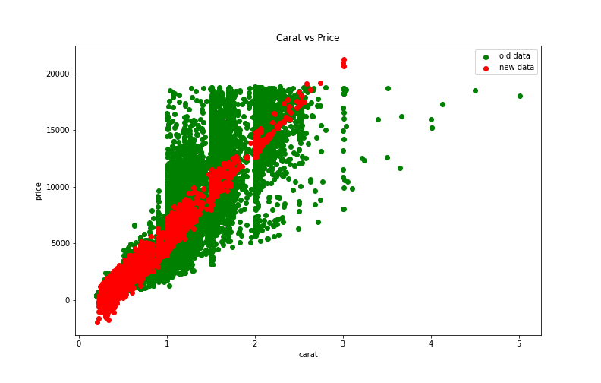

* The predicted prices show strong correlation than the actual data. This is because we are not accounting for everything that affects prices. There are many more things than weight (carat) that affect it. We had cut and clarity factored in to our formula but not even that will account for all the variation.
* After looking at this plot the model appears on average to predict the prices ok. While the formula may not be accurate for an individual diamond, it should do a decent job at predicting the price we should pay for several diamonds at once since it on average looks representative.

# Step 3: Make a Recommendation

*Answer the following questions:*

1. What price do you recommend the jewelry company to bid? Please explain how you arrived at that number.

* I recommend a bid of $8,213,465.93. I arrived at this number by using a formula from the regression model provided that was based on previous diamonds sales and applied it to the diamonds that were up for bid. I then factored in the margin the investors were looking for which was 30% so I multiply the predicted amount 11,733,522.76 by .70 to get the final predicted bid of $8,213,465.93