Project 2.1: Data Cleanup

## Step 1: Business and Data Understanding

*Provide an explanation of the key decisions that need to be made. (250 word limit)*

### Key Decisions:

*Answer these questions*

1. What decisions needs to be made?

To recommend the city for Pawdacity’s newest store, based on predicted yearly sales.

1. What data is needed to inform those decisions?

I need data on existing store's year sales, census population data as well as demographic information associated with these existing stores such as households with individuals under 18, land area, population density, and total families that would allow us to detect areas with more potential customers to see whether any of these variables can drive our existing store sales.

## Step 2: Building the Training Set

*Build your training set given the data provided to you. Your column sums of your dataset should match the sums in the table below.*

*In addition provide the averages on your data set here to help reviewers check your work. You should round up to two decimal places, ex: 1.24*

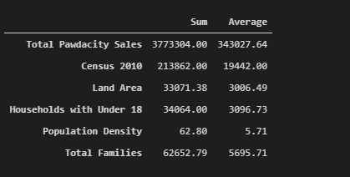

## Step 3: Dealing with Outliers

*Answer these questions*

Are there any cities that are outliers in the training set?

* The outlier cities are Cheyenne, Gillette, and Rock Springs

Which outlier have you chosen to remove or impute? Because this dataset is a small data set (11 cities), **you should only remove or impute one outlier**. Please explain your reasoning.

* Due to the small data set constrain. Any removal of an outlier city will result in 9.1% data set reduction.
* The large land area and total sales made Rock Springs and Gillette city respective outliers while large total sales, census population, population density, and total families made Cheyenne an outlier city.
* I will remove the Cheyenne city due to unusual properties (not part of the population I study)